Experiment Procedure Documentation

Introduction
This document captures the instructions to integrate this template with your quiz.

Instructions
- Open the index.htm page and select the algorithm.
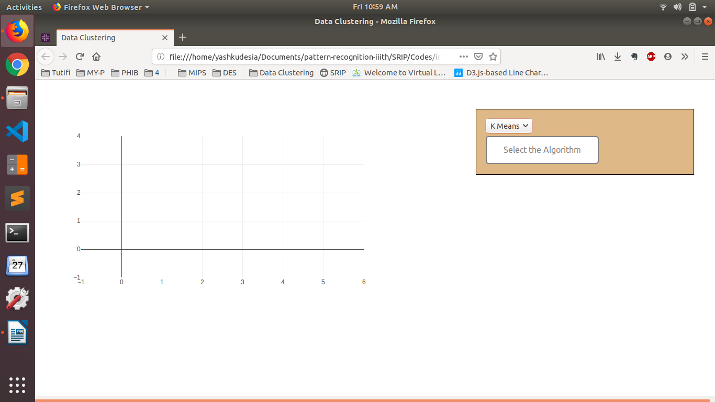

A2. If you select the kmeans, then first load some data sets (for proper result, load more than 2 dataset).Here is fig I have loaded L1 (red color) and L4 (yellow color).
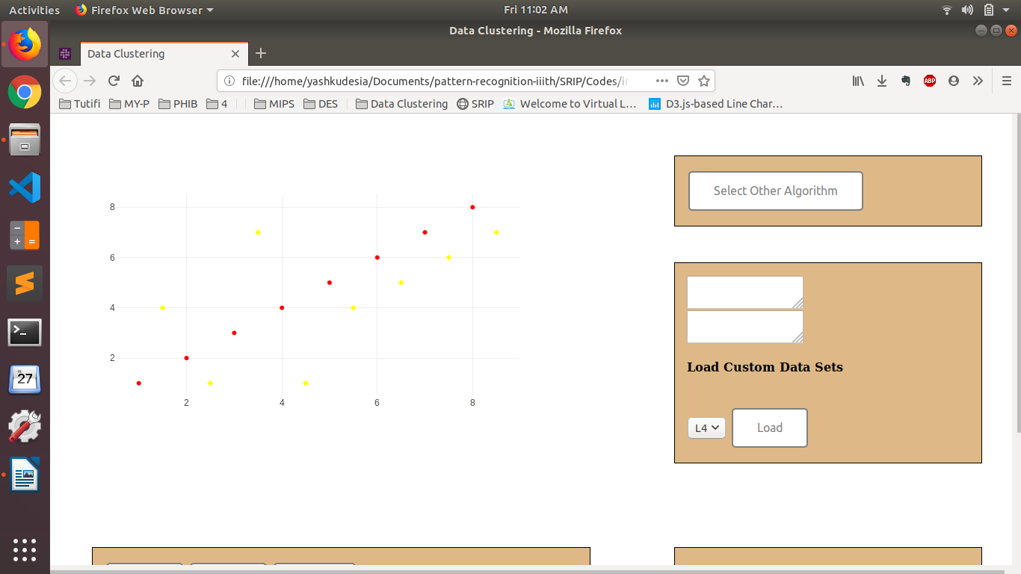
A3. Now Mark points (brown color) on the graph after toggling the Testpoint button.
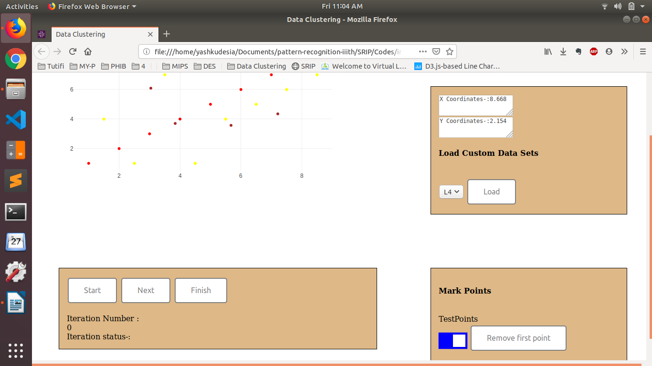
A4. Now click on start for initialisation purposes and first iteration.Following start either click Next for step wise iteration or finsih for compeleting the algorithm. (here finsh is clicked after start)
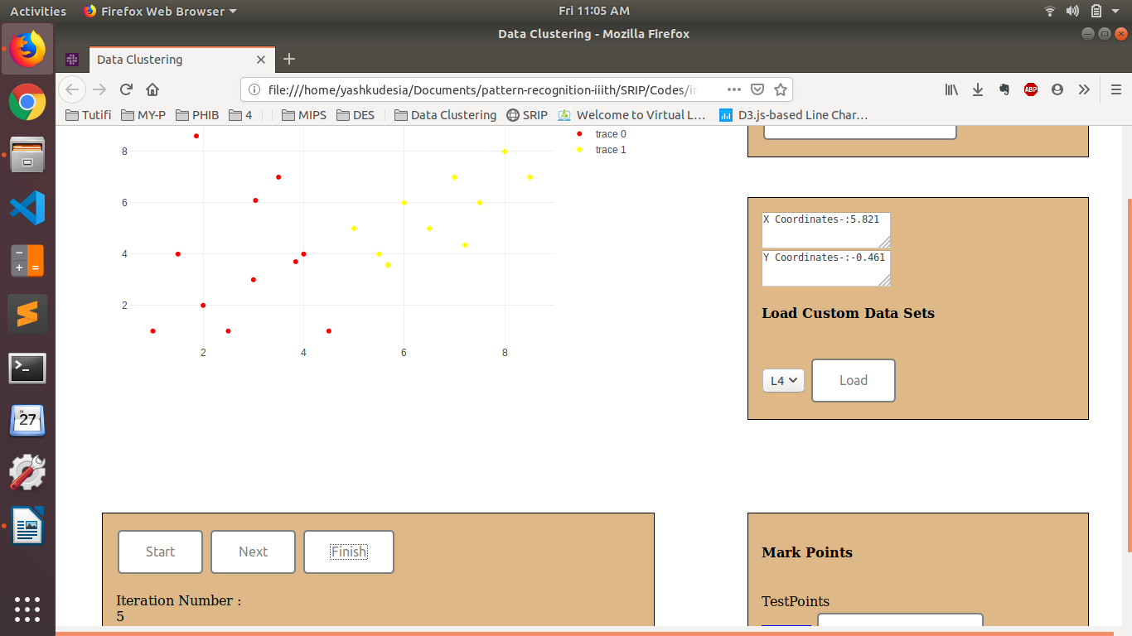
B2. If you choose the MST Clustering, then mark the testpoints.
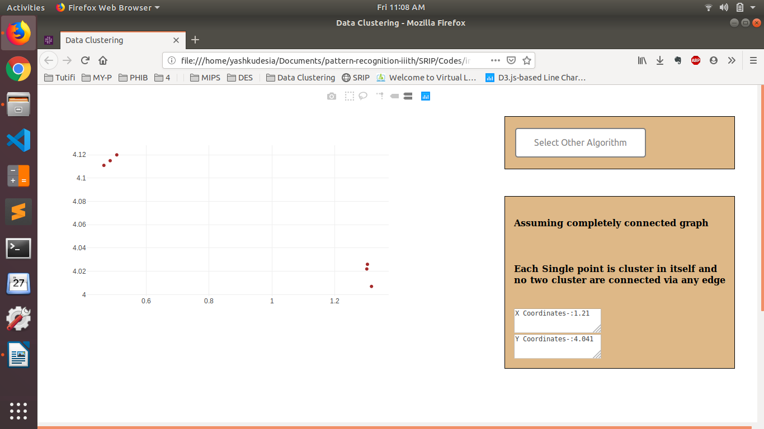
B3. Now click on start for initialisation purposes and first iteration.Following start either click Next for step wise iteration or finsih for compeleting the algorithm. (here finsh is clicked after start)
