Salon Website

Overview : The Salon site only for women clients where they can book an appointment online and get to know the services and offers provided by the salon .

Pages

- Home Page:
- About Us:
- Contact Us:
- Services:
- Career

Home Page:

The Home Page will basically consists of a navigation bar , below it a slider , latest services offered,
Offers , Book an appointment, testimonals ,Footer.

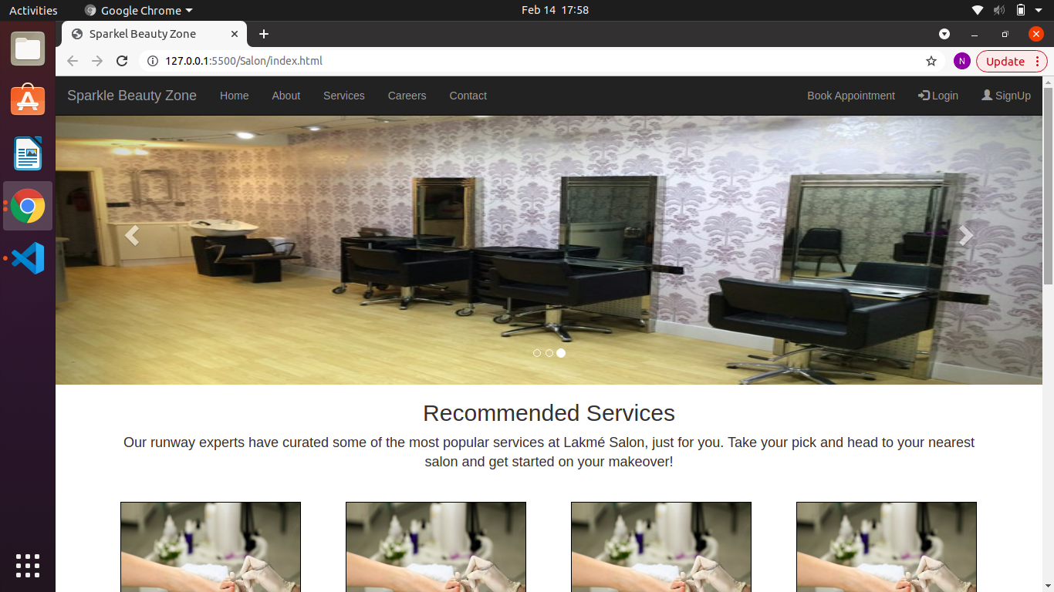

About Us:

This page will describes about the speciallity of the salon.

Services:

The services page will describes about the each and every services in details with prices and offers .
Here the clients will be able to book an appointment online and pay via Payment Gateway or pay later (once the service has been taken by the client).

Contact Us :

This page will have a enquiry form , the map of the salon , Address .

Career:

The career page talks about the where anybody wishes to learn and wants the hands on expericens about the services will get to know about the seminars, workshops provided by the salon.

