**VISVESVARAYA TECHNOLOGICAL UNIVERSITY**

**“JnanaSangama”, Belgaum -590014, Karnataka.**



**LAB REPORT**

**on**

**BIG DATA ANALYTICS**

**(20CS6PEBDA)**

***Submitted by***

**NEHA B CHADAGA (1BM19CS098)**

***in partial fulfillment for the award of the degree of***

**BACHELOR OF ENGINEERING**

***in***

**COMPUTER SCIENCE AND ENGINEERING**



**B.M.S. COLLEGE OF ENGINEERING**

**(Autonomous Institution under VTU)**

**BENGALURU-560019**

**May-2022 to July-2022**

**B. M. S. College of Engineering,**

**Bull Temple Road, Bangalore 560019**

(Affiliated To Visvesvaraya Technological University, Belgaum)

**Department of Computer Science and Engineering**



**CERTIFICATE**

This is to certify that the Lab work entitled “**BIG DATA ANALYTICS**” carried out by **NEHA B CHADAGA(1BM19CS098),** who is bonafide student of **B. M. S. College of Engineering.** It is in partial fulfillment for the award of **Bachelor of Engineering in Computer Science and Engineering** of the Visvesvaraya Technological University, Belgaum during the year 2022. The Lab report has been approved as it satisfies the academic requirements in respect of a **Course Title - (Course code)** work prescribed for the said degree.

Name of the Lab-Incharge               **Dr. Jyothi S Nayak**

Designation Professor and Head

Department of CSE Department of CSE

BMSCE, Bengaluru BMSCE, Bengaluru

`

**Index Sheet**

|  |  |  |
| --- | --- | --- |
| **Sl. No.** | **Experiment Title** | **Page No.** |
| **1** | **MongoDB CRUD Demonstration** | **4** |
| **2** | **Cassandra-Employee Database** | **8** |
| **3** | **Cassandra-Library Database** | **10** |
|  |  |  |
|  |  |  |
|  |  |  |
|  |  |  |
|  |  |  |
|  |  |  |
|  |  |  |
|  |  |  |
|  |  |  |
|  |  |  |
|  |  |  |
|  |  |  |

**Course Outcome**

|  |  |
| --- | --- |
| CO1 | Apply the concept of NoSQL, Hadoop or Spark for a given task |
| CO2 | Analyze the Big Data and obtain insight using data analytics mechanisms. |
| CO3 | Design and implement Big data applications by applying NoSQL, Hadoop or Spark |

### Experiment 1

1

1. **CREATE DATABASE IN MONGODB.**

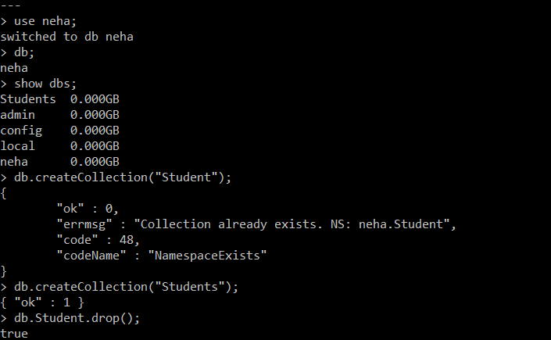

1. **CRUD (CREATE, READ, UPDATE, DELETE) OPERATIONS**

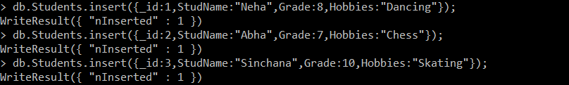



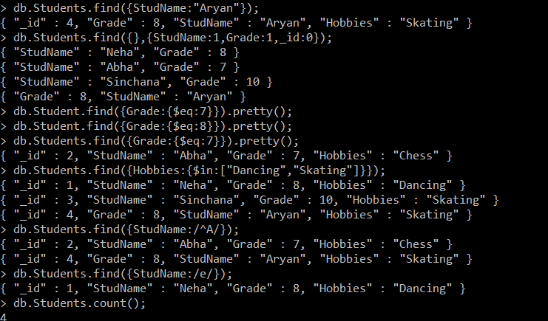

bda5

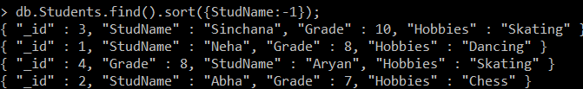

1. **Import data from a CSV file**

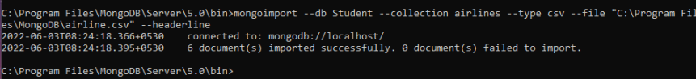

1. **Export data to a CSV file**

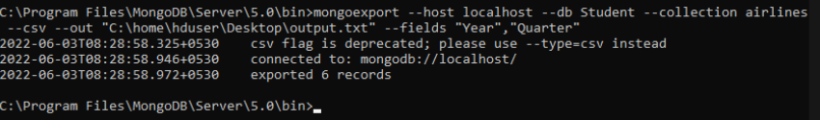

**V. Save Method and add a new field to existing Document:**

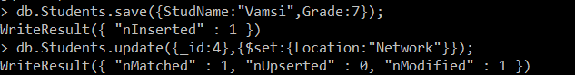

**VI. Other Operations**

bda8

bda9

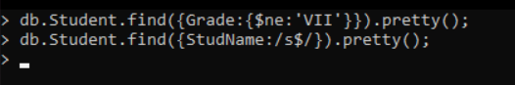

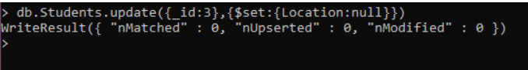

bda12

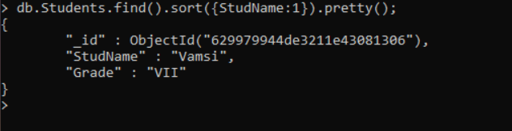

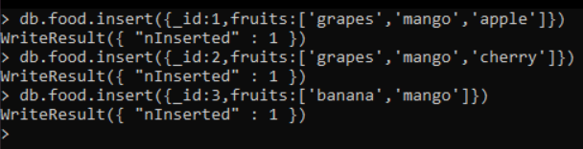

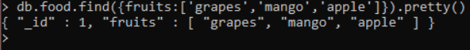

bda16

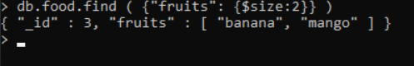

bda18

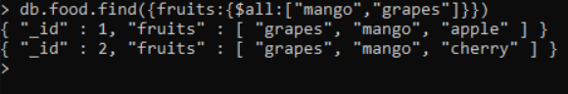

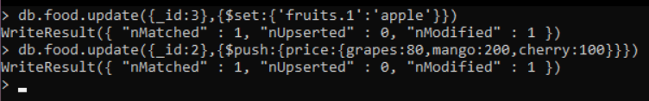

bda21



## EXPERIMENT 2

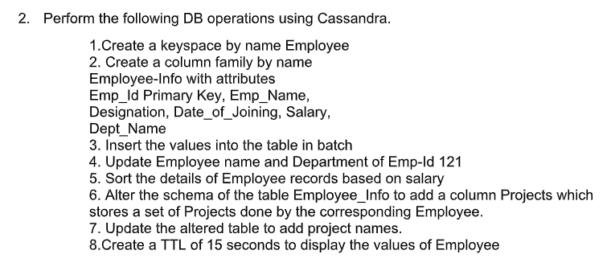

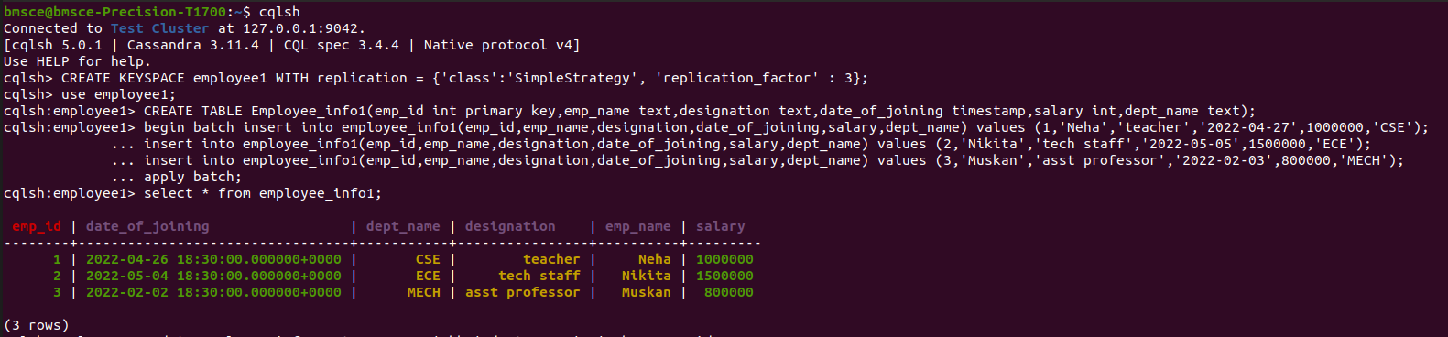**1,2,3:**

**4:**

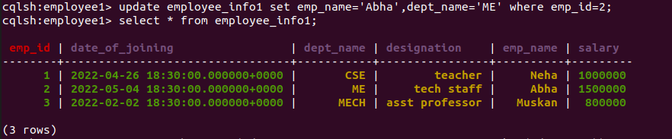**5:**



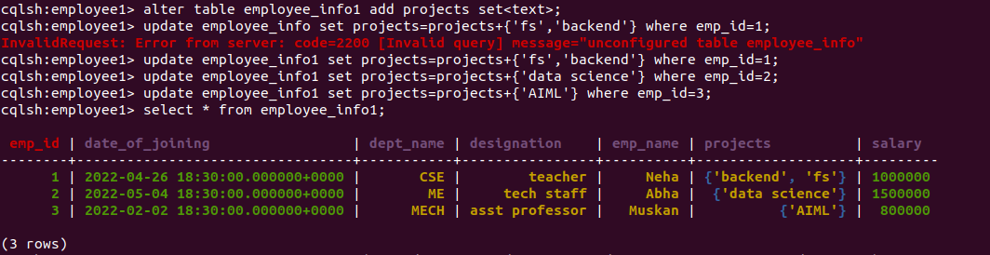

**6,7:**

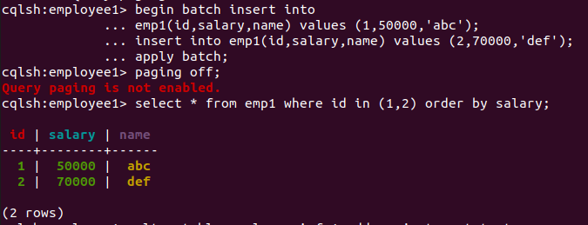

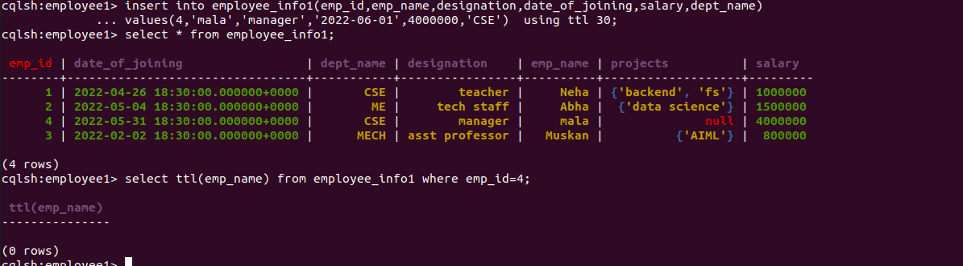**8:**

## EXPERIMENT 3

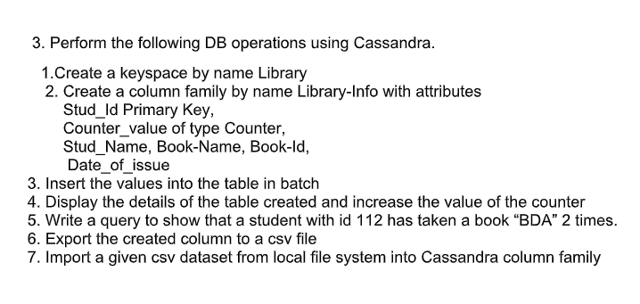

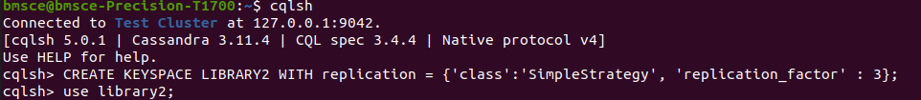**1:**

**2:**



**3:**



**4:**

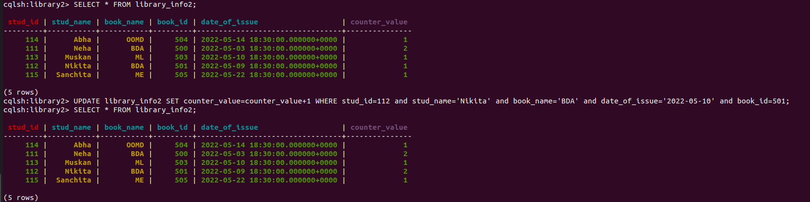

**5:**

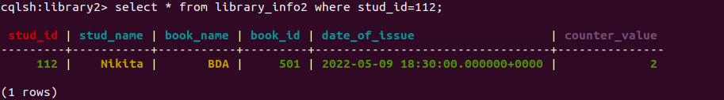

**6:**

**7:**

