BDA LAB 4
Name:Neha B Chadaga
USN:1BM19CS098

1. Create a key space by name Employee
2. Create a column family by name Employee-Info with attributes Emp_Id Primary Key, Emp_Name, Designation, Date_of_Joining, Salary, Dept_Name
3. Insert the values into the table in batch

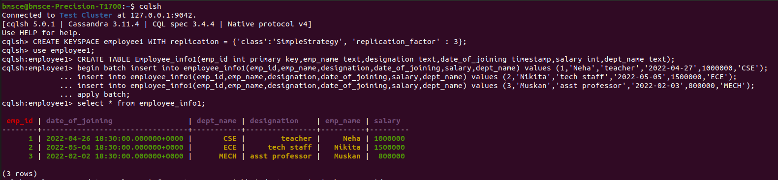

4. Update Employee name and Department of Emp-Id 2

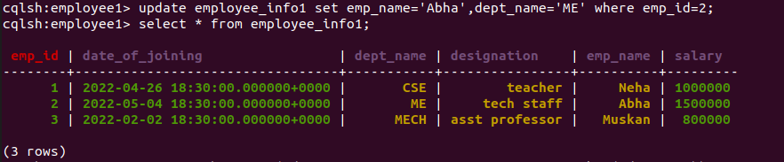

5. Sort the details of Employee records based on salary

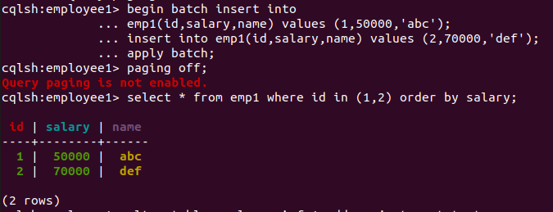

6. Alter the schema of the table Employee_Info to add a column Projects which stores a set of Projects done by the corresponding Employee.
7. Update the altered table to add project names.

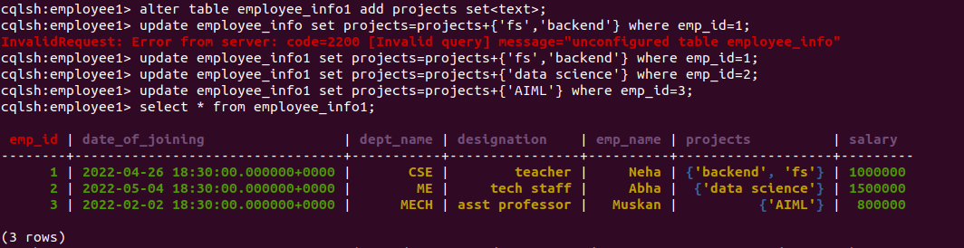
8 Create a TTL of 30 seconds to display the values of Employees.

