BDA LAB 3
Name: Neha B Chadaga
USN: 1BM19CS098

1) Start hadoop

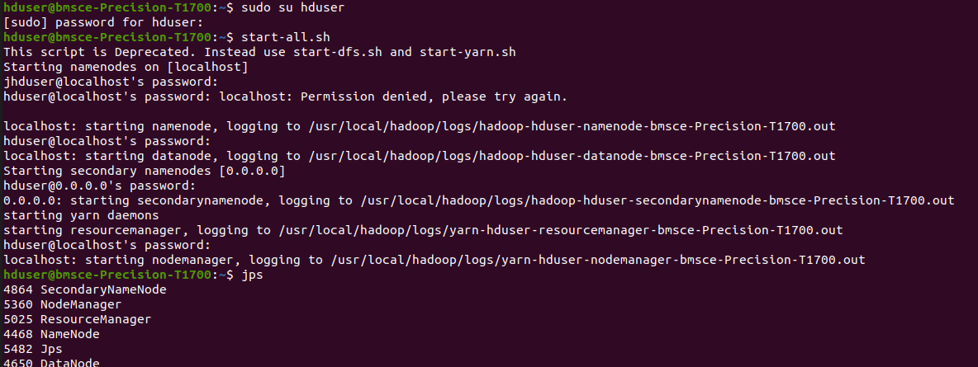

2)mkdir command

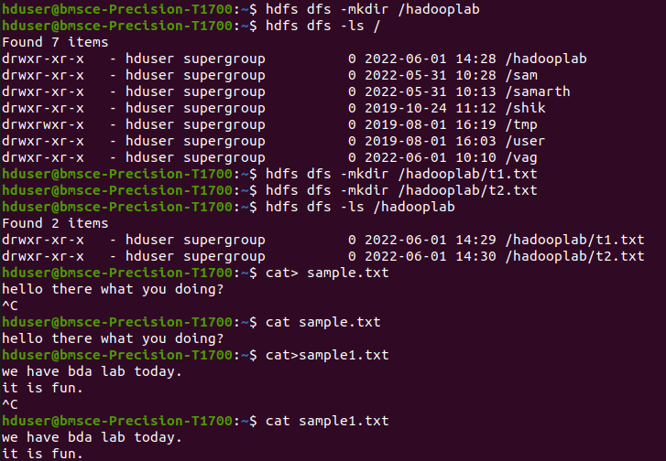
3)put command and copyFromLocal command

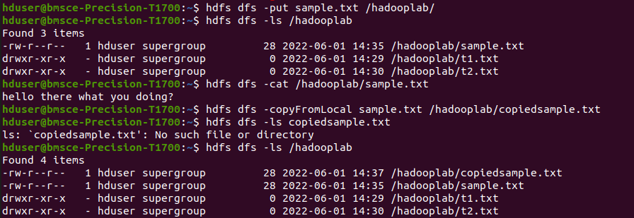

4)get command and copttoLocal command

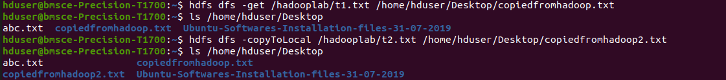
5) mv and cp commands

