# DBMS LAB PROGRAM 1

NAME: NEHA B CHADAGA

USN: 1BM19CS098

SEM: 4

SECTION: ‘B’

BATCH: B4

#### CODE:

create database insurance;

show databases;

use insurance;

show tables;

create table PERSON(Driver_ID varchar(10), Name varchar(10), Address varchar(15), Primary key(Driver_ID));

desc PERSON;

create table CAR(Regno varchar(10), Model varchar(20), Year date, Primary key(Regno));

create table ACCIDENT(Report_no int, Adate date, Location varchar(15), Primary key(Report_no));

create table OWNS(Driver_ID varchar(10), Regno varchar(10), Primary key(Driver_ID,Regno),

foreign key(Driver_ID) references PERSON(Driver_ID),

foreign key(Regno) references CAR(Regno));

show tables;

create table PARTICIPATED(Driver_ID varchar(10), Regno varchar(10), Report_no int,

Damage_amt float, foreign key(Driver_ID, Regno) references OWNS(Driver_ID, Regno)

ON DELETE CASCADE, foreign key(Report_no) references ACCIDENT(Report_no) ON DELETE CASCADE);

ALTER TABLE CAR MODIFY Year INTEGER;

desc CAR;

insert into PERSON values('1111', 'RAMU', 'KS Layout');

insert into PERSON values('2222', 'JOHN', 'INDIRANAGAR');

insert into PERSON values('3333', 'PRIYA', 'JAYANAGAR');

insert into PERSON values('4444', 'GOPAL', 'WHITEFIELD');

insert into PERSON values('5555', 'LATHA', 'VIJAYANAGAR');

insert into CAR values('KA04Q2301', 'MARUTHI-DX', 2000 );

insert into CAR values('KA05P1000', 'FORDICON', 2000 );

insert into CAR values('KA03L1234', 'ZEN-VXI', 1999 );

insert into CAR values('KA03L9999', 'MARUTH-DX', 2002 );

insert into CAR values('KA01P4020', 'INDICA-VX', 2002);

insert into ACCIDENT values( 12, '2002-06-01', 'MG ROAD' );

insert into ACCIDENT values( 200, '2002-12-10', 'DOUBLE ROAD' );

insert into ACCIDENT values( 300, '1999-07-23', 'MG ROAD' );

insert into ACCIDENT values( 25000, '2000-06-11', 'RESIDENCY ROAD' );

insert into ACCIDENT values( 26500, '2001-10-16', 'RICHMOND CIRCLE' );

insert into OWNS values('1111', 'KA04Q2301');

insert into OWNS values('1111', 'KA05P1000');

insert into OWNS values('2222', 'KA03L1234');

insert into OWNS values('3333', 'KA03L9999');

insert into OWNS values('4444', 'KA01P4020');

insert into PARTICIPATED values('1111', 'KA04Q2301', 12, 20000);

insert into PARTICIPATED values('2222', 'KA03L1234', 200, 500);

insert into PARTICIPATED values('3333', 'KA03L9999', 300, 10000);

insert into PARTICIPATED values('4444', 'KA01P4020', 25000, 2375);

insert into PARTICIPATED values('1111', 'KA05P1000', 26500, 70000);

commit;

update CAR set Model='MARUTHI-DX' where regno='KA03L9999';

update PARTICIPATED set Damage_amt=25000 where Report_no=12;

select * from PARTICIPATED;

select count(*) from ACCIDENT where Adate like '2002-__-__';

select count(A.Report_no) from ACCIDENT A, PARTICIPATED P, CAR C where

A.Report_no=P.Report_no AND P.Regno=C.Regno AND C.Model="MARUTHI-DX";

#### CODE SCREENSHOTS:

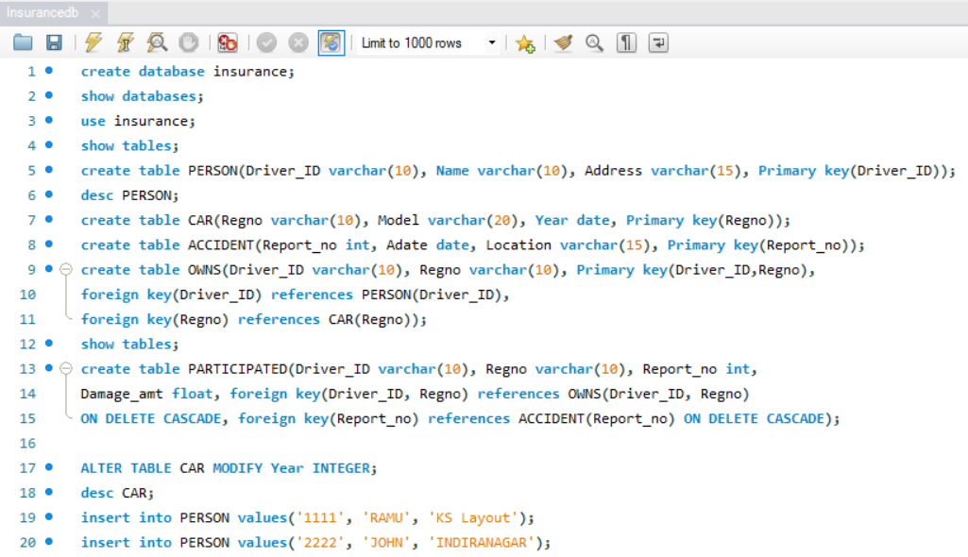

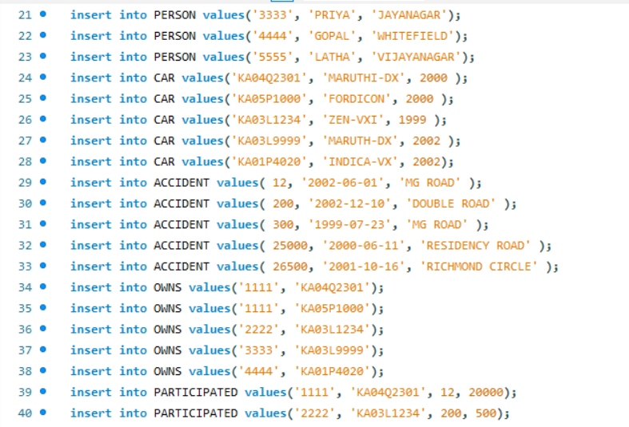

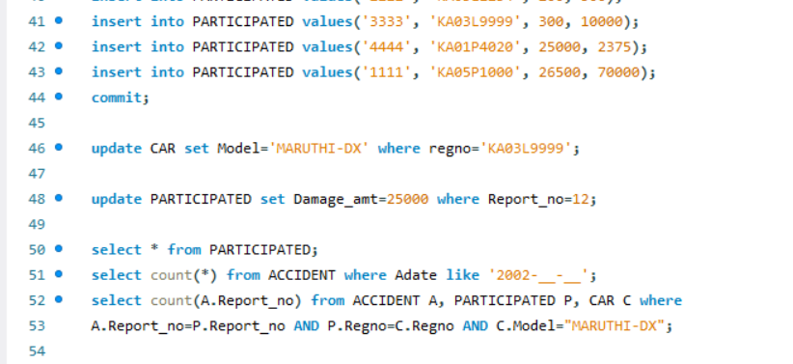

#### OUTPUT SCREENSHOTS:

