28/10/2021
Thursday

1) Write a shell script to find whether number is positive, negative or zero.

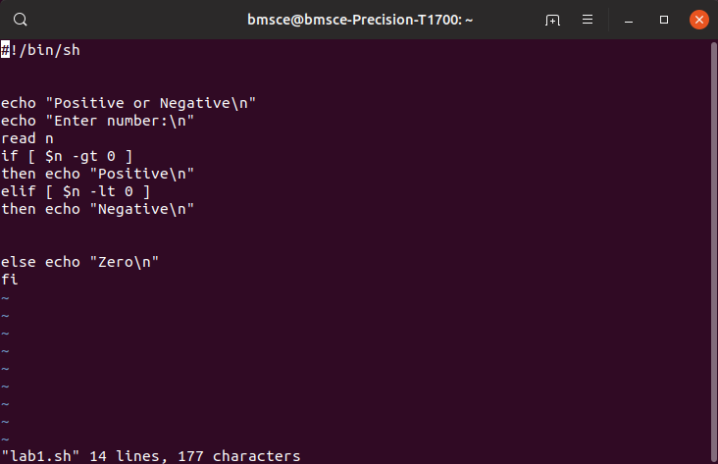

OUTPUT:
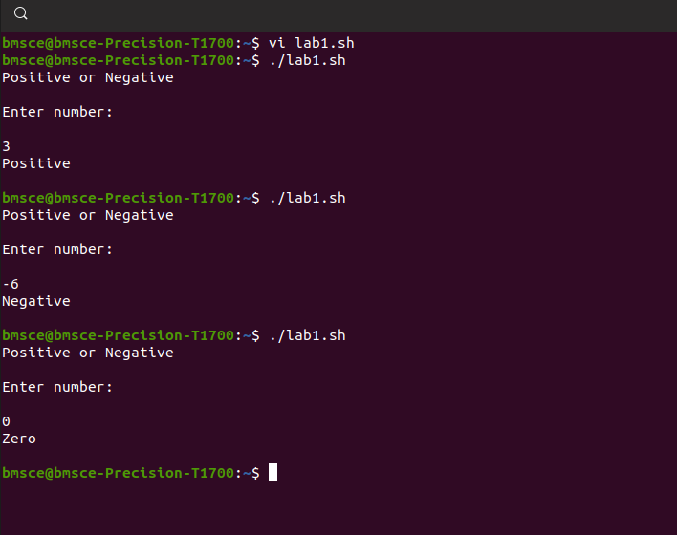

2) Write a shell script to find greatest of 3 numbers.

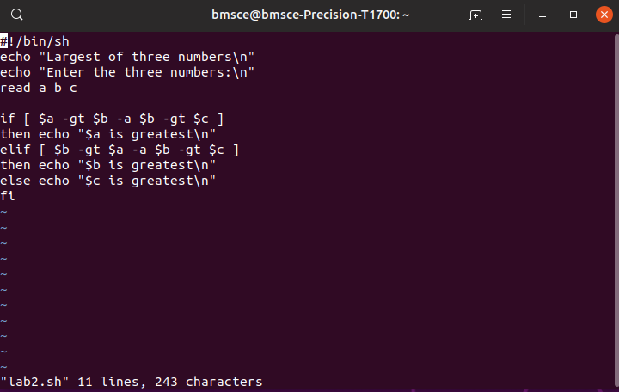
OUTPUT:
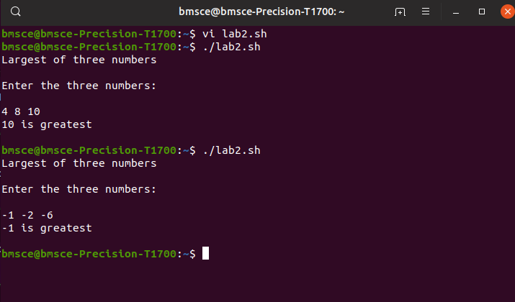

3) Write a shell script to find whether year is leap or not.

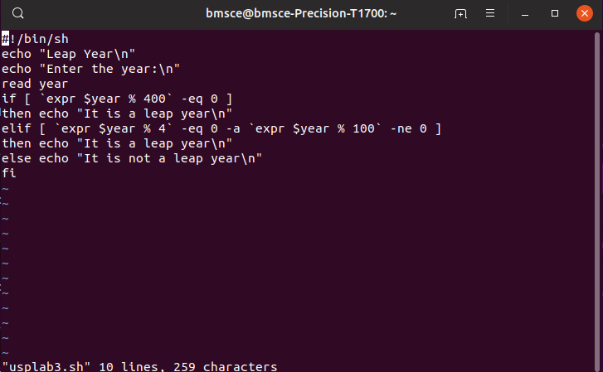
OUTPUT:

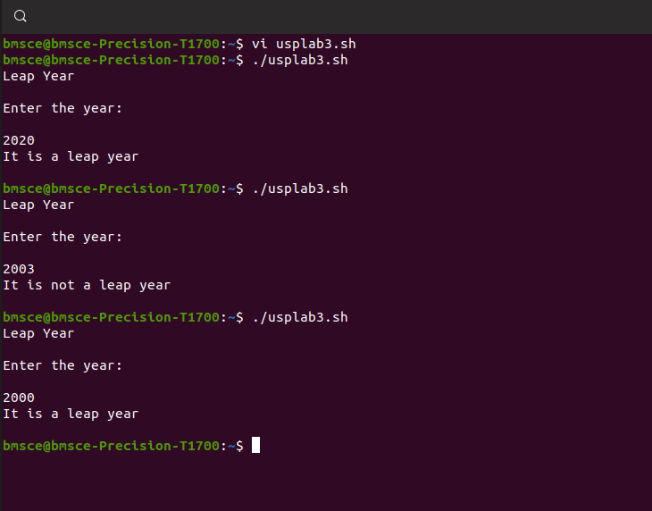

4) Write a shell script to find area of a circle.

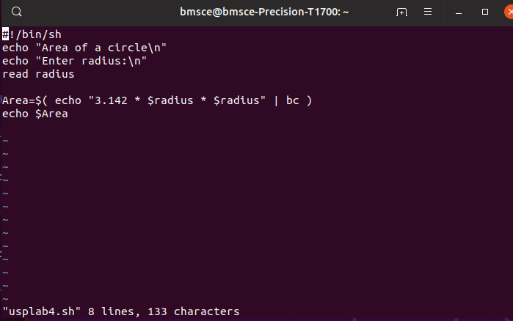

OUTPUT:

