UNIX LAB 1-Assignment

1. Find the present directory
2.Write the / directory structure
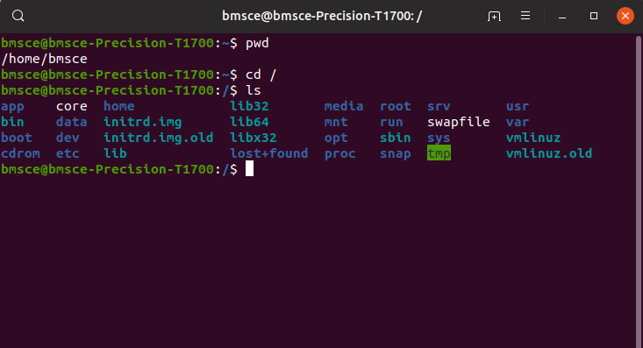

3. Write a few commands available in /bin and /sbin

4. Create a new directory Test
5.Write Permissions of directory Test
6.Copy File etc/resolv.conf to directoy Test
7. Rename Test directory to Testing
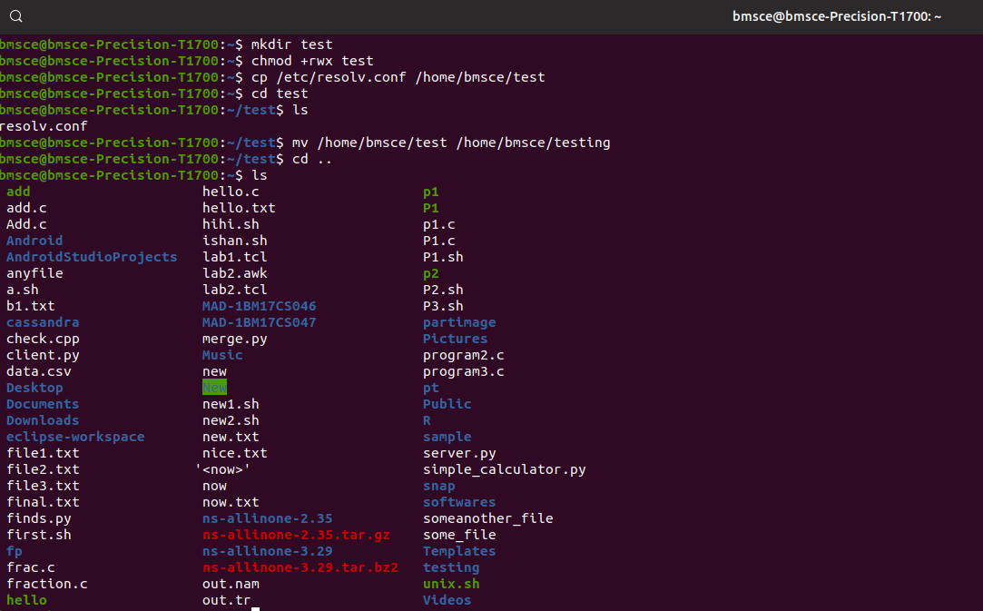
8.Change Permission of Testing directory to 775
9. Change Permission of /tmp to 700
10. Change Permissions of Guest dir to 700
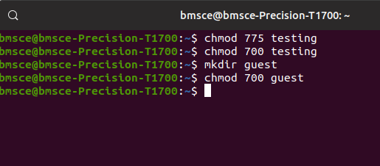

11. Delete the directory Testing
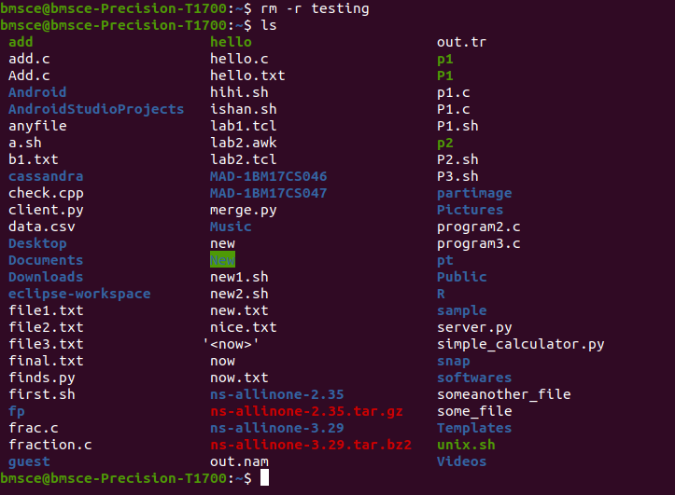

12. Find Kernel Version
13. Change directory to /
