**Name: Neha M**

**Roll No: 24**

**Batch: B**

**Date: 23/05/22**

**NETWORKING&SYSTEM ADMINISTRATION LAB**

**Experiment No.:**

**Aim**

Docker Installation.

**Procedure**

**Step 1 :** Open the terminal on Ubuntu.

**Step 2** : Remove any [Docker files](https://www.simplilearn.com/tutorials/docker-tutorial/what-is-dockerfile) that are running in the system, using the following command

Command : $ sudo apt-get remove docker docker-engine docker.io

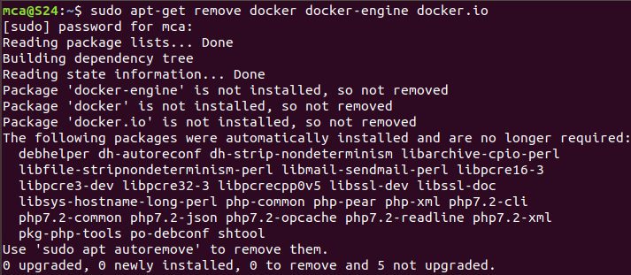

After entering the above command, you will need to enter the password of the root and press enter.

**Step 3** : Check if the system is up-to-date using the following command:

Command : $ sudo apt-get update

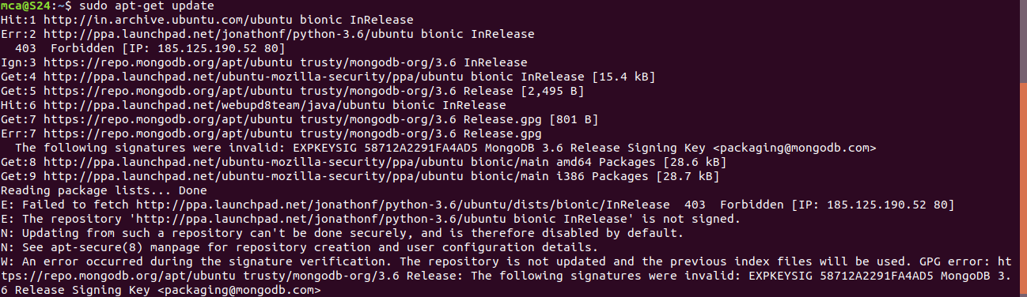

**Step 4** : Install Docker using the following command:

Command :$ sudo apt install docker.io

You’ll then get a prompt asking you to choose between y/n – choose ‘**y**’

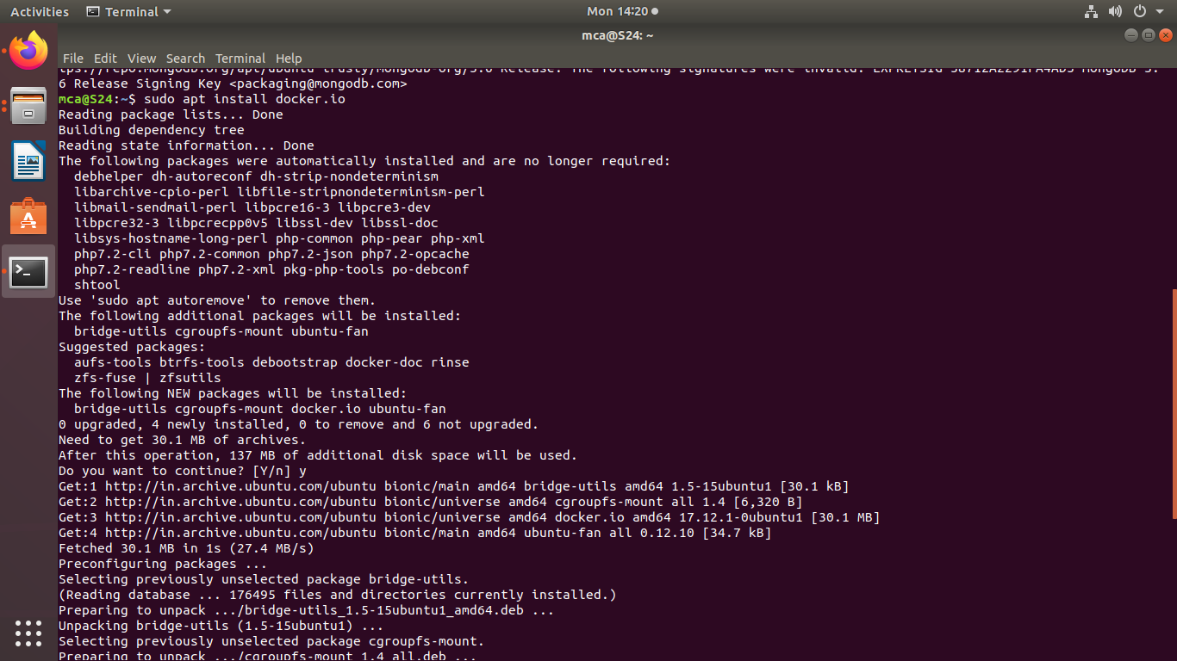

**Step 5** : Install all the dependency packages using the following command:

Command :$ sudo snap install docker



**Step 6** : Before testing Docker, check the version installed using the following command:

Command :$ docker –version



**Step 7** : Pull an image from the Docker hub using the following command:

Command : $ sudo docker run hello-world

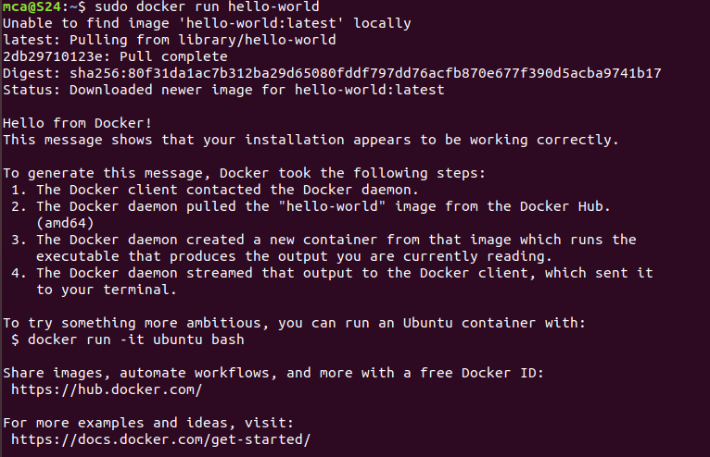

Here, hello-world is the docker image present on the Docker hub.

**Step 8** : Check if the docker image has been pulled and is present in your system using the following command:

Command : $ sudo docker images



**Step 9** : To display all the containers pulled, use the following command:

Command : $ sudo docker ps -a



**Step 10** : To check for containers in a running state, use the following command:

Command : $ sudo docker ps

