- Implement Singleton Design Pattern on a dummy class.
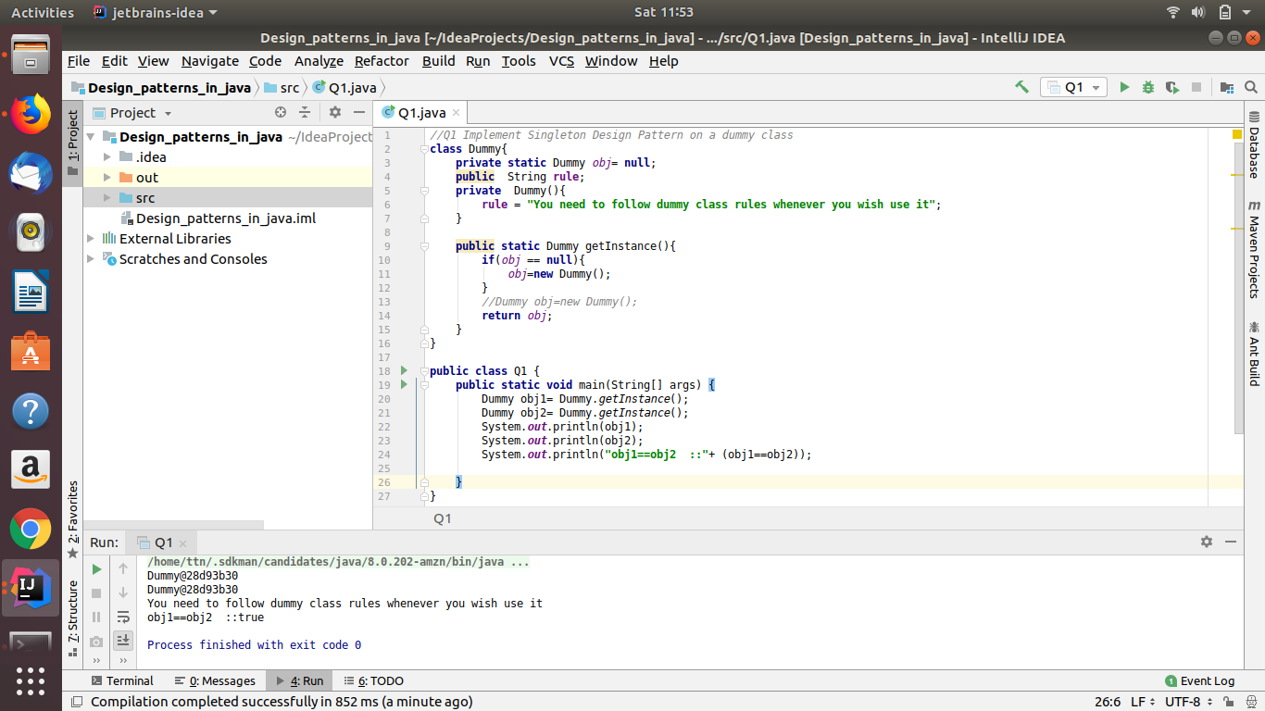
- Implement Factory Pattern to get the Polygon of differnt type.
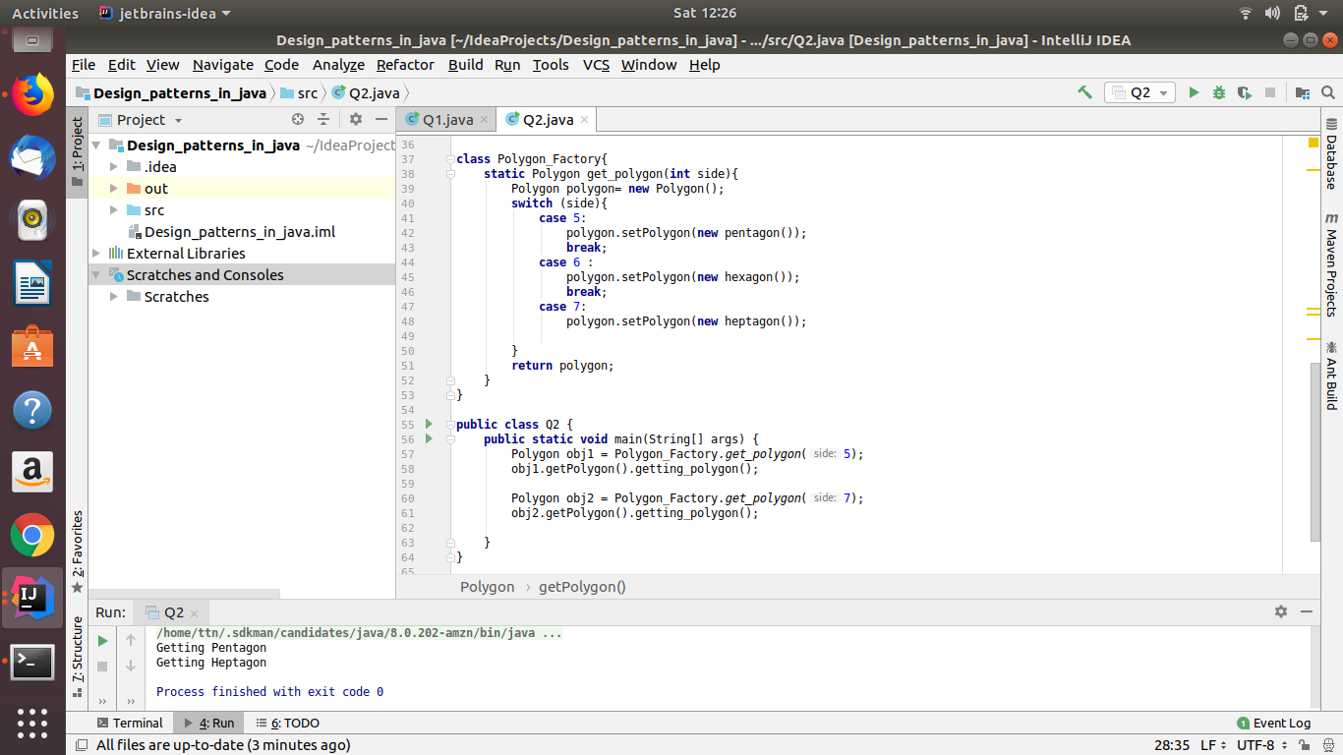
- Implement Abstract Factory Pattern to create cars of different categories from different countries.
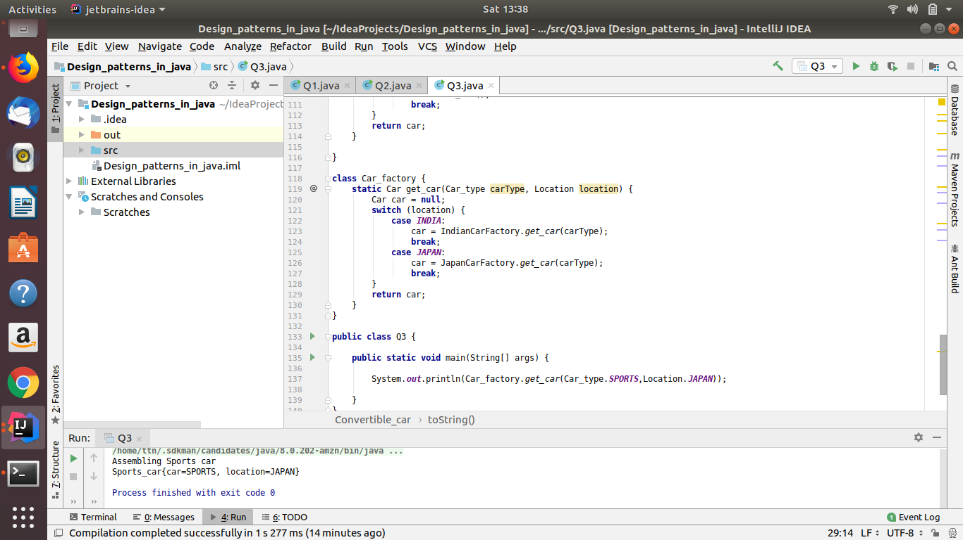
- Implement Builder pattern to create a student object with more than 6 fields.
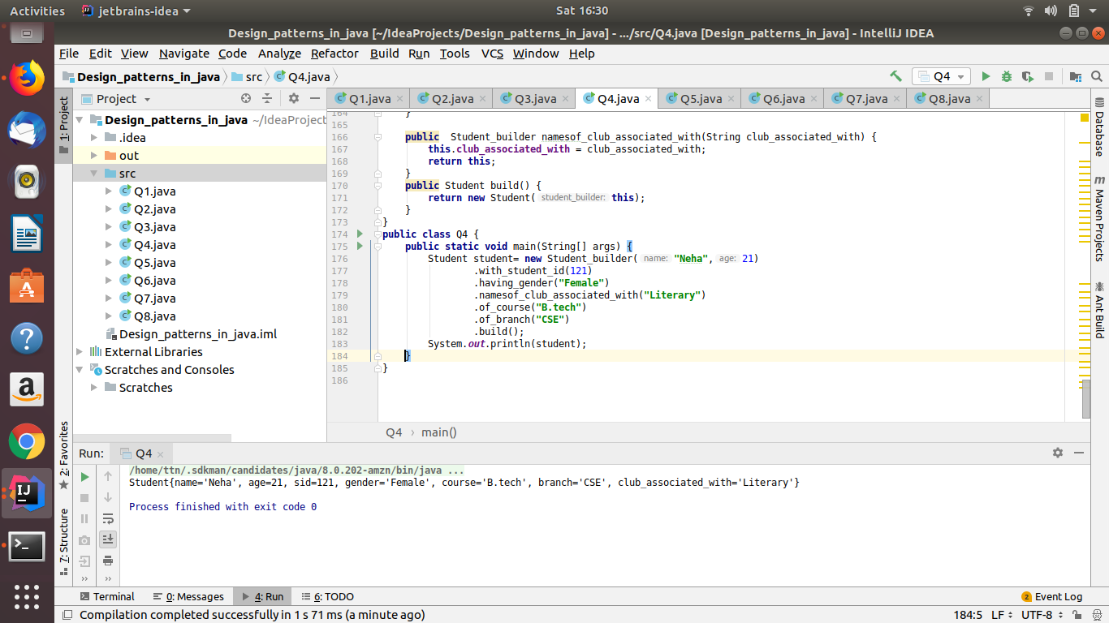
- Implement Bridge Design Pattern for Color and Shape such that Shape and Color can be combined together e.g BlueSquare, RedSquare, PinkTriangle etc.
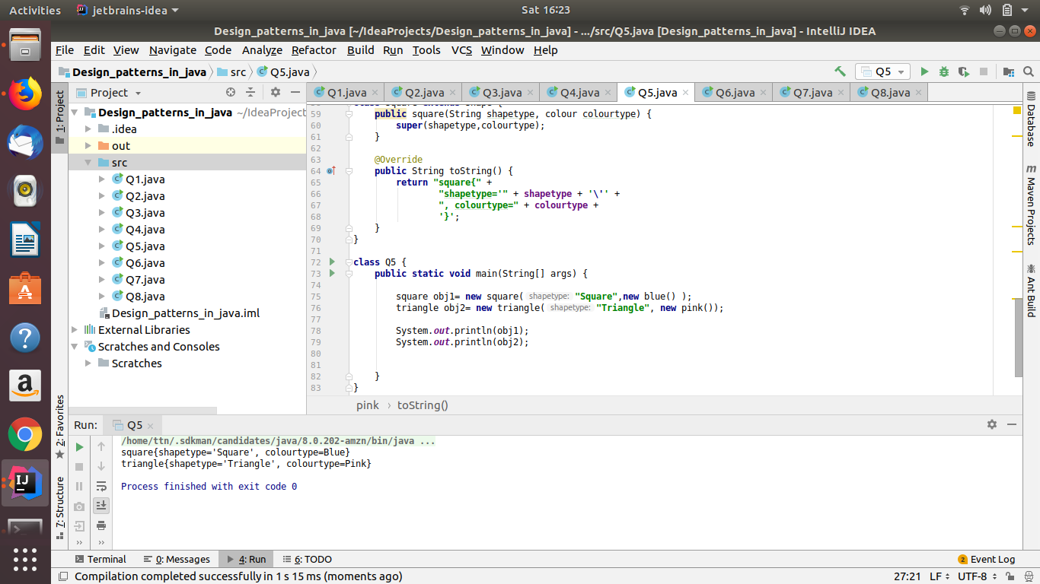
- Implement Decorator pattern to decorate the Pizza with topings.
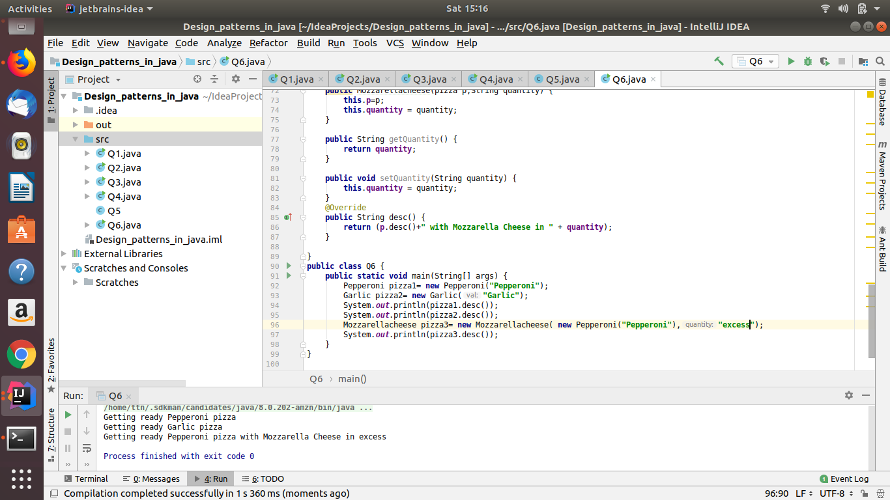
- Implement Composite Design Pattern to maintaing the directories of employees on the basis of departments.
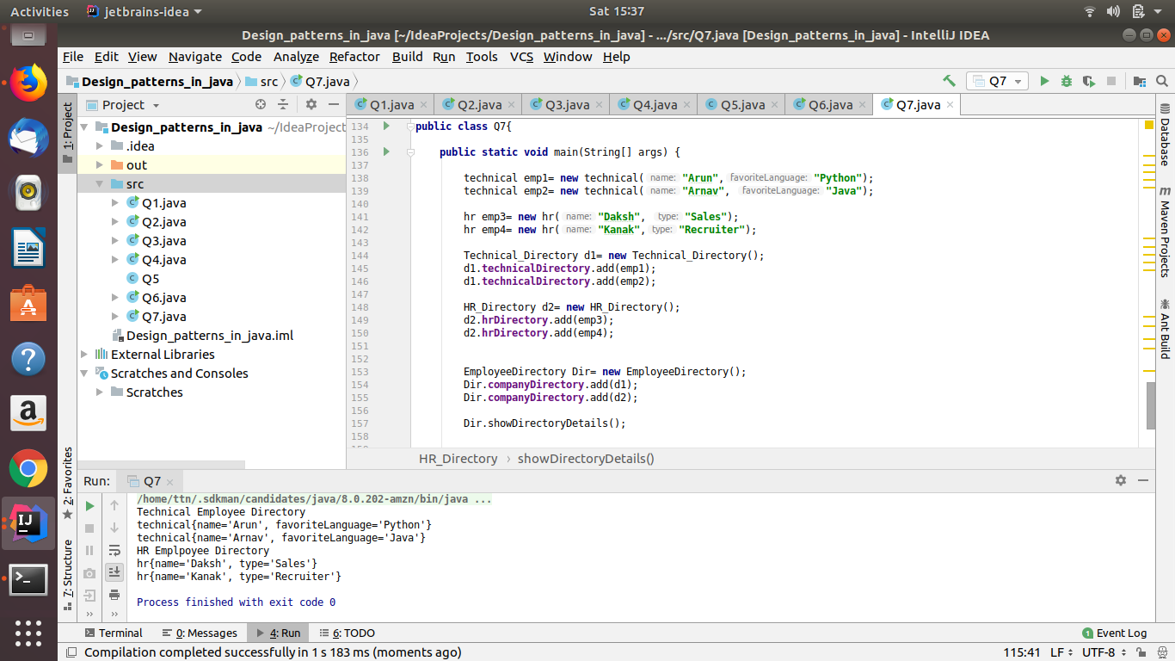
- Implement proxy design for accessing Record of a student and allow the access only to Admin.
