- Create and Run a Thread using Runnable Interface and Thread class.
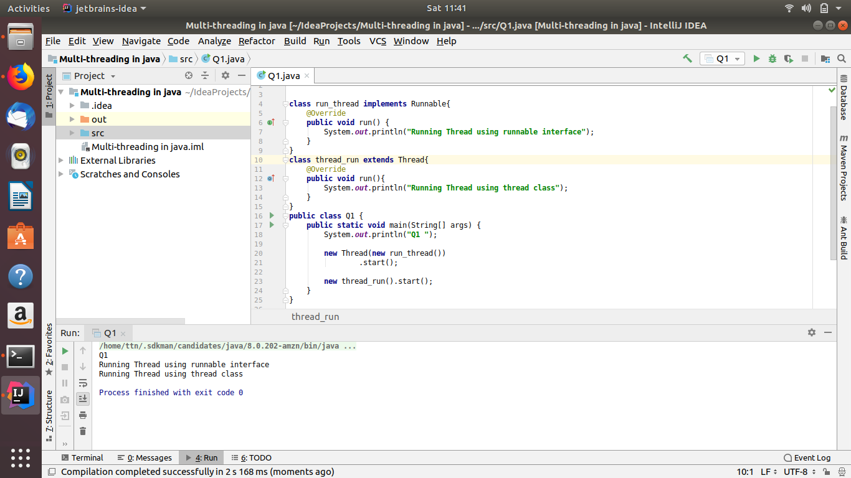
- Use sleep and join methods with thread.
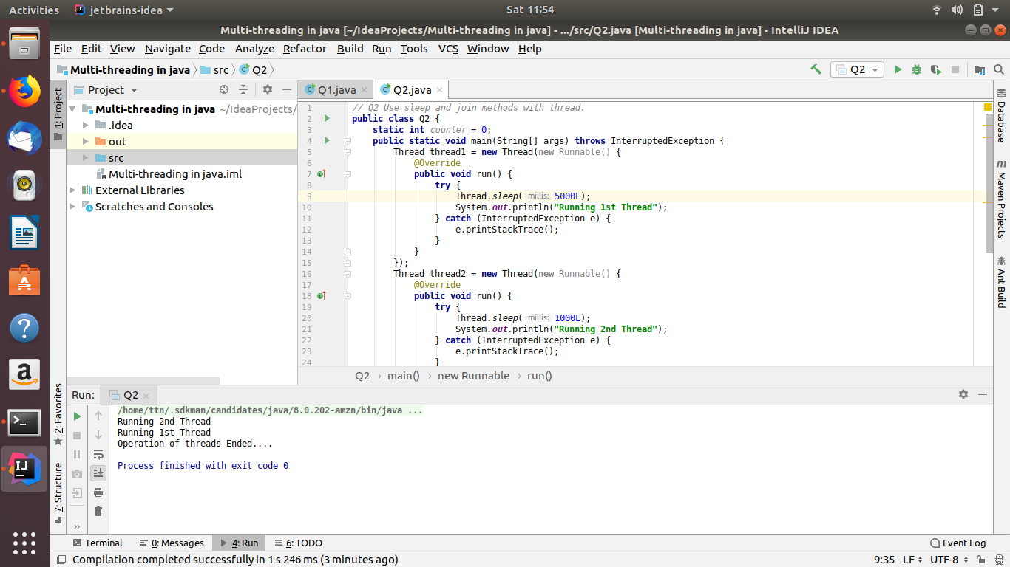

- Use a singleThreadExecutor to submit multiple threads.
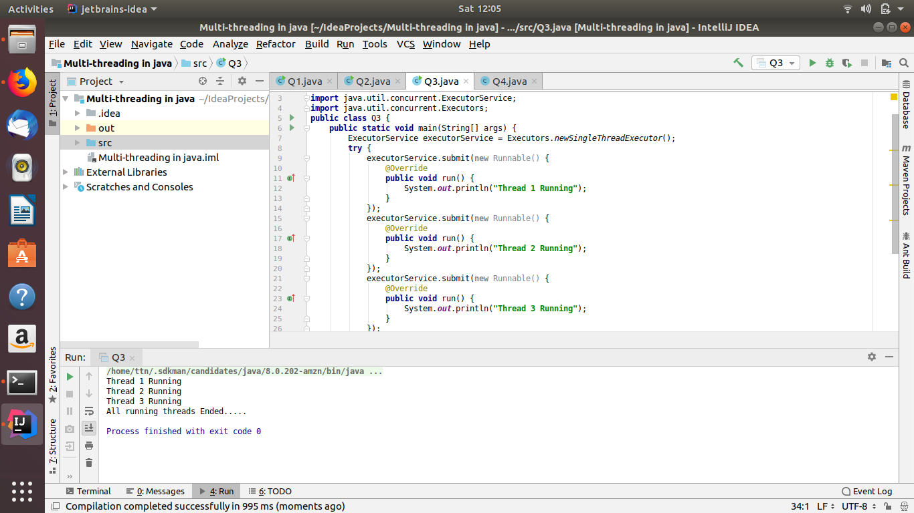
- Try shutdown() and shutdownNow() and observe the difference.
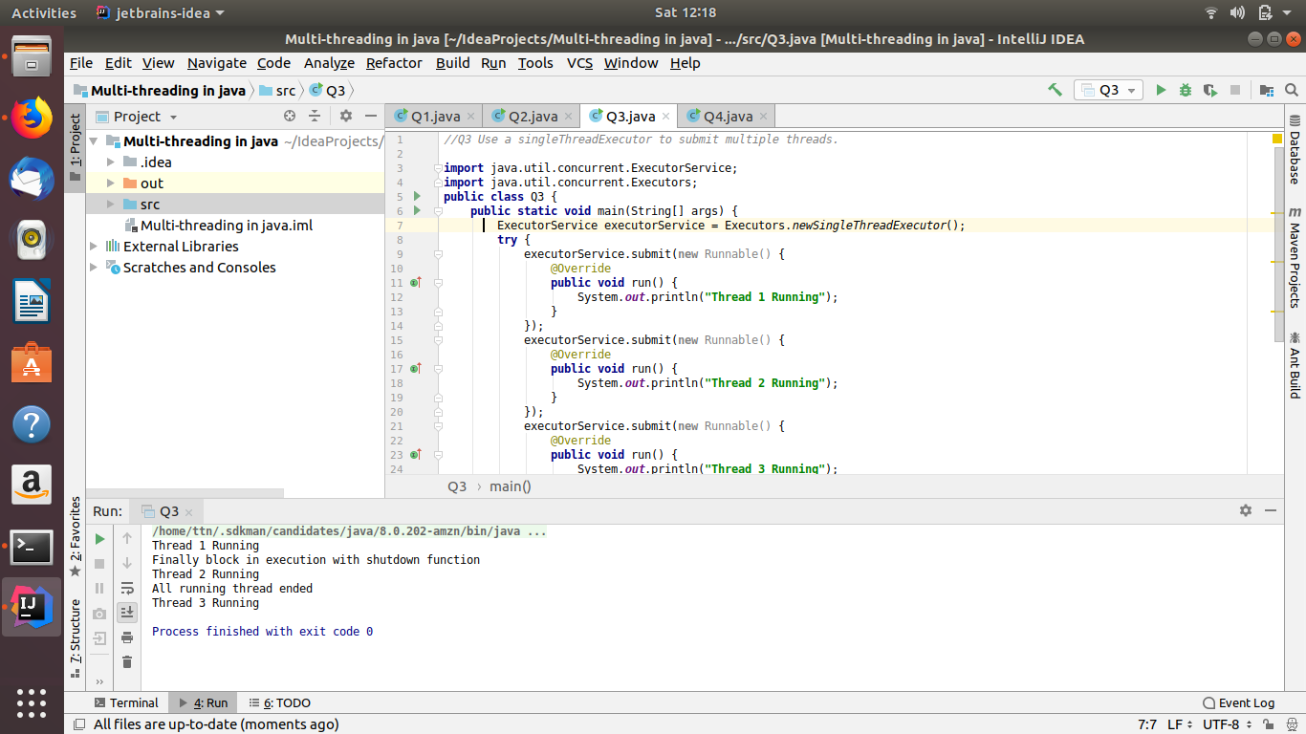

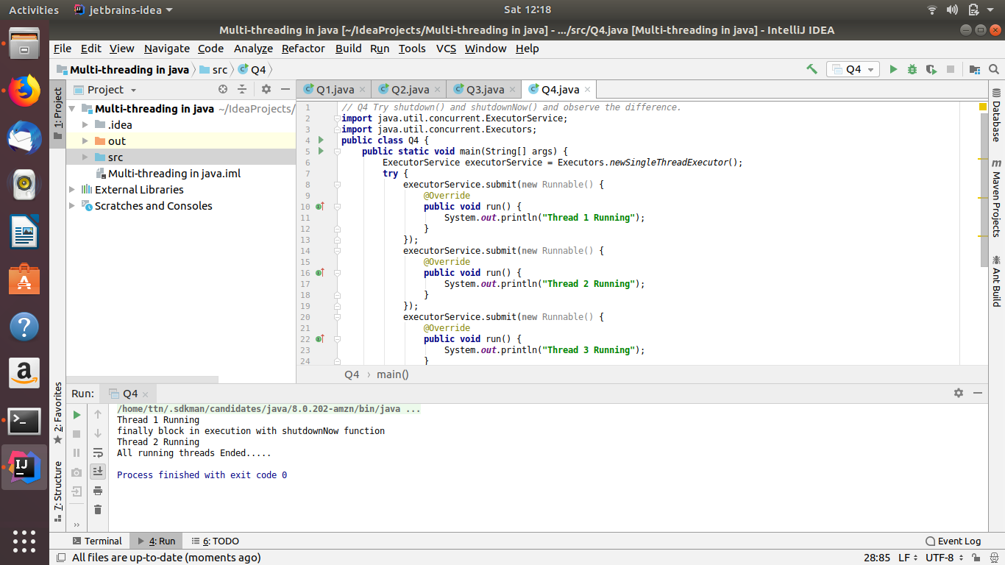
- Use isShutDown() and isTerminate() with ExecutorService.
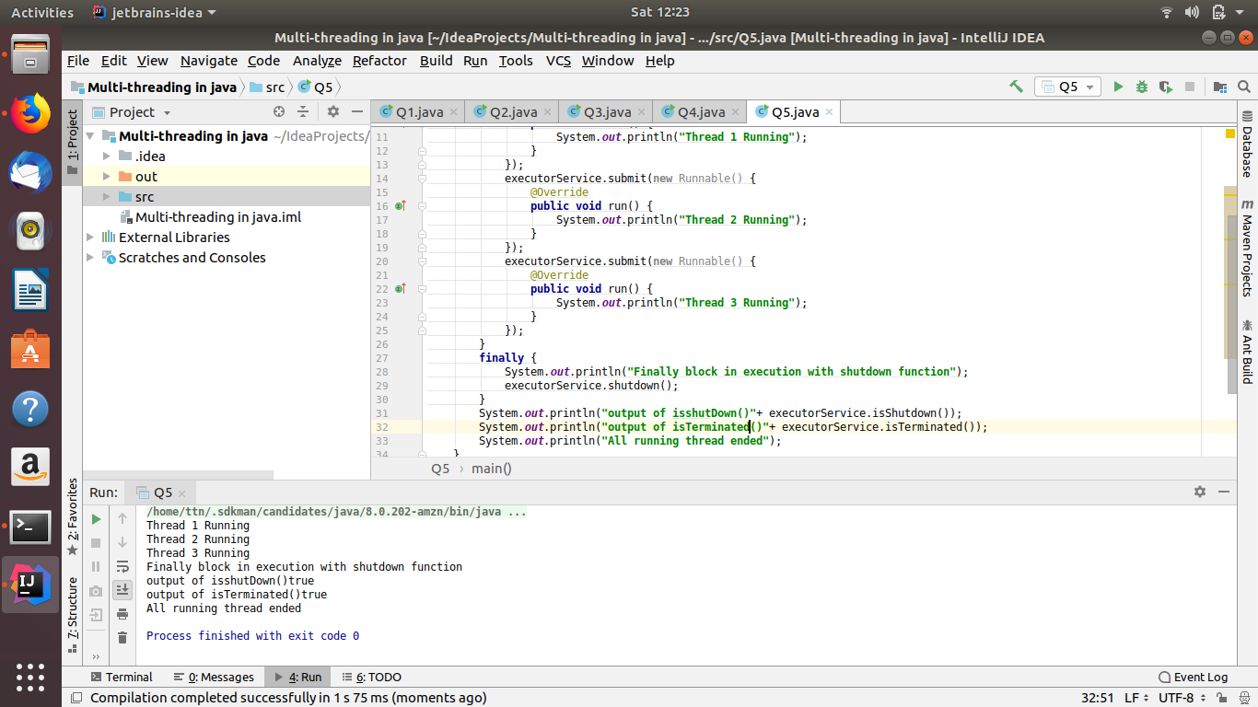

- Return a Future from ExecutorService by using callable and use get(), isDone(), isCancelled() with the Future object to know the status of task submitted.
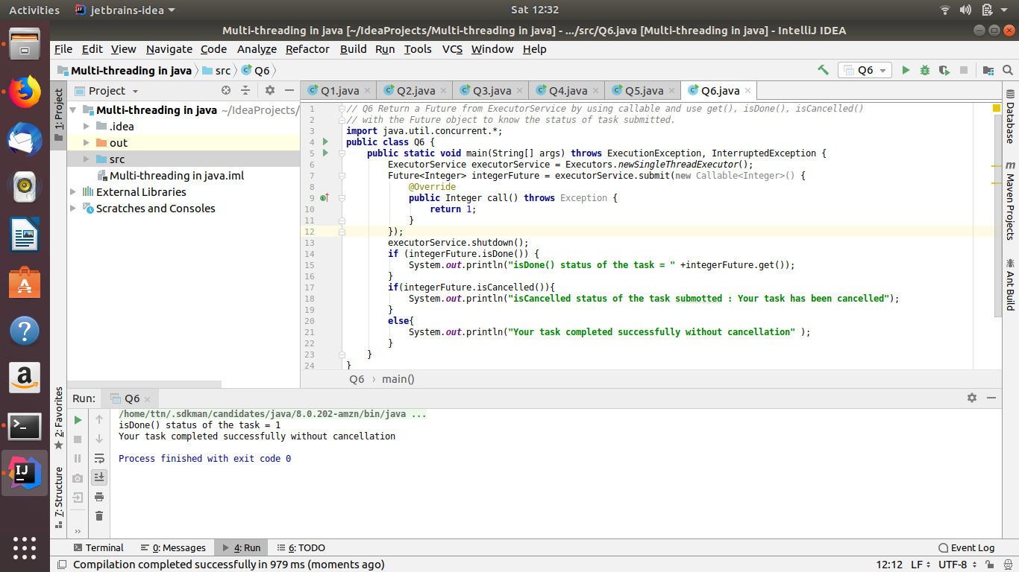
- Submit List of tasks to ExecutorService and wait for the completion of all the tasks.
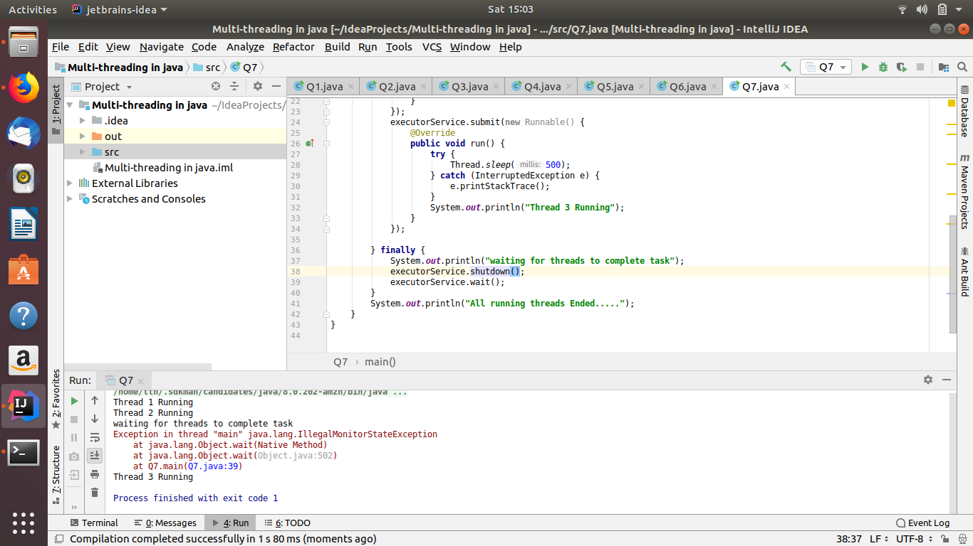

- Schedule task using schedule(), scheduleAtFixedRate() and scheduleAtFixedDelay()
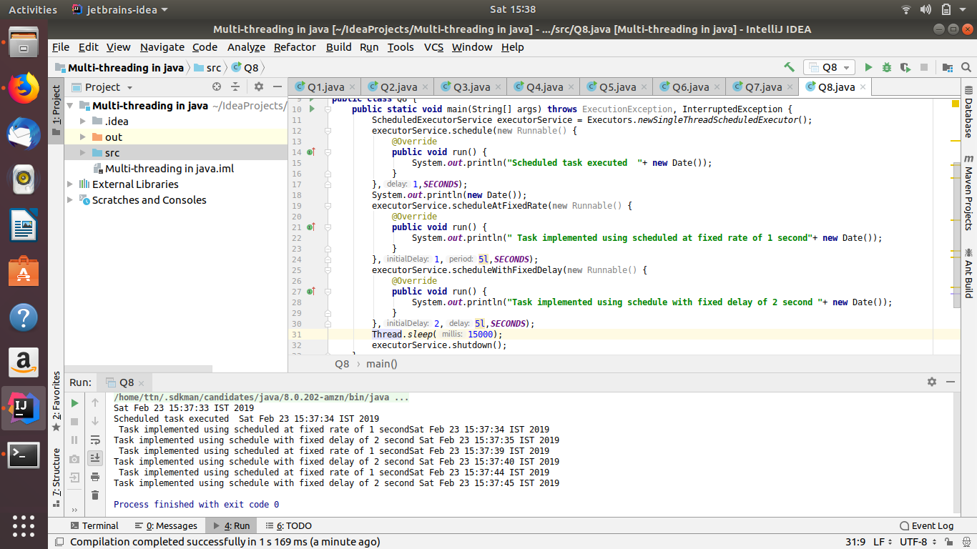
- Increase concurrency with Thread pools using newCachedThreadPool() and newFixedThreadPool().
Soln. (i) newFixedThreadPool()
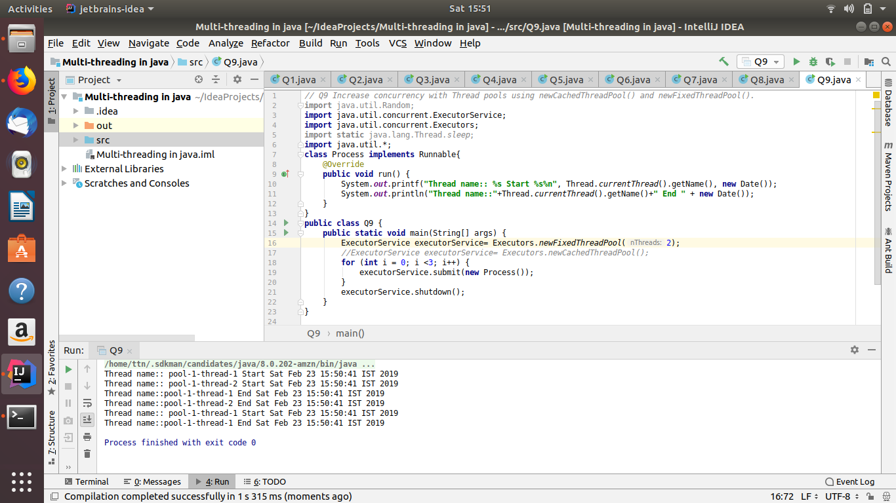

(ii) newCachedThreadPool()
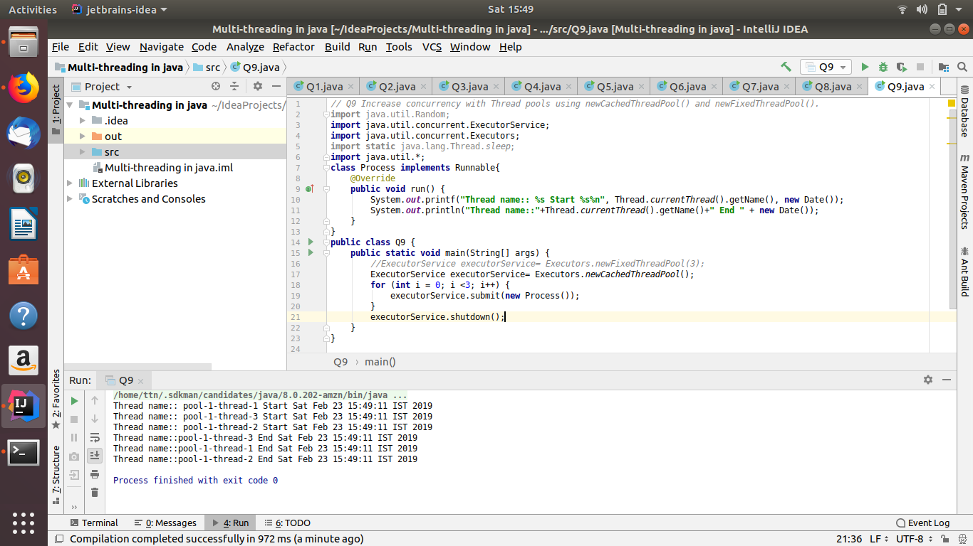
- Use Synchronize method to enable synchronization between multiple threads trying to access method at same time.
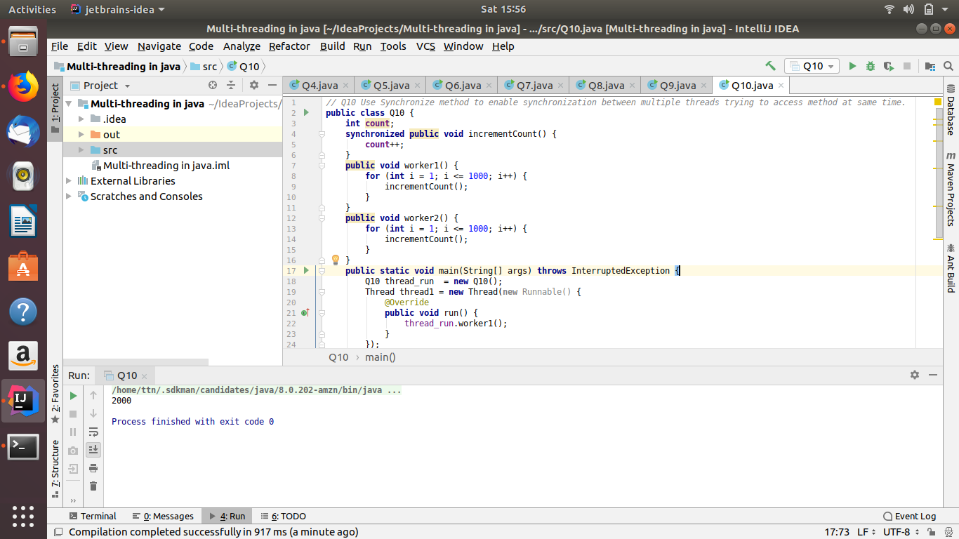

- Use Synchronize block to enable synchronization between multiple threads trying to access method at same time.
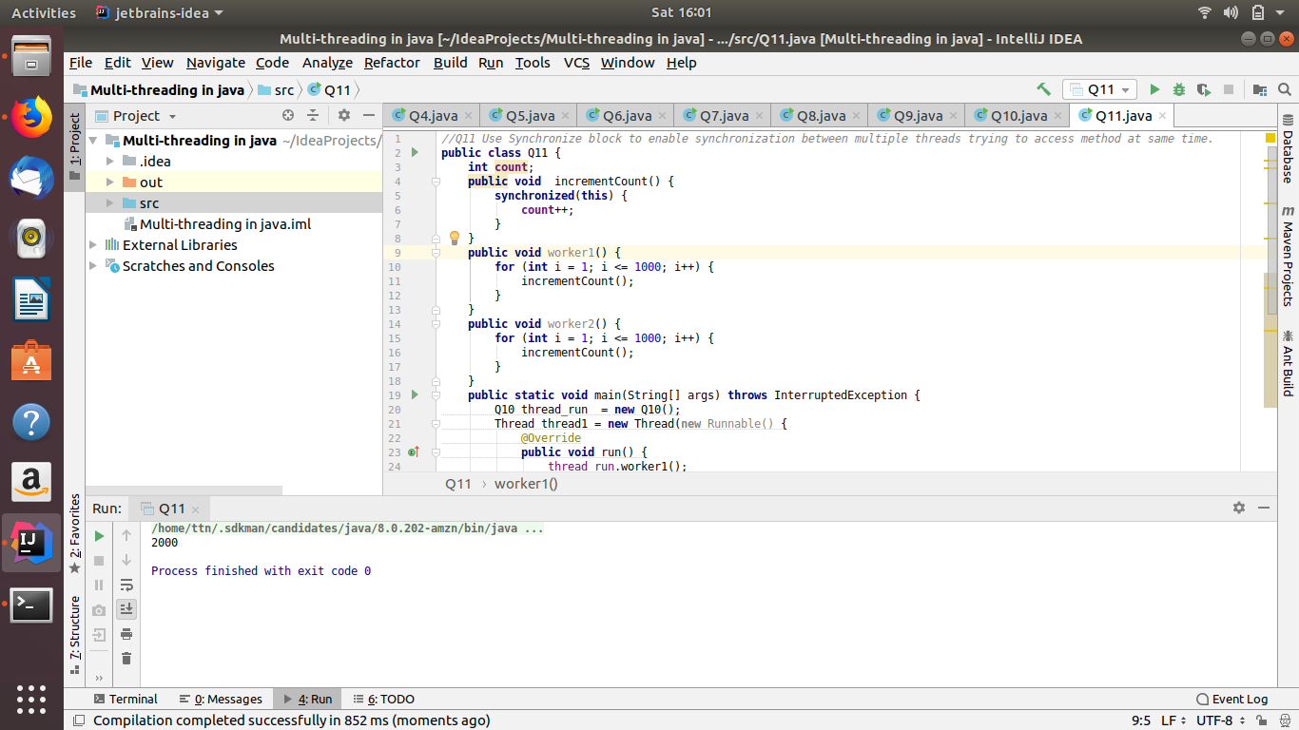
- Use Atomic Classes instead of Synchronize method and blocks.
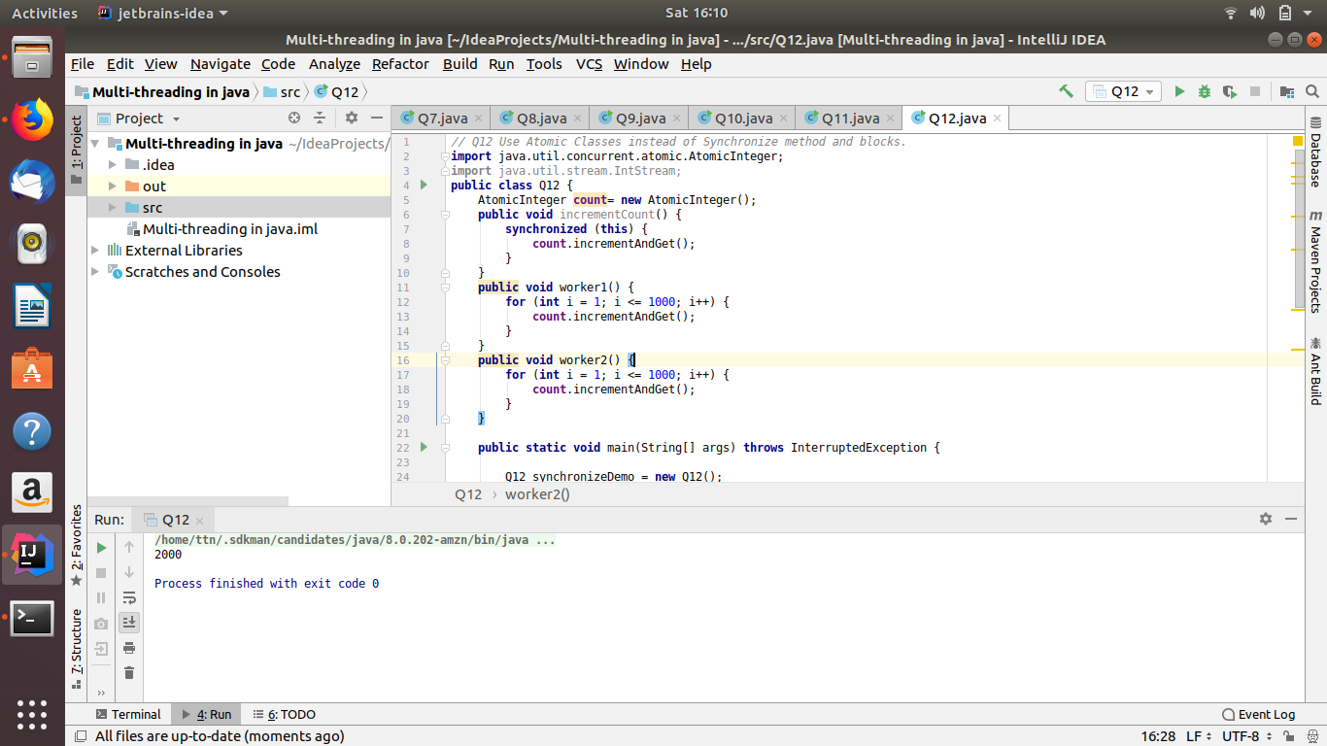

- Coordinate 2 threads using wait() and notify().
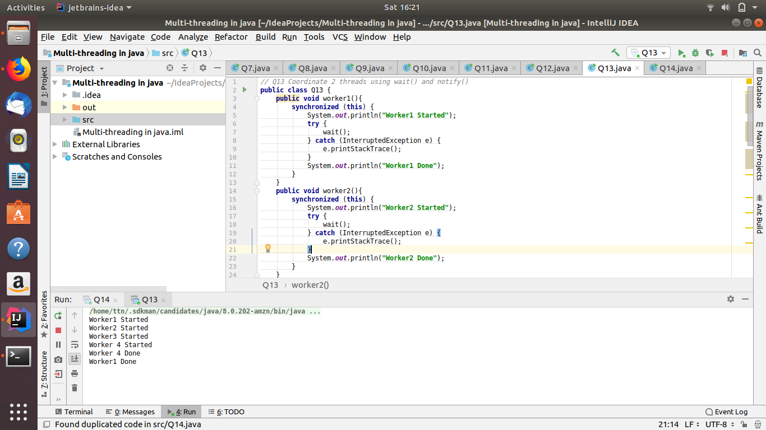
- Coordinate mulitple threads using wait() and notifyAll()
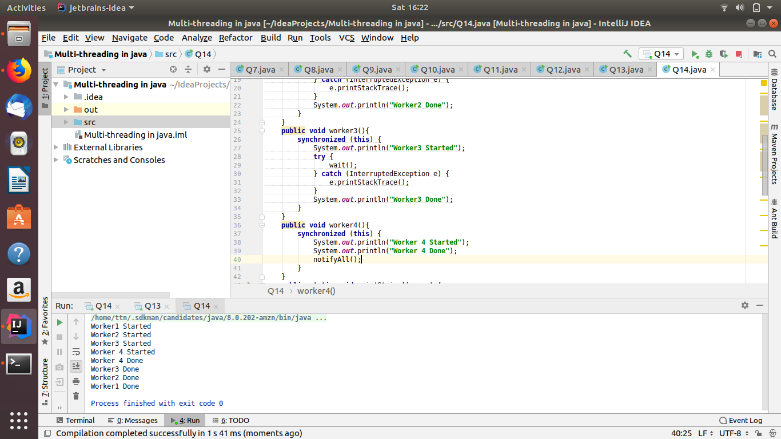

- Use Reentract lock for coordinating 2 threads with signal(), signalAll() and wait().
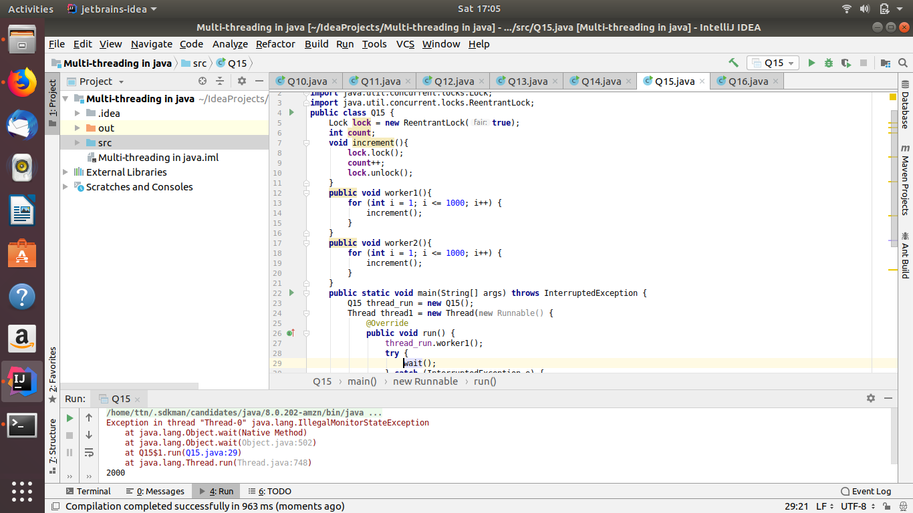
- Create a deadlock and Resolve it using tryLock().
