Introduction
In the maintenance of large-scale online service systems, logs serve a critical role. When an online service experiences a failure, engineers rely on the recorded logs to understand the cause of the issue and identify potential problems. Traditionally, engineers perform simple keyword searches (such as “error” and “exception”) of logs that may be associated with the failures. Such an approach is time-consuming and ineffective in the production environment, especially for large-scale online service systems.
Engineers usually evaluate an online service system in a controlled laboratory environment before implementing it in a real production environment. The laboratory environment usually mimics a small-scale cloud setting with limited data, while the production environment comprises a more extensive and intricate cloud infrastructure accommodating vast amounts of data. Due to the variations between these two environments, online service systems frequently encounter unanticipated issues, even if they were thoroughly tested in the laboratory environment.
Our proposed approach, LogCluster, aims to simplify the process of identifying issues through log analysis by clustering related logs together. This approach also leverages a knowledge base to determine if the log sequences have been previously encountered. The examination of a few representative log sequences extracted from the clusters is sufficient for engineers to identify a problem, thereby reducing the number of logs to be reviewed significantly. Furthermore, this approach improves identification accuracy.
In our work, we assign weights to log messages and group similar log sequences into clusters. We then extract a representative log sequence from each cluster. The operation of LogCluster can be divided into two phases: the construction phase and the production phase.
In the construction phase, we use the log sequences collected from the testing environment and cluster them to construct an initial knowledge base. In the production phase, we analyze the log sequences collected from the actual production environment, cluster them, and check if the clusters can be found in the knowledge base. In this way, developers only need to examine a small number of representative log sequences from the clusters that are previously unseen. Therefore, LogCluster further reduces the total number of logs that need to be manually examined and improves the effectiveness of problem identification.

- What will be analyzed from the application logs and why?
The analysis of application logs can provide valuable insights into the performance and behavior of an application. By examining the logs, various aspects of the application can be analyzed, including:

- Debugging: Application logs can be used to identify and debug issues in the application. By examining the logs, developers can identify error messages, stack traces, and other information that can help them pinpoint the source of the problem.
- Performance: Logs can be used to analyze the performance of an application. By examining the logs, developers can identify slow or inefficient parts of the application, as well as track resource usage such as CPU, memory, and disk I/O.
- Security: Logs can be used to identify security threats or breaches. By analyzing the logs, administrators can detect unauthorized access attempts, abnormal user behavior, and other suspicious activity.
- Compliance: Logs can be used to ensure compliance with regulations and policies. By analyzing the logs, administrators can track user activity, access to sensitive data, and other compliance-related events.

2) Data Preparation approach
To analyze the application logs, we perform the following four steps: log collection, log parsing, feature extraction, and anomaly detection.

Log collection: Logs are routinely generated by large-scale systems to record runtime information and system states. Each log message contains a timestamp and indicates what has occurred. These logs are a valuable source of information that can be utilized for various purposes, such as anomaly detection, and therefore, they are collected for further use. We have collected HDFS logs.

Log parsing: Logs are unstructured and contain free-form text. The purpose of log parsing is to extract a group of event templates, whereby raw logs can be structured. More specifically, each log message can be parsed into an event template (constant part) with some specific parameters (variable part).
For instance, given the logs of “Connection from 10.10.34.12 closed” and “Connection from 10.10.34.13 closed”, the words "Connection," "from," and "closed" are considered constant because they remain the same across different log messages. In contrast, the remaining parts of the log message are variable, as they change based on the specific event being logged. These variable parts may include information such as IP addresses or port numbers. Developers define the constant parts in source code, while variable parts are generated dynamically. The goal of log parsing is to extract the constant parts from the variable parts and create a standardized log event.

There are two types of log parsing methods: clustering based (e.g., LKE, LogSig) and heuristic-based (e.g., iPLoM, SLCT). In this project, W has used a clustering-based method (LKE).
In clustering-based log parsers, distances between logs are calculated first, and clustering techniques are often employed to group logs into different clusters in the next step. Finally, an event template is generated from each cluster.
For heuristic-based approaches, the occurrences of each word on each log position are counted. Next, frequent words are selected and composed as the event candidates.

Feature Extraction: The main purpose of this step is to extract valuable features from log events that could be fed into anomaly detection models. The input of feature extraction is log events generated in the log parsing step, and the output is an event count matrix. To extract features, we first need to separate log data into various groups, where each group represents a log sequence. To do so, windowing is applied to divide a log dataset into finite chunks. we use three different types of windows: fixed windows, sliding windows, and session windows.

Fixed window: Both fixed windows and sliding windows are based on timestamp, which records the occurrence time of each log. Each fixed window has its size, which means the period or time duration. Window size is Δt, which is a constant value, such as one hour or one day. Thus, the number of fixed windows depends on the predefined window size. Logs that happened in the same window are regarded as a log sequence
Sliding window: Different from fixed windows, sliding windows consist of two attributes: window size and step size, e.g., hourly windows sliding every five minutes. In general, the step size is smaller than the window size, therefore causing the overlap of different windows.
Session window: Session windows are based on identifiers instead of the timestamp. Identifiers are utilized to mark different execution paths in some log data. For instance, HDFS logs with block_id record the allocation, writing, replication, and deletion of certain blocks. Thus, we can group logs according to the identifiers, where each session window has a unique identifier.

We have used Session Window in this project. After constructing the log sequences the session window method an event count matrix X is generated. In each log sequence, we count the occurrence number of each log event to form the event count vector. For example, if the event count vector is [0, 0, 2, 3, 0, 1, 0], it means that event 3 occurred twice and event 4 occurred three times in this log sequence.
Multiple event count vectors are combined to form a matrix called X, which represents the frequency of occurrence of each event across all log sequences. Specifically, the element Xi,j of the matrix X represents the number of times the event j appeared in the i-th log sequence.
This is also called Log Vectorization: Here, we assign a weight to each event in a vector.

IDF-based Event Weighting: For each log event, we calculate its IDF (Inverse Document Frequency) values. IDF is commonly used as a term weighting technique in information retrieval. We treat each event as a term and each log sequence as a document. Intuitively, if an event frequently appears in many log sequences, its discriminative power is lower than the event that only appears in a small number of log sequences. Formally, IDF is calculated as:

$$W_{idf}=log⁡\left(\frac{N}{n_{t}}\right)$$

where N is the total number of log sequences, and $n_{t}$ denotes the number of sequences where the event t appears. Using IDF, the events that occur very frequently have lower weights and the events that occur rarely have higher weights.

- ML model
Log Clustering: LogCluster performs two main sets of tasks: the construction phase and the production phase.
In the construction phase, we use the log sequences collected from the testing environment. We convert the log sequences into vectors and cluster them. After clustering the sequences, we proceed to choose a representative sequence from each cluster. These selected sequences, along with their corresponding solutions, are then stored in a knowledge base for future reference and use.
During the production phase, we examine log sequences that are gathered from the actual production environment. We perform log vectorization and clustering, which are identical to the methods used in the construction phase. Next, we extract a representative sequence from each cluster and compare it to previously analyzed clusters stored in the knowledge base to determine if it is a match.
The engineers are only required to manually examine the representative log sequences that are previously unseen. The knowledge base is also updated with the new clusters. In this way, LogCluster can further reduce the effort required for log-based problem identification.

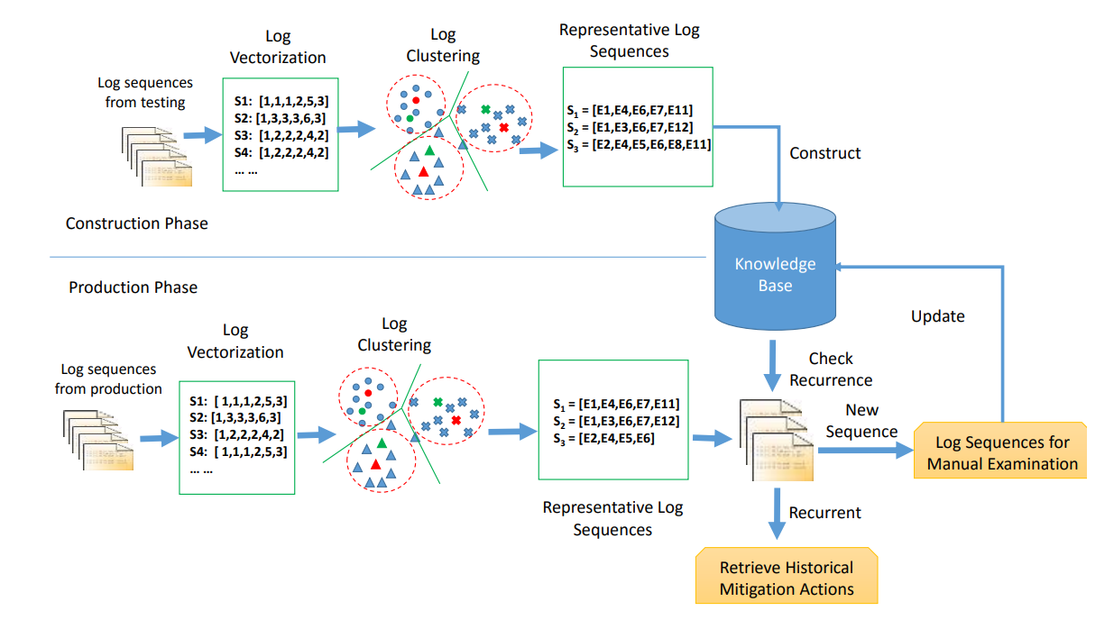
Figure 1. The overall structure of LogCluster

How do we perform clustering?
Having obtained the vector representation of log sequences, we compute the cosine similarity between any two N-dimensional vectors $X_{i}$ and $X_{j}$ as follows:

Similarity($X_{i}$, $X_{j}$) =$\frac{X_{i}.X_{j}}{\left|X_{i}\right|.\left| X_{j}\right|}$

Having computed the similarity between two log sequences, we perform log clustering using the Agglomerative Hierarchical clustering technique. Initially, in the Agglomerative Hierarchical clustering technique for log clustering, each log sequence is considered as an individual cluster, and no two log sequences are grouped together in the beginning. Then, the closest pair of clusters is selected and merged. To decide which pair of clusters should be merged, the distance metric between the clusters should be defined. In our approach, we adopt the maximum distance of all element pairs between two clusters as the cluster distance metric. In other words, the cluster distance metric depends on the maximum distance between the log sequences in each cluster. We adopt a distance threshold θ as a stopping criterion for the clustering process. The value of θ is set empirically (in our experiments, we set it to 0.5. Once the maximum distance between a pair of clusters is above the distance threshold, the clustering process for this pair is stopped. For example, in the below Figure, two clusters (Cluster 1 and Cluster 2) are produced. In this way, similar log sequences are grouped into the same cluster.

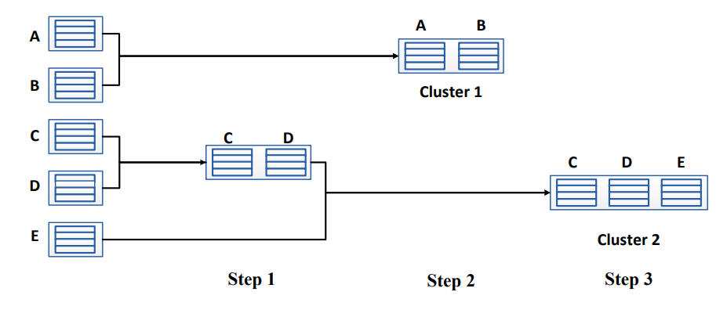
Figure 2. Illustration of the Agglomerative Hierarchical Clustering Process

Extracting Representative Log Sequence: Once we have performed log clustering, we end up with multiple clusters. For each of these clusters, we need to choose a representative log sequence that will serve as the centroid of the cluster. To select this representative sequence, we evaluate each log sequence i within the cluster by calculating its score. This score is determined based on the average distance of the log sequence to the other log sequences present in the same cluster.

𝑆𝑐𝑜𝑟𝑒(𝑖) = $\frac{1}{n-1 }$ $\sum_{j=1}^{n}{(1-Similarity\left(X_{i}, X_{j}\right))}$

where n is the number of log sequences in the cluster. From each cluster, we select the log sequence with the minimal score as the representative sequence of the cluster. The selected sequences are the candidates for manual examination.

