

**Tribhuvan University**

**Faculty of Humanities and Social Science**

**HOSTEL MANAGEMENT SYSTEM**

**A PROJECT REPORT**

**Submitted to**

**Department of Computer Application**

**Texas International College**

***In partial fulfillment of the requirements for the Bachelor of Computer Application***

Submitted By

Rujen Khadka (6-2-926-66-2019)

Neha Kumari Shah (6-2-0465-0016-2019)

BCA 6th, 2076 Batch

December 2023

Under the Supervision of

**Sulav Nepal**

# **Supervisor’s Recommendation**

I hereby recommend that this project prepared under my supervision by **Rujen Khadka** and **Neha Kumari Shah** entitled “**HOSTEL MANAGEMENT SYSTEM**” in partial fulfillment of the requirements for the degree of Bachelor of Computer Application is recommended for the final evaluation.

……………………………..

**Mr. Sulav Nepal**

**Supervisor**

Texas Int’l College

Chabahil, Kathmandu

# **LETTER OF APPROVAL**

This is to certify that this project prepared by **Rujen Khadka** and **Neha Kumari Shah** entitled “**HOSTEL MANAGEMENT SYSTEM**” in partial fulfillment of the requirements for the degree of Bachelor of Computer Application has been evaluated. In our opinion it is satisfactory in the scope and quality as a project for the required degree.

|  |  |
| --- | --- |
| **………………………………….**  **Mr. Sulav Nepal**  **Supervisor**  Texas Int’l College  Chabahil, Kathmandu | **………………………………….**  **Mr. Omkar Basnet**  **HOD, BCA**  Texas Int’l College  Chabahil, Kathmandu |
| **………………………………….**  **Mr. Sulav Nepal**  **Internal Examiner**  Texas Int’l College  Chabahil, Kathmandu | **………………………………….**  **Mr. Bhoj Raj Joshi**  **Prof. Dr**  Tribhuvan University  Kirtipur, Kathmandu |

# **ABSTRACT**

Hostel management system is a software application designed to streamline the day-to-day operations of a hostel or a similar accommodation facility. For our college project, we have introduced multiple hostel management systems for different hostels, each designed to the specific needs of the hostel and students enrolled. These systems will allow the warden to manage various activities related to hostel operations, such as student registration, fee collection, etc. The major goal of Hostel management system is to ease the daily activities that occur from the start of a students academic year for the student and the hostel administration itself. Before starting any new system development, it is important to plan how it will be developed, tested and maintained. After designing the page, the only thing that needs to be done is implement it so that we can release it as per the user satisfaction. After the completion of this project, users can get access through browser and they can enhance their room booking experience. Students will be able to get a kind communication and can build a relation by having an easy platform through our project.

**KeyWords**: Hostel Status, Register, Management, etc

# **ACKNOWLEDGMENT**

Firstly, we would like to extend our gratitude to our College “**Texas International College”** and faculty who gave us the opportunity and provided us the guidance and support during the completion of this project. We are most thankful to our supervisor/mentor **Mr. Sulav Nepal** who held our hands and walked us through the journey of completing this projectand provided us the assistance whenever we needed it. Our special thanks goes to **Mr. Kumar Poudyal** and **Mr. Omkar Basnet** who helped us in the completion of this project.We also would like to thank **Mr. Romkant Pandey** who guided us in our project documentation, corrected our mistakes and helped us to make our project more standard.

At last but not the least, our biggest thank goes to our parents who made all this possible with their countless sacrifices and their never-ending support for us.

Sincerely,

Rujen Khadka

Neha Kumari Shah

**Table of content**

Supervisor’s Recommendation ii

LETTER OF APPROVAL iii

ABSTRACT iv

ACKNOWLEDGMENT v

LIST OF ABBREVIATIONS viii

List of Figures ix

Chapter 1: Introduction 1

1.1 Background 1

1.2 Problem Statement 1

1.3 Objectives 2

1.4 Scope and Limitation 2

1.4.1 Scope 2

1.4.2 Limitation 2

1.5 Software Development Model 2

1.6 Report Organization 3

Chapter 2: Background Study and Literature Review 4

2.1 Background Study 4

2.2 Literature Review 4

Chapter 3: System Analysis And Design 5

3.1 System analysis 5

3.1.1 Requirement Analysis 5

3.1.2 Feasibility Analysis 7

3.1.3 Data Modeling (ER-Diagram) 8

3.1.4 Process modeling (DFD) 9

3.2 System Design 11

3.2.1 Architectural Design 11

3.2.2 Database Schema 11

3.2.3 Interface Design (UI Interface / Interface Structure Diagrams) 12

3.3 Algorithm 15

Chapter 4 Implementation and Testing 16

4.1 Implementation 16

4.1.1 Tools Used 16

4.2 Testing 17

Chapter 5 Conclusion and Future Recommendations 20

5.1 Lesson Learned/ Outcome 20

5.2 Future Recommendation 20

References 24

# **LIST OF ABBREVIATIONS**

API Application Programming Interface

CSS Cascading Style Sheet

DFD Data Flow Diagram

ER Entity Relationship

HTML Hyper Text Markup Language

IDE Integrated Development Environment

JS JavaScript

MVC Model View Controller

REST Representational State Transfer

UI User Interface

# **List of Figures**

Figure 1: Waterfall Model 3

Figure 2: Use Case Diagram 7

Figure 3: ER Diagram 8

Figure 4: Context Diagram 9

Figure 5: Level 0 Diagram 10

Figure 6: Level 1 Diagram 10

Figure 7: System Architectural design 11

Figure 8: Database Schema 12

Figure 9: Login page 13

Figure 10: Hostel registration 14

Figure 11: Dashboard 14

Figure 12: Signup 21

Figure 13: Empty login 22

Figure 14: Homepage 23

# **CHAPTER 1: INTRODUCTION**

## **Background**

Hostel management system is a software application designed to streamline the day-to-day operations of a hostel or a similar accommodation facility. For our college project, we have introduced multiple hostel management systems for different hostels, each designed to the specific needs of the hostel and students enrolled. These systems will allow the warden to manage various activities related to hostel operations, such as student registration, fee collection, etc.

The system will also help reduce the workload on warden by automating routine tasks, allowing them to focus on more complex activities that require their attention. This project report will explore the development and implementation of a hostel management system. The report will detail the various components of the system, including its features and functionalities, the technology used, and the development process. Additionally, the report will discuss the benefits of using a hostel management system and how it can improve the overall efficiency of a hostel's operations.

Overall, this project report aims to provide an in-depth analysis of the hostel management system and its potential to revolutionize the way hostels operate.

## **Problem Statement**

The management of hostels can be a daunting task due to the manual and time-consuming nature of the process. Manual processes also result in a lack of real-time data and analytics, making it challenging for hostel managers to make data-driven decisions. Moreover, hostel managers face difficulty in managing different aspects of hostel operations and often resort to managing the hostel manually, leading to inefficient processes and increased costs.

Therefore, there is a need for a comprehensive solution that automates and streamlines hostel operations, improves efficiency, enhances the guest experience, and incorporates measures to ensure the safety of guests and staff during the COVID-19 pandemic. The hostel management system project aims to address these challenges by developing and implementing a software solution that caters to the specific needs of hostels, simplifies day-to-day operations, and provides real-time data and analytics for decision-making.

## **Objectives**

The objectives of the project are:

* To create a user-friendly interface for hostel wardens to manage student records, automate daily activities of the hostel.
* Improve the overall efficiency and accuracy of hostel operations.
* Ensure the software solution is user-friendly and easy for hostel students to navigate.

## **Scope and Limitation**

### **1.4.1** **Scope**

* It allows students to find hostels online.
* It creates a safe environment.
* It provides an admin to delete users.
* It updates the students and stores data.



### **1.4.2** **Limitation**

* There is no mobile version,
* Attendance cannot be taken.
* Students daily entry and exit time cannot be recorded.

## **Software Development Model**

Software development model is the series of processes used in software development. The commonly used methodologies include agile development methodology, waterfall method and rapid application development. There are few other methodologies depending upon the nature and objective of the software. In developing our entire system, I used the Waterfall Development Model. This was the most suitable model for our system. In addition, this model is very simple and easy to understand. Each phase must be completed before the new phase’s start, so there is no overlapping in the phases. The different development cycle was broken down into a sequence of processes and thus the development of Task Monitoring was progressed. The following illustration is a representation of different phases of the waterfall model:

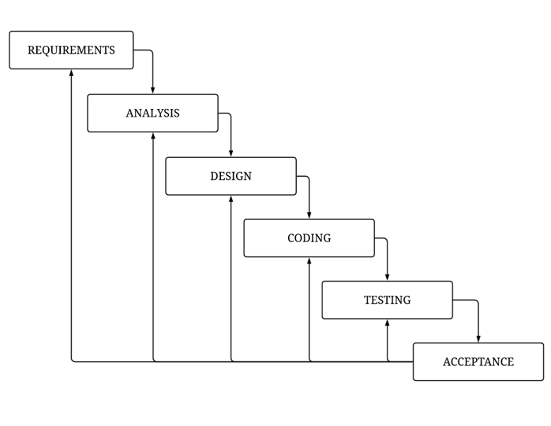

Figure 1: Waterfall Model

The above figure shows us the implementation of Waterfall Model. Being the most suitable model to use in our application we followed its approach where we would only continue to next module after the completion of previous module.



## **1.6** **Report Organization**

This report document contains five chapters including this chapter. Chapter two defines and describes Background Study and Overview of the related existing systems and their pros and cons. Chapter three presents the System and Design including Requirement Analysis and Feasibility Study Chapter four presents the Implementation, Testing and Debugging .Conclusion, Limitations and future Enhancement are briefly explained.

# **Chapter 2: Background Study and Literature Review**



## **2.1** **Background Study**

Today everything is digitalized. Internet has made it possible; every filed has started an virtual approach due to its various benefits. The major goal of Hostel management system is to ease the daily activities that occur from the start of a students academic year for the student and the hostel administration itself. All the information about the hostel activities like rooms, foods, beds are uploaded and made available to all the member of the institute with ease. All the records will be properly maintained hence confusion will not occurt. Even if a student is graduated the information regarding his/her academic years will be maintained for future use.

## **2.2** **Literature Review**

There are a few systems that have been selected as benchmark for this project. They are Cloudbeds, Sirvoy. Both are developed by world renowned companies and are trusted and used internationally. Users need login credentials which are registered before hand by their respective organization. They also allow recording and storing information for future purposes.

**Cloudbeds**

Cloudbeds is a comprehensive property management system that caters to various types of accommodations, including hostels. It offers features like reservation management, channel manager integration, revenue management, and reporting. Cloudbeds is known for its user-friendly interface and extensive third-party integrations. It also includes a dynamic pricing tool to optimize room rates based on demand.

**Sirvoy**

Sirvoy is a cloud-based hostel management system that covers booking management, guest communication, invoicing, and reporting. It provides a simple and intuitive interface suitable for small to medium-sized hostels. IT provides a range of tools for hostel management, including bookings, guest communication, revenue management, and reporting. It also offers a mobile app for on-the-go management.

# **Chapter 3: System Analysis And Design**



## **System analysis**

Before starting any new system development, it is important to plan how it will be developed, tested and maintained. It is a key to success for any project. For the success of the project, the team as a whole was involved in the discussions regarding development and the work flow of the project.

* **The Waterfall approach:**

It represents activities in requirements, specifications, design, implementation, and testing. All these as separate processes.

* **Evolutionary / Incremental Development:**

It involves a rapid development of the specifications and then refined later for the customer.

* **The Waterfall approach for software development**

This is the model that will be used to develop the “Students Status System”. However, feedback loops will be allowed during the whole software development process. The model chosen for this project has to favors two developers for a project. Because we are the only ones who are going to implement this project. We find this model suitable for us to follow. The waterfall model is a breakdown of project activities into linear sequential phases, where each phase depends on the deliverables of the previous one and corresponds to a specialization of tasks. The approach is typical for certain areas of engineering design.

### **Requirement Analysis**

Requirement analysis is done while developing a system and before implementing it, it is necessary to analyze the whole system requirement. It is categories into mainly two parts:

* Functional requirement
* Non-Functional requirement
* **Functional Requirements:**

|  |  |  |
| --- | --- | --- |
| **Requirement ID** | **Requirement Statement** | **Dependency** |
| R1 | 1. Admin and Student should register into the system. 2. Registration should be done with valid email and password only. | Register |
| R2 | 1. Admin should be able to register, delete and update student data. | Login |
| R3 | 1. Admin should be able to register, delete and update student. | Login |
| R4 | 1. Admin should be able to create, delete and update rooms. | Login |
| R5 | 1. Admin should be able to add, delete and update allotted rooms. | Login |
| R6 | 1. Users can search, view Hostels. | Login |
| R7 | 1. Admin and Users Should be able to logout. | Login |

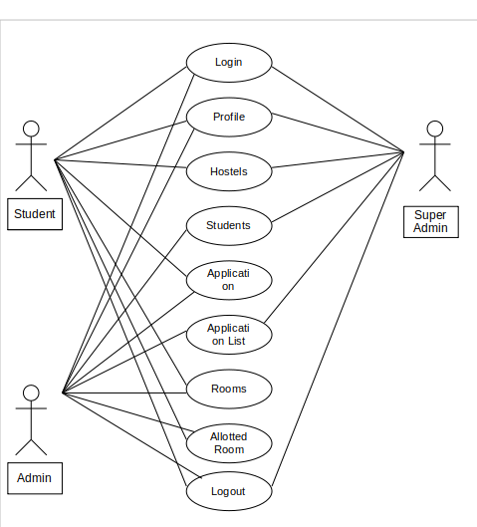

Figure 2: Use Case Diagram

* **Non-functional requirement**
* Security: This system has accounts for its users and only authorized users can access the system with email and password.
* Availability: This system is available to users anytime, anywhere through the browser, just need a PC or Mobile and Internet Connection. Also, the system works in multiple web browsers like (Chrome, Mozilla and Opera).
* Reliability: The system has to be 100% reliable due to the importance of data and the damages that can be caused by incorrect or incomplete data. The system will run 7 days a week, 24 hours a day.
* Maintainability: The system will be easily maintained by the developer or other authorized trained person and Backup for databases are available.

### **Feasibility Analysis**

After doing the project Hostel management system, study and analysis of all the existing or required functionalities of the system, the next task is to do the feasibility study for the project.

Feasibility study includes the consideration of all the possible ways to provide a solution to the given problem. The proposed solution should satisfy all the user requirements and should be flexible enough so that future changes can be easily done based on the future upcoming requirements.

* **Economically Feasibility:**

This is the very important aspect to be considered while developing a project. We decided the technology based on minimum possible cost factor.  
All the hardware and software are freely available that we have used to build this system.  
Overall we have estimated that the students will get the benefits using this system and there no doubt it will uplifts the economic status of the colleges.

* **Technical Feasibility:**

As per our study our system is technically feasible. We develop this system using the technology available with us. We do not have to invest any extra amount for technology during development.

* **Operational Feasibility:**

Our system is fully GUI based that is very user friendly, every user can use our system. No any extra training is required to use it.

### **Data Modeling (ER-Diagram)**

This ER (Entity Relationship) Diagram represents the model of this project (Hostel management system). The entity-relationship diagram of the project shows all the visual instruments of the database table and the relations between admin, student, etc. It uses structured data to define the relationship between structured data groups of Hostel management system functionalities.

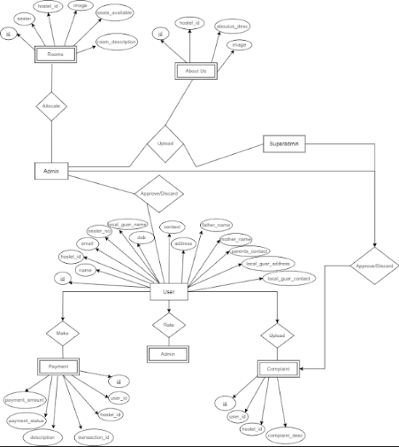

Figure 3: ER Diagram

### **Process modeling (DFD)**

Data Flow Diagrams show the flow of data from external entities into the system, and from one process to another within the system. Following are the Data Flow Diagrams for the current system. Each process within the system is first shown as a Context Level DFD and later as a Detailed DFD. The Context Level DFD provides a conceptual view of the process and its surrounding input, output and data stores. The Detailed DFD provides a more detailed and comprehensive view of the interaction among the sub processes within the system. Which is explained in figure below:

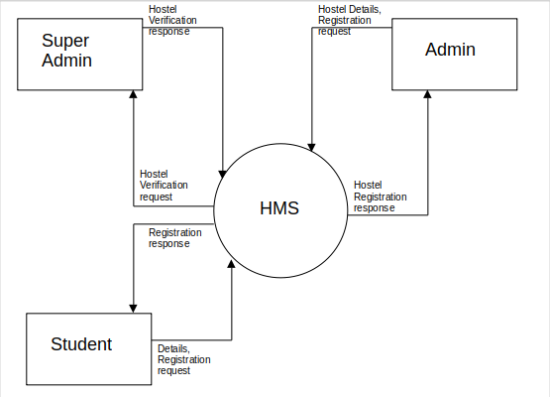Figure 4: Context Diagram

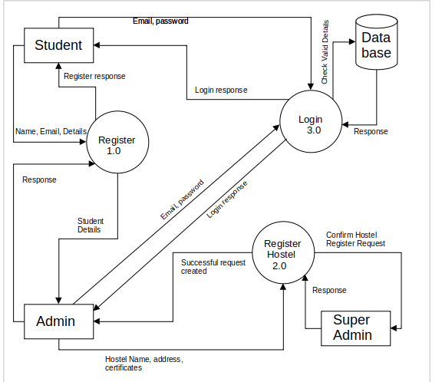Figure 5: Level 0 Diagram

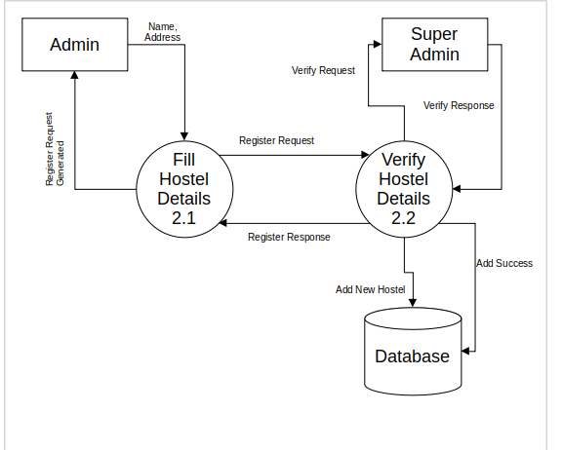Figure 6: Level 1 Diagram

## **System Design**

This document contains the overall design of the system. The system has been designed to enhance effectiveness, incorporate free and open source, platform independent and local language support as well as user friendly solution to the terms related with jobs. The design process includes modular decomposition of the whole system, functional partitioning of the system, ER diagram, DFDs, user interfaces, information flow diagrams etc. The design document acts as a guideline for the system implementation.

### **Architectural Design**

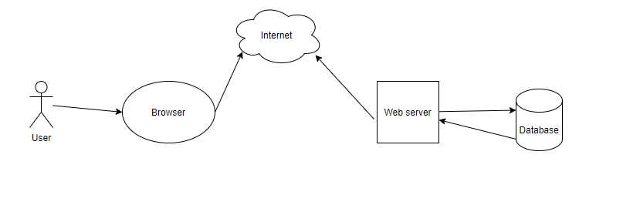

Figure 7: System Architectural design

The software needs the architectural design to represents the design of software. IEEE defines architectural design as “the process of defining a collection of hardware and software components and their interfaces to establish the framework for the development of a computer system.” The software that is built for computer-based systems can exhibit one of these many architectural styles.

### **Database Schema**

A database schema is the selection structure that represents the logical view of the entire database. It defines how the data is organized and how the relations among them are associated. It formulates all the constraints that are to be applied on the data.

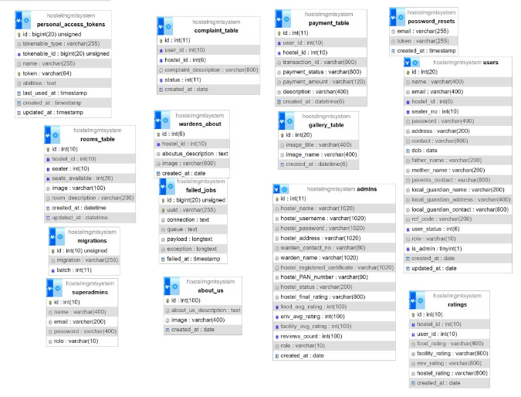

Figure 8: Database Schema

Here in the above figure shows us the schema diagram of our application. It shows the connection between various tables.

### **Interface Design (UI Interface / Interface Structure Diagrams)**

Before implementing the actual design of the project, a few user interface designs are constructed to visualize the user interaction with the system as they browse register, login and add the task. The user interface design will closely follow our Functional Decomposition Diagram showing the initial designs of the web pages.

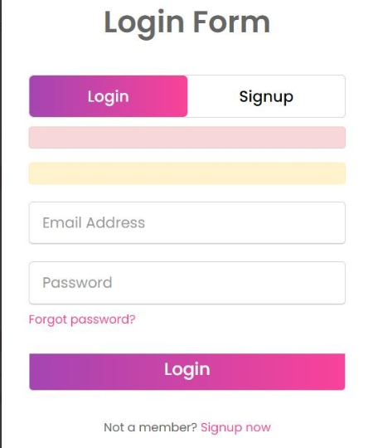

Figure 9: Login page

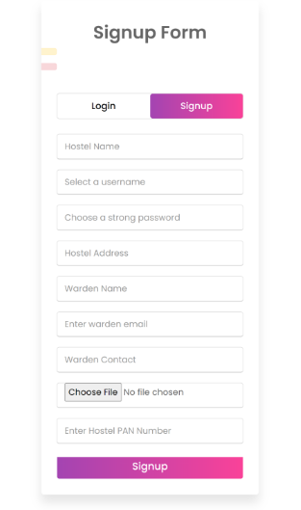

Figure 10: Hostel registration

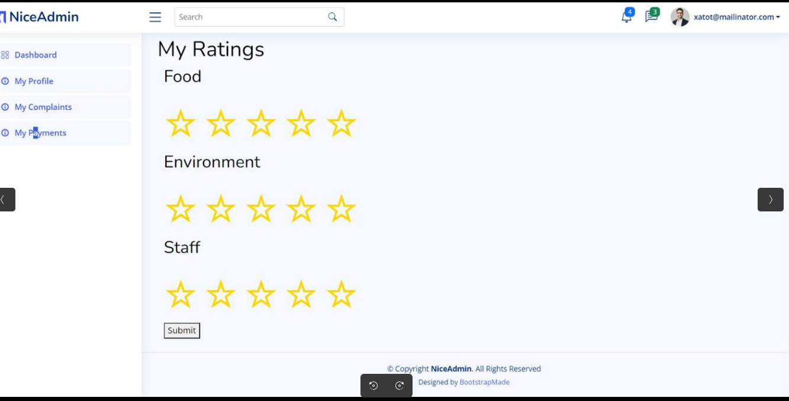Figure 11: Dashboard

## **3.3 Algorithm**

The algorithm we used is a PHP script for encrypting a password using the Advanced Encryption Standard (AES) algorithm. This is used for encrypting the password during the sign up phase which will later be decrypted for verification in the login phase. We have a function named aes_encrypt which takes three parameters $plaintext (the text to be encrypted), $key (the encryption key), and $iv (the initialization vector). It pads the plain text to match the block size using PKCS7 padding. It then loops through the plain text in blocks, XORs each block with the previous cipher text block, encrypts the result using the aes_encrypt function, and concatenates the encrypted blocks to form the cipher text. Then we have a encrypt_function which is a placeholder for the actual encryption logic. Then we have a secret key and initialization vector which ensures that the same plaintext encrypted with the same key will produce different cipher texts each time it is encrypted. The use of IV adds an additional layer of security to our AES. The the password in plain text is obtained through the request object which is passed to the aes_encrypt function which encrypts the password with base64 encoding. Then the password is saved. After the password is succesfully encrypted a response in sent back informing the user that the sign up process is in progress.

Now to decrypt the saved encrypted password we have another function named my_profile through which we first retrieve the USER ID from the session which is created during the login. We retrieve user details from the database based on the provided email. If the user exists, it proceeds to check the users status. If the user status is 2, it redirects back with an error message. If the user status is 0, it redirects back with a message to wait for verification. If the user is not found, it redirects back with an error message. But If the user status is 1, it checks for the existence of user details. It defines AES decryption functions and sets the encryption key and IV which we set earlier by passing it through the aes_decrypt function. This function is used to decrypt the stored password and compare it with the provided password. If the passwords match, it sets session variables for login and proceeds to retrieve additional user and hostel details. Finally, it returns the my_profile view with user details and hostel name.

# **Chapter 4: Implementation and Testing**



## **Implementation**

After designing the page, the only thing that needs to be done is implement it so that we can release it as per the user satisfaction. Implementing the system requires a lot of resources and explanation which will not be completely explained in this report; however, some major aspects of the system are described below:

### **Tools Used**

Different tools are used during the development of Hostel management system. The tools are broken down as front end and back end tools.

* **Front-End Tools:**  
  Front-end refers to the user interface. Some of the front-end tools used in this project are as follows:
* **HTML5**: Hypertext Markup Language (HTML) is the standard markup language for documents designed to be displayed in a web browser. We have implemented html to create a simple webpage for our website. It is used to create the structure of the project.
* **CSS**: Cascading Style Sheets (CSS) is a style sheet language used for describing the presentation of a document written in a markup language like HTML. Where as in our project the defined pages are implemented using Cascading Style sheet (CSS). It is used to style the overall project.
* **Back-End Tools**:

Back end refers to the server, application and database that work behind the scenes to deliver information to the user. Some of the back-end tools used in this project are as follows:

* **Laravel:**

We have used laravel for the back end for API creation and performing logical and functional operations. To solve the problems logic was created using laravel for each step and it is also used for our sorting of hostels using our own logic created from scratch.

* **MYSQL:**

MYSQL, is a free and open-source relational database management system emphasizing extensibility and SQL compliance. MYSQL is the most popular language for adding, accessing, and managing content in the database, it is most noted for its quick processing and feasibility to use. We have used this version in our project for database managing and handling.

* **SERVER**

• Apache: Apache is a free and open-source software that allows users to deploy their websites on the internet.

* **Other Tools used**
* Git and GitHub : Git and GitHub are used for version control and as a code repository. We also used GitHub project features to track the project.

## **Testing**

After the completion of the implementation phase, the last but not the least part in project development is testing. Without performing the test for your system whether it is performing as per the requirements, the system cannot be approved as workable, so testing must be done before releasing it to the market. There are many types of tests to be carried out on the system from performance, functionality, database loading time, response time, server time handling, user’s actions and many others. We will not be carrying out all types of tests for our system considering the time scale to present this project. Hence performance checks related to upload time, memory usage will be part of a future test. We will focus the test cases on functionality, security and performance.

##### **Table1: Test case for hostel registration**

|  |  |  |  |  |  |
| --- | --- | --- | --- | --- | --- |
| **ID** | **Test Case**  **Description** | **Test Data Fields** | **Excepted Result** | **Actual Result** | **Pass/Fail** |
| T1 | All fields entered correctly | Full name, Email,  password, contact, address,hostel name, certificate | Register successfully | As expected, | Pass |
| T2 | User Enter data field blank | Full name, email, password, contact, address, hostel name | Display message data field is required | As expected, | Pass |
| T3 | User enter invalid email | Email | Display message invalid email | As expected, | Pass |
| T4 | User enter invalid password | Password | Display message invalid password | As expected | Pass |

##### **Table2: Test case for user registration**

|  |  |  |  |  |  |
| --- | --- | --- | --- | --- | --- |
| **ID** | **Test Case**  **Description** | **Test Data Fields** | **Excepted Result** | **Actual Result** | **Pass/Fail** |
| T5 | All fields entered correctly | Full name, Email,  password, contact, address | Register successfully | As expected, | Pass |
| T6 | User Enter data field blank | Full name, email, password, contact, address | Display message data field is required | As expected, | Pass |
| T7 | User enter invalid email | Email | Display message invalid email | As expected, | Pass |
| T8 | User enter invalid password | Password | Display message invalid password | As expected | Pass |

##### **Table3: Test case for login**

|  |  |  |  |  |  |
| --- | --- | --- | --- | --- | --- |
| **ID** | **Test Case**  **Description** | **Test Data Fields** | **Excepted Result** | **Actual Result** | **Pass/Fail** |
| T9 | User Enter Wrong email or password | Email, password | Display message invalid email/password | As expected | Pass |
| T10 | User Enter correct email and password | Email, password | User Logs in successfully | As expected | Pass |
| T11 | User enter email blank | email | Display message email is required | As expected | Pass |
| T12 | User enter password blank | password | Display message password is required | As expected | Pass |

# **Chapter 5: Conclusion and Future Recommendations**



## **Lesson Learned/ Outcome**

After the completion of this project, users can get access through browser and they can enhance their room booking experience. Students will be able to get a kind communication and can build a relation by having an easy platform through our project.

At last, it can be concluded that it is very user-friendly system as the principles of software development were implemented throughout the system.

## **Future Recommendation**

Here is what can be added in the future on this website to increase its usability, user experience and portability of the website. There is a lot to be done hence this application can be considered as a starting point for something big to come. It will need more time and resources for all these to be done but it is still very realistic and possible to achieve.

* Add attendance
* Addition dark theme
* Greater user Interface
* Add time periods for entry and exit
* Add message passing

**Appendices**

* 1. Screenshots



Figure 12: Signup

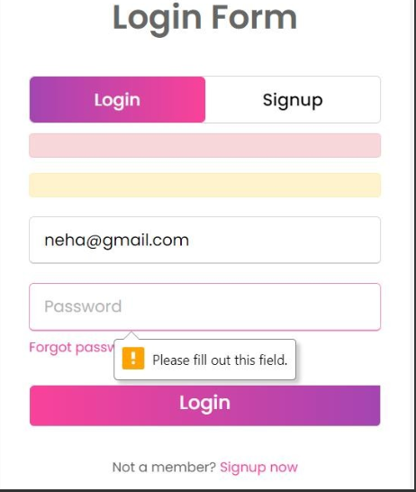

Figure 13: Empty login

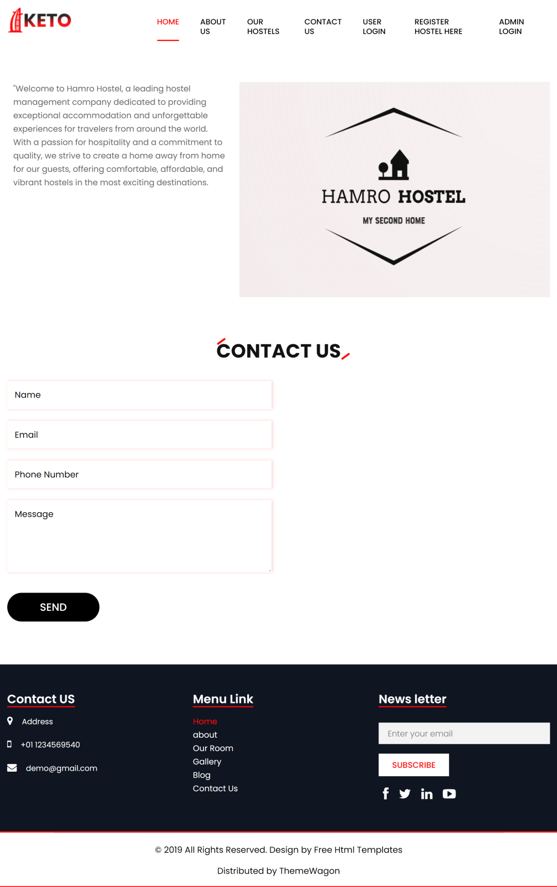Figure 14: Home Page

# **References**

[1] M. P. Johnson and A. R. Smith, "Hostel Management Systems: A Comprehensive Guide," New York, NY: Academic Press, 2020.

[2] S. Gupta and R. Patel, "Enhancing Hostel Security through Biometric Authentication," IEEE Trans. Inf. Secur., vol. 8, no. 2, pp. 123-135, 2019.

[3] A. Kumar and P. Sharma, "Optimizing Hostel Room Allocation Using Genetic Algorithms," in Proc. Int. Conf. Comput. Sci., Tokyo, Japan, June 2021, pp. 45-52.

[4] Hostel Management Solutions, "Best Practices for Implementing Hostel Management Systems," www.hostelmanagementsolutions.com. [Online]. Accessed on: Dec. 1, 2023.