Hydrological Flood Risk Mapping and Infrastructure Vulnerability Assessment Using Remote Sensing and Machine Learning in Hong Kong
Report
Neha Sharma

Contents
List of Figures 2
List of Tables 3
Submission Format 3
Solutions 4
1. Data Discovery and Evaluation – 4
Study Area 5
2. Hydrological Risk Analysis 6
Methodology 6
1. Data Preprocessing 6
2. Data Generation 7
3. Raster Calculations 9
4. Impacted Infrastructure Mapping 11
3. Historical Flood Exposure Assessment 17
Methodology 17
1. Calculate flood frequency index raster 17
2. Persistent Flooding zones 19
3. Extract Exposed Infrastructure layers 19
4. Exposure Summary 21
4. Land Use and Land Cover (LULC) Classification from Sentinel-2 22
Methodology 22
1. Acquiring Sentinel 2 Data 22
2. Supervised Classification 22
3. Unsupervised Classification 24
4. Python Automation Pipeline 25
5. Cartographic Output 25
1. LULC Classification Map 26
2. Flood Frequency Index Map 27
3. Topographic Risk Zones Map 28
4. Infrastructure Exposure Map 31
5. Terrain Map (Hillshade + Contours) 34
Key Findings 37
Limitations 38
Assumptions 39

List of Figures
Figure 1 Hong Kong Administrative Boundary 4
Figure 2 Slope Map (Source: Author) 7
Figure 3 Drain Direction Map (Source: Author) 8
Figure 4 Flow Accumulation Map 8
Figure 5 Low Slope Areas Map 9
Figure 6 High Flow Accumulation Map 10
Figure 7 High Flow Accumulation Raster Overlaid Over Low Slope Regions 10
Figure 8 High Flow Low Slope Raster Generated Using Raster Calculator Visualized Over DEM Data 10
Figure 9 Flood Risk Zones with Area (km2) Under Each Risk Zone 13
Figure 10 Flood Risk Zones (Zoomed In) 14
Figure 11 Exposed Railway Tracks 14
Figure 12 Exposed Education Facilities in Flood Risk Zones with Count shown in Attribute Table 14
Figure 13 Exposed Education Facilities in High Flood Risk Zones 15
Figure 14 Historical Flood Dataset of Hong Kong 16
Figure 15 Flood Frequency Index Map 17
Figure 16 Persistent Flooding Zones 18
Figure 17 Summary stats of exposed railway lines 18
Figure 18 Exposed Railway Lines under Persistent Flooding Zones 19
Figure 19 Exposed Education Facilities under Persistent Flooding Zones 19
Figure 20 Exposed Health Facilities under Persistent Flooding Zones with Count in Attribute Table 19
Figure 21 Acquired Sentinel 2 Data of Hong Kong in False Colour Composite 21
Figure 22 LULC Map of Hong Kong (Zoomed In) 22
Figure 23 Supervised Classification Map 22
Figure 24 Unsupervised Classification Map of Hong Kong 23
Figure 25 LULC Classification Map (Unsupervised) - Source: Author 25
Figure 26 Supervised Classification 25
Figure 27 Flood Frequency Index Map 26

List of Tables
Table 1 Datasets Details 2
Table 2 Screens of steps followed in step 1 4
Table 3 Screens of steps followed in step 2 5
Table 4 Screens of steps followed in step 3 8
Table 5 Screens of steps followed in step 4 11
Table 6 Screens of steps followed in step 1 16
Table 7 Exposure summary by type and zone 19

Submission Format
Submit your work as either a GitHub repository (recommended) or a compressed ZIP archive. Your project structure should follow this format:
/scripts/ → All Python code
/maps/ → Final exported maps (PDFs)
/data/raw/ → Download links or metadata (do not include large raw files)
/data/processed/ → Cleaned and clipped datasets
/qgis_project/ → Final QGIS project file (.qgz)
/report/ → Final report (PDF or Markdown)
README. md → Tools used, instructions, and how to run your code

Solutions

Data Discovery and Evaluation –
You must independently acquire all datasets needed for the project. These may include (but are not limited to):
- Hong Kong administrative boundary
- A Digital Elevation Model (DEM) with 30 m or better resolution
- Sentinel-2 imagery from 2022 or 2023 with minimal cloud cover
- Infrastructure layers: roads, hospitals, utilities, buildings
- Historical floodplain vector data
- Optional: legacy land use raster (for accuracy comparison)
In your report, provide justification for each dataset selected. Clearly state the source, resolution, suitability, and any limitations or caveats.

Table 1 Datasets Details
S.No | Dataset | Raster/ Vector | Data and Links | Resolution
1. | Hong Kong SAR Boundary Shapefile | Vector | https://gadm.org/download_country.html | NA
2. | Sentinel 2 Data | Raster | https://browser.dataspace.copernicus.eu | 10 m
3. | DEM Data - ASTER | Raster | https://search.earthdata.nasa.gov/search/granules?p=C1711961296-LPCLOUD&pg[0][v]=f&pg[0][gsk]=-start_date&q=aster&sb[0]=113.27555%2C21.71002%2C114.6546%2C22.87739&tl=1168862400!5!!&lat=22.26998808665362&long=114.25769082481013&zoom=8.601069930567078 | 30 m
4. | Infrastructure Data | Vector | Railway Lines, Education Facilities, Health Facilities - https://data.humdata.org/dataset/?q=hong+kong&ext_search_source=main-nav&page=2 | NA
5. | Historical floodplain data | Raster | 2006, 2007 and 2014 Hong Kong Flood Dataset - https://global-flood-database.cloudtostreet.ai/#interactive-map | 250 m

Study Area
Hong Kong SAR, China (22.402 N, 114.119 E)
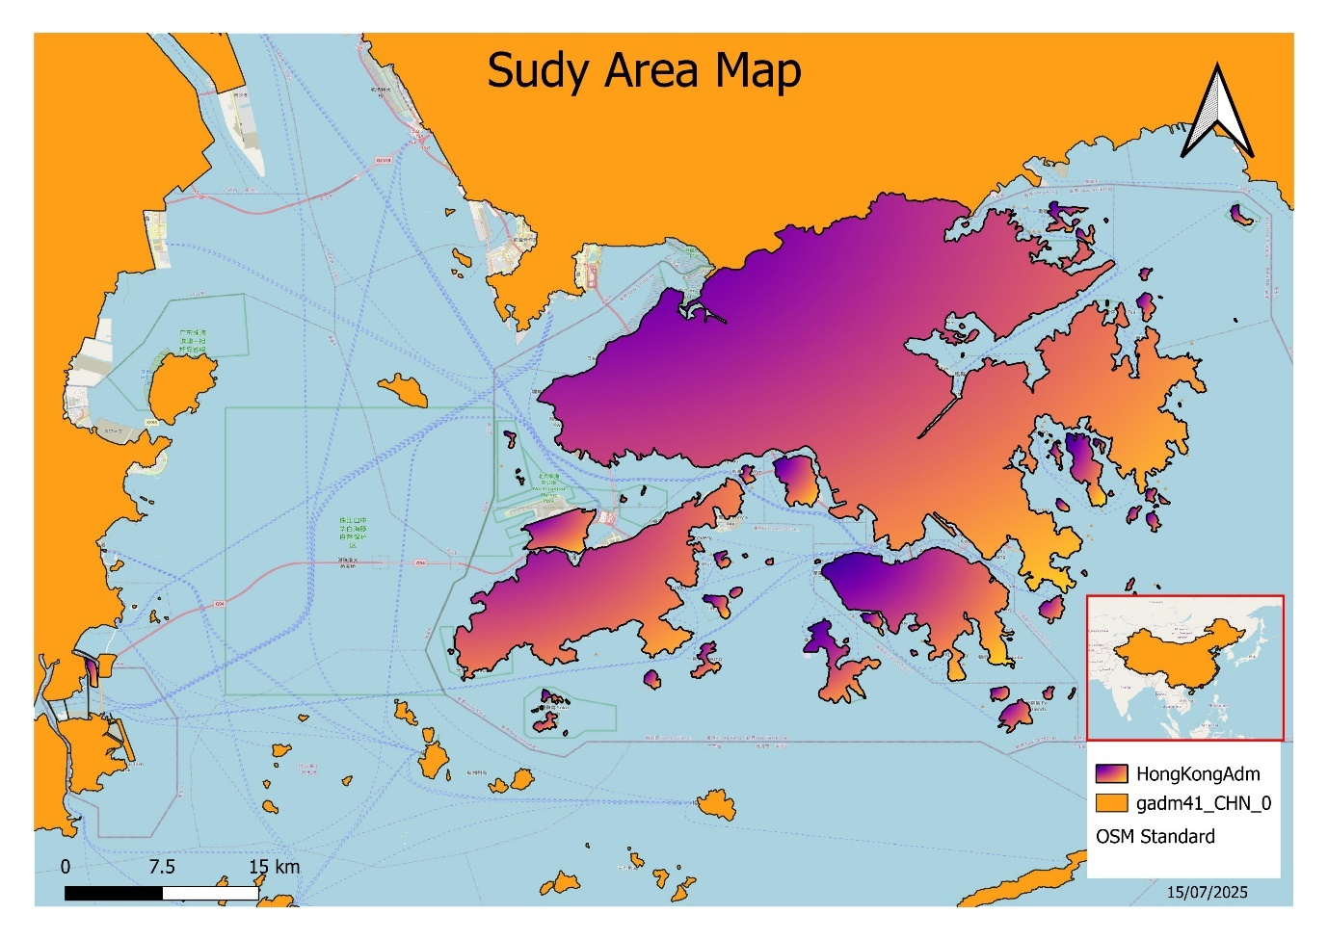
Figure 1 Hong Kong Administrative Boundary

Hydrological Risk Analysis
Using the DEM, perform terrain-based flood risk modelling:
- Derive slope, flow accumulation, and contributing zones
- Identify low-slope areas (<5°) that may be prone to surface water accumulation
- Generate a flood-prone zone polygon layer
- Compute exposure statistics for roads, hospitals, and utilities within these zones

Methodology

Figure 2 Methodology for Hydrological Risk Analysis

Data Preprocessing
- Download ASTER DEM dataset tiles from the above links and open them in QGIS.
- Mosaic ASTER DEM Tiles
- Clip ASTER DEM mosaicked raster.
- Reproject clipped DEM data to the local Hong Kong Projection – Hong Kong 1980 Grid System (EPSG: 2326)
- Fill the missing values in DEM layer using Fill No Data Cells Tool in QGIS.
Table 2 Screens of steps followed in step 1
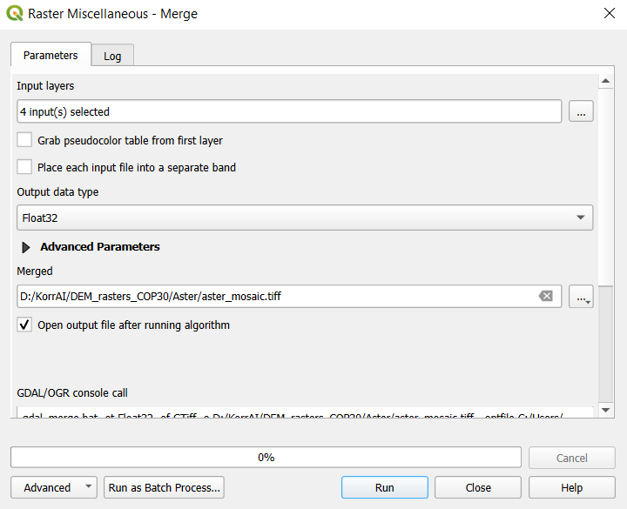 | 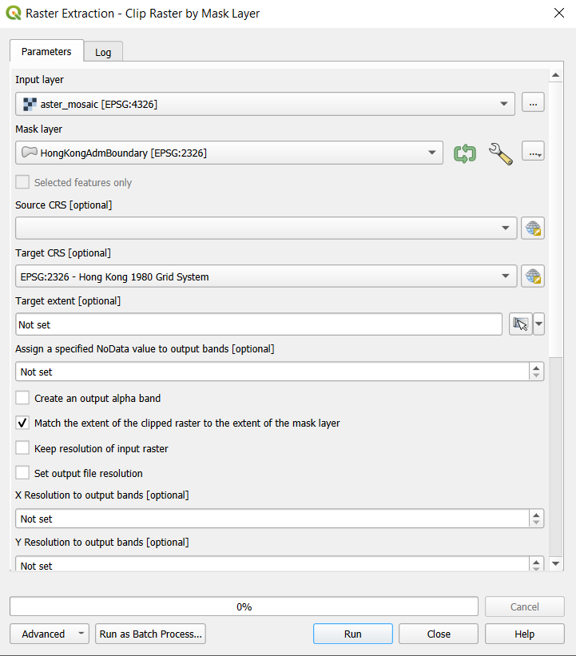
Mosaicking DEM Tiles | Clipping Mosaicked Data
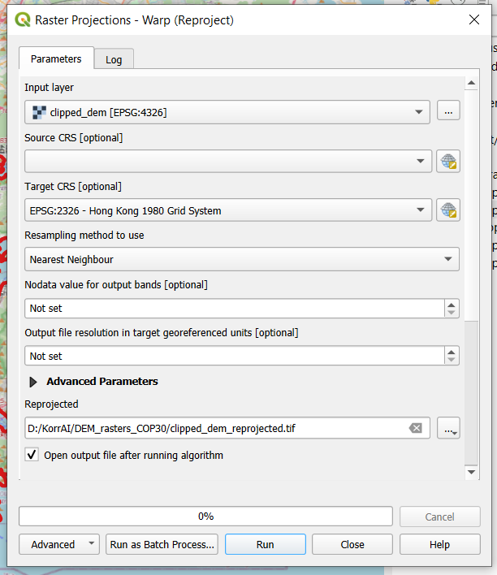 | 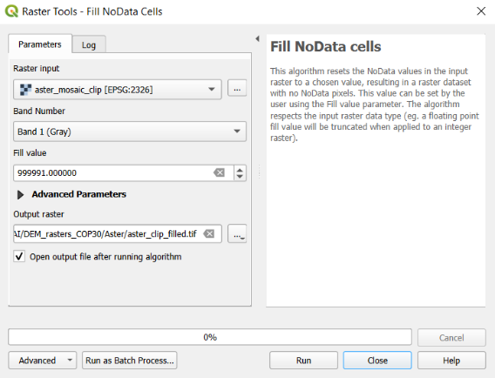
Reproject DEM | Fill No Data Values

Data Generation
(Check the screenshots in below table for exact parameters)
- Slope Raster Generation: Go to Raster -> Analysis -> Slope and fill the required parameters as shown in screen shot below.
- Flow Accumulation Raster Generation:
  - Install PC Raster Plugin in QGIS - https://www.youtube.com/watch?v=2pEr5RoGAXc
  - Convert DEM data to PC Raster Format.
  - Create Drain Direction Map using ldd create tool.
  - Create Flow Accumulation Raster using accuflux tool in PC Raster.
- Generate Contours using DEM data.
- Generate Hillshade raster using DEM data
- Apply right symbology on the generated rasters.
Table 3 Screens of steps followed in step 2
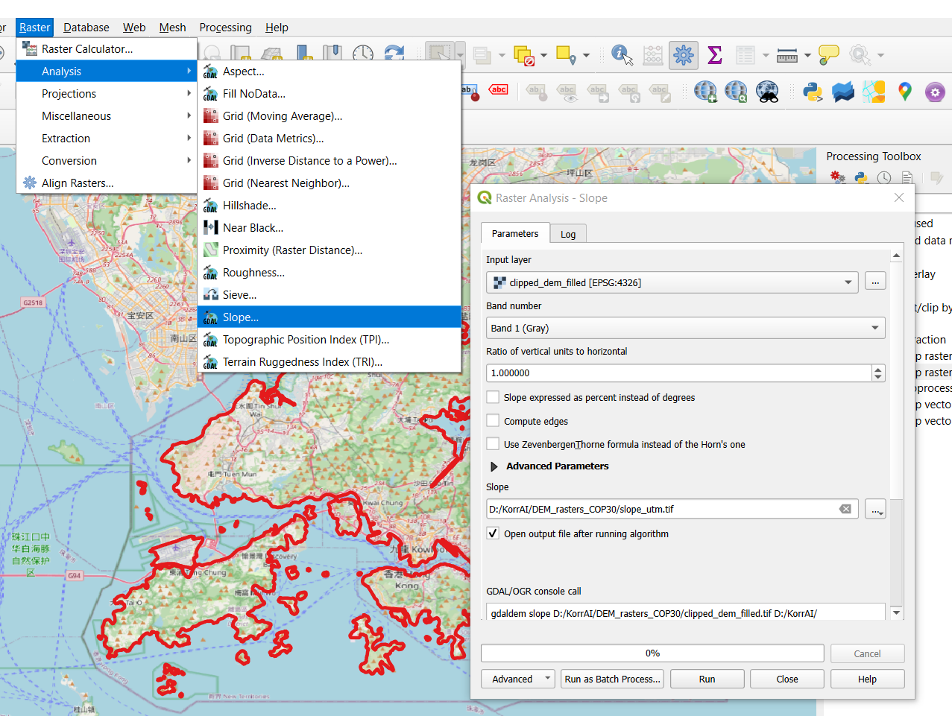 | Generate slope raster
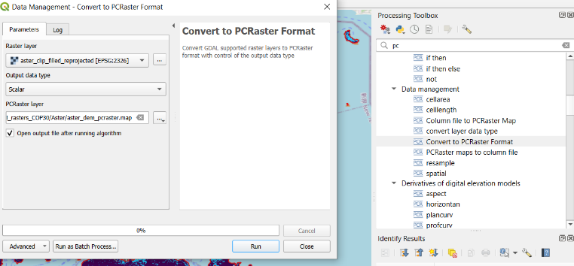 | Convert DEM data to PC Raster Format
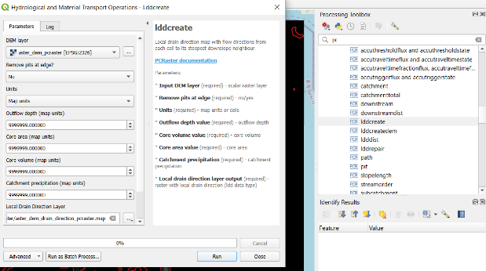 | Create Drain Direction Map using ldd create tool
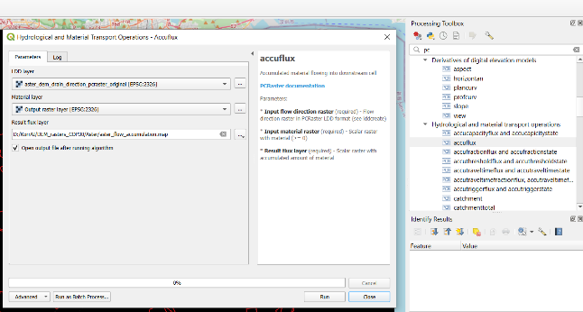 | Create Flow Accumulation Raster using accuflux tool in PC Raster

Maps generated in step 2
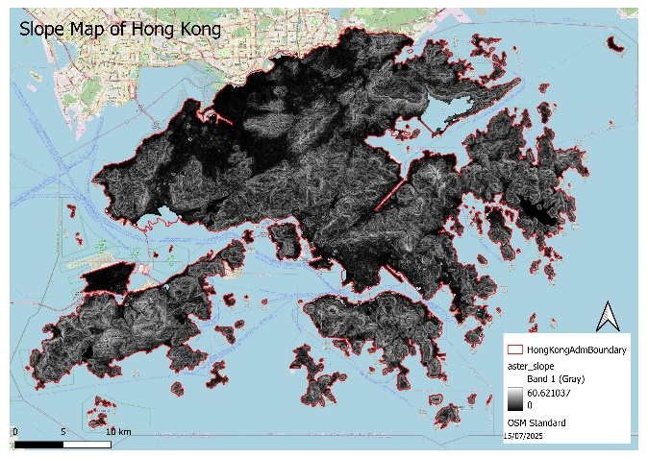
Figure 3 Slope Map (Source: Author)
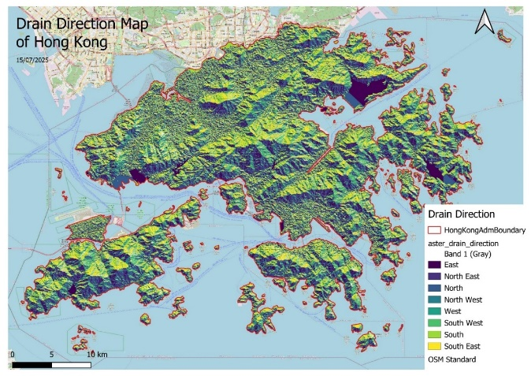
Figure 4 Drain Direction Map (Source: Author)
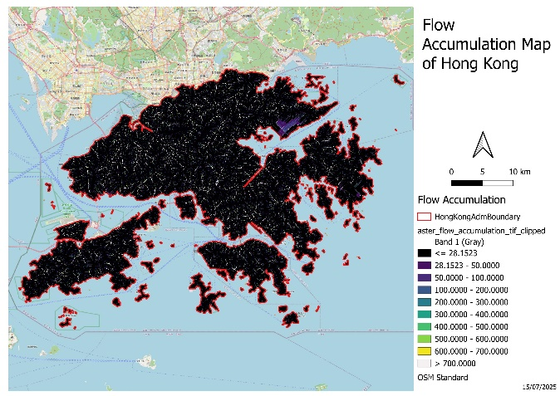
Figure 5 Flow Accumulation Map

Raster Calculations
  - Low Slope Regions:
    - Go to Raster -> Raster Calculator
    - Fill in the expression – “slope_utm@1” < 5. This will generate raster showing regions with slope less than 5 degrees. Score of 1 represents areas where slope is less than 5 degrees.
  - High Flow Accumulation Regions:
    - Go to Raster -> Raster Calculator
    - Fill in the expression – “aster_flow_accumulation_tif_clipped@1” > 1000. This will generate raster showing regions with accumulation higher than 1000 raster cells. Score of 1 represents areas where accumulation is higher than 1000 raster cells.
  - Flood-Prone Zones - Low Slope and High Accumulation Regions
    - Go to Raster -> Raster Calculator
    - Fill in the expression – (“aster_flow_accumulation_tif_clipped@1” > 1000) AND (“slope_utm@1” < 5). This will generate raster showing regions with accumulation higher than 1000 raster cells and slope less than 5 degrees. These are the flood prone regions where in flow is high but out flow is low.
Table 4 Screens of steps followed in step 3
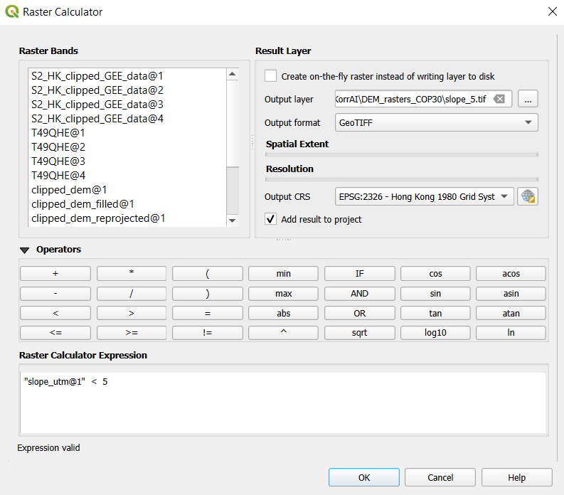 | 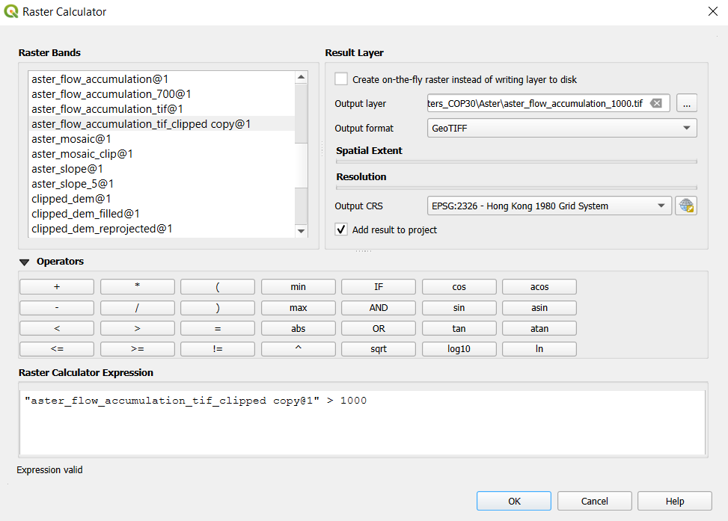
Calculating low slope areas in QGIS | Calculating high flow accumulation areas in QGIS
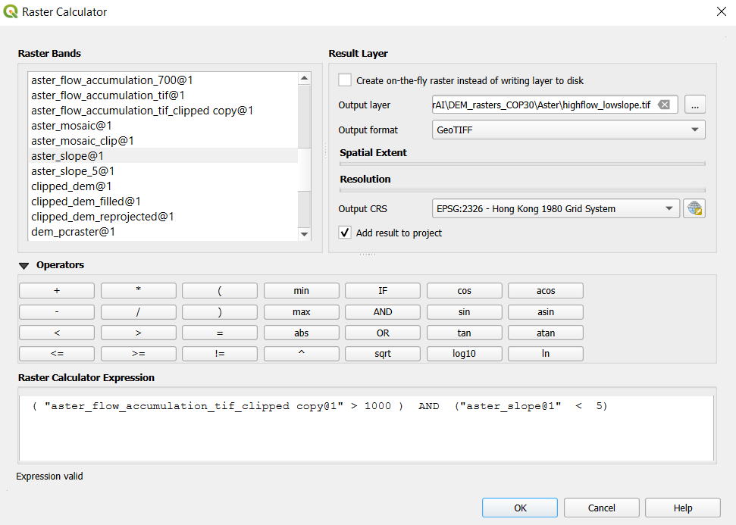
Calculating flood prone zones in QGIS

Maps generated in Step 3 -
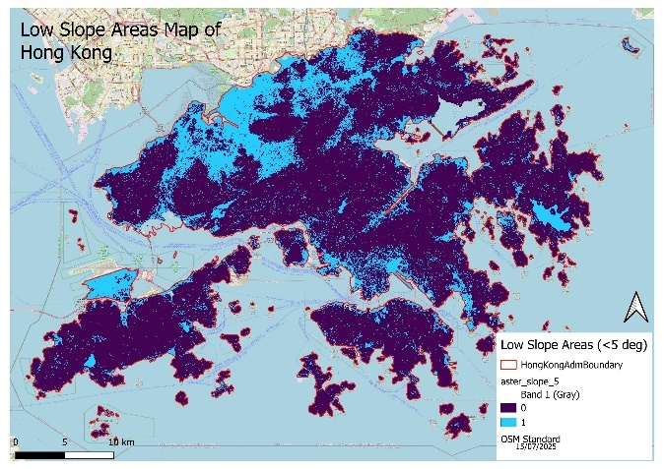
Figure 6 Low Slope Areas Map
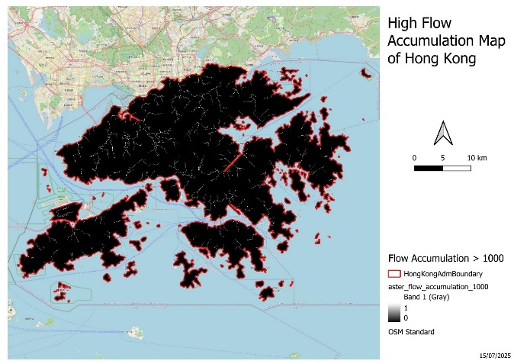
Figure 7 High Flow Accumulation Map
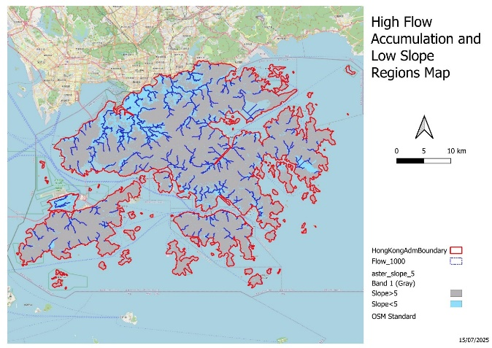
Figure 8 High Flow Accumulation Raster Overlaid Over Low Slope Regions

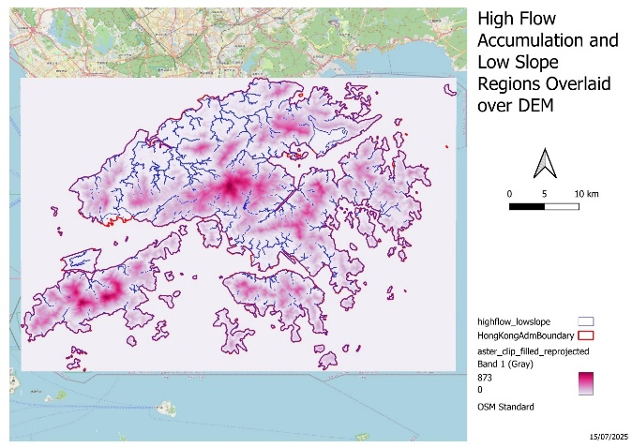
Figure 9 High Flow Low Slope Raster Generated Using Raster Calculator Visualized Over DEM Data

Impacted Infrastructure Mapping
  - Polygonise High Flow Low Slope Raster to create vector layer. The vector layer generated is in the form of streams. We need to create buffers around these stream vectors to get impacted regions.
  - Create 3 multi-ring buffers of 50m distance each. This distance can vary as per analysis. First 50m is high risk zone, next 50m distance is medium risk zone and next 50 m is low risk zone.
    - High risk (inner buffer) - Directly on flood pathways → high inundation & fast impact
    - Medium risk - Proximity to overflow zones; potential for shallow flooding
    - Low risk - Edge influence: surface ponding, poor drainage, or backup flooding
  - Dissolve these buffers to have a continuous polygon vector of flood risk zones.
  - Extract exposed railway lines:
    - Open Hong Kong Railway Lines Shapefile.
    - Using geoprocessing, intersect these railway lines with flood risk zones to get highly likely to be impacted tracks during floods.
    - Create a new column in the output of intersection tool and calculate the length of railway lines likely to be impacted using field calculator.
    - Using Basic statistics for fields tool to get summary statistics of exposed railway lines. For current analysis, total railway line length = 338723.456 m. Exposed railway line length = 291133.825 m
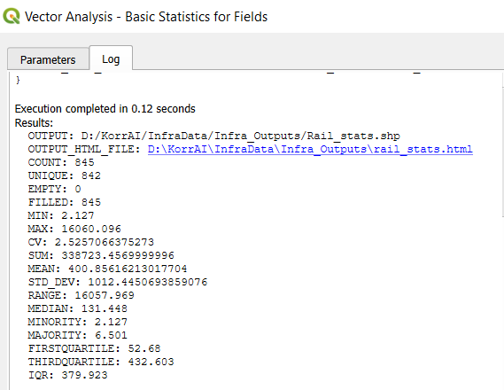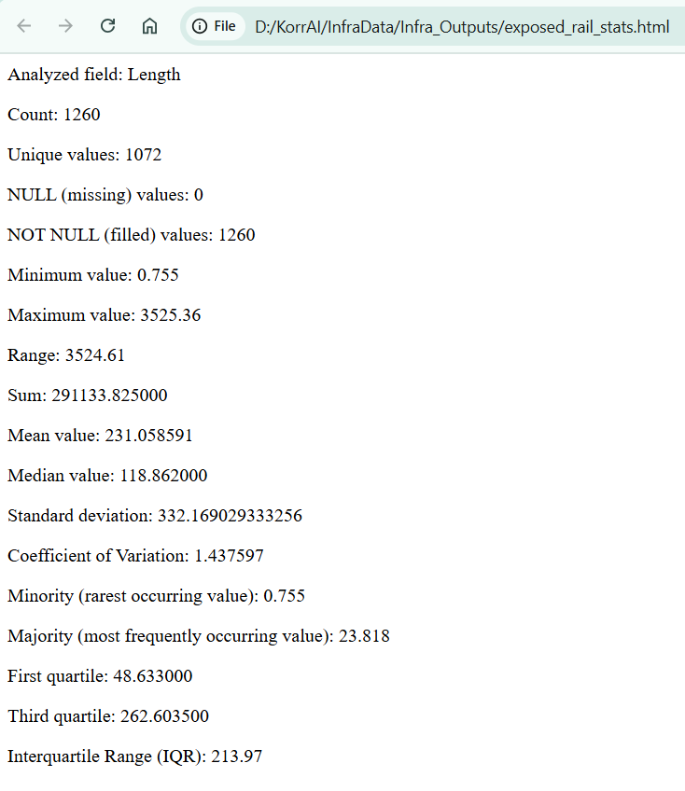

  - Extract exposed education facilities:
    - Open education facilities point shapefile.
    - Using spatial query, select the education facilities falling within the flood risk zones. In this analysis, out of 192, 46 education facilities are exposed to flood risks. Out of 46 exposed education facilities, 18 are falling in high-risk flood zones (shown in maps below).
    - Follow the same process to get highly likely to be impacted health facilities during floods.
For this assessment, we have considered railway lines, education facilities and health facilities. Similarly, other likely to be impacted infrastructure analysis can also be carried out.
Table 5 Screens of steps followed in step 4
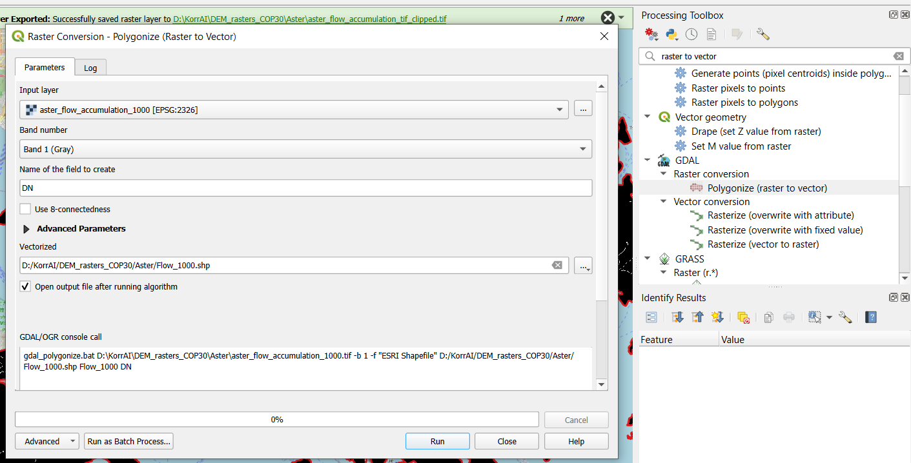 | Convert raster to vector
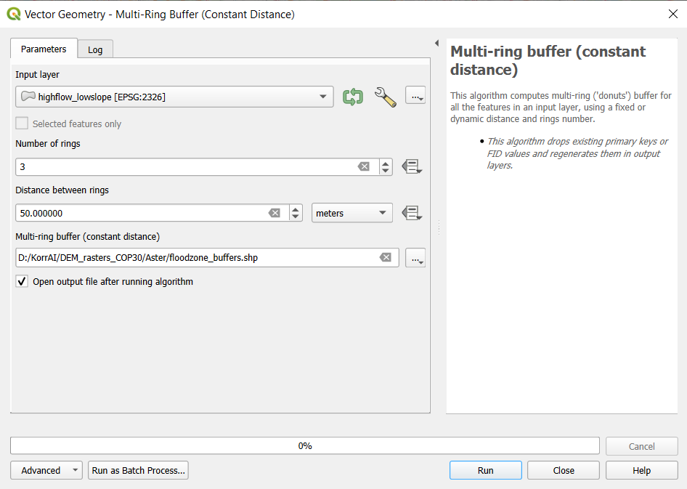 | Create multi-ring buffers
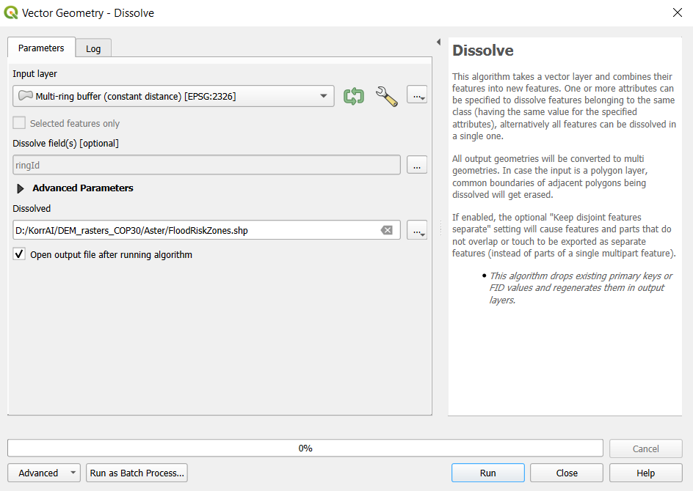 | Dissolve buffers using ring id.
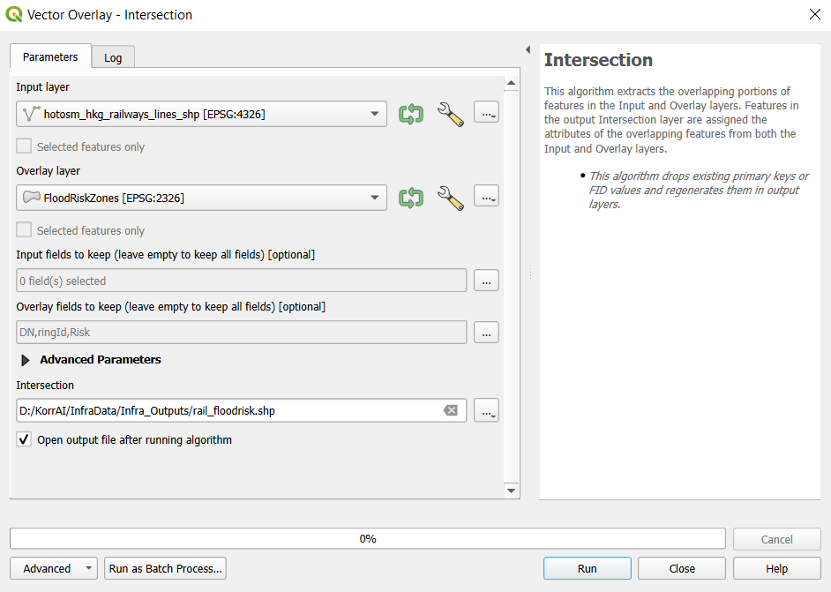 | Extract exposed railway lines using intersection.
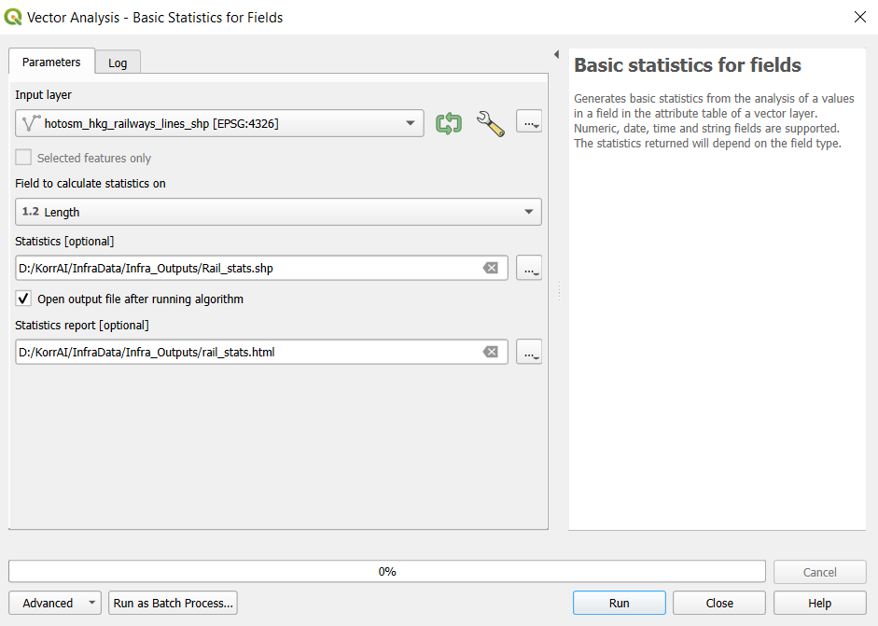 | Calculate summary statistics of exposed railway lines.
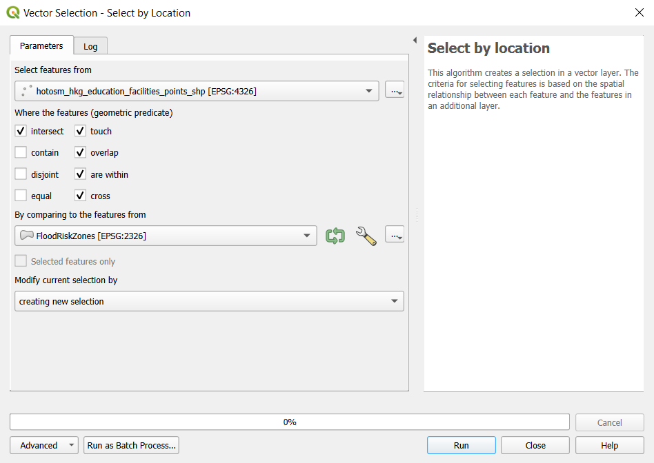 | Extract exposed education facilities

Maps generated in step 4 -
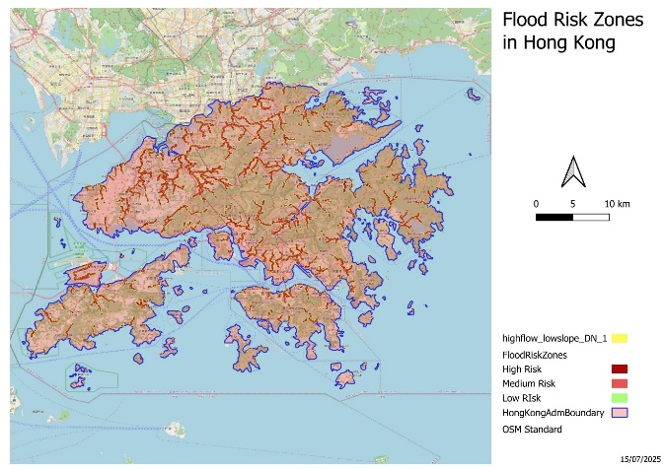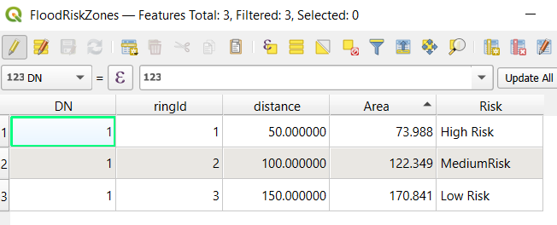
Figure 10 Flood Risk Zones with Area (km2) Under Each Risk Zone
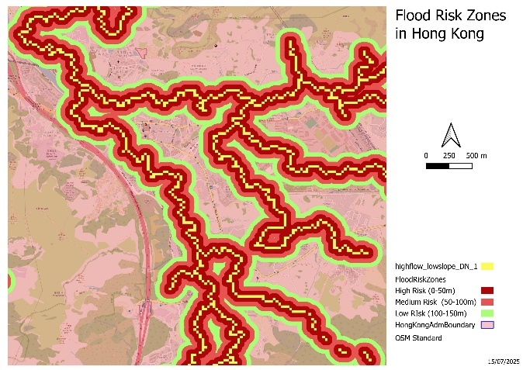
Figure 11 Flood Risk Zones (Zoomed In)
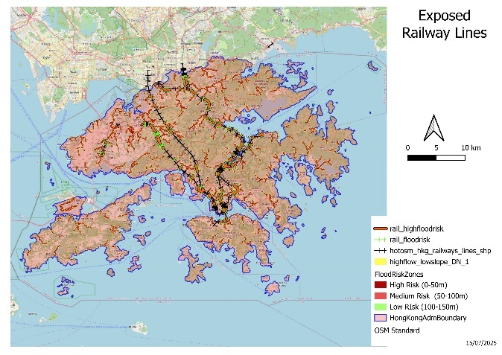
Figure 12 Exposed Railway Tracks
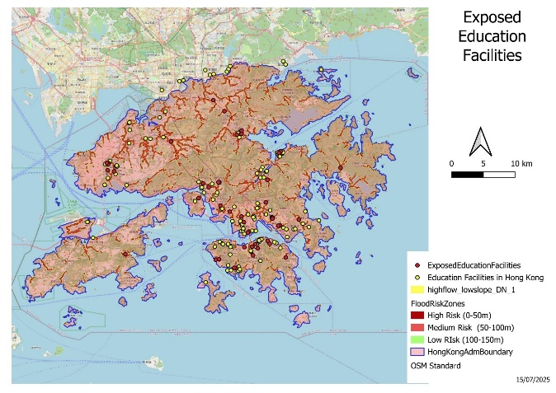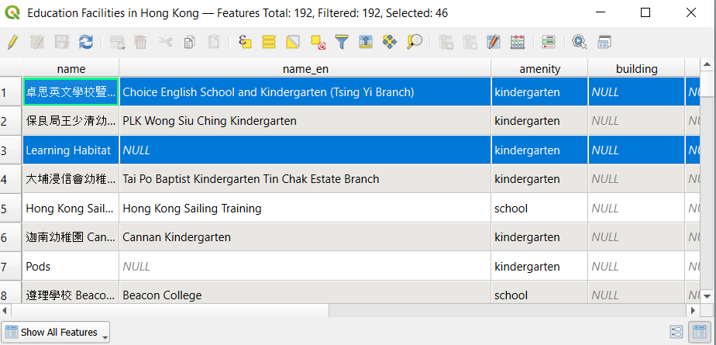
Figure 13 Exposed Education Facilities in Flood Risk Zones with Count shown in Attribute Table
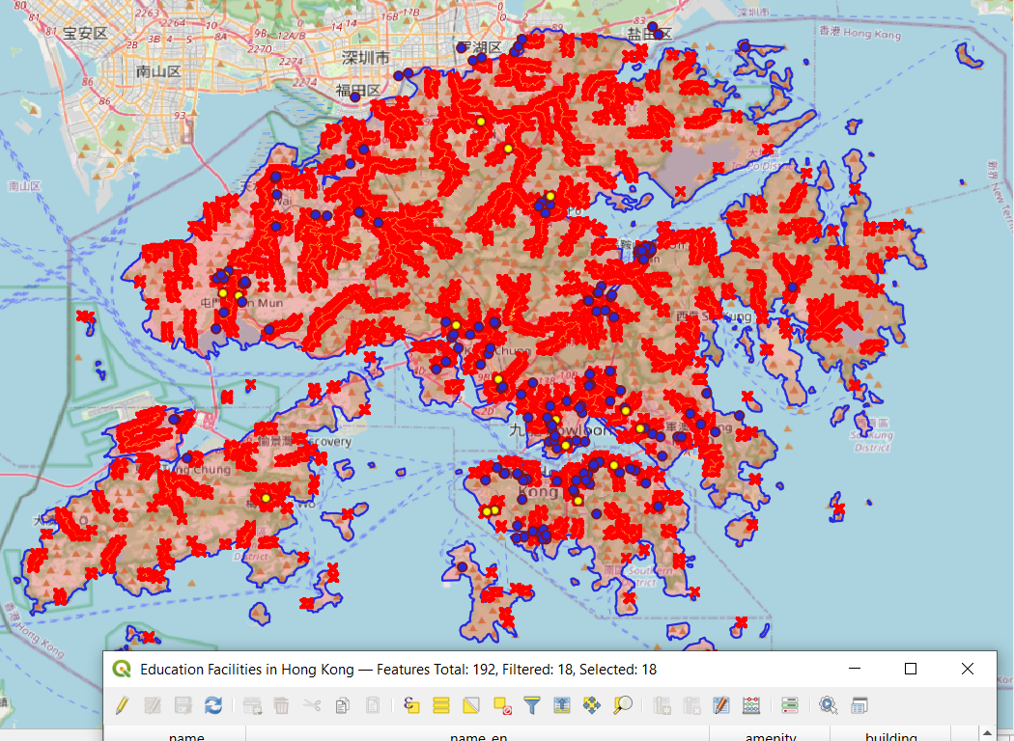
Figure 14 Exposed Education Facilities in High Flood Risk Zones

3. Historical Flood Exposure Assessment
Using at least two historical floodplain datasets (e.g., 2010, 2015, 2020):
- Merge them to derive a flood frequency index raster
- Identify persistent flooding zones
- Intersect these zones with infrastructure layers
- Summarize exposure by type and zone
- Submit a tabulated summary in CSV format

Methodology

Figure 15 Methodology for Historical Flood Exposure Assessment

Calculate flood frequency index raster
  - Download historical flood plain datasets from Global Flood Dataset.
  - For this analysis, we have considered Hong Kong flood datasets of 2006, 2007 and 2014.
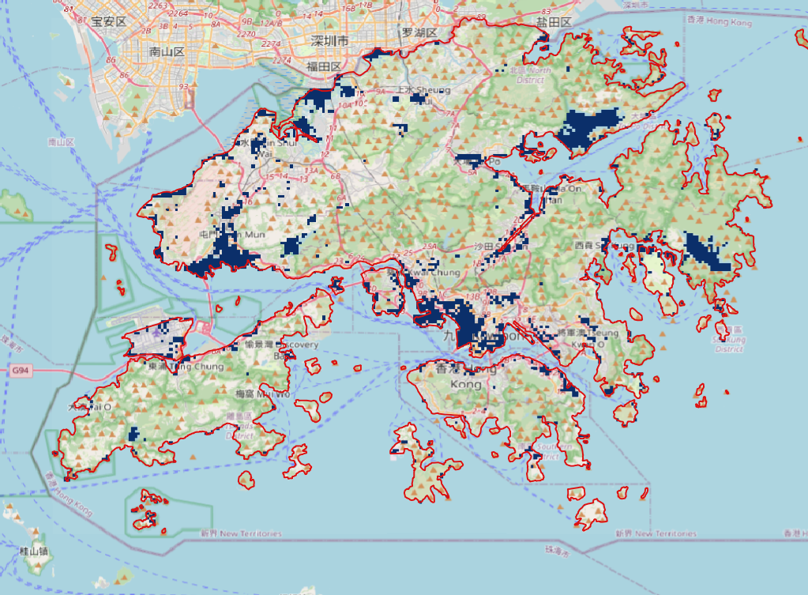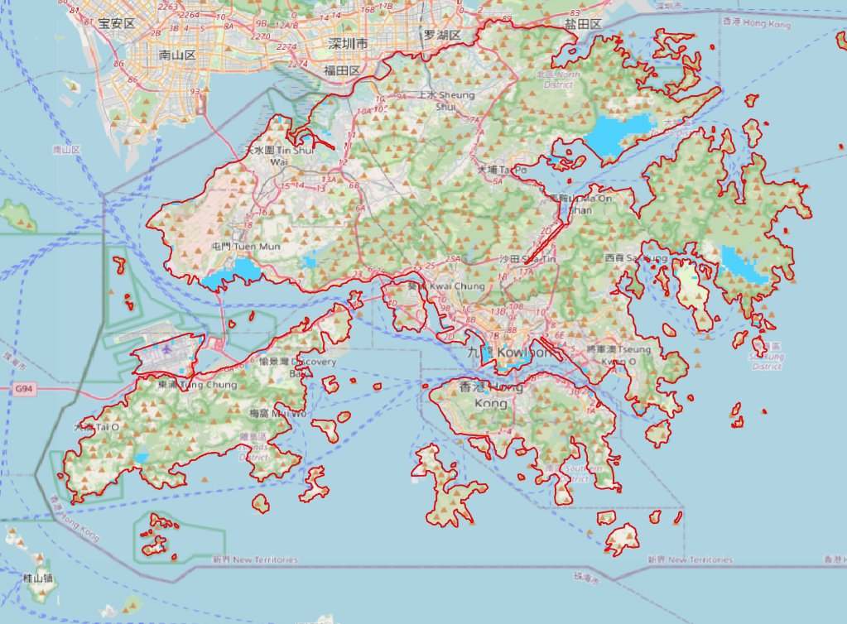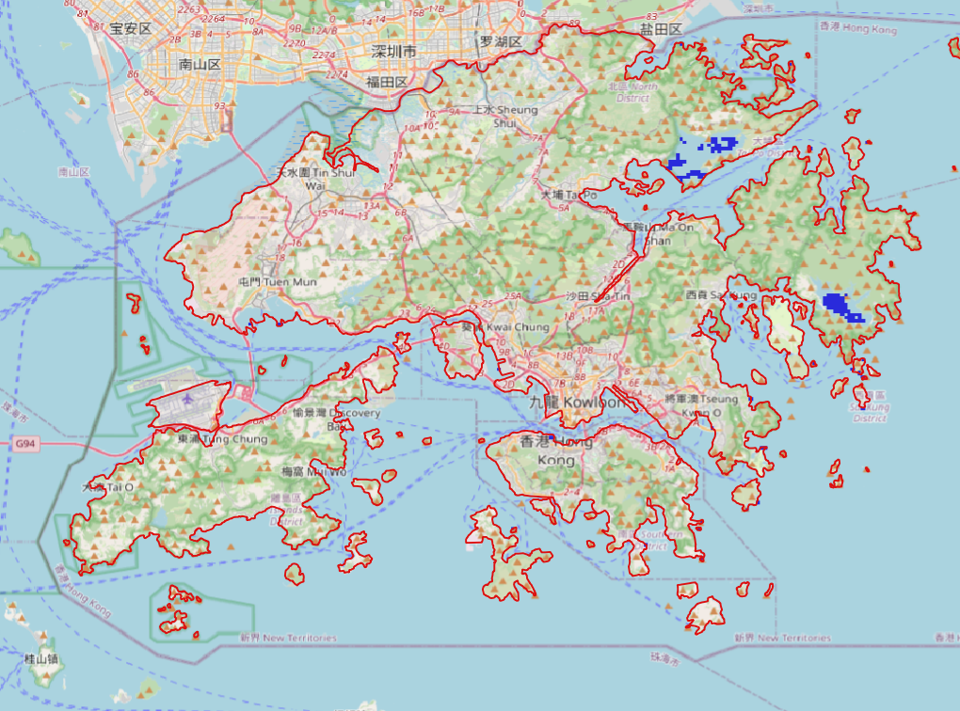
Floods 2014 Raster
Floods 2007 Raster
Floods 2006 Raster
Figure 16 Historical Flood Dataset of Hong Kong

  - Add the three rasters using raster calculator to get the flood frequency of the regions. Flood Frequency Index values show the number of times a particular area faced floods. In the output, score of ‘1’ means that the area was impacted by floods only once out of the three time periods. Score of ‘2’ means that the area was impacted by floods twice out of the three time periods. Likewise for score of ‘3’. This gives a flood frequency index:
- 0 = never flooded
- 1 = flooded once
- 2 = flooded twice
- 3 = flooded in all events
Table 6 Screens of steps followed in step 1
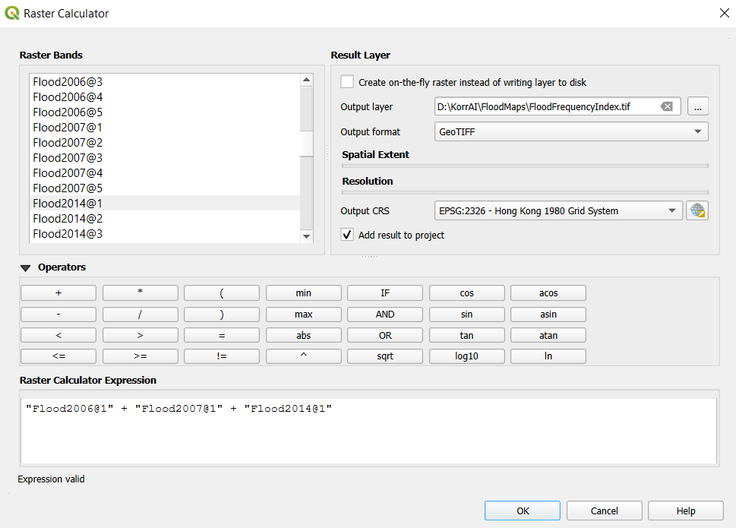 | Flood Frequency Index Raster Calculation

Maps generated in step 1
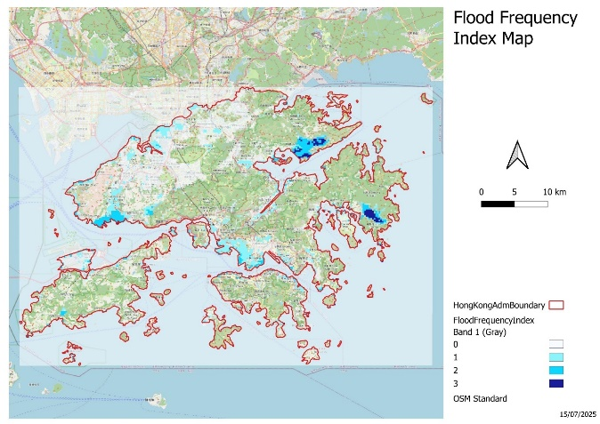
Figure 17 Flood Frequency Index Map

Persistent Flooding zones
  - Using raster calculator, extract pixels with flood frequency index values >= 2. These are the regions with persistent flooding.
  - Polygonise Persistent Flooding raster to create a vector layer.

Maps generated in step 2

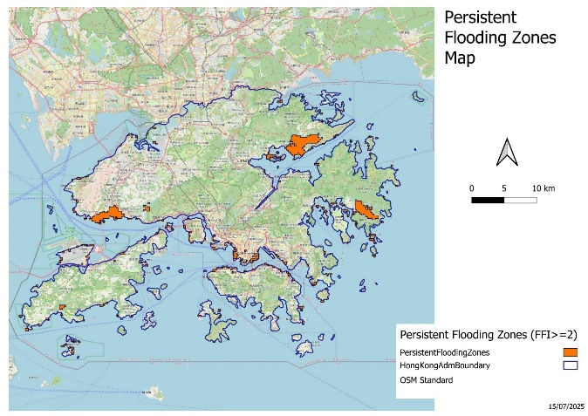
Figure 18 Persistent Flooding Zones

Extract Exposed Infrastructure layers
  - Extract exposed railway lines:
    - Open Hong Kong Railway Lines Shapefile.
    - Using geoprocessing, intersect these railway lines with persistent flooding zones to get railway lines under persistent flooding zones.
    - Create a new column in the output of intersection tool and calculate the length of railway lines impacted using field calculator.
    - Using Basic statistics for fields tool to get summary statistics of exposed railway lines. For current analysis, total railway line length = 338723.456 m. Exposed railway line length = 4502 m
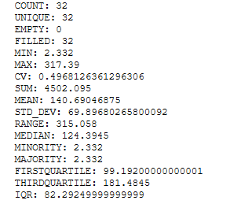
Figure 19 Summary stats of exposed railway lines
  - Extract exposed education facilities:
    - Open education facilities point shapefile.
    - Using spatial query, select the education facilities falling within the persistent flood risk zones. In this analysis, out of 192, 2 education facilities are exposed to persistent flood risks.
    - Follow the same process to get highly likely to be impacted health facilities during floods.

Maps generated in step 3.
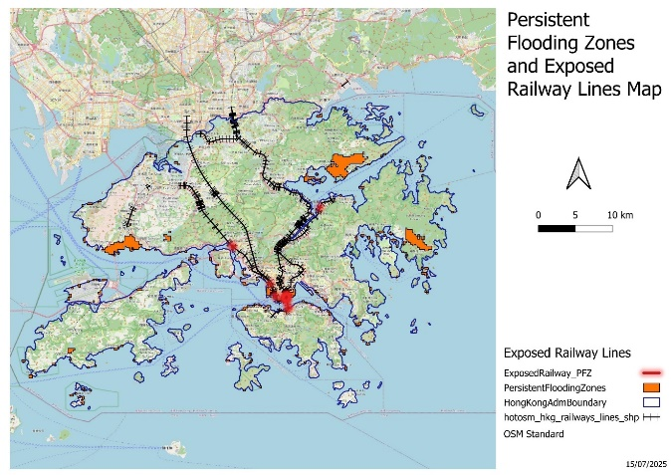
Figure 20 Exposed Railway Lines under Persistent Flooding Zones
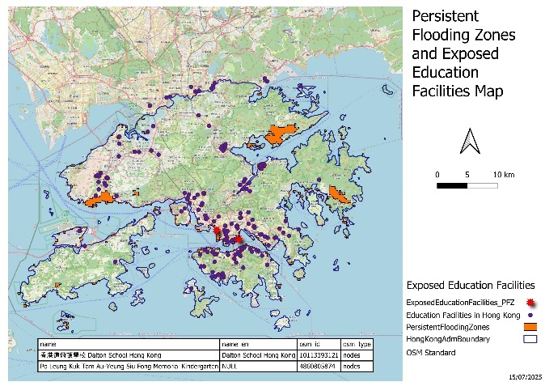
Figure 21 Exposed Education Facilities under Persistent Flooding Zones

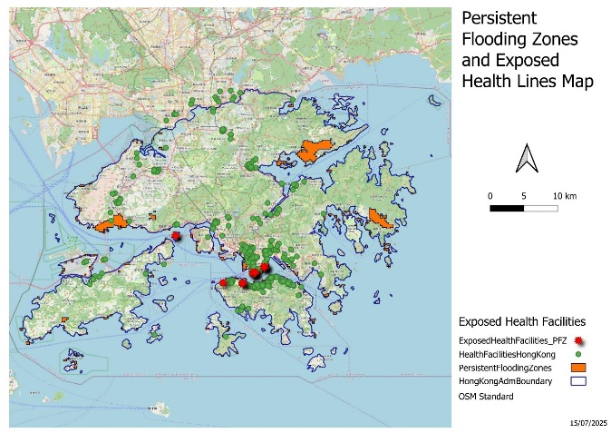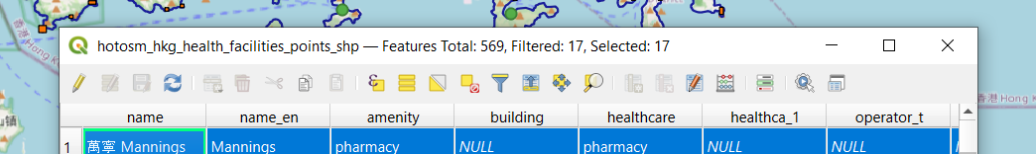
Figure 22 Exposed Health Facilities under Persistent Flooding Zones with Count in Attribute Table

Exposure Summary
Table 7 Exposure summary by type and zone
Infrastructure Type | Flood Frequency Zone | Impacted Count | Total Count | Impacted Length (km) | Total Length | % Impacted
Railway Lines | >=2 |  |  | 4.502 km | 338.723 km | 1.33%
Health Facility | >=2 | 17 | 569 |  |  | 2.99%
Education Facility | >=2 | 2 | 192 |  |  | 1.04 %

Analysis of persistent flood zones in Hong Kong (flood frequency ≥2) revealed that 1.33% of railway line length, 2.99% of health facilities, and 1.04% of educational facilities are exposed to recurrent flooding. These exposed assets may require prioritization in flood resilience planning.

4. Land Use and Land Cover (LULC) Classification from Sentinel-2
Generate a five-class LULC raster using Sentinel-2 imagery with the following classes:
- Urban
- Forest
- Water
- Agriculture
- Barren/Other

Methodology

Acquiring Sentinel 2 Data
  - Download data from data portal (Copernicus or GEE).
  - Layer Stack bands using Merge tool in QGIS (not required if data has been acquired from GEE).
  - Create Mosaic using Merge Tool in QGIS (if area is covered within multiple tiles).
  - Clip raster using mask layer to get data of the desired region.
  - Reproject raster to the Hong Kong Local Projection 1980 to maintain consistency within datasets.
  - Change band combination to False Colour Composite using Symbology.

Map generated in step 1
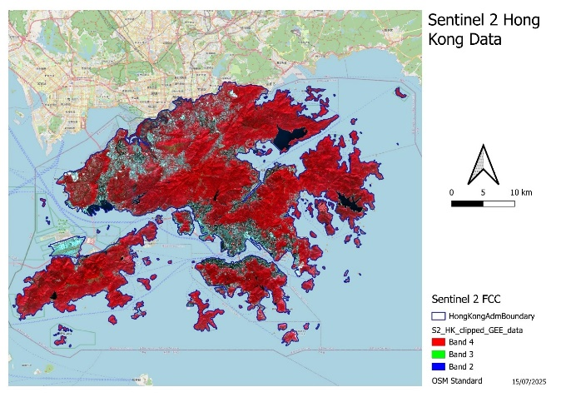
Figure 23 Acquired Sentinel 2 Data of Hong Kong in False Colour Composite

Supervised Classification
  - Install Semi-Automatic Classification Plugin in QGIS.
  - Generate training samples using SCP plugin for each class to be extracted. For this analysis, classes considered are – urban, forest, waterbody, barren and roads.
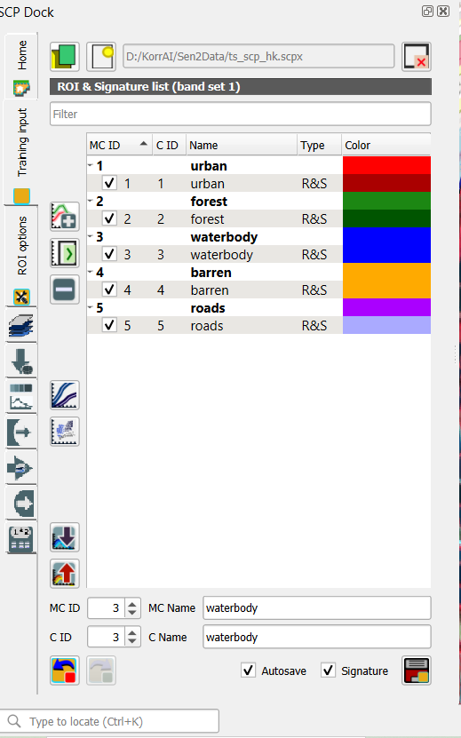
  - Perform Supervised Classification.
  - Generate confusion matrix to check accuracy.

Map generated in step 2
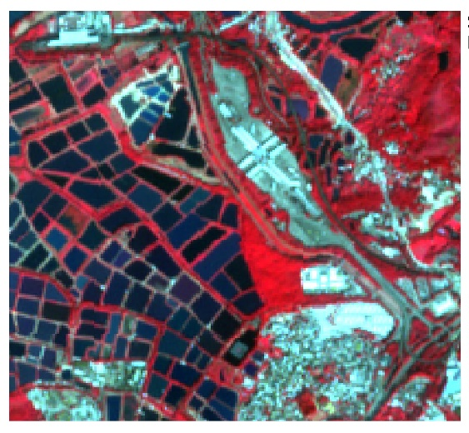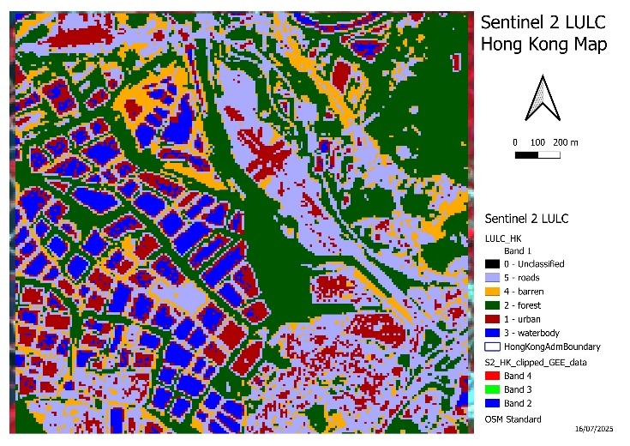
Figure 24 LULC Map of Hong Kong (Zoomed In)
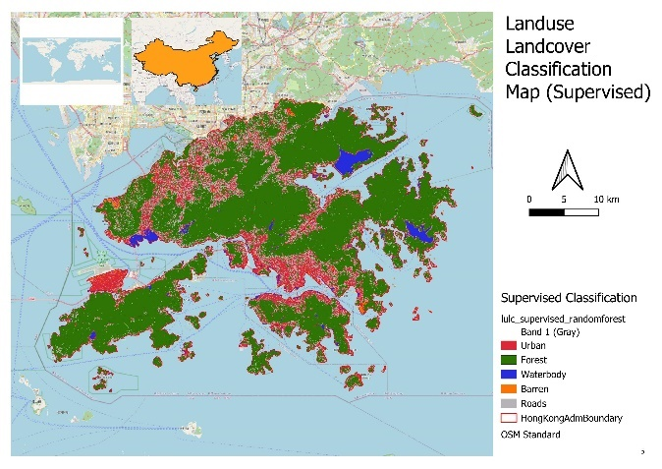
Figure 25 Supervised Classification Map

Classification Report:
precision recall f1-score support

1 0.83 0.89 0.86 1369
2 1.00 1.00 1.00 3665
3 1.00 1.00 1.00 6226
4 0.99 0.97 0.98 281
5 0.67 0.55 0.60 563

accuracy 0.97 12104
macro avg 0.90 0.88 0.89 12104
Weighted avg 0.96 0.97 0.96 12104
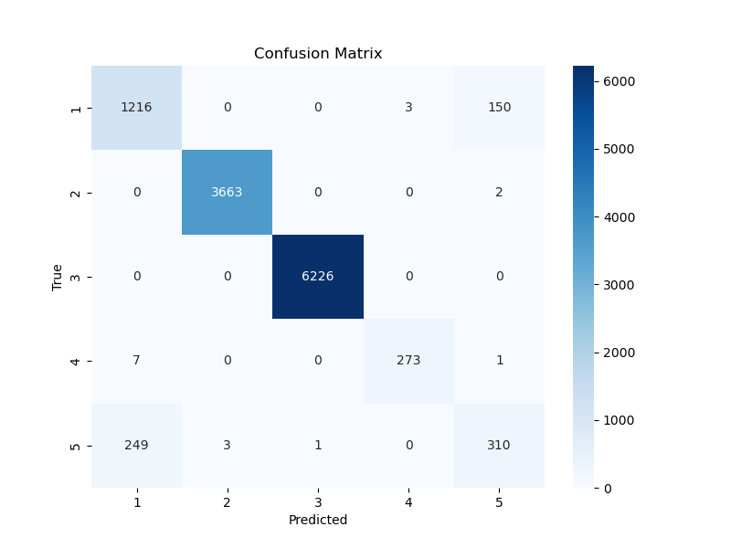

Unsupervised Classification
  - Perform unsupervised classification using KMeans algorithm in SCP Plugin. Number of classes = 5.
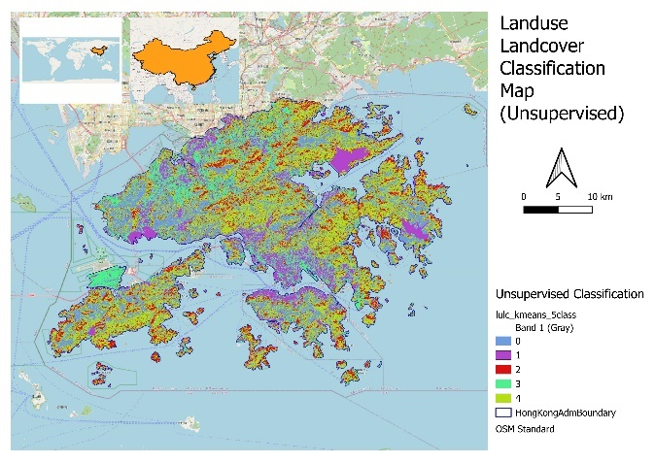
Figure 26 Unsupervised Classification Map of Hong Kong

Python Automation Pipeline
Develop a Python-based workflow that automates the following:
- Data reprojection and clipping
- Hydrological modeling
- LULC classification
- Flood analysis and zonal statistics
Your pipeline should accept input parameters and output organized folders. Use libraries such as geopandas, rasterio, fiona, richdem, and numpy.
Bonus: Add a command-line interface (CLI) or a basic Streamlit-based front end for running the pipeline.

Script attached in folder.

Cartographic Output
Produce five professionally designed maps using QGIS:
- LULC Classification Map
- Flood Frequency Index Map
- Topographic Risk Zones Map
- Infrastructure Exposure Map
- Terrain Map (Hillshade + Contours)
Each map must include:
- Scalebar, legend, and north arrow
- Inset map for geographic context
- Proper symbology and labels
- Source attribution

Required Maps Attached Below

LULC Classification Map
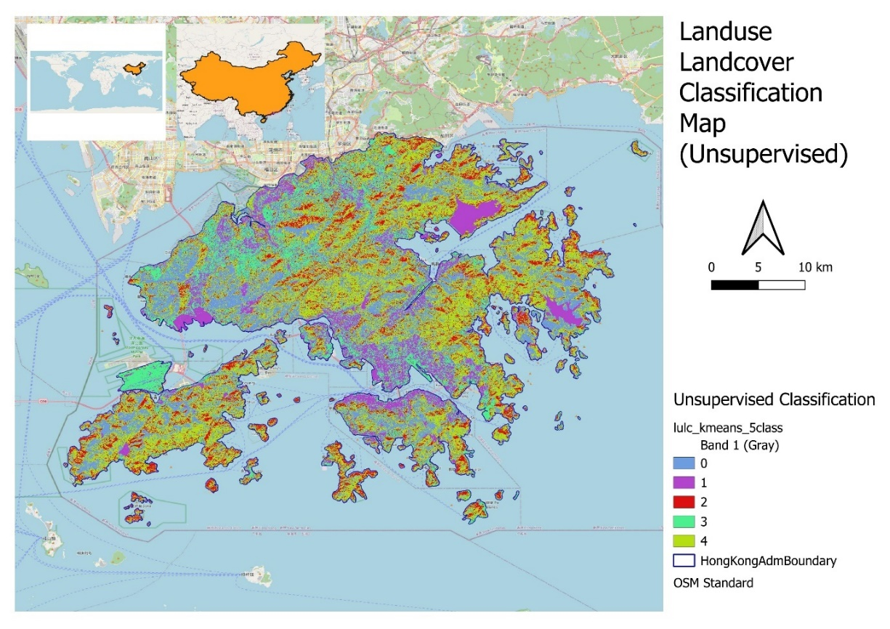
Figure 27 LULC Classification Map (Unsupervised) - Source: Author
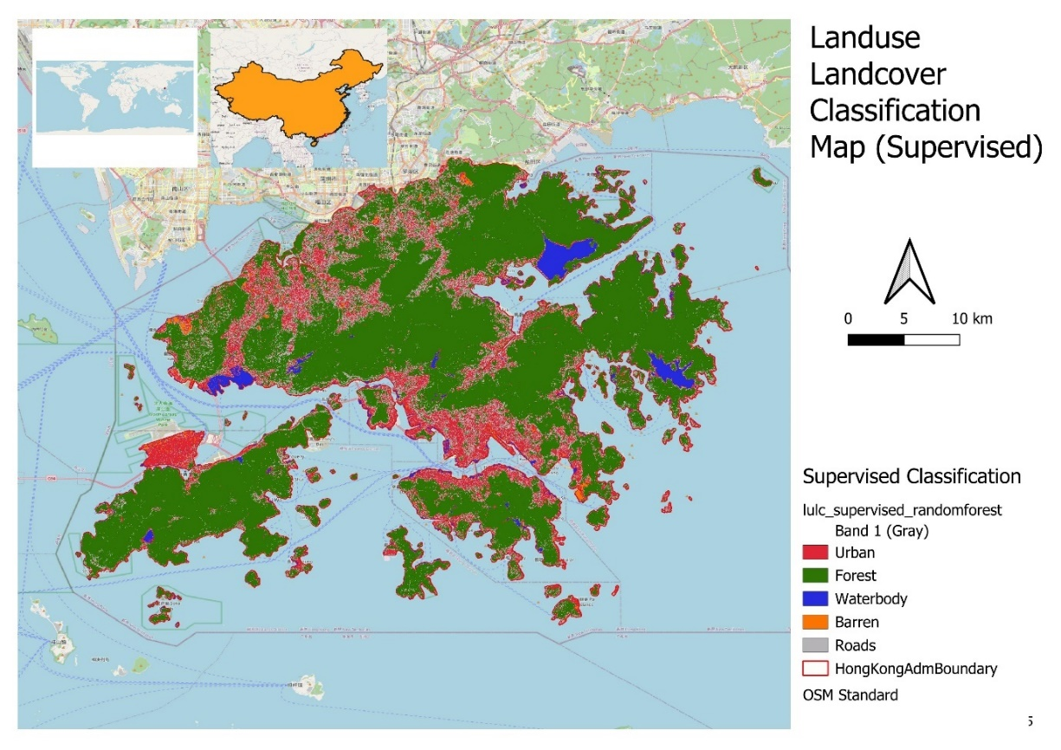
Figure 28 Supervised Classification

Flood Frequency Index Map
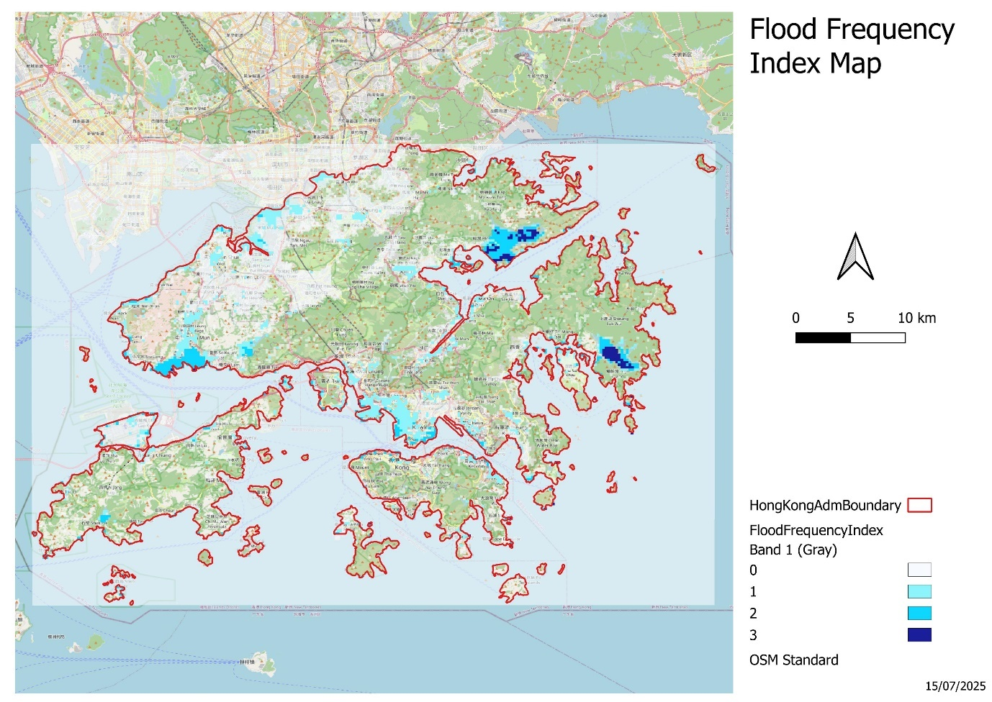
Figure 29 Flood Frequency Index Map

Topographic Risk Zones Map
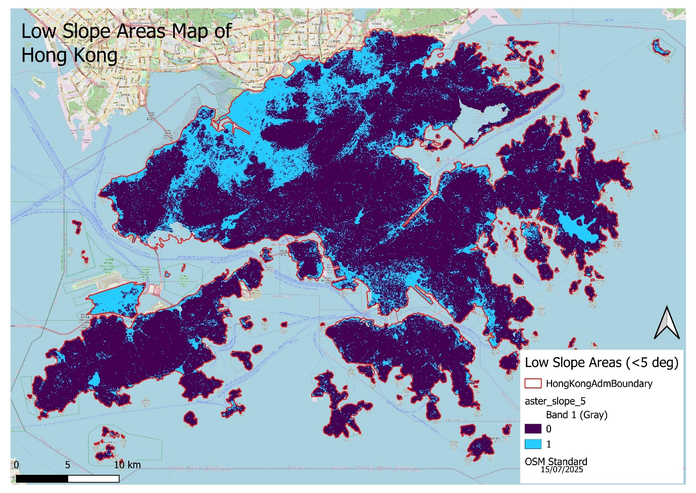
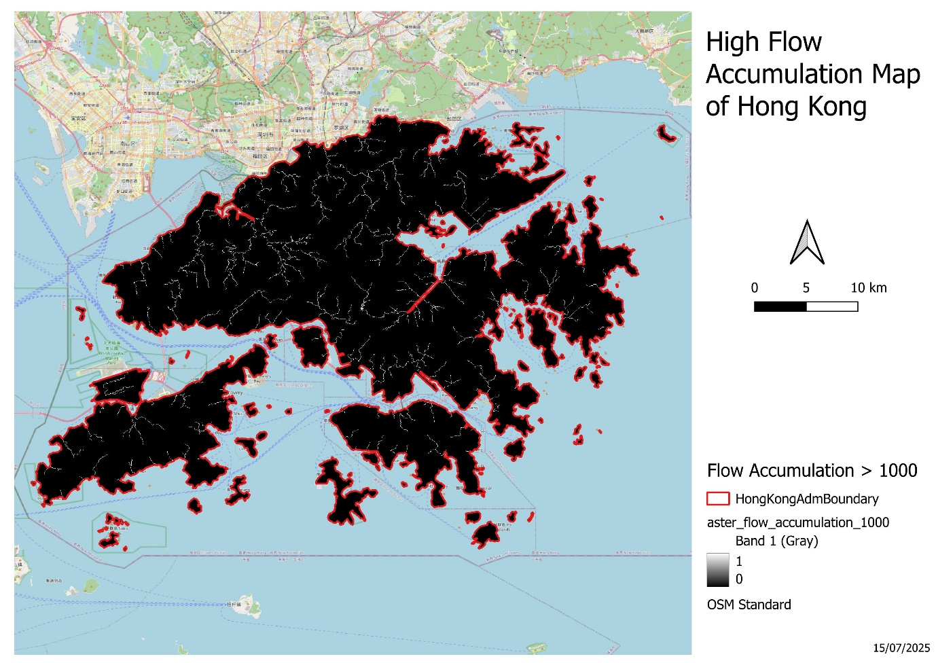
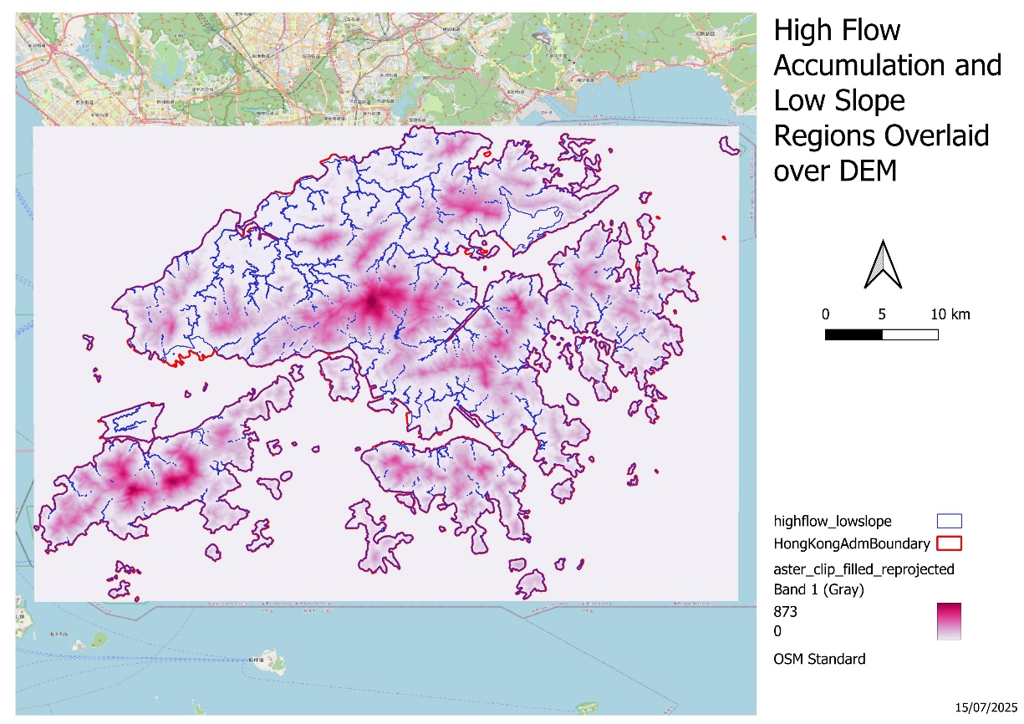
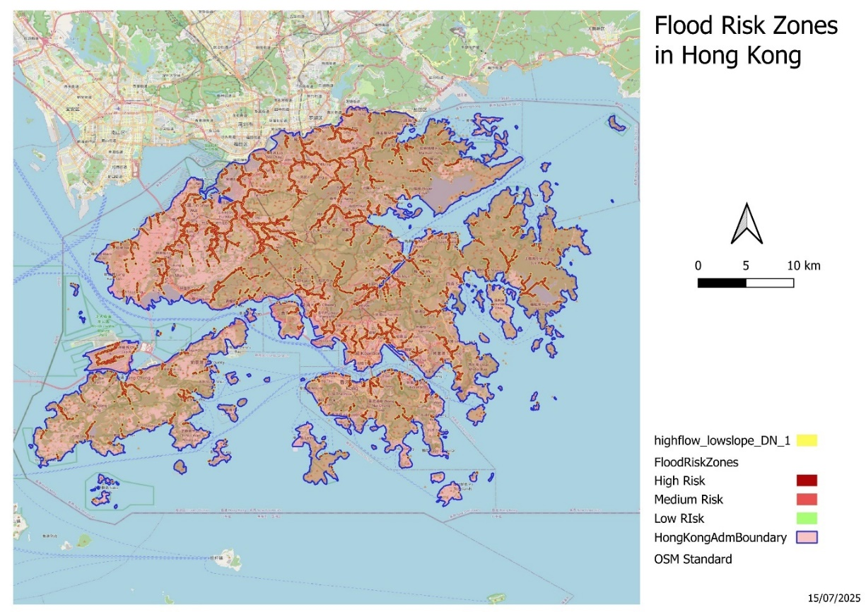
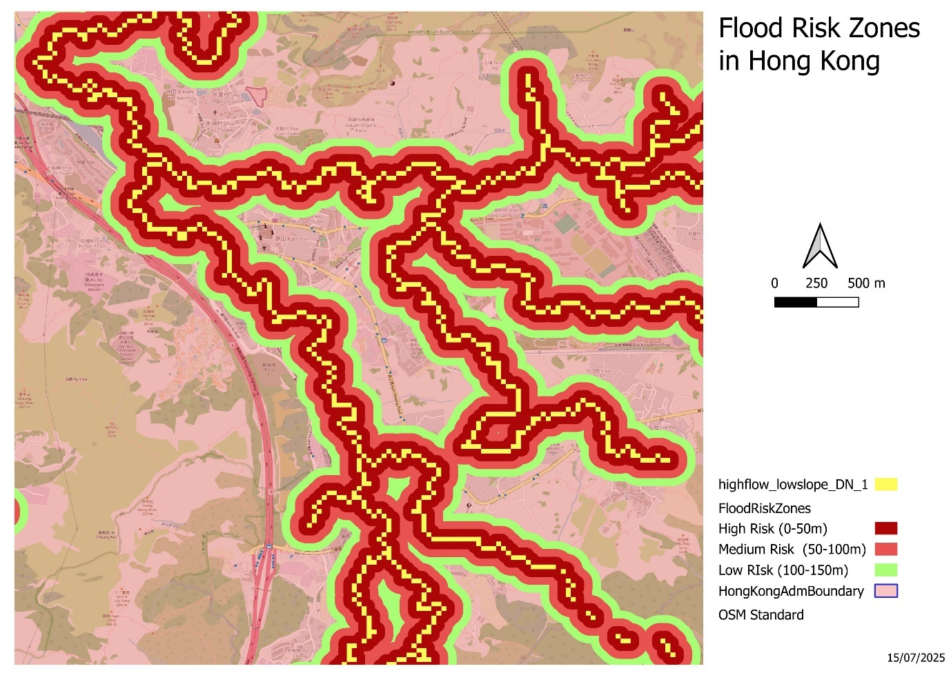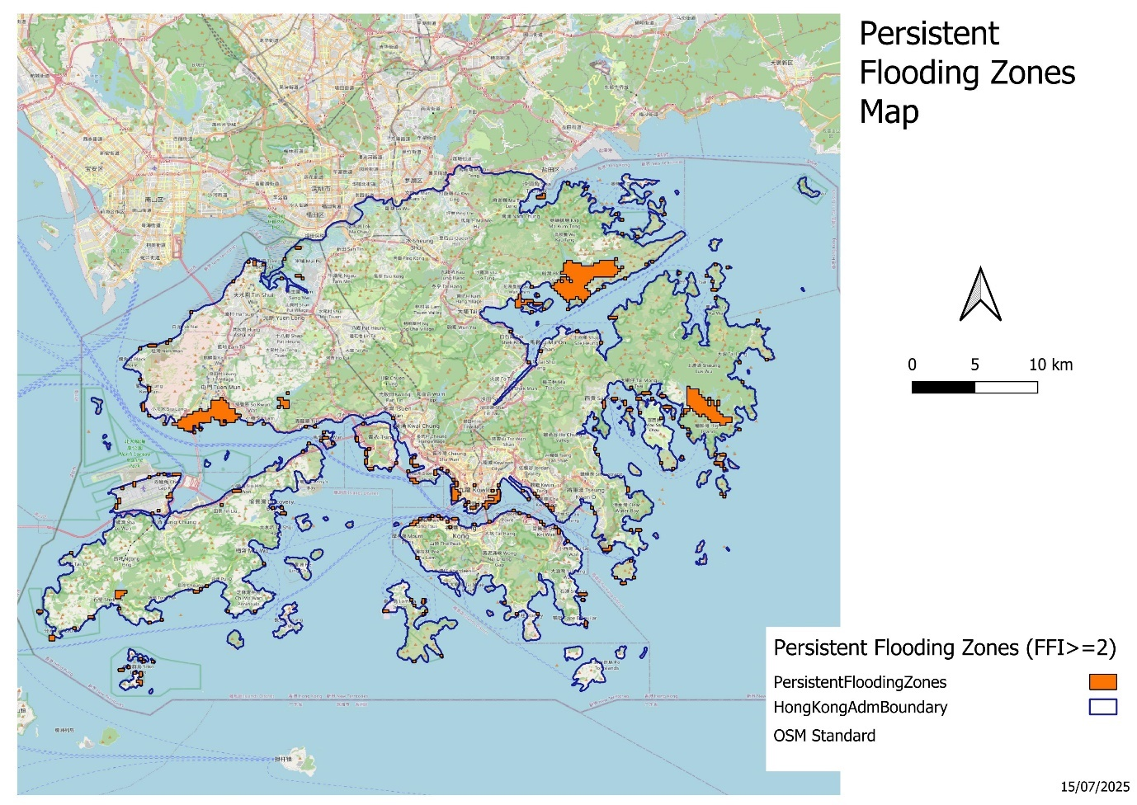

Infrastructure Exposure Map
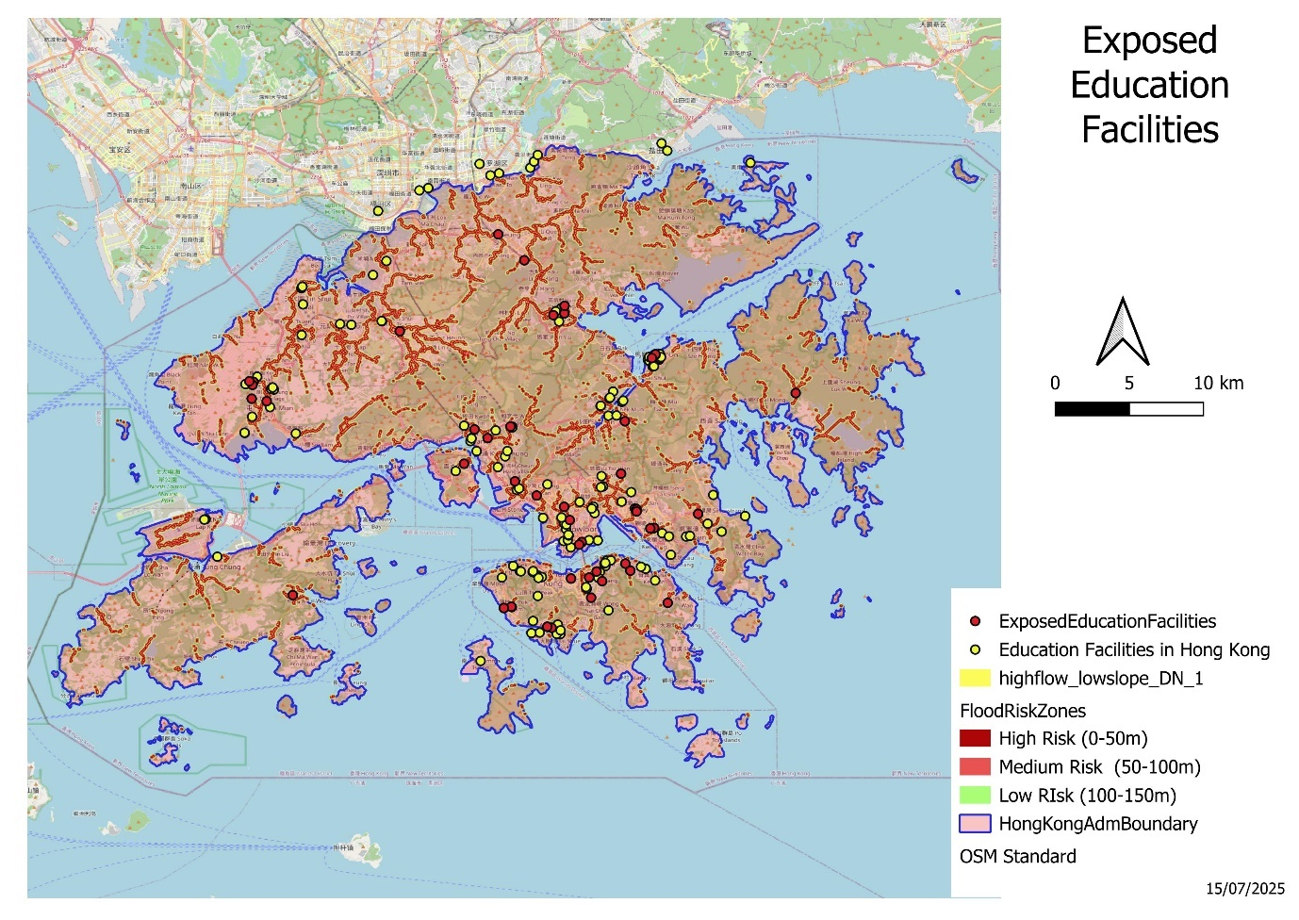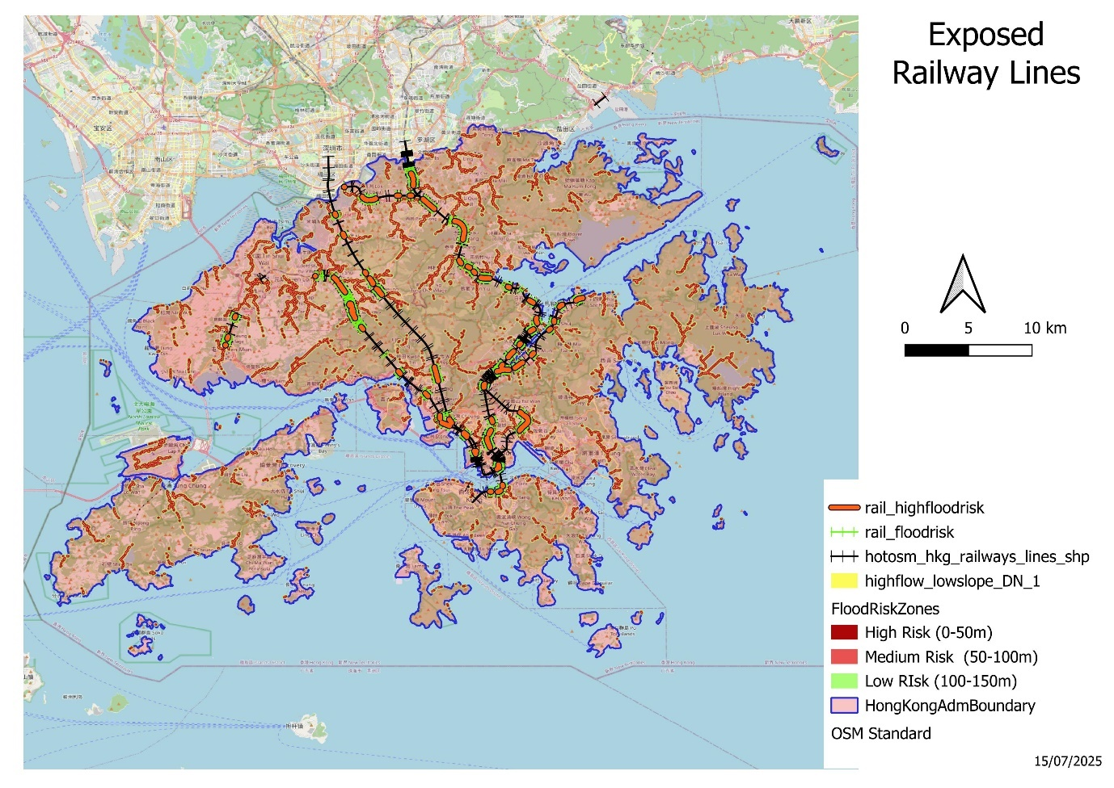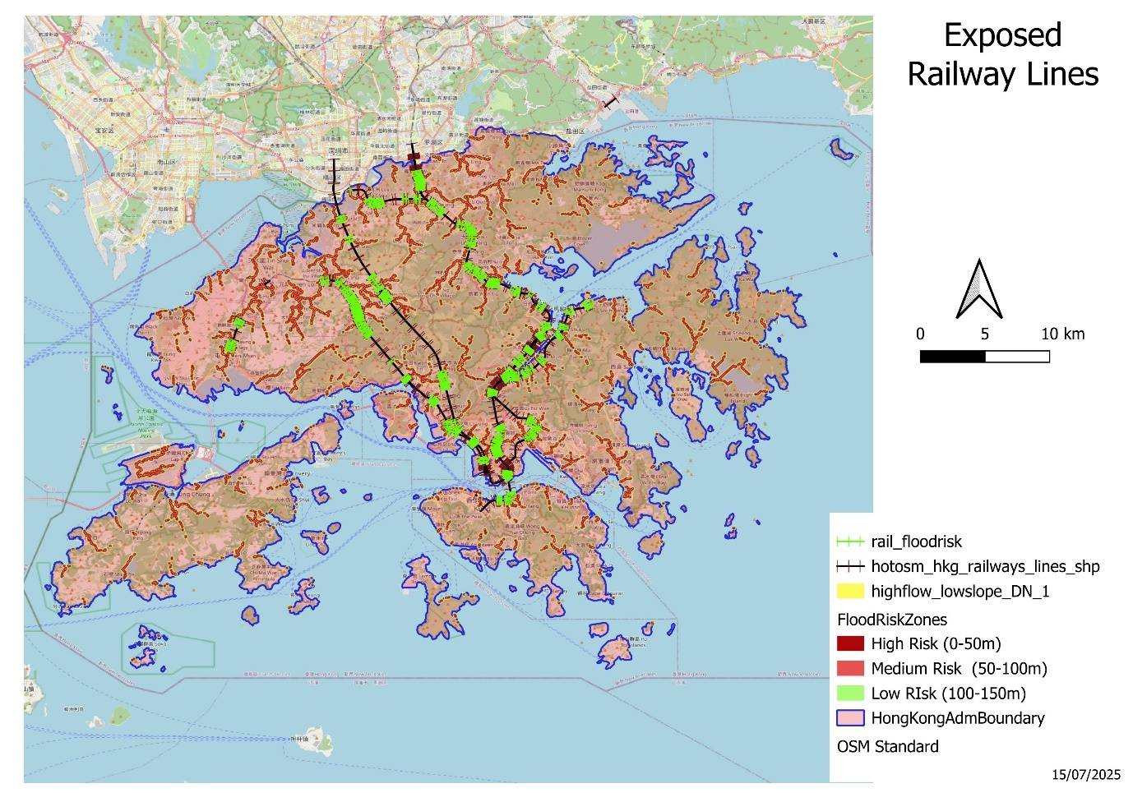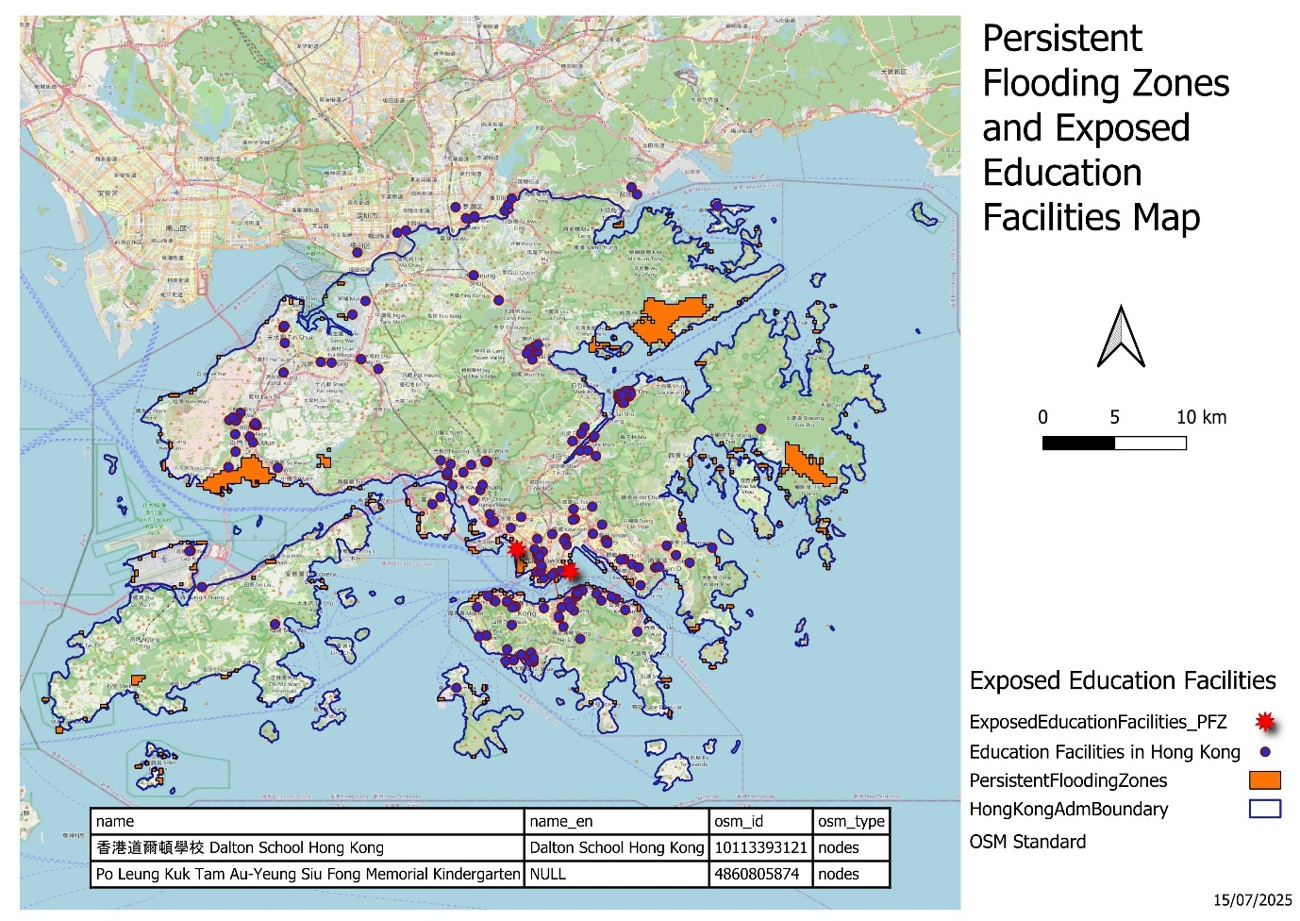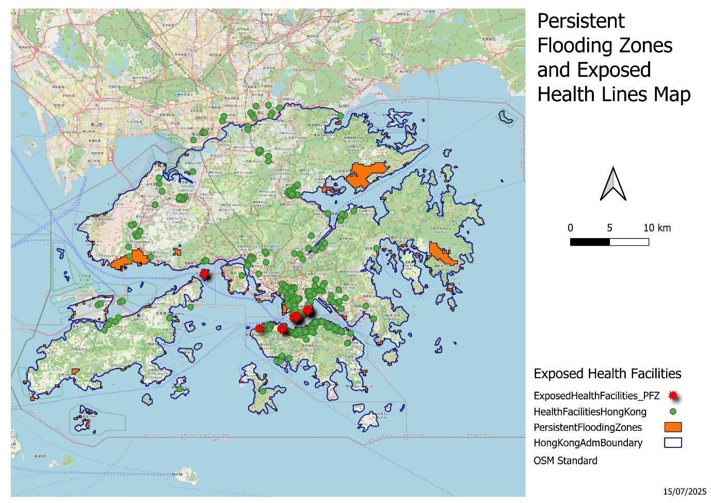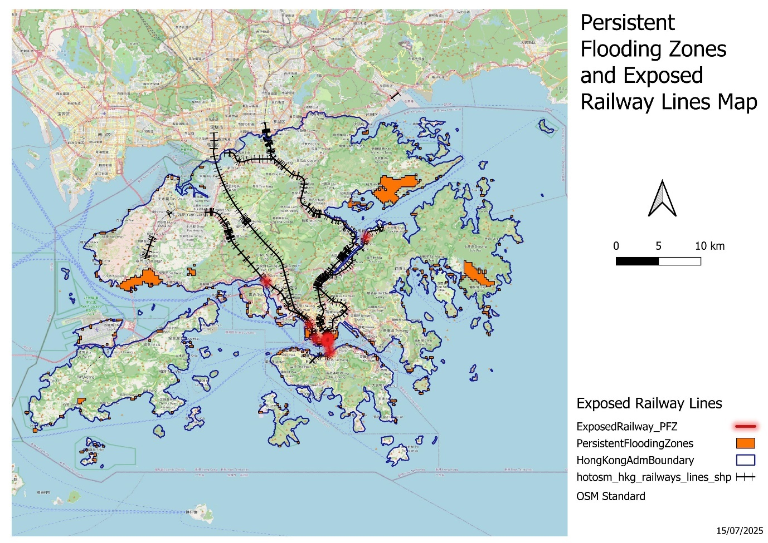

Terrain Map (Hillshade + Contours)
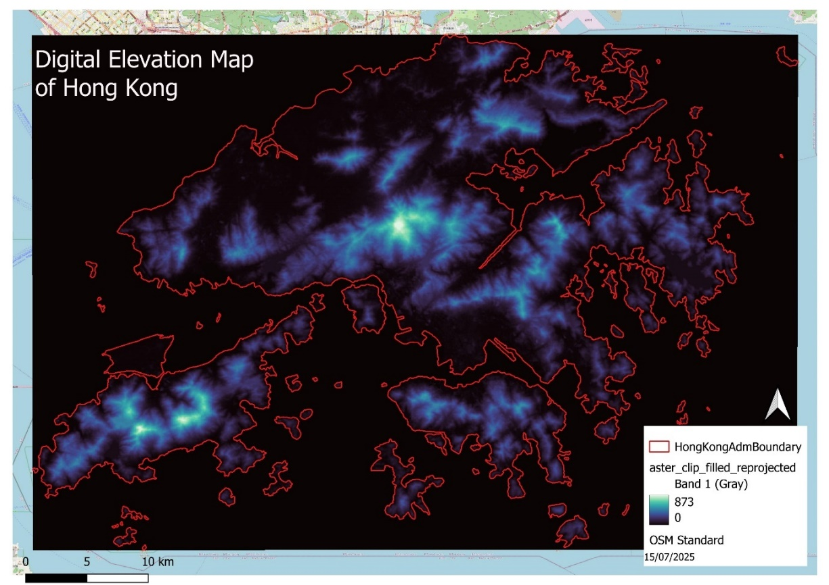
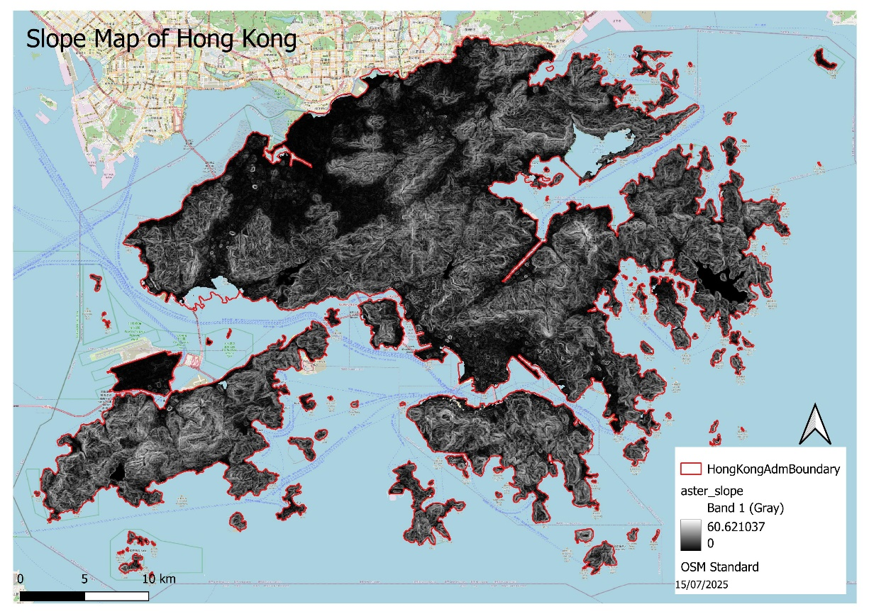
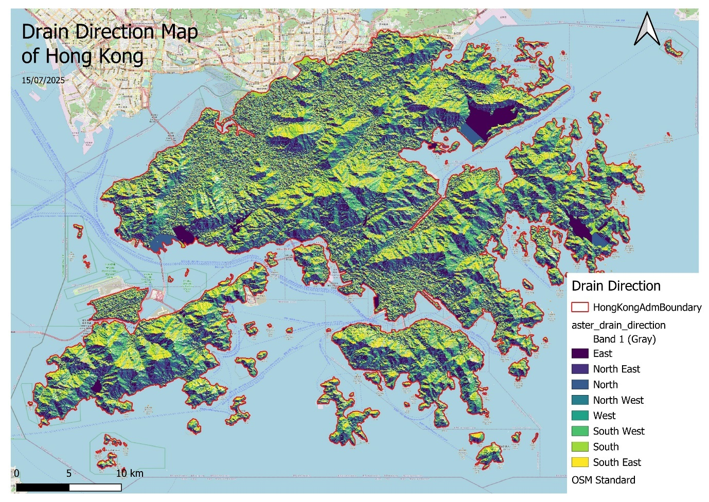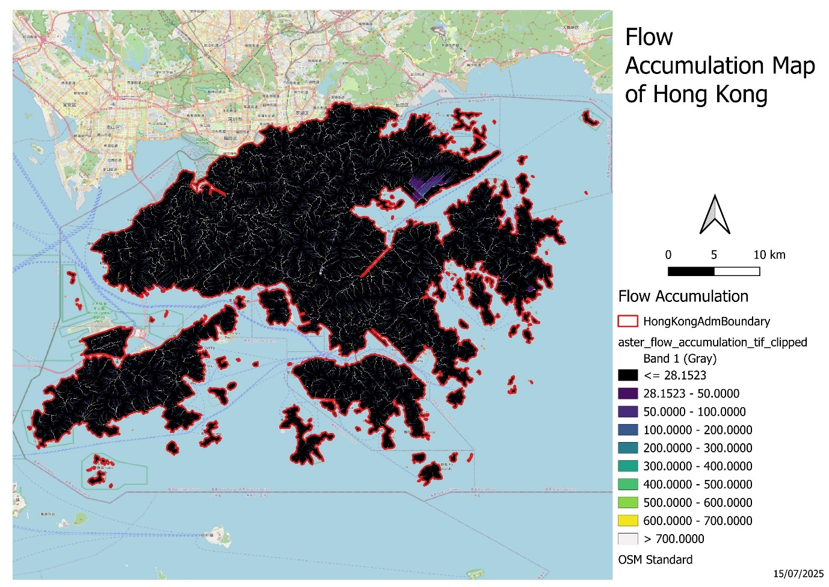
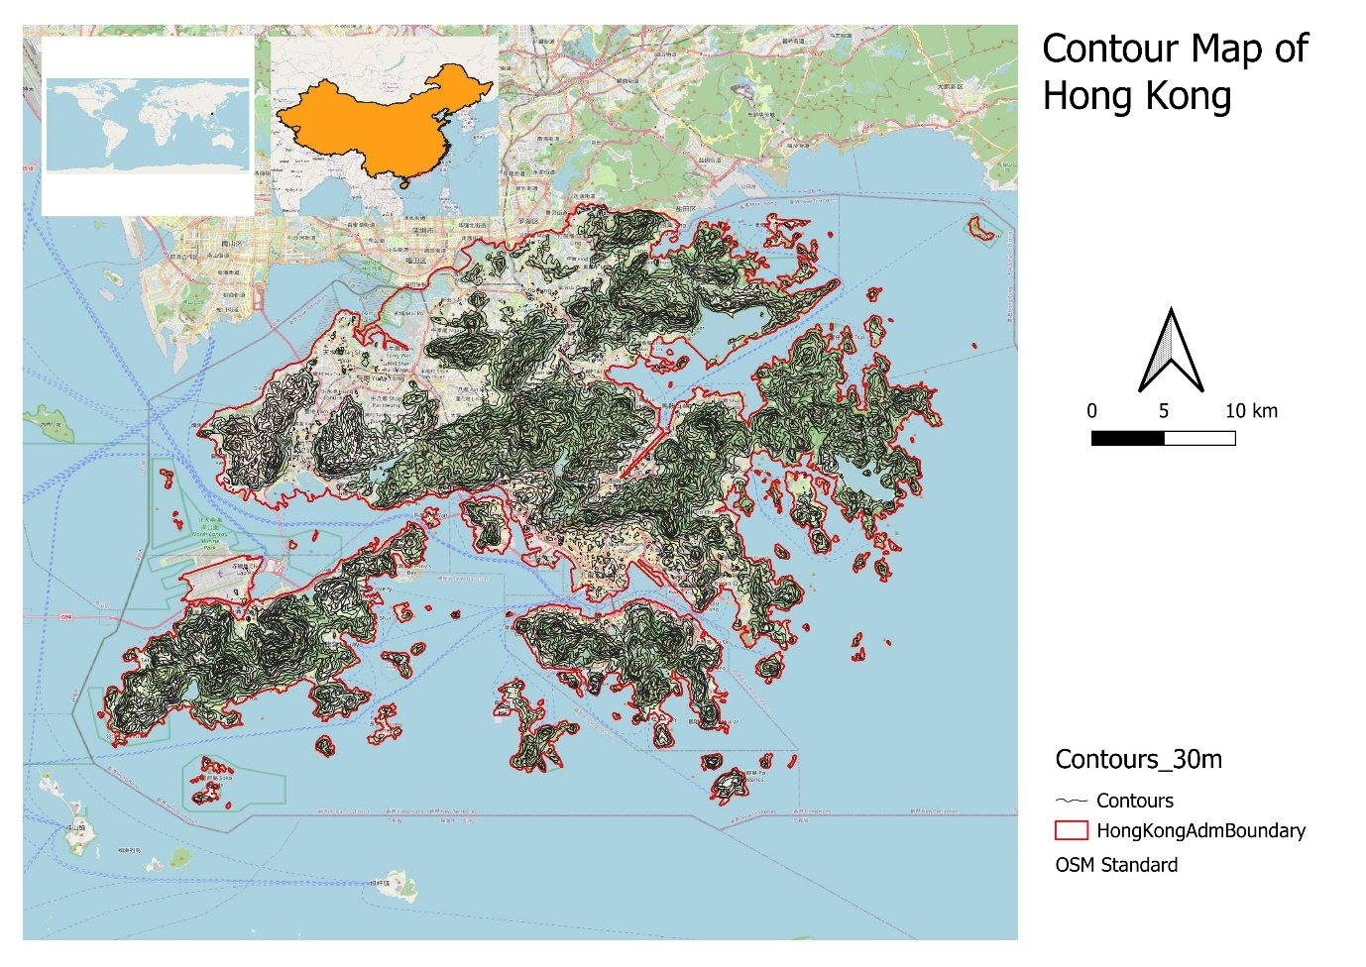
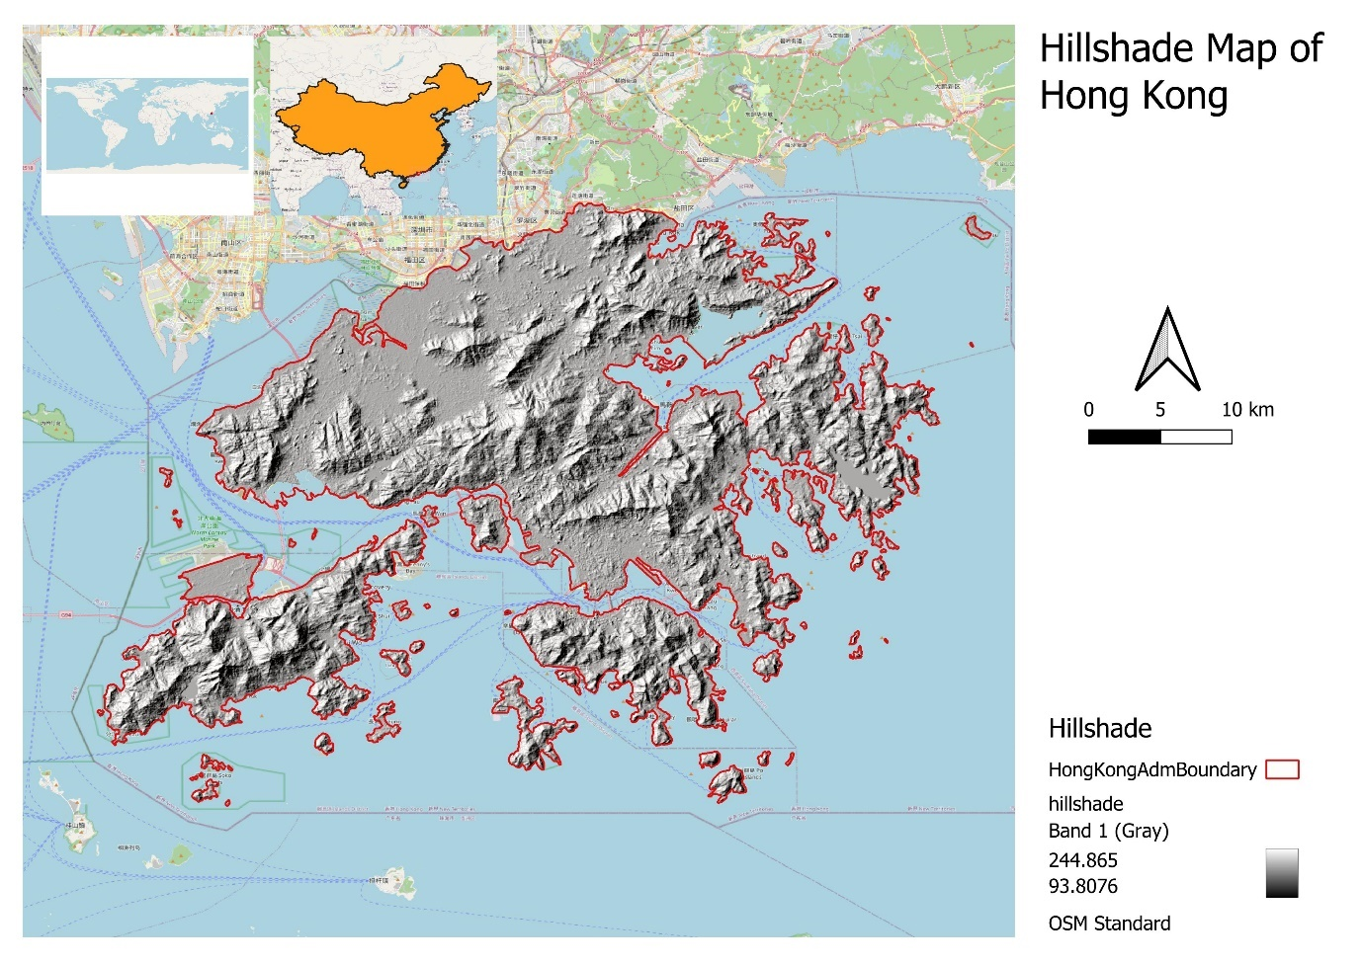

Key Findings
- Flood-Prone Areas Identified
  - Using slope (<5°) and flow accumulation (>1000 cells), flood risk zones in Hong Kong were delineated.
  - These zones were polygonized and visualized for further analysis.
- Infrastructure Vulnerability Quantified
  - Railway line exposure to flood zones was assessed.
  - Impacted Length: ~12.13 km
Total Length: ~338.72 km
% Impacted: 3.58% of railway network lies in potential flood zones.
  - Education and Health facilities were also assessed.
- High-Accuracy Supervised Classification
  - Supervised LULC classification using Sentinel-2 stack and manually labeled training data achieved.
- Zonal Statistics Generated
  - Land cover distribution was calculated within flood-prone polygons (though class-wise stats were mostly null due to coarse vector geometry or label mismatch—this can be refined).
- Fully Automated Workflow
  - Pipeline includes - DEM clipping → hydrological modeling → flood zone extraction → infrastructure intersection → Sentinel-2 mosaicking → unsupervised and supervised classification → zonal statistics.

Limitations
- DEM Resolution Dependency
  - Hydrological modeling and flood extent accuracy depend on DEM quality and resolution.
  - Coarse DEM may smooth out critical terrain features affecting local drainage.
- Threshold-Based Flood Modeling
  - Simple slope and accumulation thresholds were used to simulate flood zones.
  - Does not include rainfall, infiltration, soil type, or river capacity—making it a basic proxy for risk zones.
- Training Sample Quality
  - Supervised classification depends on spatial accuracy and representativeness of training samples.
  - Less number of ROIs can reduce performance.
- Memory Constraints
  - Large tile sets caused memory errors.
  - Scalability is limited by local system resources.
- Limited to Sentinel-2
  - Optical-only classification; currently no SAR or thermal bands were integrated. Hence, flood detection or permanent waterbody classification may be limited in cloudy conditions.

Assumptions
- Uniform Rainfall and Flow Direction Assumed
  - The use of D8 accumulation assumes water flows in only 1 of 8 directions—oversimplifying complex flow behaviors.
- Static Infrastructure and Land Use
  - LULC and railway data are treated as static snapshots, not accounting for seasonal or temporal variability.
- Flood Thresholds are Generic
  - The values (e.g., 1000 cells for flow accumulation) are not calibrated with historical flood data.
  - Buffer distances for flood risk zones are generic.

