# BCP: Voicemail Touch Tone Menu Tree

## Summary:

Provides detailed information on the Business Class Phone Feature Voice Mail User Interface.

## General Guidelines:

* None

## Restrictions:

None

**Voicemail Touch Tone Menu Tree**

A guided menu which assists users in managing messages and voice mailbox options is included automatically with the feature. A map of the keys associated with the voice mail interface may be found in the following diagram. The keys marked in red are new options for the new features (Auto Attendant, Group Voicemail, and Shared Voicemail).

[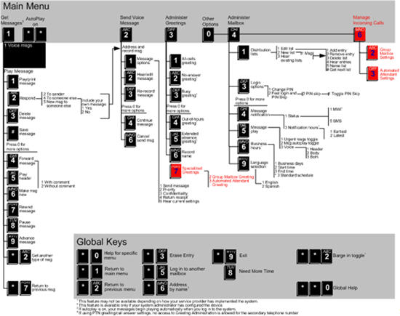](http://www.twcvault.com/V2/Vault2/ArticleImages/Uploads/BC_Products/Business%20Class%20Phone/VoiceMail_User_Interface.pdf)

**Review / Change / Approval Log**

|  |  |  |  |
| --- | --- | --- | --- |
| Version | Author  (List Role / Names) | Date | Review Outcome |
| 1.0 | KM Team – Jim Pasinski | 10/22/2014 | Finalized Document |