Neha Gupta | E20BCA018

LAMP | Assignment-2

**MINI PERSONAL PORTFOLIO PROJECT ASSIGNMENT**

**Information:**

There is previous assignment-01 updated version of my mini project personal portfolio

With the help of using languages like HTML, CSS, PHP, and MySQL. Where HTML and CSS

Use for UI and styling. PHP and MySQL use for database.

1. Create a **signup page**

Function: User can signup to our website just follow to steps

1. Enter user name
2. Enter password (create your password)

The data store in MySQL database – Database name: signupform

– Table name: registration

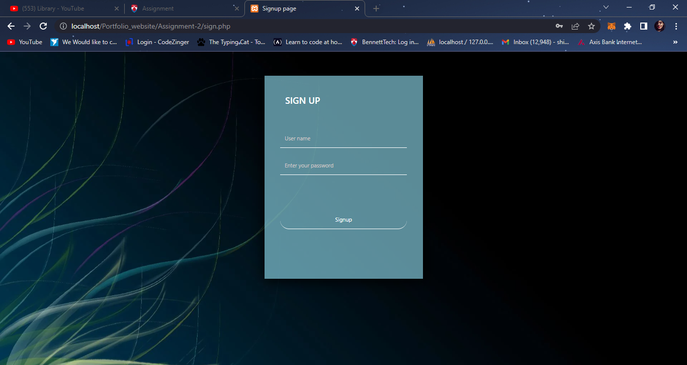

Database snapshot – once the user register, the data stored in the database.

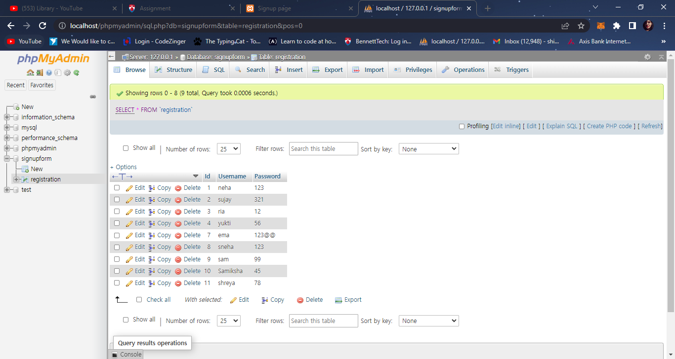

When user signup with the existing account, then it shows the error – User already exist.

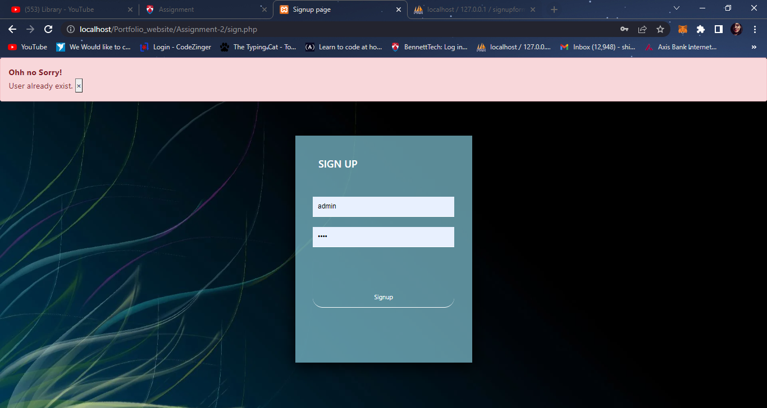

1. When user successfully signup, they redirect to **login page.**

For login follow the two simple steps:

1. Enter your set user id- username
2. Enter your set password

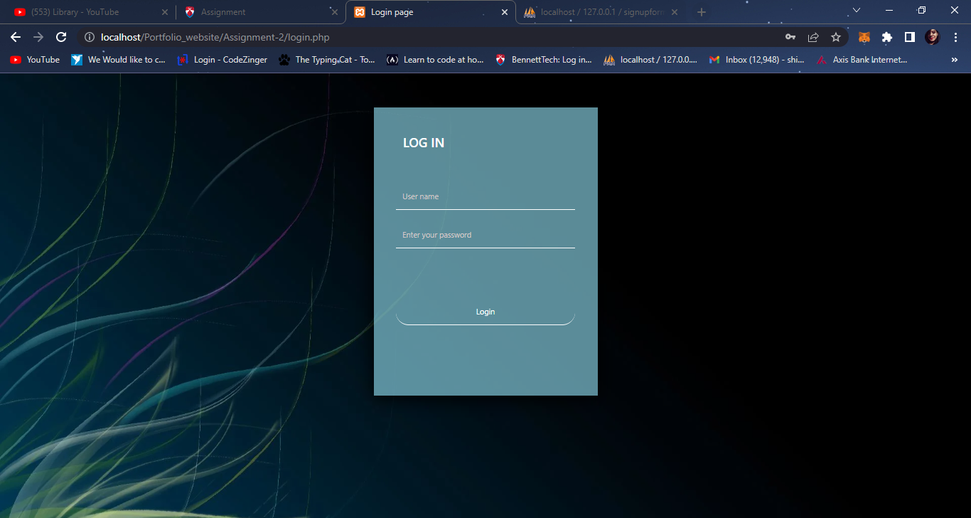

1. Include files: I have included header and footer files in each page
2. After login user can redirect to **home page**.

Functions: As you can see there are two buttons, when user click on download cv -> the user can download my CV and when user click on logout, the session has been logout and user can have to again login.

Snapshot of **homepage**

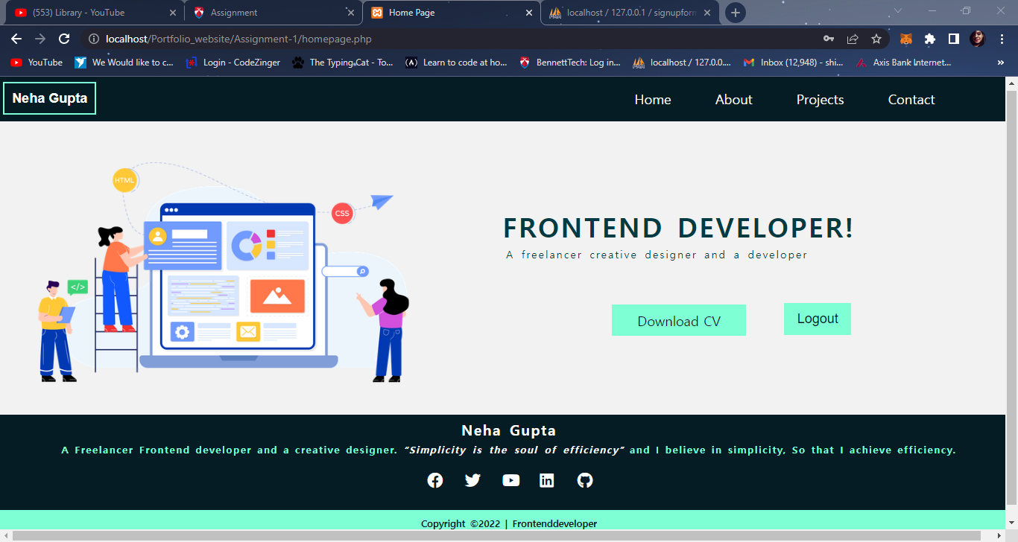

**About page:**

When user can click on more about us -> redirect to the skill page

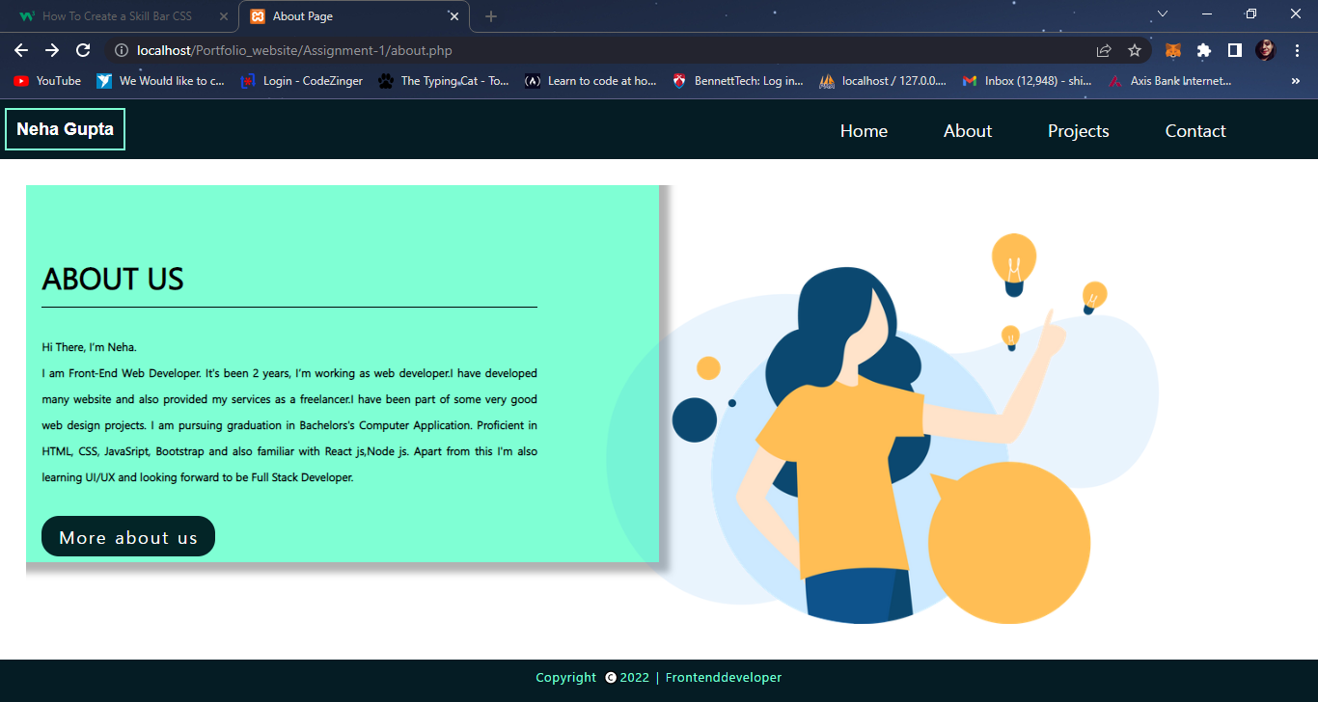

**Skill page:**

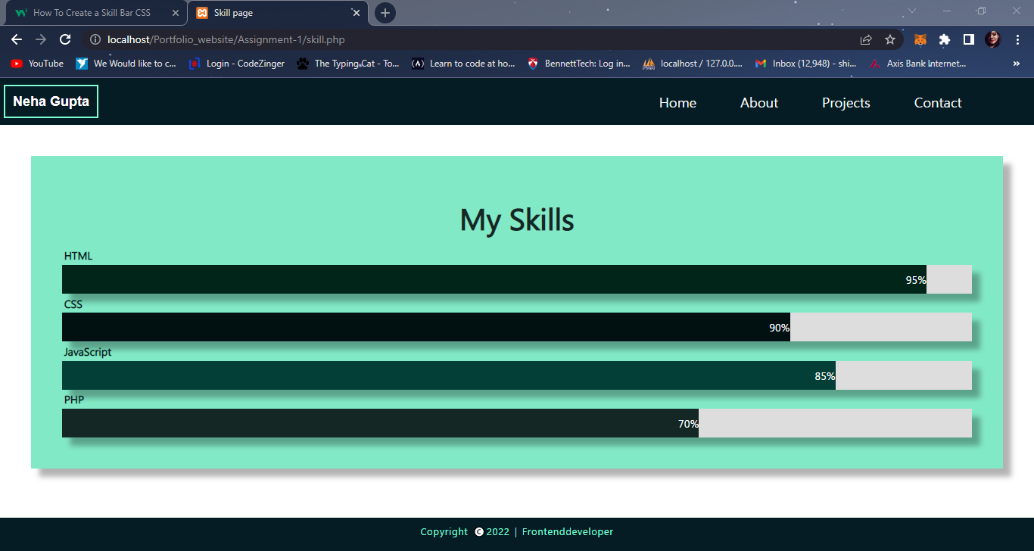

1. **Project page**

When user click on project then its redirect to the project page.

Function:

1. When user hover on card then information of project can display
2. When user click on Read more, they redirect to GitHub repository link.

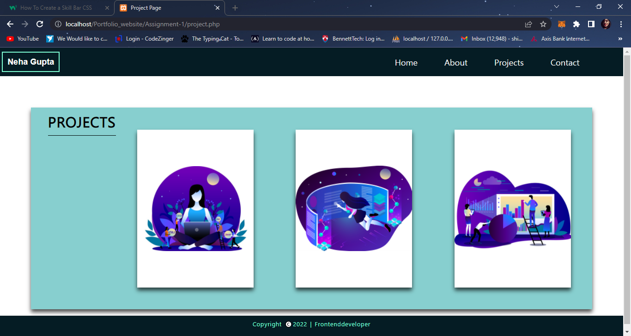

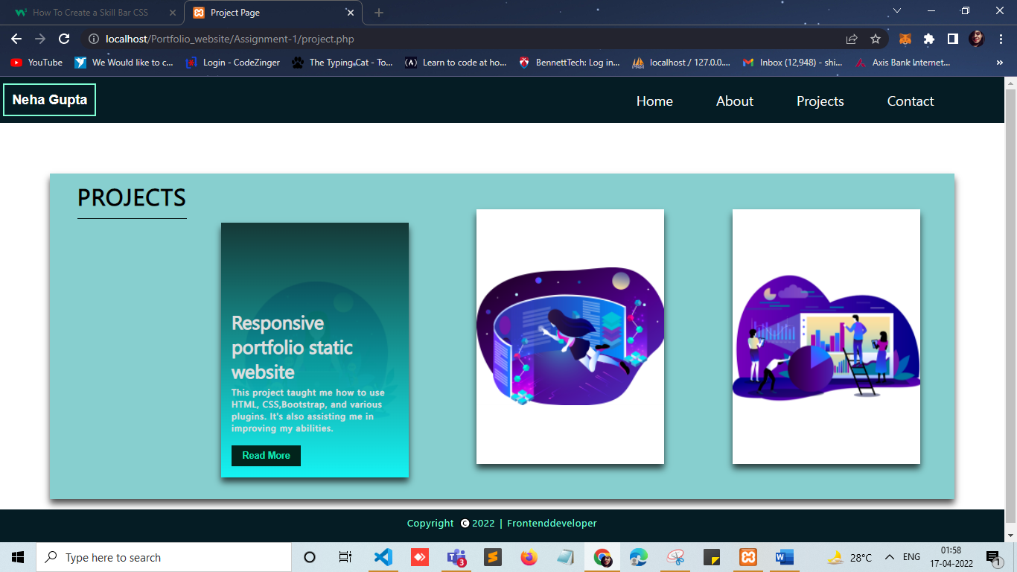

1. **Contact page**

Functions:

When user submit their response/Feedback, then msg send to the mail.

Using php mail function.

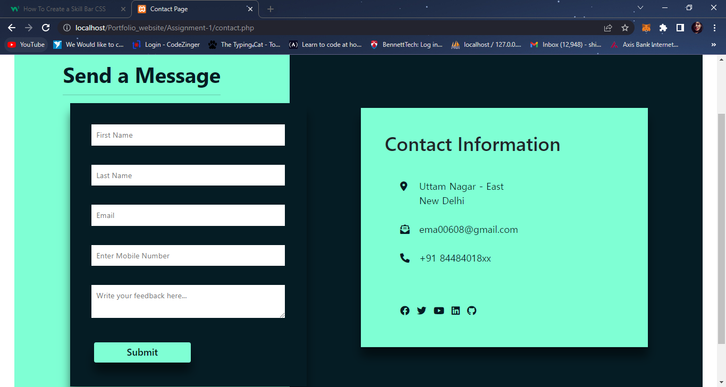

GitHub link – to view codes

<https://github.com/neha06-git/PORTFOLIO_website.git>