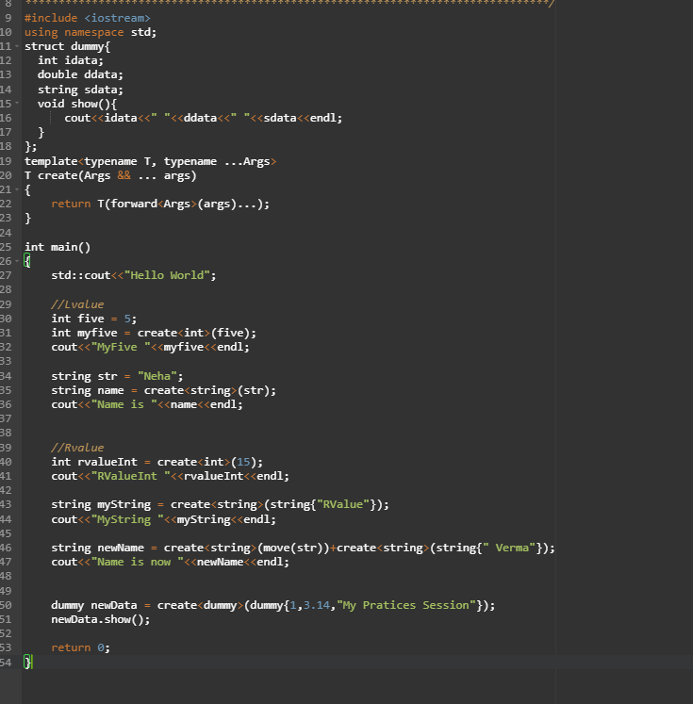
1. When is T&& a forwarding reference?
- Only when T is a deduced template parameter.
- template <typename T> void foo(T&& x);
✔️ This accepts both lvalues and rvalues.

2. Why can't we just use x inside foo()?
Inside the function, x is always an lvalue, even if it came from an rvalue.
That’s the root problem.

3. Why do we need std::forward<T>(x)?
- It returns:
  - an lvalue if original was lvalue
  - an rvalue if original was rvalue
It preserves original value category → this is “perfect forwarding”.

4. What happens if we incorrectly use std::move(x)?
- Everything becomes rvalue
- Lvalues will be moved-from
- Wrong overloads may be chosen
- Code breaks subtly → undefined behavior possible

5. Typical perfect-forwarding pattern
template <typename F, typename... Args>
decltype(auto) call(F&& f, Args&&... args) {
return std::forward<F>(f)(
std::forward<Args>(args)...);
}
Used internally by:
- std::thread
- std::make_shared
- emplace_back
- std::bind

6. When to use perfect forwarding
- write factories (create<T>)
- implement wrappers (logger, tracer, benchmarking wrapper)
- pass callables (std::function alternative)
- forward constructor arguments (emplace_back pattern)

⭐ BONUS: One-line remembering rule
Use T&& + std::forward<T> whenever your function only forwards arguments and must not change their L/R value nature.

