Game Design Document

Fill up the following document

1. Write the title of your project.

DORA – The Corona Version

1. What is the goal of the game?

Help Dora not get affected by the virus

1. Write a brief story of your game.

Dora wants to reach her home but because of the covid pandemic

she is unable to go home.Virus is attacking her always. Help her to

escape from virus.

1. Which are the playing characters of this game?

* Playing characters are the ones who respond to the user based on the input from the user.
* Cars, monkeys, dinos, wizards, etc., are the playing characters in the game.

|  |  |  |
| --- | --- | --- |
| Number | Character Name | What can this character do? |
| 1 | Dora | Jump and run |
| 2 |  |  |
| 3 |  |  |
| 4 |  |  |
| 5 |  |  |
| 6 |  |  |
| 7 |  |  |
| 8 |  |  |

1. Which are the Non-Playing Characters of this game?

* Non-Playing characters are the ones that don't have an action or behavior when the user interacts with the game.
* Hurdles, stones, bananas, coins, etc., are non-playing characters in the game.

|  |  |  |
| --- | --- | --- |
| Number | Character Name | What can this character do? |
| 1 | Viruses | Obstacles come in opposite direction of main character and collide with them. |
| 2 |  |  |
| 3 |  |  |
| 4 |  |  |
| 5 |  |  |
| 6 |  |  |
| 7 |  |  |
| 8 |  |  |

Draw your imagination of this game. What does this game look like?

* Draw the game either on your computer or on paper.
* Add images of the game scenes to show each of the playing and non-playing characters at least once.

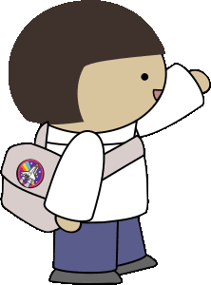MAIN CHARACTER – DORA

OBSTACLE - VIRUS

How do you plan to make your game engaging?

By making dora respond to keyboard keys.