OfficeNest
Sustainable Office Supplies & Corporate Gifting
Capstone Project — Project Documentation

1. Project Overview
OfficeNest is a sustainable office-supplies and corporate-gifting business whose website, AI voice agent, and automated workflows handle customer enquiries, calls, invoicing, and reporting with minimal human involvement. The platform combines a modern business website (built on Bolt) with AI-driven customer engagement and backend workflow automation (n8n), delivering a business-ready digital solution.

2. Business Idea & Target Customers
Business Idea
A one-stop platform supplying eco-friendly office essentials and curated corporate gifts to companies that value sustainability and brand image, with an AI-powered buying experience end-to-end.
Target Customers
- HR & Admin teams across SMBs and enterprises
- Startups building an eco-conscious brand identity
- Companies sourcing corporate gifts for events, onboarding, or milestones
Unique Value Proposition
- 100% sustainable, certified sourcing
- AI Voice Agent answers every call instantly
- Automated sentiment-based service recovery
- Same-day automated invoicing

3. Website Features
- Modern, visually appealing, dynamic-background design
- Animated cursor effects and engaging UI/UX interactions
- Fully responsive across desktop, tablet, and mobile
- Clear navigation and user-friendly information architecture
- Dedicated sections for Products/Services, Target Customers, and USP
- CTA buttons: Contact Us, Book a Demo, Get a Quote, Schedule a Call
- Contact page with business email, business phone number, and contact form

4. AI Features Integrated
Feature | Description
AI Voice Agent | Answers inbound calls, interacts naturally, and collects basic enquiry information.
AI Chatbot | Engages website visitors and qualifies leads before human follow-up.
AI Email Assistant | Sends immediate, contextual acknowledgement replies to every enquiry.
AI Sentiment Analysis | Classifies every customer call as Positive, Neutral, or Negative.
AI Content Generation | Assists with product descriptions and follow-up messaging.
AI Lead Qualification | Scores and prioritizes enquiries for faster sales response.

5. Backend Automation Workflows (n8n)

5.1 Email Automation
- Automatically acknowledges every customer email
- Stores all incoming emails
- Maintains a running enquiry database

5.2 Call Analytics
- Captures and stores call details in Google Sheets (Name, Phone, Sentiment, Recording URL)
- Tracks total daily customer calls
- Classifies each call's sentiment using AI
- Generates a daily report: total calls, positive/neutral/negative counts, sentiment distribution

5.3 Analytics Reporting
- Automatically emails the daily analytics report to the admin
- Report includes email enquiries, call statistics, sentiment analysis, and AI-generated insights

5.4 Invoice Automation
- Generates an invoice automatically on customer payment
- Sends the invoice to the customer's registered email
- Can alternatively be triggered manually via an n8n workflow

6. Architecture Diagram
The diagram below shows the complete workflow — from customer entry points (website, email, phone, payment) through the n8n automation hub, into the AI processing layer, and finally into storage and automated outputs.
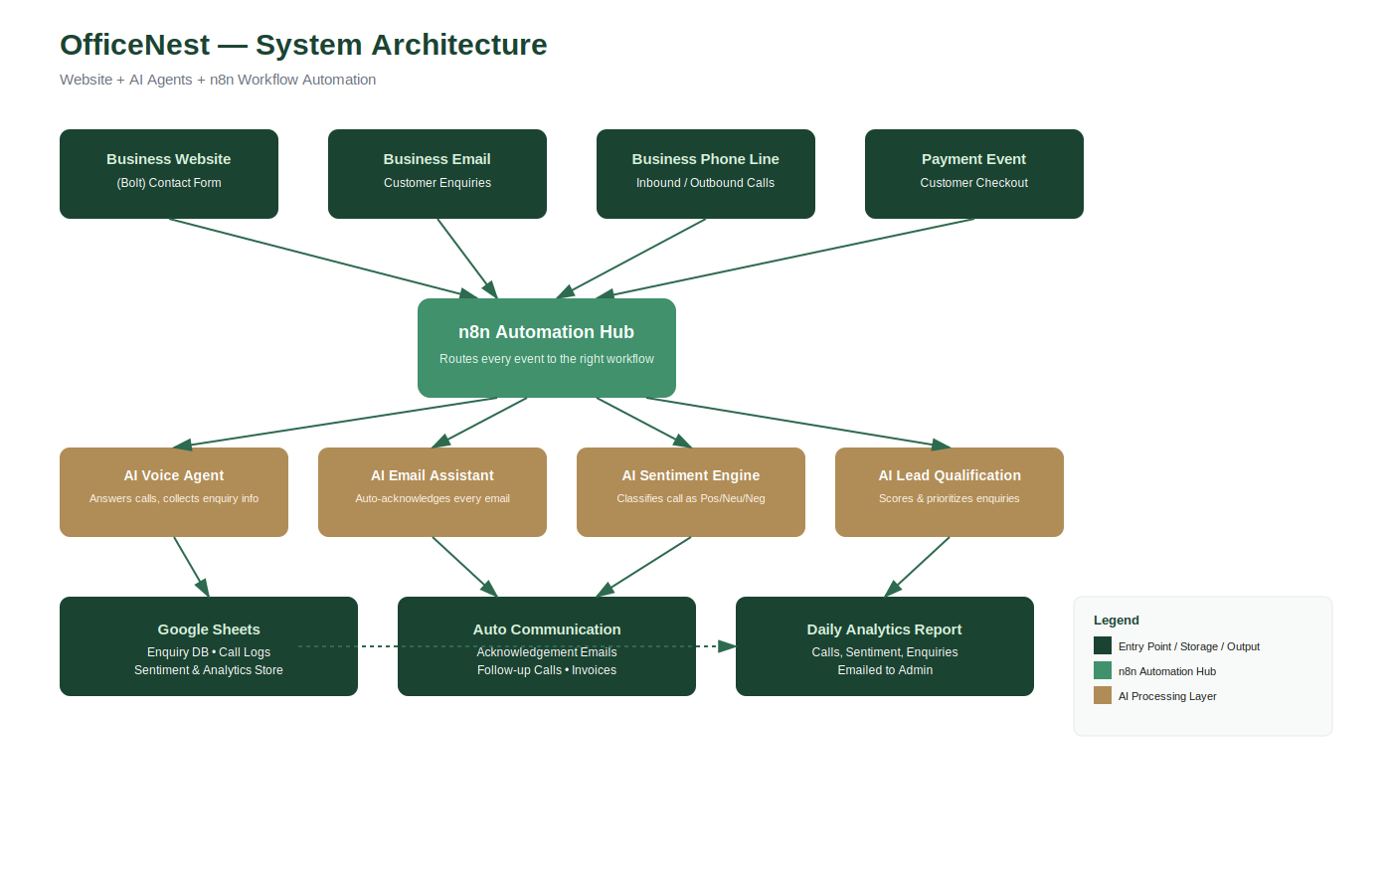

7. Tech Stack
Layer | Tool
Frontend | Bolt (Bolt.new) — responsive website build
Automation | n8n — email, call, invoice & reporting workflows
Voice AI | AI Voice Agent for inbound/outbound calls
Sentiment AI | AI-based classification (Positive / Neutral / Negative)
Data Storage | Google Sheets — enquiry & call analytics
Communication | Email + telephony integration

8. Current Project Status
Completed
- Business website built on Bolt with responsive UI
- Contact form live and functional
- Product/service, USP, and CTA sections in place
In Progress / Roadmap
- n8n workflow integration with the website (email + call automation)
- AI Voice Agent connection for live call handling
- Sentiment analytics dashboard and daily reporting
- Invoice automation on payment trigger

9. Deliverables Checklist
Deliverable | Status
Website URL | Complete
GitHub Repository | Complete
Workflow Automation Files | In Progress
Project Presentation (PPT) | Complete
Project Documentation | Complete
Demo Video | In Progress
Architecture Diagram | Complete

10. Learning Outcomes
- Building AI-powered business websites
- Creating responsive, modern web applications
- Implementing workflow automation using n8n
- Integrating AI Voice Agents and intelligent customer support
- Automating emails, invoices, and business processes
- Collecting and analysing customer data with AI sentiment analysis
- Developing real-world, deployable digital business solutions

