Project Report
on
Medical Expert System
AI Tools – 1 25CAP-614
Submitted by
Neha 25MCI10056
Under the guidance of
Mr. Ashaq Hussain Bhat
in partial fulfilment for the award of the degree of

MASTER OF COMPUTER APPLICATIONS

ARTIFICIAL INTELLIGENCE AND MACHINE LEARNING


Chandigarh University
November 2025

Certificate

This is to certify that Neha, a student of Master of Computer Applications (MCA) –Artificial Intelligence & Machine Learning, has successfully completed the Minor Project titled “Medical Expert System” under the esteemed guidance of Mr. Ashaq Hussain Bhat, Assistant Professor, University Institute of Computing (UIC), Chandigarh University.
This project was undertaken as a part of the academic curriculum and is submitted in partial fulfilment of the requirements for the MCA program. The work presented in this project is a result of independent research, diligent effort, and dedication, demonstrating the student’s ability to apply theoretical knowledge to practical problem-solving.
The project, “Medical Expert System”, is an intelligent consultation platform that uses rule-based reasoning to provide preliminary medical guidance. Built with Python, Tkinter, and the Experta library, it integrates a user-friendly graphical interface that simulates a virtual doctor-patient conversation. The system applies artificial intelligence and expert system concepts to analyze user inputs (symptoms) and suggest possible diagnoses along with advice. This project demonstrates key principles of AI-based decision-making, knowledge representation, inference mechanisms, and real-time user interaction in GUI-based expert systems..
I hereby confirm that this project is an original work carried out by the student and has not been submitted elsewhere for the award of any other degree, diploma, or certification.

Project Guide:
Mr. Ashaq Hussain Bhat
Assistant Professor
University Institute of Computing
Chandigarh University

Acknowledgement

I would like to express my sincere gratitude to Chandigarh University and the University
Institute of Computing (UIC) for providing me with the opportunity to undertake this project, "Medical Expert System".
I extend my heartfelt appreciation to my esteemed mentor, Mr. Ashaq Hussain Bhat, Assistant Professor, for his invaluable guidance, continuous support, and insightful feedback throughout the project. His expertise in Artificial Intelligence and Expert Systems played a crucial role in the successful completion of this project.
I am also grateful to my friends and peers for their encouragement and discussions, which helped refine my approach. Lastly, I thank my family for their unwavering support and motivation during this research.
This project has been an incredible learning experience, and I hope it serves as a foundation for further exploration in Artificial Intelligence and Expert Systems.

Neha
MCA –Artificial Intelligence & Machine Learning
Chandigarh University

Contents
Section | Page Number
Abstract | 5
1. Introduction | 6
2. Tools and Technologies Used | 7
3. Implementation Steps | 8
4. Screenshots / Results | 11
5. Conclusion | 13
6. References | 14

Abstract

With the rapid advancement of artificial intelligence and its applications in healthcare, intelligent systems have become increasingly vital in providing preliminary medical assistance. The Medical Expert System project aims to simulate the reasoning process of a healthcare professional to offer users basic medical guidance based on their symptoms. This intelligent consultation system provides a foundation for AI-assisted diagnosis and promotes awareness of medical reasoning using expert system principles.
The system is developed in Python, utilizing Tkinter for an interactive graphical user interface and the Experta library for implementing rule-based reasoning. The architecture follows an expert system model, consisting of a knowledge base, inference engine, and user interface. The knowledge base stores medical rules and symptom–disease relationships, while the inference engine applies forward chaining to deduce possible conditions from user inputs. The GUI enables a smooth, conversation-like interaction between the user and the system, guiding them through symptom queries and providing relevant diagnostic suggestions.
The core functionalities include symptom analysis, disease prediction, and recommendations for medical consultation. The system engages users through dynamic questioning and delivers results based on the reasoning rules defined by the expert knowledge base. By integrating artificial intelligence principles with a user-friendly design, the project bridges the gap between healthcare expertise and digital accessibility.
The primary objective of this project is to develop an intelligent, interactive tool that demonstrates the application of AI and expert systems in medical diagnostics. It showcases how knowledge representation, inference mechanisms, and human–computer interaction can work together to create an efficient, decision-support system.
In conclusion, the Medical Expert System exemplifies the practical implementation of artificial intelligence concepts in real-world problem solving. It not only serves as a technical project but also as an educational model for understanding how rule-based reasoning can support healthcare decision-making and improve accessibility to basic medical information.

1. Introduction
In today’s technology-driven era, the integration of artificial intelligence into various domains has transformed the way problems are approached and solved. One of the most promising applications of AI is in the field of medical diagnosis and healthcare assistance, where intelligent systems can support doctors and patients by providing quick, preliminary medical advice. However, in many cases, access to immediate medical consultation is limited due to time constraints, geographical barriers, or lack of resources. This creates a need for an intelligent system that can simulate the reasoning process of a human expert to offer basic medical guidance.
The Medical Expert System is developed to address this need by providing an intelligent, interactive platform that helps users identify possible health conditions based on the symptoms they report. The system interacts with users in a conversational manner, asking relevant questions and inferring possible diagnoses using a rule-based reasoning approach. By combining the concepts of Artificial Intelligence (AI) and Expert Systems, this project demonstrates how computer programs can mimic human reasoning to assist in decision-making.
The system uses Python as the primary programming language, integrating the Experta library to implement the knowledge-based inference engine. The Tkinter library is used to design an intuitive graphical user interface (GUI) that allows users to interact with the system in a friendly and efficient manner. The knowledge base consists of predefined medical rules and symptom-disease mappings, which serve as the foundation for diagnosis. The inference engine applies logical reasoning to match user inputs with relevant rules and generate possible conclusions.
The Medical Expert System provides a seamless experience where users can describe their symptoms and receive potential diagnoses or suggestions for further medical consultation. It eliminates the need for deep technical knowledge by using a simple, chat-based interface that guides users step-by-step through the consultation process. The project demonstrates the practical application of AI principles such as knowledge representation, inference mechanisms, and decision-making under uncertainty.
The objective of this project is to develop an intelligent system that can assist in basic medical diagnosis, increase awareness about possible health issues, and demonstrate the real-world utility of expert systems. By implementing a modular and extendable structure, the system can be enhanced in the future with additional rules, natural language processing, or integration with real medical databases.
In conclusion, the Medical Expert System showcases how artificial intelligence can contribute to healthcare by delivering accessible, quick, and reliable preliminary medical advice. It serves as an educational and practical example of how rule-based systems can replicate expert-level reasoning and provide valuable support in everyday life.

2. Tools and Technologies Used
This project utilizes various tools and technologies to build an intelligent, rule-based medical consultation system. The chosen stack supports interactive GUI development, AI reasoning, and structured knowledge management to deliver a smooth and informative user experience.
2.1 Programming Language
Python
Python is used as the core programming language due to its simplicity, readability, and extensive support for AI and GUI development.
- Provides powerful libraries for expert system implementation (e.g., Experta).
- Supports modular design and rapid development.
- Integrates easily with GUI frameworks and external data sources.
2.2 Artificial Intelligence Framework
Experta Library
Experta is a Python-based framework for building rule-based expert systems. It allows developers to define facts, rules, and inference logic efficiently.
- Implements forward-chaining inference mechanism.
- Supports structured knowledge representation using classes and decorators.
- Provides a clear separation between knowledge base and reasoning engine.

2.3 Graphical User Interface
Tkinter
Tkinter is used to develop the user-friendly graphical interface that simulates a chat between the system and the user.
- Provides interactive components such as buttons, text boxes, and message windows.
- Enables real-time communication between the user and the inference engine.
- Offers high portability and ease of use for desktop applications.

2.4 Knowledge Representation
Rule-Based Knowledge Base
The medical knowledge is encoded as a set of rules and facts representing relationships between symptoms and possible diseases.
- Each rule follows an “IF–THEN” logic for inference.
- Simplifies reasoning and decision-making processes.
- Allows easy modification and expansion for future enhancements.

3. Implementation Steps
- The development of the Medical Expert System was carried out in the following essential steps, focusing on the integration of artificial intelligence concepts, rule-based reasoning, and a user-friendly graphical interface.

- 3.1 Graphical User Interface (GUI) Setup
- Developed using Python’s Tkinter library.
- Designed a clean, interactive chat-style interface to simulate a doctor–patient conversation.
- Implemented components such as message display area, input field, and “Send” button.
- Ensured a responsive and user-friendly layout for smooth interaction.
- Added message formatting to differentiate system queries and user responses visually.

- 3.2 Knowledge Base Construction
- Built a rule-based knowledge base using the Experta library.
- Defined medical facts and rules representing relationships between symptoms and diseases.
- Each rule follows the IF–THEN structure (e.g., IF cough and fever THEN flu).
- Knowledge base can be easily extended by adding new rules for more conditions.
- Designed to simulate the reasoning process of a human medical expert.

- 3.3 Inference Engine Implementation
- The inference engine was developed using Experta’s forward-chaining mechanism.
- It collects user responses and matches them against predefined rules to infer possible diagnoses.
- Automatically triggers the next relevant question based on the user’s previous input.
- Stops once a rule’s condition is satisfied, and displays the final diagnosis or advice to the user.
- Ensures logical consistency and efficiency during the reasoning process.

- 3.4 System Interaction Flow
- The system initiates the conversation by greeting the user and asking for symptoms.
- User inputs are captured through the Tkinter interface and passed to the expert system engine.
- The engine evaluates inputs and provides the next question or a diagnosis suggestion.
- A background thread manages engine execution to keep the interface responsive.
- Interaction continues until a suitable conclusion is reached (diagnosis or medical recommendation).

- 3.5 Core Features
- Symptom-Based Diagnosis: Predicts possible medical conditions from user-described symptoms.
- Conversational Interface: Engages users in an interactive dialogue, improving usability.
- Rule-Based Reasoning: Mimics medical expert logic through predefined condition–conclusion rules.
- Extensibility: New rules and conditions can be added without modifying the main system logic.
- User Guidance: Provides health suggestions and recommends consulting a doctor when necessary.

4. Screenshots/Result

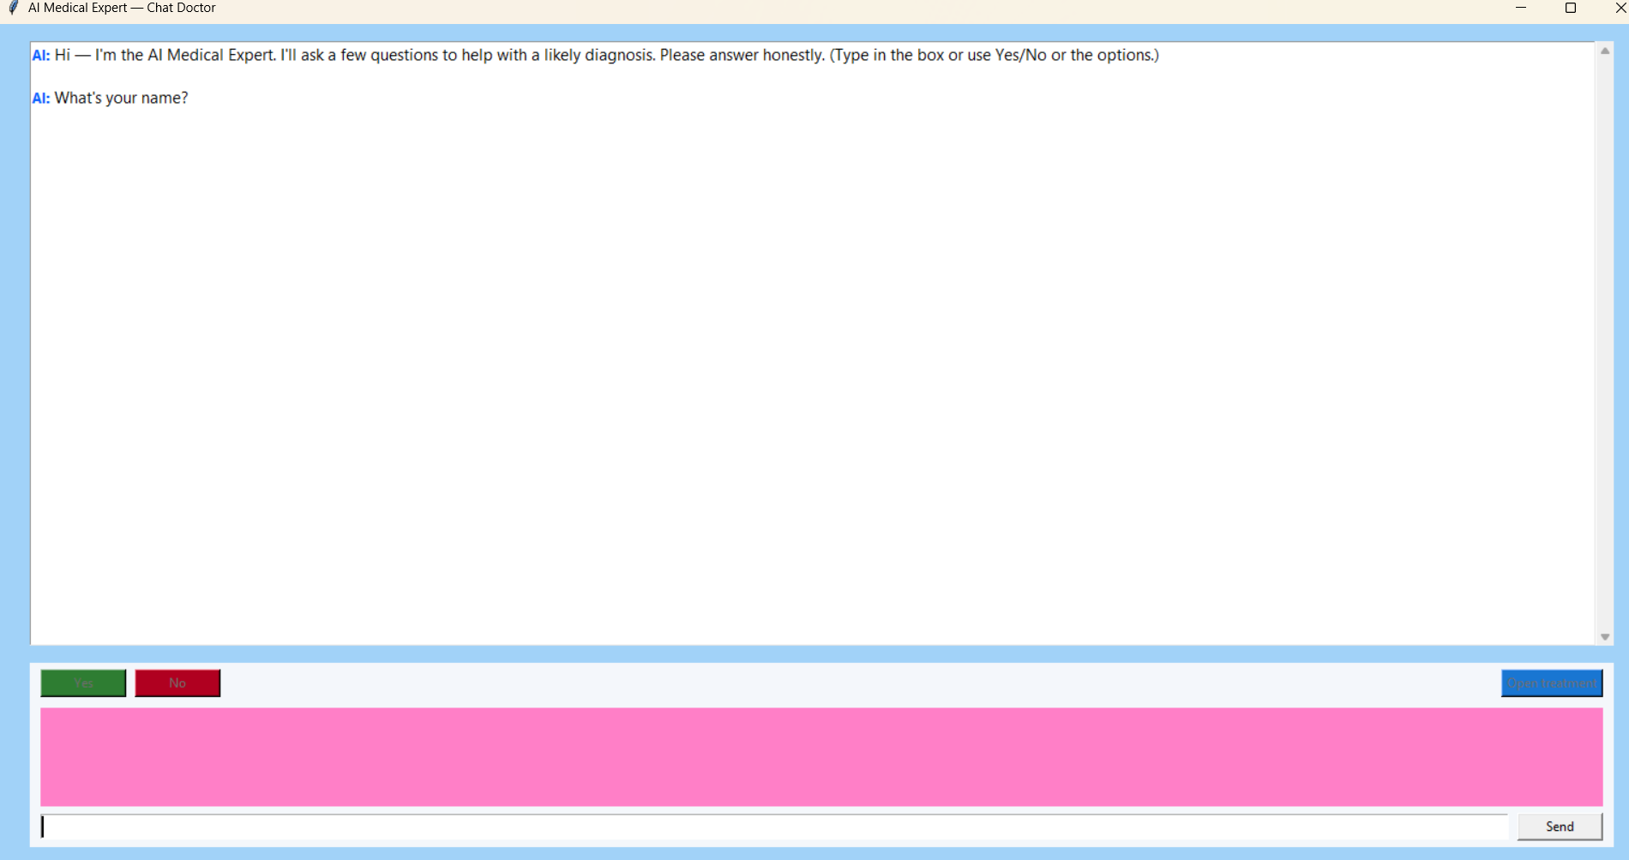

Fig.1: Output Interface

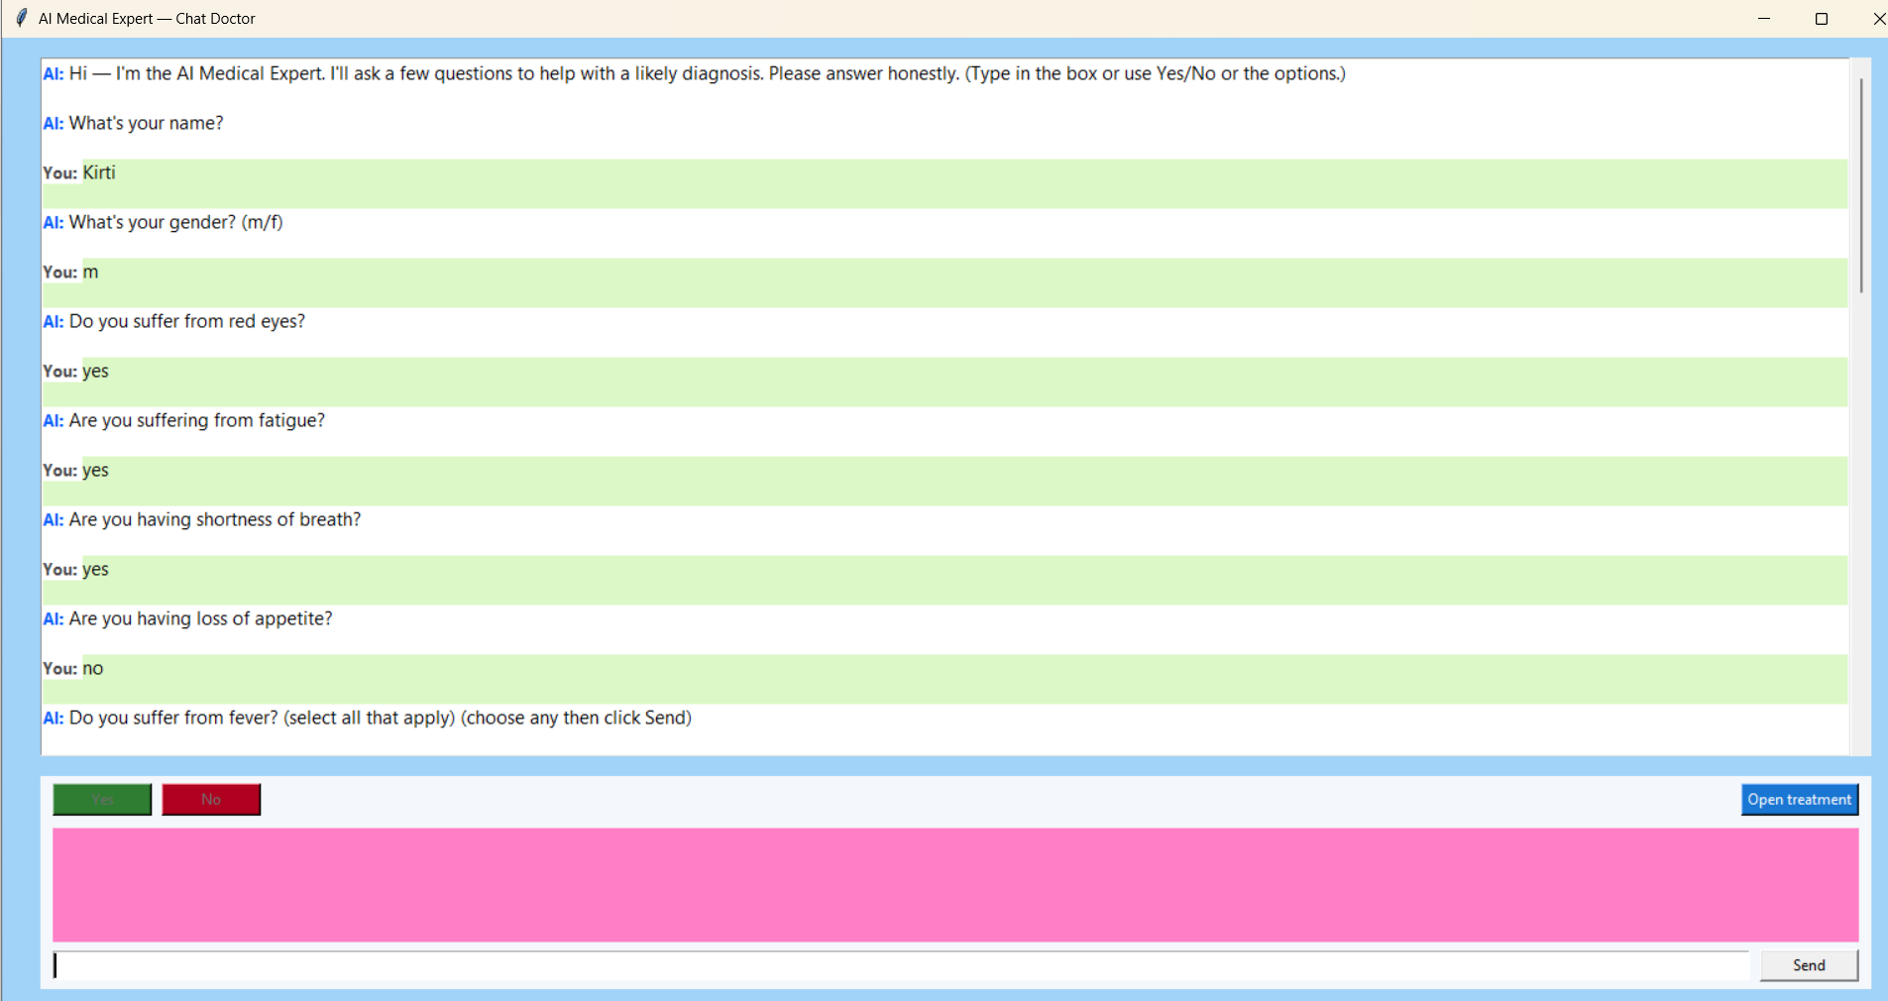

Fig.2: Entering the required input values.

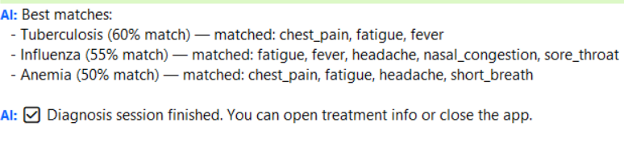

Fig.3 : Diseases diagnosis by AI based on the symptoms entered .

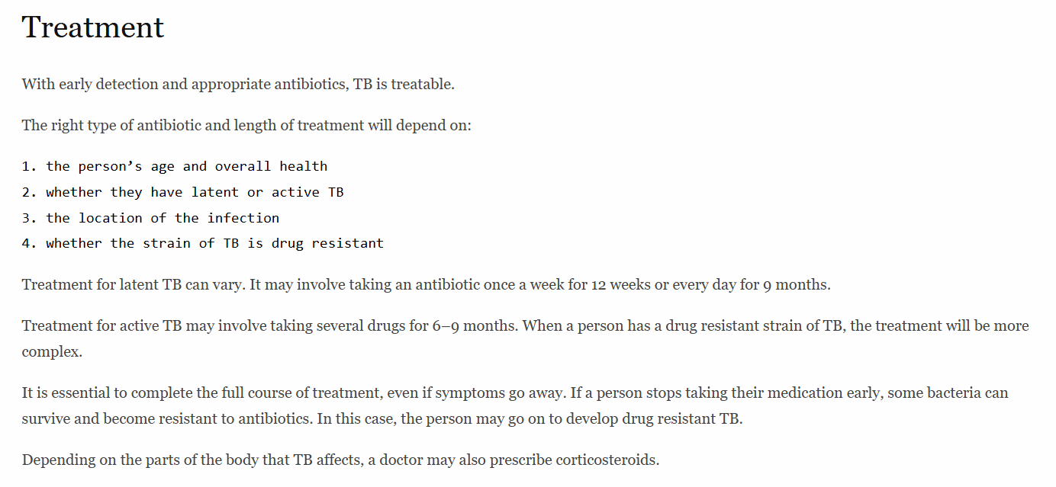

Fig.4 :Treatment suggested by the EXPERT SYSTEM.

5. Conclusion
Intelligence and Expert System concepts in the healthcare domain. It provides an intelligent, interactive platform that mimics the reasoning process of a medical professional to offer users preliminary diagnostic suggestions based on their symptoms. By combining a rule-based inference engine with an intuitive graphical user interface, the system delivers a smooth and engaging consultation experience.
Through the integration of Python, Tkinter, and the Experta library, the project illustrates how knowledge representation and logical reasoning can be implemented in real-world applications. The use of a forward-chaining inference mechanism ensures accurate decision-making by applying medical rules systematically to user inputs. The chat-based design enhances accessibility and user interaction, making it suitable for non-technical users.
This project not only strengthens understanding of artificial intelligence principles—such as knowledge engineering, inference control, and decision support—but also highlights the potential of AI in assisting healthcare delivery. Although the system provides basic guidance and not professional medical advice, it represents an important step toward intelligent, knowledge-driven diagnostic tools.
In the future, the system can be expanded to include a larger medical database, natural language processing (NLP) for better communication, and integration with online healthcare services for real-time consultation. These improvements could make the Medical Expert System even more robust, adaptive, and closer to real-world clinical applications.
Overall, the Medical Expert System serves as an excellent example of how artificial intelligence can be leveraged to enhance problem-solving in healthcare. It bridges the gap between technology and medical reasoning, offering an educational and practical approach to AI-based expert system development.

6. References
GitHub : https://github.com/neha23328/Medical-Expert-System
• Python Official Documentation – https://docs.python.org/3/

• Tkinter GUI Programming Documentation – https://docs.python.org/3/library/tkinter.html

• Experta Library Documentation – https://experta.readthedocs.io/en/latest/

• Artificial Intelligence: A Modern Approach, Stuart Russell & Peter Norvig, Pearson Education.

• Rule-Based Expert Systems – Research papers and tutorials on expert system design and inference mechanisms.

• AI in Healthcare Applications – Articles and resources on the use of artificial intelligence for medical diagnosis and decision support.

