Project Report
on
Smart AI Path Planner
DAA 25CAP-612
Submitted by
Neha 25MCI10056
Under the guidance of
Mr. Mohammad Rashid
in partial fulfilment for the award of the degree of

MASTER OF COMPUTER APPLICATIONS

ARTIFICIAL INTELLIGENCE & MACHINE LEARNING


Chandigarh University
November 2025

Certificate

This is to certify that Neha, a student of Master of Computer Applications (MCA) –Artificial Intelligence & Machine Learning , has successfully completed the Minor Project titled “Smart AI Path Planner” under the esteemed guidance of Mr. Mohammad Rashid, Assistant Professor, University Institute of Computing (UIC), Chandigarh University.
This project was undertaken as a part of the academic curriculum and is submitted in partial fulfilment of the requirements for the MCA program. The work presented in this project is a result of independent research, diligent effort, and dedication, demonstrating the student’s ability to apply theoretical knowledge to practical problem-solving.
The project “Smart AI Path Planner” is an interactive visualization tool that demonstrates classic pathfinding algorithms such as BFS, DFS, A*, and Best-First Search. It showcases key Design and Analysis of Algorithms (DAA) concepts like graph traversal, heuristic search, and performance comparison. Built using Python (Tkinter and Matplotlib), it visualizes each algorithm’s exploration process in real time and compares their efficiency through charts and metrics. The project effectively connects theoretical DAA concepts with practical implementation and analysis.
I hereby confirm that this project is an original work carried out by the student and has not been submitted elsewhere for the award of any other degree, diploma, or certification.

Project Guide:
Mr. Mohammad Rashid
Assistant Professor
University Institute of Computing
Chandigarh University

Acknowledgement

I would like to express my sincere gratitude to Chandigarh University and the University
Institute of Computing (UIC) for providing me with the opportunity to undertake this project, "Smart AI Path Planner"
I extend my heartfelt appreciation to my esteemed mentor, Mr. Mohammad Rashid, Assistant Professor, for his invaluable guidance, continuous support, and insightful feedback throughout the project. His expertise in Design and Analysis of Algorithms (DAA) played a crucial role in the successful completion of this project.
I am also grateful to my friends and peers for their encouragement and discussions, which helped refine my approach. Lastly, I thank my family for their unwavering support and motivation during this research.
This project has been an incredible learning experience, deepening my understanding of graph algorithms, heuristic search techniques, and algorithmic efficiency. I hope it serves as a foundation for further exploration and innovation in the field of Design and Analysis of Algorithms (DAA).

Neha
MCA – Artificial Intelligence & Machine Learning
Chandigarh University

Contents

Section | Page Number
Abstract | 5
1. Introduction | 6
2. Tools and Technologies Used | 7
3. Implementation Steps | 8
4. Screenshots / Results | 10
5. Conclusion | 13
6. References | 14

Abstract

With the growing importance of intelligent systems and automation, pathfinding algorithms play a vital role in navigation, robotics, and game development. The Smart AI Path Planner is a desktop-based visualization tool designed to demonstrate and compare various graph search algorithms including Breadth-First Search (BFS), Depth-First Search (DFS), A*, and Best-First Search.
Developed using Python with Tkinter for the graphical interface and Matplotlib for data visualization, the system allows users to observe the real-time working of each algorithm on a dynamic grid. It visually highlights node exploration, optimal path formation, and comparative performance in terms of nodes explored, execution time, and path length.
The objective of this project is to provide an interactive learning platform that bridges theoretical DAA concepts with practical implementation. By integrating visualization and analytics, the system helps users understand algorithmic efficiency, heuristic influence, and computational behavior in pathfinding problems.
In conclusion, the Smart AI Path Planner effectively demonstrates the Design and Analysis of Algorithms (DAA) through real-time visualization, fostering deeper understanding of search strategies, optimization, and performance evaluation in algorithmic problem-solving.

1. Introduction
In today’s technology-driven world, intelligent systems rely heavily on efficient algorithms to solve complex computational and decision-making problems. One of the most fundamental challenges in computer science and artificial intelligence is pathfinding—determining an optimal route between two points within a defined space. Pathfinding algorithms have widespread applications in robotics, navigation systems, games, and network routing, where accuracy and efficiency are crucial.
The Smart AI Path Planner project aims to visually demonstrate how different graph search algorithms operate and perform under similar conditions. It provides an interactive platform where users can generate a grid environment with obstacles and observe the step-by-step exploration process of algorithms such as Breadth-First Search (BFS), Depth-First Search (DFS), A*, and Best-First Search.
Developed using Python, with Tkinter for the graphical interface and Matplotlib for performance visualization, the system highlights each algorithm’s ability to explore, backtrack, and find optimal paths. The real-time animations allow users to understand algorithmic behavior more intuitively, while the charts compare metrics like nodes visited, execution time, and path length.
The main objective of this project is to bridge the gap between theoretical learning and practical understanding of Design and Analysis of Algorithms (DAA). By combining algorithm visualization with performance analysis, the Smart AI Path Planner serves as an educational tool that enhances comprehension of search strategies, heuristic functions, and computational efficiency in problem-solving

2. Tools and Technologies Used

This project utilizes a combination of programming tools, libraries, and visualization technologies to develop an interactive and educational desktop application for pathfinding algorithm visualization. Each component contributes to delivering a smooth, responsive, and visually engaging experience.

2.1 Programming Language

Python
Python serves as the core programming language for this project. It provides extensive libraries and simplicity in syntax, making it ideal for implementing algorithms and GUI-based visualizations. Python’s modular structure enables efficient integration of multiple components, including interface design and data visualization.

2.2 Graphical User Interface

Tkinter
Tkinter, the standard GUI library for Python, is used to design the application’s interface. It provides an interactive grid layout where pathfinding algorithms such as BFS, DFS, A*, and Best-First Search are visually represented in real time.

Canvas Widget: Used to draw the grid and animate cell color changes during algorithm execution.

Buttons and Frames: Facilitate user interaction for generating grids and running algorithms.

Text Widget: Displays algorithm insights and results.

2.3 Data Visualization

Matplotlib
Matplotlib is integrated to display comparative performance metrics of algorithms through bar charts and pie charts.

Bar Chart: Represents the number of nodes explored by each algorithm.

Pie Chart: Shows the percentage share of exploration among all algorithms.
This enhances the project’s analytical and comparative learning aspect.

2.4 Supporting Libraries

Time: Used to manage delays for smooth animation during visualization.

Random: Helps in generating randomized maze-like grids with obstacles.

Collections (Deque): Provides efficient queue operations for BFS implementation.

2.5 Development Environment

IDE: The project was developed using VS Code / PyCharm for code editing and debugging.

Platform: Runs on Python 3.x across Windows, macOS, or Linux environments.

3. Implementation Steps
The development of the Smart AI Path Planner application was carried out through the following key stages:

3.1 GUI Setup

- Designed an interactive graphical interface using Tkinter.
- Created a canvas to represent the grid where cells change colors dynamically during algorithm execution.
- Added control buttons to generate new grids and run algorithms (BFS, DFS, A*, Best-First).
- Incorporated text and label widgets to display algorithm insights, results, and statistics.

3.2 Grid Generation
- Implemented a 20×20 grid represented as a 2D list where each cell can be:
  - 0 – empty cell
  - 1 – obstacle or wall

- Used the random module to generate obstacles, ensuring both start (top-left) and goal (bottom-right) cells remain open.

- Each new grid can be generated instantly through the “Generate Grid” button.

3.3 Algorithm Implementation
Implemented four major pathfinding algorithms to demonstrate different search strategies:
- Breadth-First Search (BFS): Explores nodes level by level to guarantee the shortest path.
- Depth-First Search (DFS): Explores deeper paths first, using backtracking when needed.
- A* (A-Star Algorithm): Combines path cost and heuristic to find the most optimal route efficiently.
- Best-First Search: Selects the next node based purely on heuristic proximity to the goal.

Each algorithm updates the grid in real time using color changes to visually represent exploration and path discovery.

3.4 Visualization and Animation

- Used color coding to represent states:
  - Cyan → Visited nodes
  - Yellow → Final path
  - Gray → Walls
  - Red/Green → Start and Goal
- Incorporated time delays for smooth, step-by-step visualization of the search process.
- The visualization helps users understand how each algorithm explores the grid differently.

3.5 Data Visualization and Insights

- Integrated Matplotlib to generate:
  - Bar Chart – showing the number of nodes explored by each algorithm.
  - Pie Chart – displaying the percentage share of exploration.

- Added an AI Insights panel to display:
  - Execution time
  - Path length
  - Nodes visited

This enables clear comparison and analytical understanding of algorithm performance.

. Screenshots/Result

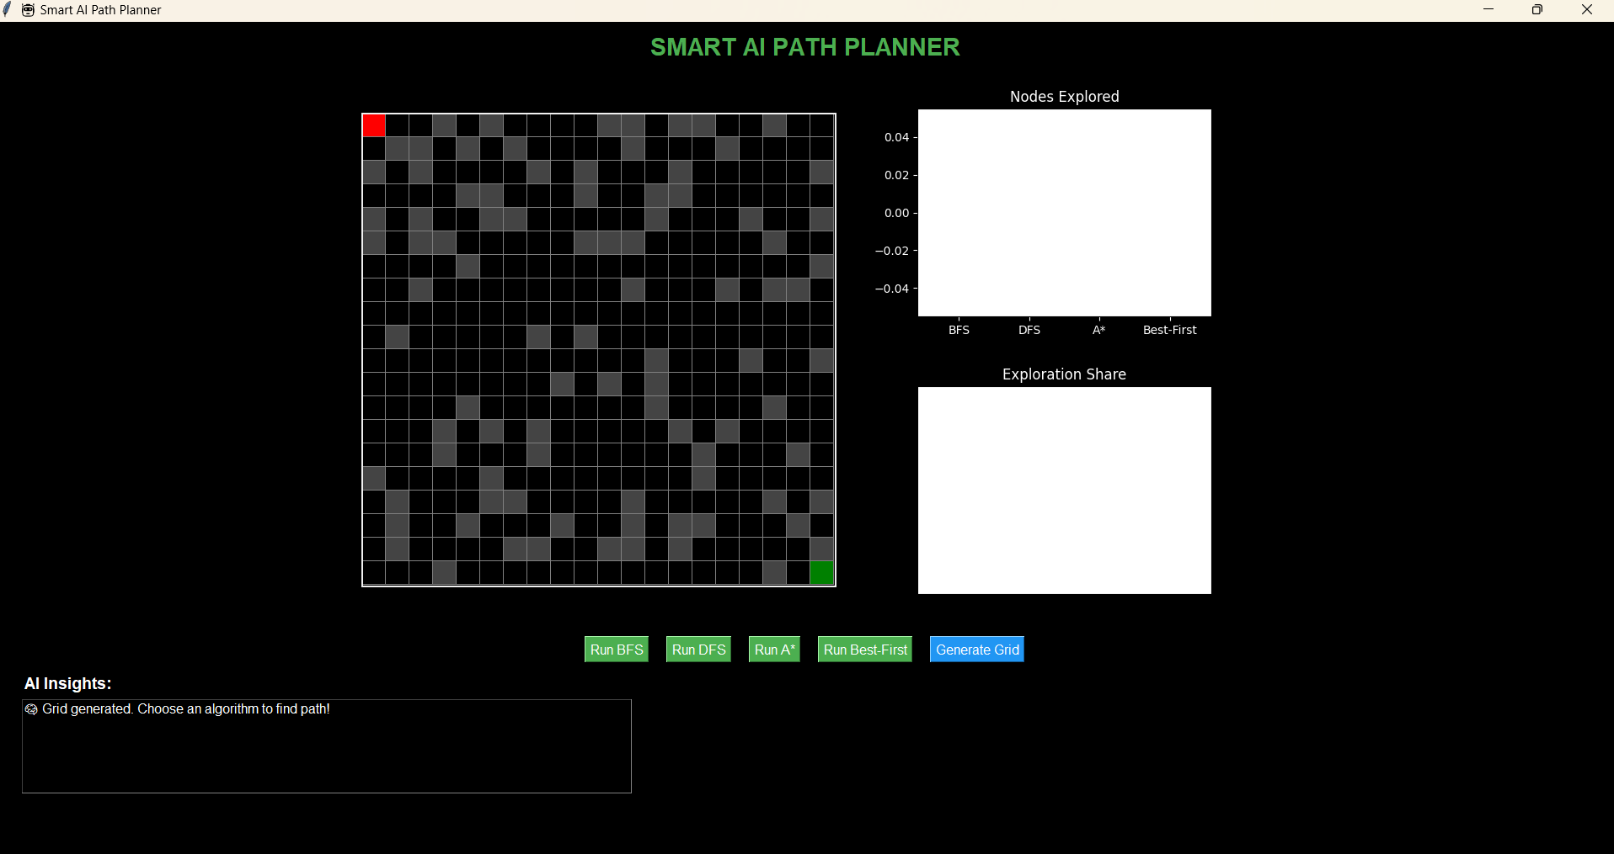
Fig.1: Output Interface
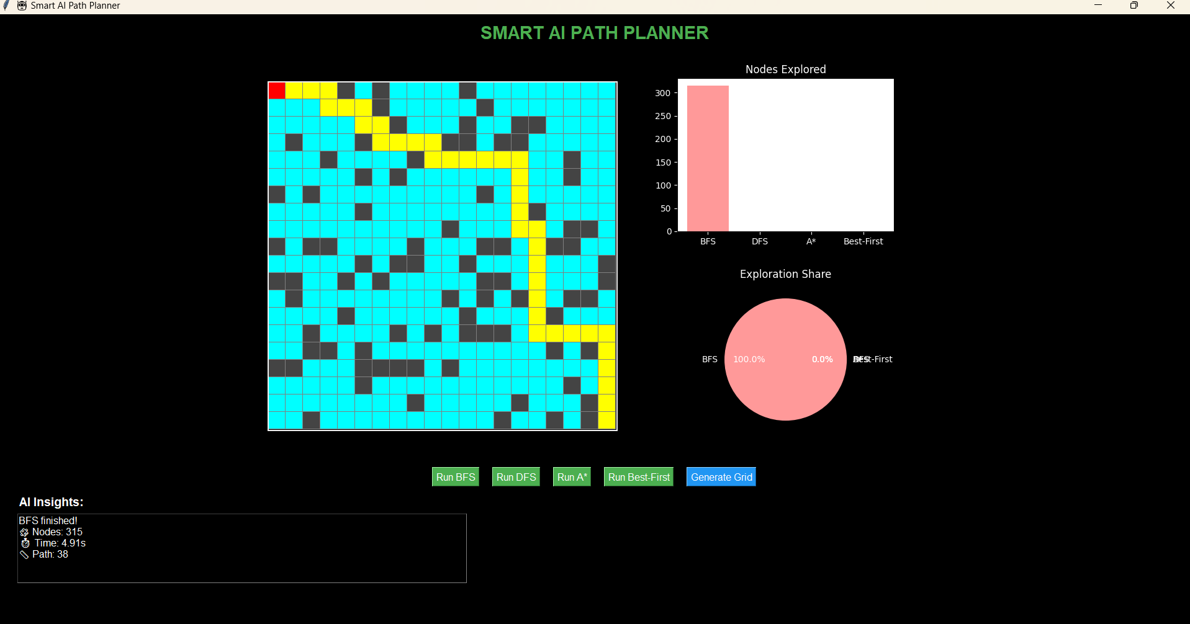
Fig.2 : Path Finding with BFS.
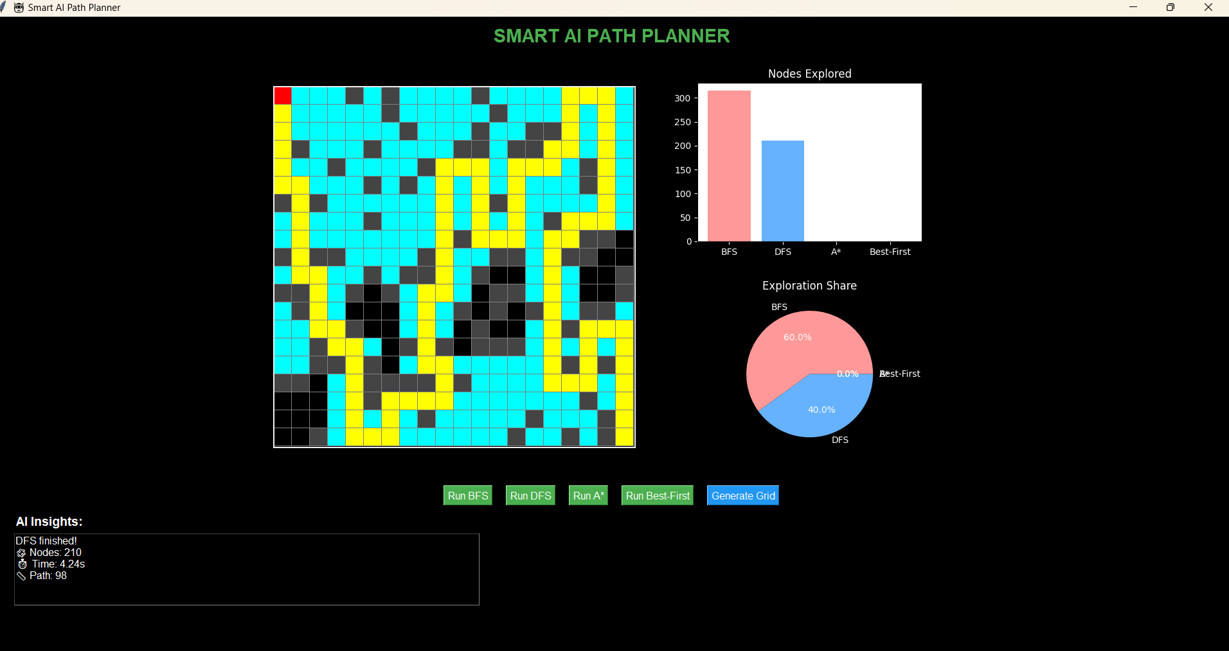
Fig .3 : Path Finding using DFS.

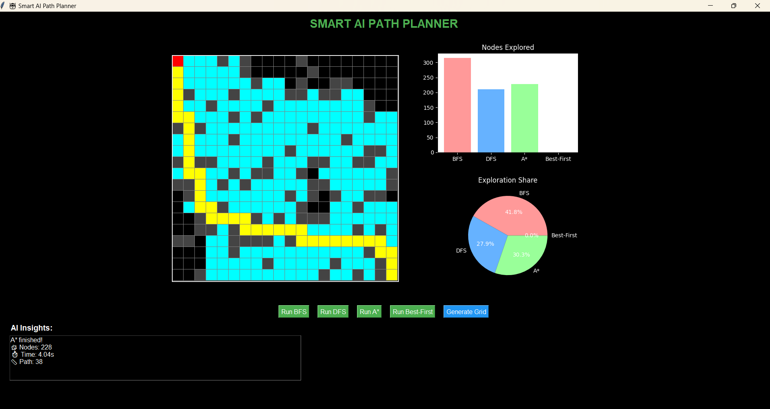
Fig.4 :Path Finding using A* .
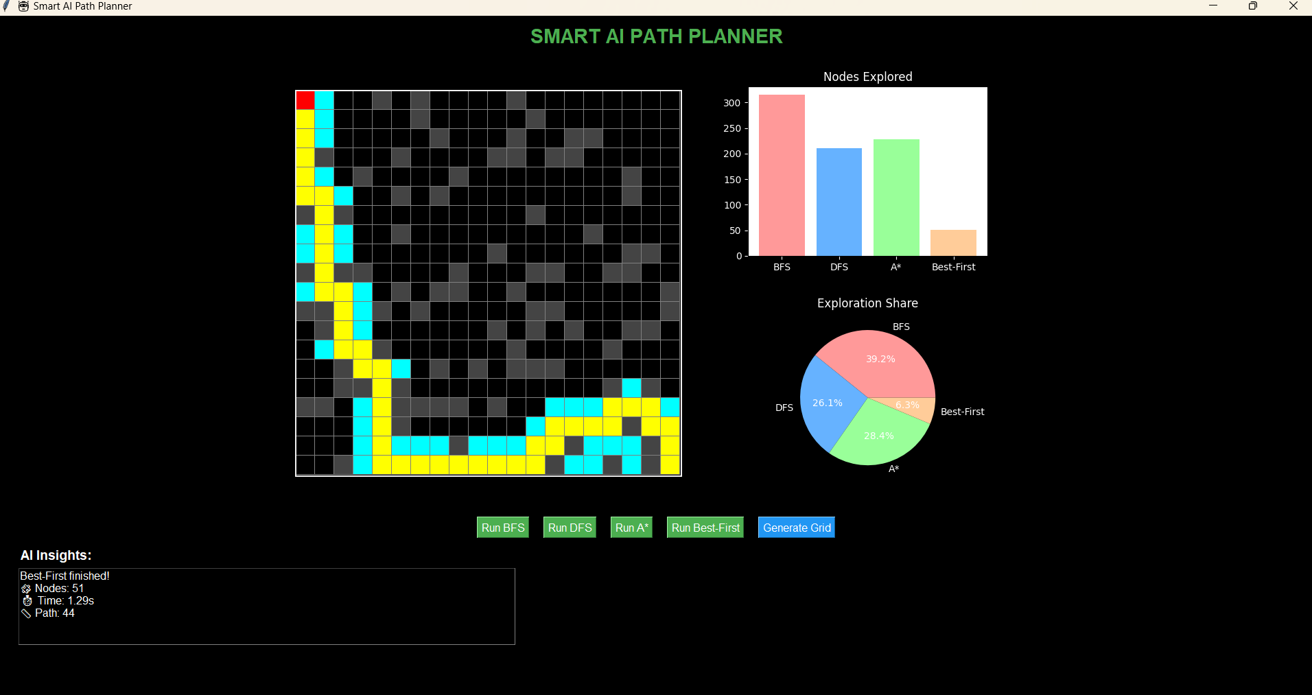
Fig.5: Path Finding using Best First Search.

5. Conclusion
The Smart AI Path Planner successfully demonstrates the working principles of various pathfinding and graph traversal algorithms in an interactive and visual manner. By integrating algorithms such as BFS, DFS, A*, and Best-First Search, the project effectively showcases their differences in exploration strategy, efficiency, and optimality.
Through the use of Tkinter for GUI development and Matplotlib for analytical visualization, the system provides an engaging and educational experience for understanding the Design and Analysis of Algorithms (DAA). Users can observe how each algorithm explores nodes, constructs paths, and performs under different conditions, thereby strengthening their conceptual understanding of algorithmic behavior and performance.
The project not only bridges theoretical knowledge with practical implementation but also emphasizes the importance of heuristics, computational efficiency, and visualization in algorithm design. Future enhancements may include support for diagonal movement, weighted grids, and additional algorithms like Dijkstra’s or Greedy Best-First Search to further enrich the learning experience.
Overall, the Smart AI Path Planner serves as an effective educational tool, illustrating the core concepts of DAA through real-time interaction, analysis, and visualization.

6. References
GitHub : https://github.com/neha23328/Smart-AI-Path-Planner

• Thomas H. Cormen, Charles E. Leiserson, Ronald L. Rivest, and Clifford Stein, Introduction to Algorithms, MIT Press.

• GeeksforGeeks – Graph Algorithms: https://www.geeksforgeeks.org/graph-data-structure-and-algorithms/

• Programiz – Graph Traversal Algorithms (BFS & DFS): https://www.programiz.com/dsa/graph-traversal

• A* Pathfinding Algorithm Explained – Red Blob Games: https://www.redblobgames.com/pathfinding/a-star/introduction.html

• Tkinter Documentation (Python GUI Library): https://docs.python.org/3/library/tkinter.html

• Matplotlib Documentation (Data Visualization in Python): https://matplotlib.org/stable/contents.html

