Project Report
on
Student Management System
Submitted by
Neha 25MCI10056
Under the guidance of
Mrs. Gurpreet Kaur
in partial fulfilment for the award of the degree of

MASTER OF COMPUTER APPLICATIONS

ARTIFICIAL INTELLIGENCE & MACHINE LEARNING


Chandigarh University
NOVEMBER 2025

Certificate

This is to certify that Neha, a student of Master of Computer Applications (MCA) – Artificial Intelligence, has successfully completed the Minor Project titled “Student Management System” under the esteemed guidance of Mrs. Gurpreet Kaur, University Institute of Computing (UIC), Chandigarh University.
This project was undertaken as a part of the academic curriculum and is submitted in partial fulfilment of the requirements for the MCA program. The work presented in this project is a result of independent research, diligent effort, and dedication, demonstrating the student’s ability to apply theoretical knowledge to practical problem-solving.
This project is a Student Management System implemented using Python, SQLite, and CustomTkinter for the GUI. It allows the management of student records in a simple and interactive desktop application. The system supports CRUD operations (Create, Read, Update, Delete) for student information including Student UID, Name, Course, and Year.
I hereby confirm that this project is an original work carried out by the student and has not been submitted elsewhere for the award of any other degree, diploma, or certification.

Project Guide:
Mrs. Gurpreet Kaur
Assistant Professor
University Institute of Computing
Chandigarh University

Acknowledgement

I would like to express my sincere gratitude to Chandigarh University and the University
Institute of Computing (UIC) for providing me with the opportunity to undertake this project, "Student Management System"
I extend my heartfelt appreciation to my esteemed mentor Mrs. Gurpreet Kaur, Assistant Professor, for his invaluable guidance, continuous support, and insightful feedback throughout the project. Her expertise in Database played a crucial role in the successful completion of this project.
I am also grateful to my friends and peers for their encouragement and discussions, which helped refine my approach. Lastly, I thank my family for their unwavering support and motivation during this research.
This project has been an incredible learning experience, and I hope it serves as a foundation for further exploration in Database Management.

Neha
MCA – Artificial Intelligence & Machine Learning
Chandigarh University

Contents
Section | Page Number
Abstract | 5
1. Introduction | 6
2. Tools and Technologies Used | 7
3. Implementation Steps | 8
4. Screenshots / Results | 9
5. Conclusion | 12
6. References | 13

Abstract

With the increasing need for efficient management of academic records, maintaining accurate and organized student data has become essential for educational institutions. The Student Management System (SMS) desktop application addresses this need by providing a centralized platform for storing, managing, and accessing student information efficiently. It is designed to help administrators, teachers, and students keep track of enrollment details, course information, and academic progression in a structured and user-friendly manner.

This desktop application is developed using Python with CustomTkinter for the frontend, delivering a responsive and interactive graphical user interface. The backend is powered by SQLite, handling secure data storage, retrieval, and database operations. Key functionalities include CRUD operations for student records, sorting and filtering by different attributes, and automated features such as random data generation and year adjustment according to course duration. The system ensures data consistency through proper input validation and highlights important entries for easy identification.

The core features of the application include adding, updating, deleting, and searching student records, multi-level sorting and filtering, and real-time data display in a dynamic table interface. Users can also generate random sample records and reset student years according to predefined course durations. The application is designed to be scalable, allowing future integration with larger databases, additional modules like attendance tracking, and reporting features.

The objective of this project is to streamline student data management, reduce manual errors, and provide a simple yet powerful tool for academic administration. By leveraging database operations and a clean GUI, the application enhances usability, ensures efficient record keeping, and supports better academic planning.

In conclusion, the Student Management System demonstrates the practical application of Python programming, database management, and GUI development in addressing real-world educational challenges. It serves not only as a technical solution but also as a foundation for improving administrative workflows and supporting informed decision-making in educational environments.

1. Introduction
In today's educational environment, managing student records efficiently has become a critical requirement for schools, colleges, and other academic institutions. Manual record-keeping is often prone to errors, time-consuming, and difficult to maintain, especially when dealing with large volumes of student data. This creates challenges such as inaccurate data, difficulty in tracking academic progress, and inefficiency in administrative processes.

To address these issues, Student Management Systems (SMS) have emerged as effective solutions for organizing and managing student information digitally. Such systems allow administrators and faculty to maintain accurate records, monitor student progress, and perform operations like adding, updating, deleting, and searching student data efficiently. By providing a centralized and interactive interface, these applications simplify the management of academic information and improve productivity.

This project presents the development of a desktop-based Student Management System that enables users to manage student records, sort and filter data, and perform automated operations like year adjustment based on course duration. The system is developed using Python with CustomTkinter for the frontend, offering a responsive and user-friendly graphical interface. SQLite is used as the backend database to securely store student details, course information, and other related data. The application also supports advanced functionalities like multi-level sorting, filtering, and random data generation for testing purposes.

The Student Management System addresses the need for an efficient and interactive tool to manage academic records. Key functionalities include adding, updating, deleting, and searching student records, filtering and sorting data, and automated adjustments based on predefined course rules. These features enhance administrative efficiency and reduce manual errors while providing a clear view of student information.
The goal of this project is to demonstrate the integration of Python programming, database management, and GUI development in building a practical tool for academic administration. The system not only simplifies record management but also serves as a foundation for implementing future enhancements such as attendance tracking, reporting, and analytics, making it a valuable asset for educational institutions.

2. Tools and Technologies Used
This project incorporates a range of tools and technologies to build a fully functional Student Management System. The stack includes technologies for GUI development, database management, and backend operations to deliver an efficient and user-friendly experience.
2.1 Frontend Technologies
Python with Custom Tkinter
CustomTkinter is used to create a modern and responsive desktop interface. It provides a component-based structure and enhanced styling options for building interactive forms and tables.
- CTkEntry, CTkComboBox, CTkButton: Input fields, dropdowns, and action buttons.
- CTkFrame and CTkLabel: Layout and labeling of GUI components.
2.2 Backend Technologies:
SQLite
SQLite serves as the relational database for storing student records, courses, and years. It ensures persistent storage and allows efficient data retrieval and updates.
- CRUD Operations: Add, update, delete, and fetch student records.
- Random Data & Year Adjustment: Automated features to manage student years based on course duration.
2.3 Programming Language:
Python
Python is used for integrating GUI components with database operations and handling business logic such as sorting, filtering, and data validation.
2.4 Data Management SQL Queries
SQL queries are used to interact with the SQLite database, ensuring structured data manipulation and retrieval.

3. Implementation Steps
The development of the Student Management System desktop application was carried out in the following essential steps:
- 3.1 Frontend Setup
- Built using Python with CustomTkinter for a modern and responsive GUI.
- Created components for student entry, update, deletion, and search functionality.
- Designed interactive tables using ttk.Treeview to display student records dynamically.
- Applied a consistent theme and styling to enhance user experience and readability.
- 3.2 Backend Setup
- Developed using SQLite as the relational database for persistent storage of student records.
- Implemented functions to perform CRUD operations: add, update, delete, and fetch student data.
- Integrated automated features such as random student data generation and year adjustment according to course duration.
- 3.3 Data Management & Validation
- Applied input validation to ensure data integrity before database insertion.
- Used Python logic to enforce constraints like valid years according to course selection.
- Implemented filtering and multi-level sorting to manage large datasets efficiently.
- 3.4 Database Integration
- Used SQLite to store:
- Student information (UID, Name, Course, Year)
- Course details and duration mapping
- Ensured data persistence and structured storage for easy retrieval and updates.
- 3.5 Core Features
- Add, Update, Delete, and Search Student Records for easy data management.
- Sorting and Filtering to organize data by UID, Name, Course, or Year.
- Random Student Data Generation for testing and demonstration purposes.
- Year Reset feature to automatically adjust student year based on course duration.
- Interactive GUI Dashboard for managing student data efficiently.
4. Screenshots/Result

- Main Dashboard – Displaying All Students
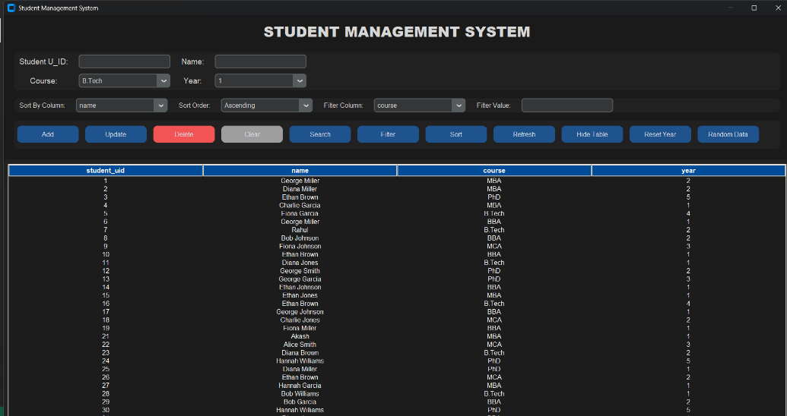

Shows the full list of students with UID, Name, Course, and Year in a dynamic table.
- Adding a New Student

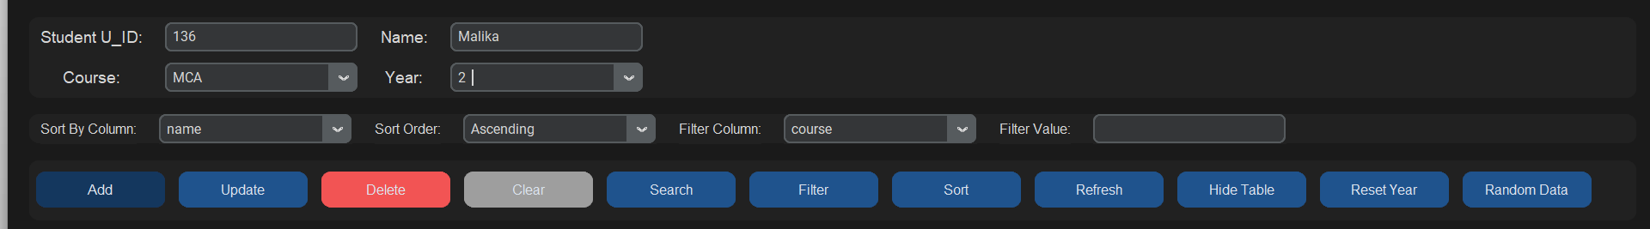
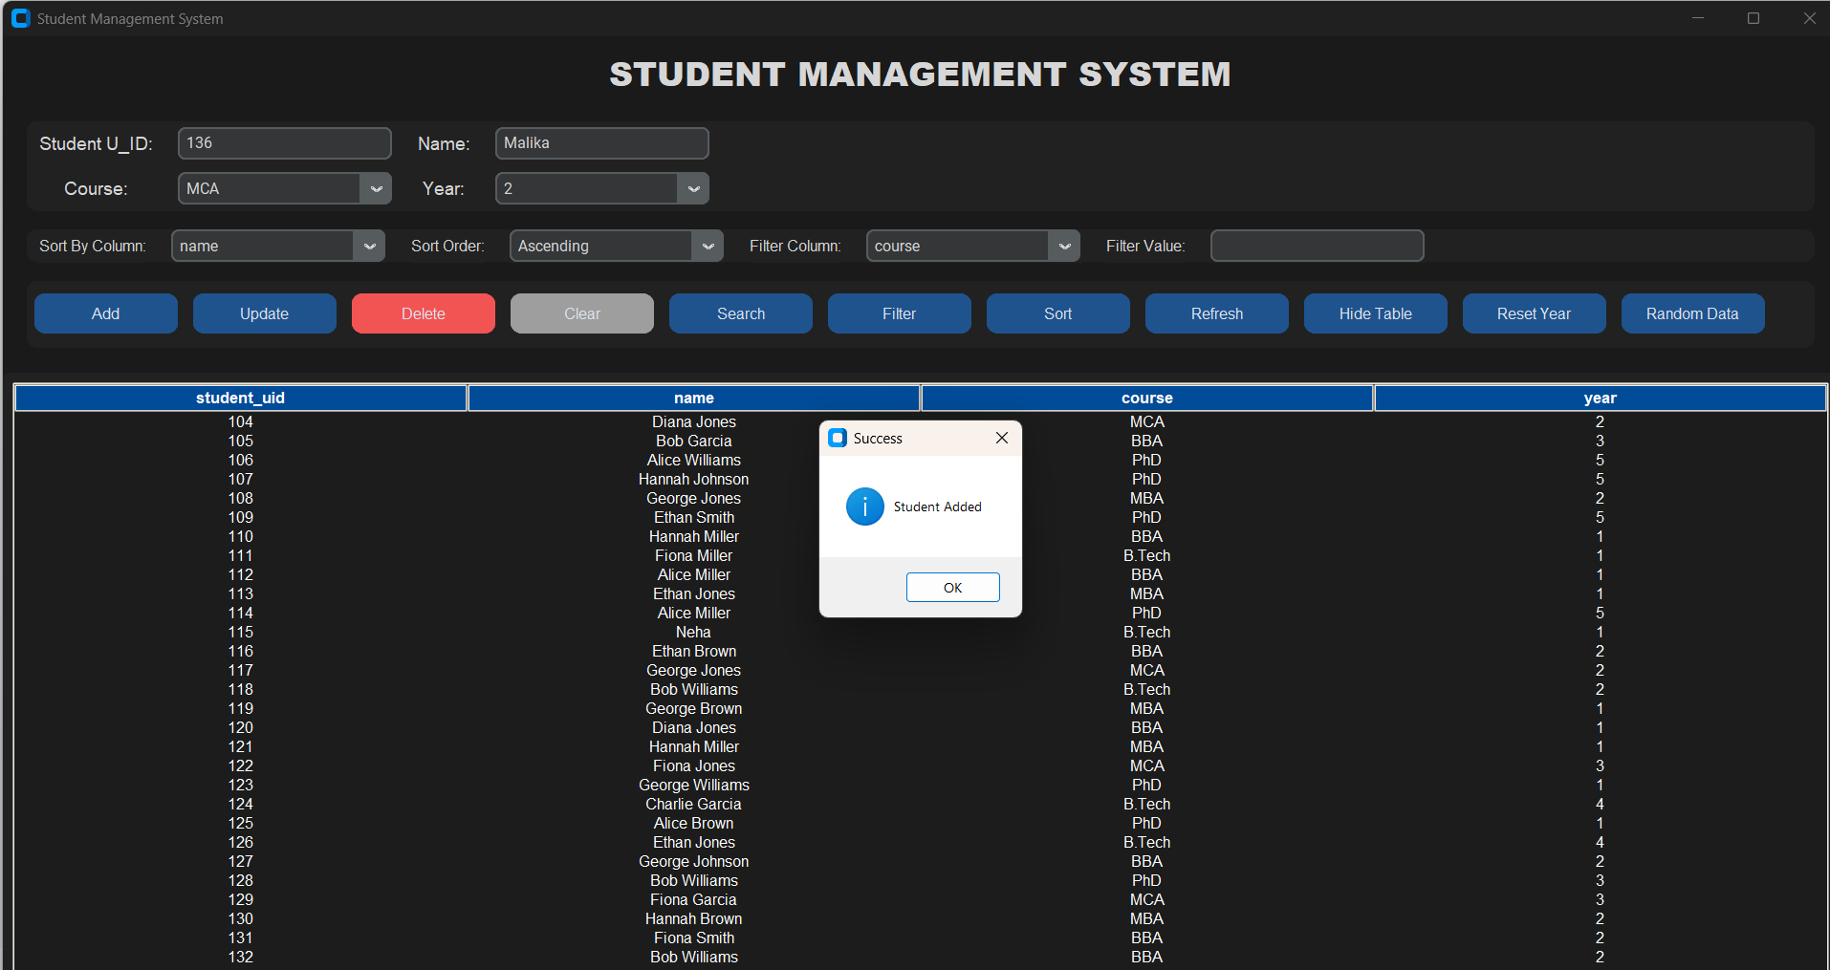
Input fields for Name, Course, and Year are filled and “Add” button is clicked to insert a new record.

- Updating a Student Record
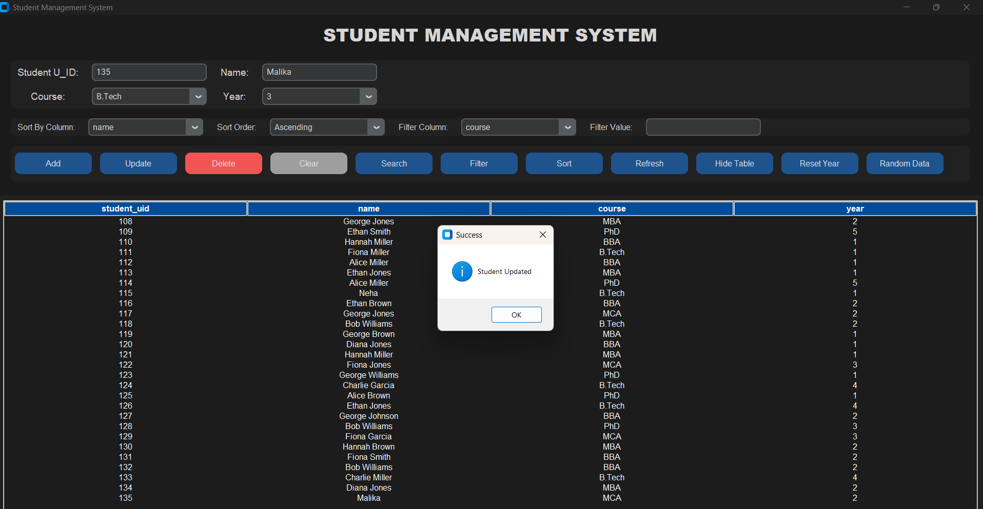
Selected student UID is modified along with Name, Course, or Year, then updated in the database.
- Filtering and Sorting
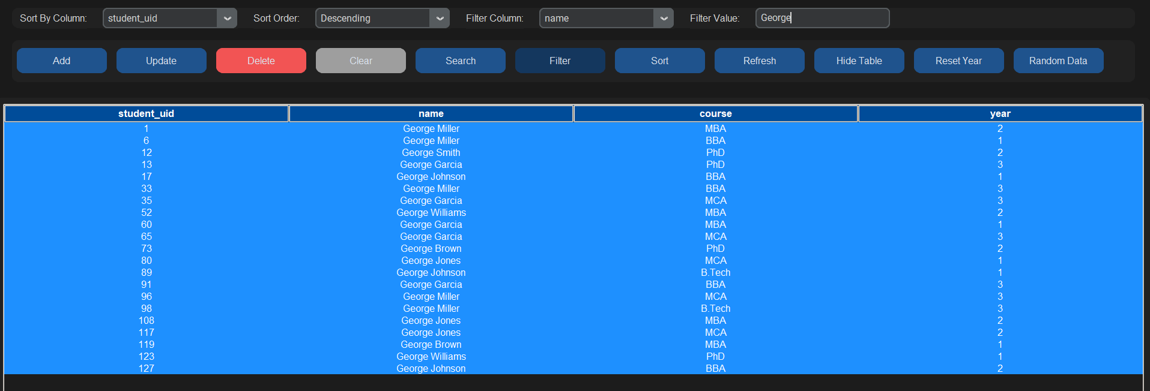
Demonstrates filtering by Course or Year and sorting by Name or UID in ascending/descending order.
- Random Data Generation & Year Reset
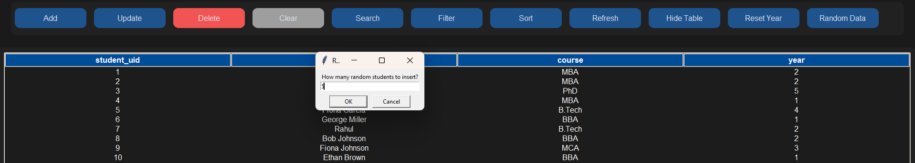
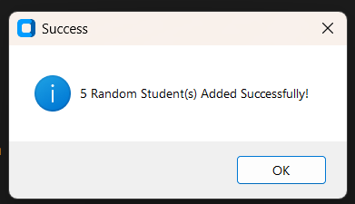
Shows automatically generated student records and the “Reset Year” feature applied according to course duration.
- Deleting a Student Record
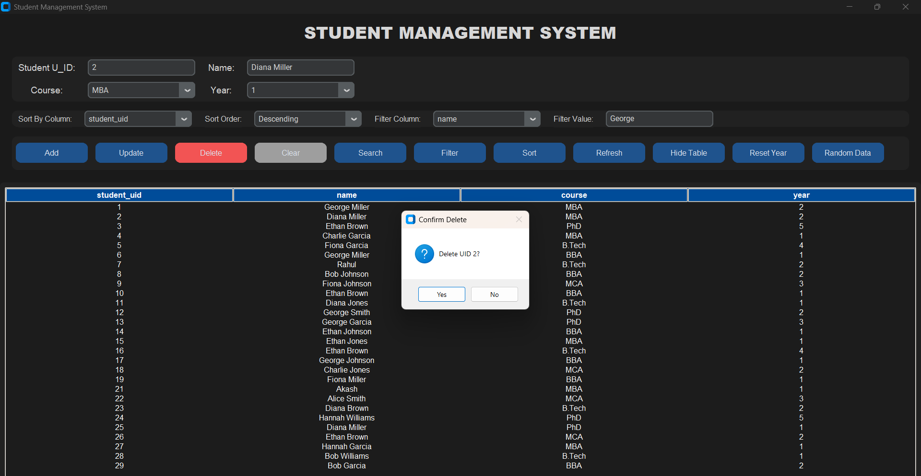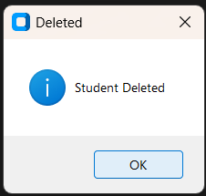
Confirms deletion of a student record from the database and the updated table view.

5. Conclusion
The Student Management System desktop application successfully integrates a range of features to facilitate efficient management of student records in an educational environment. By providing functionalities such as adding, updating, deleting, searching, filtering, and sorting student data, the application offers a streamlined and interactive experience for administrators and faculty members. The combination of Python with CustomTkinter for the frontend and SQLite for the backend ensures a responsive, reliable, and scalable solution for handling student information.
The project not only demonstrates the practical application of programming, database management, and GUI development but also emphasizes the importance of data integrity, input validation, and user-friendly design in administrative tools. Features like random data generation and automated year adjustment according to course duration enhance usability and reduce manual effort.
Future improvements could include advanced reporting and analytics, integration with attendance and grading modules, multi-user access, and enhanced security for sensitive student data.
Overall, the Student Management System serves as an efficient and scalable tool for academic administration, helping institutions maintain accurate student records, streamline workflows, and support informed decision-making.

6. References

1. GitHub: https://github.com/neha23328/Student-Management-System
2. Python Documentation – https://docs.python.org/3/
3. CustomTkinter Documentation – https://github.com/TomSchimansky/CustomTkinter
4. Tkinter Tutorial for GUI Development – https://docs.python.org/3/library/tkinter.html
5. SQLite Documentation – https://www.sqlite.org/docs.html
6. Python SQLite3 Module – https://docs.python.org/3/library/sqlite3.html
7. Treeview Widget in Tkinter – https://docs.python.org/3/library/tkinter.ttk.html#treeview
8. CRUD Operations in Python with SQLite – https://www.geeksforgeeks.org/sqlite-in-python/
9. Sorting and Filtering Data in Python Tables – https://realpython.com/python-sort/
10. Random Data Generation in Python – https://docs.python.org/3/library/random.html

