*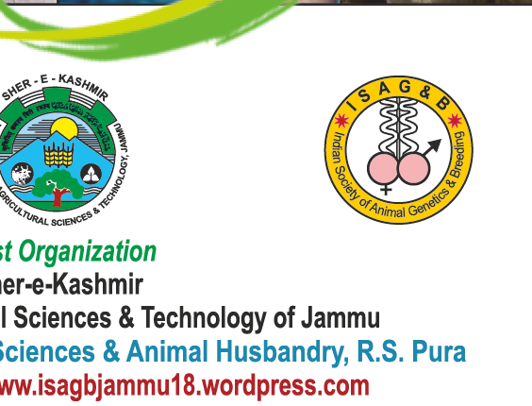*******National Symposium on**

Animal Breeding Policies and Programmes for Sustainable Productivity and the Way Forward &

**XV Annual Convention of Indian Society of Animal Genetics & Breeding**

On 16-17th April, 2020

ISAGB 2020 REGISTRATION FORM

1. Name of the Participant ………………………………………………………………….
2. Designation………………………………………Mobile no. …………………………..
3. ISAGB life member: Yes / No

(If Yes, kindly indicate the Membership No.)

1. Address and e-mail for communication…………………………………………………….

………………………………………………………………………..………….……….…

………………………………………………………………………………………………

1. Date & Expected time of arrival and Departure ………………………………………
   * + Arrival and Departure by train / Flight no. ………………………………………………
2. No. of accompanying persons with age…………………………………………..…..……
3. Accommodation (single / with spouse)…………………………………………….…..….
4. Food preference: (Veg / Non-veg)………………………………………………….….….
5. Accommodation in Hotel: A/C or Non A/C Rooms

|  |  |  |
| --- | --- | --- |
| A/C Double Rooms: Single occupant | | Sharing |
| Non A/C Double Room: |  |  |
| Multiple-Sharing Rooms |  |  |
| University guest House |  |  |
| Dormitories A/C | Non A/C |  |
| Student accommodation: Tariff <250/free | |  |

11. Willing to participate in Post-conference and local trip: Yes / No…………………….…

|  |  |  |  |
| --- | --- | --- | --- |
|  | Post Conference Tour |  | Family Tour |

1. Mode of payment of Registration Fee : Cash / Online Transfer

(For on line transfer: Name of Account holder: ISAGB National Symposium 2020; A/C: 83992300001693; Syndicate Bank, PGIVER, Jamdoli, Jaipur ; IFSC Code : [SYNB0008399](https://economictimes.indiatimes.com/wealth/ifsccode/bank-syndicate-bank,state-rajasthan,district-jaipur,branch-pgiver-jamdoli,ifsccode-SYNB0008399.cms))

1. Amount paid (Rs): …………………………………………………………………………
2. Details of Bank Draft / Online Transfer: Name of Bank ………………………………….

DD / UTR / Transaction ID No ….................................. . dt. ……………..…………..…

Signature of the participant