1.How are inline and block elements different from each other?
Answer: A block-level element always start on a new line and takes up full width available(stretches left and right as far as it can).
The <div></div> is a block level element.
A inline element always does not start on a new line and takes up as much as width necessary.
the <span></span> is a inline element.

2.Explain the difference between visibility:hidden and display:none
Answer: display:none removes the element from the normal flow of the page, allowing other elements to fill in.
visibility:hidden leaves the element in the normal flow of the page such that is still occupies space.

3. Explain the clear and float properties.
Answer: The float property is used for positioning and formatting content e.g. let an image float left to the text in a container.
The clear CSS property sets whether an element must be moved below (cleared) floating elements that precede it. The clear property applies to floating and non-floating elements.

4. Explain difference between absolute, relative,fixed and static.
5. Write the HTML code to create a table in which there are 4 columns( ID , Employee Name, Designation, Department) and at least 6 rows. Also do some styling to it.
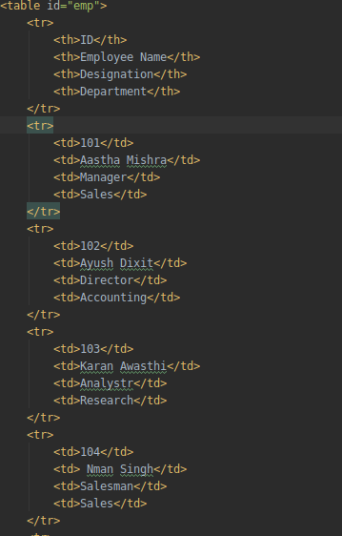

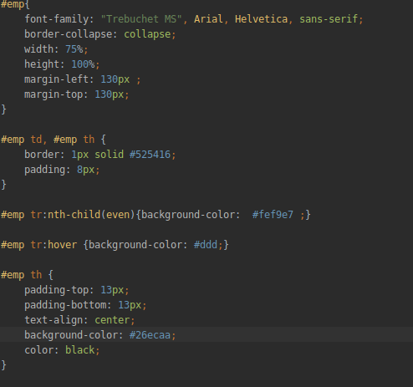
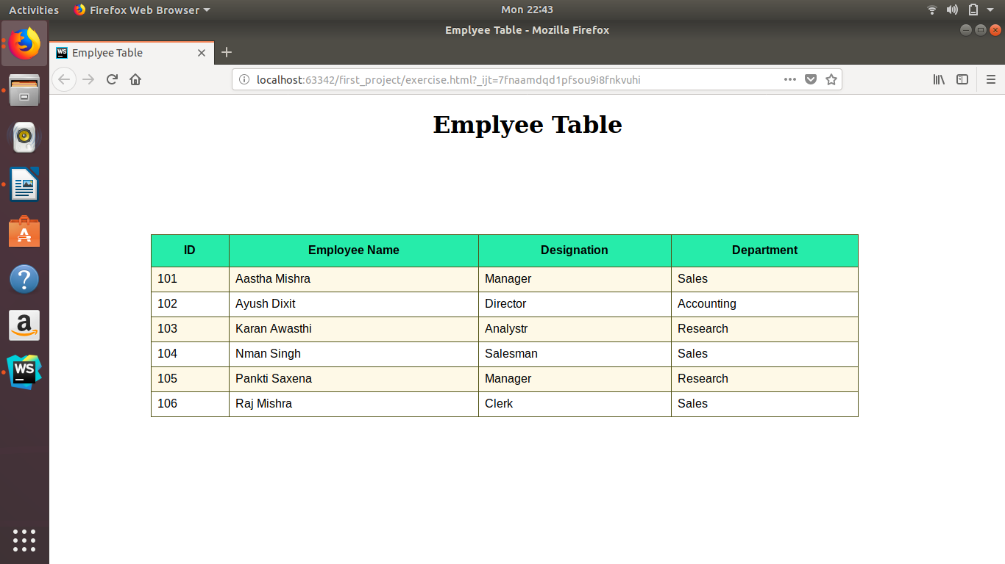
6. Why do we use meta tags?
Ans. Metadata is data (information) about data.
The <meta> tag provides metadata about the HTML document. Metadata will not be displayed on the page, but will be machine parsable.
Meta elements are typically used to specify page description, keywords, author of the document, last modified, and other metadata.
The metadata can be used by browsers (how to display content or reload page), search engines (keywords), or other web services.
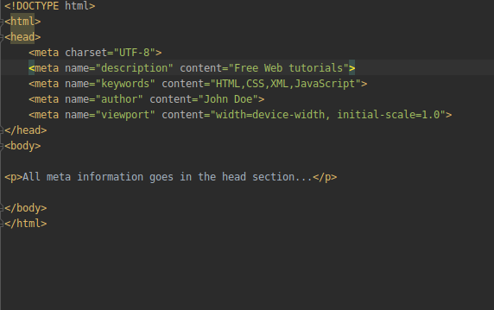

7. Explain box model.
Answer: All HTML elements can be considered as boxes. In CSS, the term "box model" is used when talking about design and layout.
The CSS box model is essentially a box that wraps around every HTML element. It consists of: margins, borders, padding, and the actual content.
Explanation of the different parts:
Content - The content of the box, where text and images appear
Padding - Clears an area around the content. The padding is transparent
Border - A border that goes around the padding and content
Margin - Clears an area outside the border. The margin is transparent

8. What are the different types of CSS Selectors?
Answer: In CSS, selectors are patterns used to select the elements you want to style.
CSS Selectors are as follows:-
1.ID's are unique
->Each element can have only one ID
->Each page can have only one element with that ID
Syntax:
#id {property: value}
2.Classes are NOT unique
->You can use the same class on multiple elements.
->You can use multiple classes on the same element.
Syntax:
.class {property: value}

9. Define Doctype.
Ans. The <!DOCTYPE> declaration must be the very first thing in your HTML document, before the <html> tag.
The <!DOCTYPE> declaration is not an HTML tag; it is an instruction to the web browser about what version of HTML the page is written in.
In HTML 4.01, the <!DOCTYPE> declaration refers to a DTD, because HTML 4.01 was based on SGML. The DTD specifies the rules for the markup language, so that the browsers render the content correctly.
HTML5 is not based on SGML, and therefore does not require a reference to a DTD.
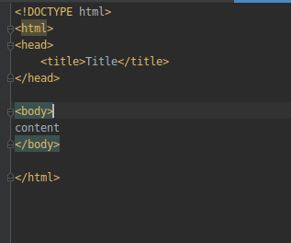
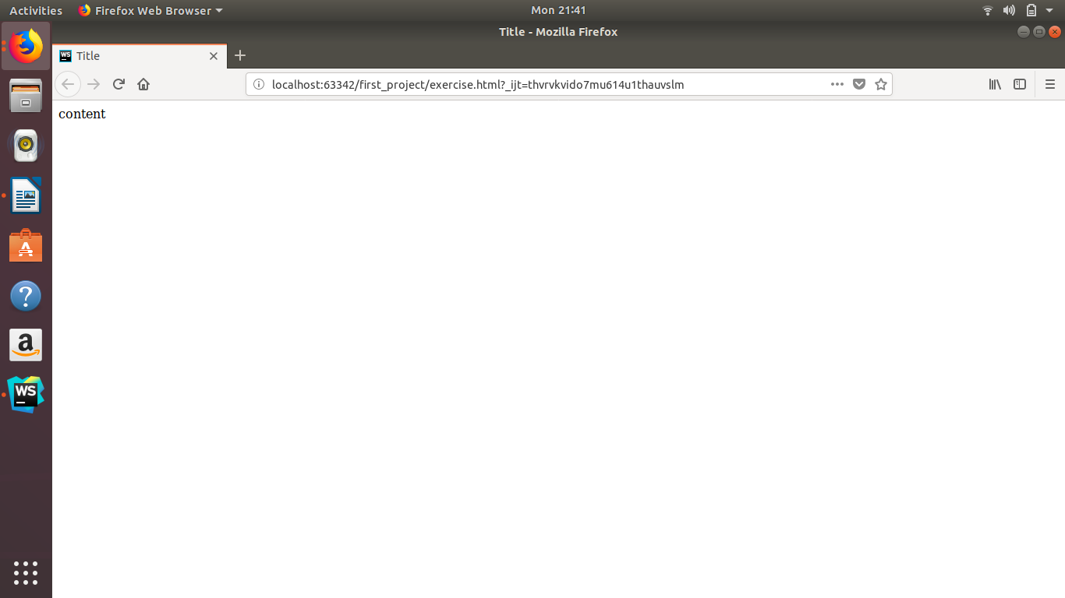

10. Explain 5 HTML5 semantic tags.
Answer: 1.<article> - Defines an article in the document
The <article> tag specifies independent, self-contained content.
An article should make sense on its own and it should be possible to distribute it independently from the rest of the site.
Potential sources for the <article> element:
Forum post
Blog post
News story
Comment
2.<aside> - Defines content aside from the page content like sidebar.
The <aside> tag defines some content aside from the content it is placed in.
The aside content should be related to the surrounding content.
3.<footer> - Defines a footer for the document or a section
The <footer> tag defines a footer for a document or section.
A <footer> element should contain information about its containing element.
4.<header> - Defines a header for the document or a section
The <header> element represents a container for introductory content or a set of navigational links.
A <header> element typically contains:
one or more heading elements (<h1> - <h6>)
logo or icon
authorship information
You can have several <header> elements in one document.
A <header> tag cannot be placed within a <footer> or another <header> element.
5.<nav> - Defines navigation links in the document
NOT all links of a document should be inside a <nav> element. The <nav> element is intended only for major block of navigation links.

11. Create HTML for web-page.jpg (check resources, highest weightage for answers)
12. Create HTML for form.png (check resources, highest weightage for answers)

