Collection Assignment

- Write Java code to define List . Insert 5 floating point numbers in List, and using an iterator, find the sum of the numbers in List.
Ans.1:
import java.util.ArrayList;
import java.util.Iterator;
import java.util.List;
public class ans1 {
public static void main(String[] args) {
List<Float> fnumbers = new ArrayList<Float>();
float sum= 0.0f;
fnumbers.add((float) 3.5);
fnumbers.add((float) 1.2);
fnumbers.add((float) 5.0);
fnumbers.add((float) 4.8);
fnumbers.add((float) 6.2);
for (int i = 0; i < fnumbers.size(); i++) {
System.out.print(fnumbers.get(i)+"\t");
} //finding sum using iterator
Iterator iterator = fnumbers.iterator();
while (iterator.hasNext())
sum= sum+(float)iterator.next();
}
System.out.println("");
//printing sum
System.out.println(sum);
}
}
Output-
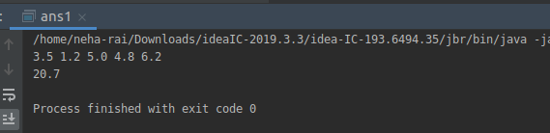

Q.2) Write a method that takes a string and returns the number of unique characters in the string.
Ans-2:
import java .util.*;
public class ans2 {
public static void main(String[] args) {
Scanner sc=new Scanner(System.in);
{ System.out.println("Enter String");
String s=sc.nextLine();
try {
HashSet<Object> str= new HashSet<Object>();
for (int i = 0; i < s.length(); i++) {
str.add(s.charAt(i));
}
Iterator<Object> itr = str.iterator();
while (itr.hasNext()) {
System.out.println(itr.next());
}
} catch (Exception e) {
System.out.println("error");
}
}
}}
Q.3)Write a method that takes a string and print the number of occurrence of each character characters in the string.
Ans-3:
import java.util.*;
public class ans3{
Scanner sc=new Scanner(System.in)
static void characterCount(String inputString
{ HashMap<Character, Integer> charCoun = new HashMap<Character, Integer>();
char[] strArray = inputString.toCharArray();
for (char ch : strArray) {
if (charCount.containsKey(ch)) {
charCount.put(ch, charCount.get(ch) + 1) }
else {charCount.put(ch, 1); } }
for (Map.Entry entry : charCount.entrySet()) {
System.out.println(entry.getKey() + " " + entry.getValue());
}
}
public static void main(String[] args)
{
String str;
Scanner sc=new Scanner(System.in);
System.out.println("enter the string ");
str=sc.nextLine();
characterCount(str }
}
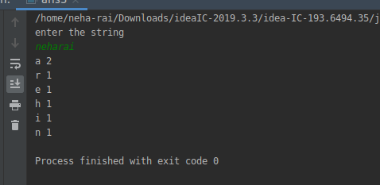

Q.4) Write a program to sort HashMap by value.
Ans-4:
import java.util.*;
public class ans4{
public static HashMap<String, Integer> sortByValue(HashMap<String, Integer> hm)
{ List<Map.Entry<String, Integer> > list =
new LinkedList<Map.Entry<String, Integer> >(hm.entrySet());
Collections.sort(list, new Comparator<Map.Entry<String, Integer> >() {
public int compare(Map.Entry<String, Integer> o1,
Map.Entry<String, Integer> o2)
{ return (o1.getValue()).compareTo(o2.getValue()) }
})
HashMap<String, Integer> temp = new LinkedHashMap<String, Integer>();
for (Map.Entry<String, Integer> aa : list) {
temp.put(aa.getKey(), aa.getValue());
}
return temp;
}
public static void main(String[] args)
{ HashMap<String, Integer> hm = new HashMap<String, Integer>();
hm.put("English", 92);
hm.put("Hindi", 80);
hm.put("Maths", 88);
hm.put("Physics", 75);
hm.put("Chemistry", 98);
hm.put("Biology", 70);
Map<String, Integer> hm1 = sortByValue(hm);
for (Map.Entry<String, Integer> en : hm1.entrySet()) {
System.out.println("Key = " + en.getKey() +
", Value = " + en.getValue());
} }
}
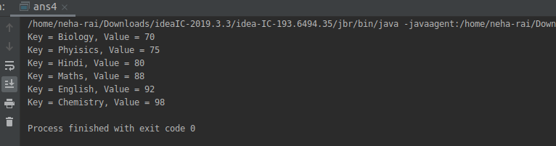

Q.5)Write a program to sort Employee objects based on highest salary using Comparator. Employee class{ Double Age; Double Salary; String Name}
Ans-5:
import java.util.*;
class Emp{
String name;
int age;
int salary;
Emp(String name,int i,int j)
{ this.name=name;
age=i;
salary=j; }
public String getName() {
return name;
}

public void setName(String name) {
this.name = name;
}
public int getAge() {
return age; }
public void setAge(int age) {
this.age = age; }
public int getSalary() {
return salary;
}
public void setSalary(int salary) {
this.salary = salary;
} }
class SalaryComparator implements Comparator
{ @Override
public int compare(Object a, Object b) {
Emp e=(Emp)a;
Emp k=(Emp)b;
return k.salary-e.salary;
} }
class Employee {
public static void main(String args[]) {

ArrayList e = new ArrayList();
e.add(new Emp("Sanjay ", 45, 70000));
e.add(new Emp("Raj",23 , 45000));
e.add(new Emp("Ram",55, 90000));
System.out.println("Sorting by Salary");
Collections.sort(e, new SalaryComparator());
Iterator itr = e.iterator();
while (itr.hasNext()) {
Emp emp = (Emp) itr.next();
System.out.println(emp.age + " " + emp.name + " " + emp.salary);
} }}
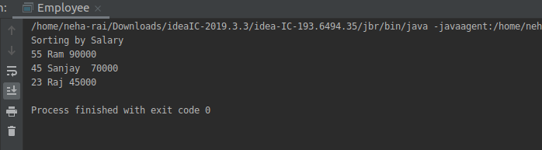

Q.6) Write a program to sort the Student objects based on Score , if the score are same then sort on First Name . Class Student{ String Name; Double Score; Double Age}
Ans-6:
import java.util.*;
class Student{
String name;
double score;
double age;
public Student(String name, double age, double score){
this.name=name;
this.age=age;
this.score=score;
}
public double getAge(){
return this.age;
}
public double getScore(){
return this.score;
}
public String getName(){
return this.name;
}
public String toString(){
return name+" "+age+" "+score;
}
}
public class SortStudentDetails {
public static void main(String[] args) {
Scanner sc = new Scanner(System.in);
List<Student> studentlist = new ArrayList<Student>();
System.out.println("Enter the number of Students");
int num = sc.nextInt();
System.out.println("Enter Employee details as: name,age,score");
for(int i=0; i<num ;i++){
String name = sc.next();
double age = sc.nextDouble();
double score = sc.nextDouble();
studentlist.add(new Student(name,age,score));
}
Collections.sort(studentlist, new Comparator<Student>() {
@Override
public int compare(Student student, Student t1) {
if(student.getScore() == t1.getScore()){
return student.getName().compareTo(t1.getName());
}
else{
if(student.getScore() >t1.getScore()){
return 1;
}
else{
return -1;
}
}
}
});
System.out.println(studentlist); }
}
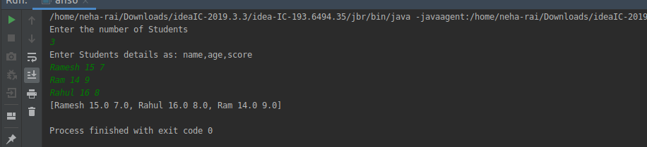

Q.7) Print the elements of an array in the decreasing frequency if 2 numbers have same frequency then print the one which came first.
Ans-7:
import java.util.*;
public class ans7 {
public static void main(String[] args) {
Scanner sc = new Scanner(System.in);
System.out.println("Enter number Of elements");
int n = sc.nextInt();
int[] arr = new int[n+1];
System.out.println("Enter the array elements");
for (int i=0; i<n; i++){
arr[i]=sc.nextInt();
}
System.out.println("Elements Sorted ByFrequency: ");
System.out.println(sort(arr,n));
}
public static ArrayList<Integer> sort(int[] arr, int size){
LinkedHashMap<Integer,Integer> map = new LinkedHashMap<Integer, Integer>();//HashMap<Integer, Integer>();
for (int i=0; i < size; i++){
if (map.containsKey(arr[i])){
int num = map.get(arr[i]);
num++;
map.put(arr[i],num); }
else {
map.put(arr[i],1);
} }

List<Map.Entry<Integer,Integer>> list = new LinkedList<Map.Entry<Integer, Integer>>(map.entrySet());
System.out.println(list);
Collections.sort(list, new Comparator<Map.Entry<Integer, Integer>>() {
@Override
public int compare(Map.Entry<Integer, Integer> integerIntegerEntry, Map.Entry<Integer, Integer> t1) {
if(integerIntegerEntry.getValue() > t1.getValue()){
return -1;
}
else {
return 1;
}
}
});
ArrayList<Integer> result = new ArrayList<Integer>();
for (Map.Entry<Integer,Integer> itr : list){
result.add(itr.getKey());
}
return result;
}
}
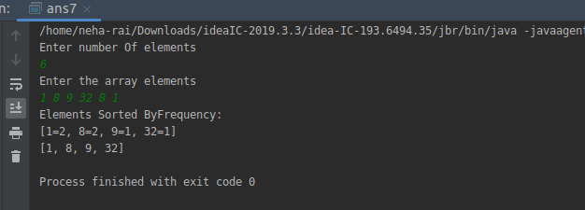

Q.8) Design a Data Structure SpecialStack that supports all the stack operations like push(), pop(), isEmpty(), isFull() and an additional operation getMin() which should return minimum element from the SpecialStack. (Expected complexity O(1))
Ans-8:
import java.util.Scanner;
class SpecialStack {
int limit;
class Node{
int data;
Node link;
}
Node top;
SpecialStack(int n){
this.limit=n;
top =null;
}
int min=Integer.MAX_VALUE;
int size=0;
void push(int x){
Node temp = new Node();
if(size == limit){
System.out.println("\n Stack is full");
return;
}
if (x < min){
min =x;
}
temp.data=x;
temp.link=top;
top=temp;
size++;
}
void pop(){
if (top == null){
System.out.println("Stack is already empty");
return;
}
top =(top).link;
}
int getMin(){
return min;
}
boolean isEmpty(){
return top==null;
}
boolean isFull(){
if(size == limit){
return true;
}
else {
return false;
}
}
void displayStack(){
if(top == null){
System.out.println("Stack is empty nothing to print");
return;
}
else {
Node temp = top;
while (temp != null){
System.out.print(" "+temp.data);
temp = temp.link;
} } } }
public class ans8{
public static void main(String[] args) {
Scanner sc = new Scanner(System.in);
System.out.println("Enter the size Of stack");
int size = sc.nextInt();
SpecialStack stack = new SpecialStack(size);
if (stack.isEmpty()){
System.out.println("Stack is empty, insert element ");
}
System.out.println("Enter stack elements: ");
for (int i=0; i<size; i++){
int num = sc.nextInt();
stack.push(num);
}
stack.displayStack();
System.out.println("\nMinimum element Of stack : "+stack.getMin());
if(stack.isFull()){
System.out.println("\nStack is full");
}
stack.pop();
stack.pop();
System.out.println("\nStack elements after popping out");
stack.displayStack();
}
}
