JAVA8 ASSIGNMENT

Q.1) Write the following a functional interface and implement it using lambda:
(1) First number is greater than second number or not
Parameter (int ,int ) Return boolean
(2) Increment the number by 1 and return incremented value
Parameter (int) Return int
(3) Concatination of 2 string
Parameter (String , String ) Return (String)
(4) Convert a string to uppercase and return .
Parameter (String) Return (String)
Ans:
interface greaterNo{
boolean findGreaterNo(int a, int b);
}
interface increamentNo{
int increament(int a);
}
interface concatenateString{
String concatenate(String s1, String s2);
}
interface conversion{
String uppercase(String s);
}
public class ans1 {
public static void main(String[] args) {
greaterNo g = (a,b)-> {
if (a > b)
return true;
else
return false;
};
System.out.println(g.findGreaterNo(11,45));
increamentNo i= (a)->{
a=a+1;
return a;
};
System.out.println(i.increament(5));
concatenateString c = (s1,s2)->{
String str = s1+s2;
return str;
};
System.out.println(c.concatenate("Ram","Verma"));
conversion v = (s)->{
return (s.toLowerCase());
};
System.out.println(v.uppercase("mountain"));

}
}
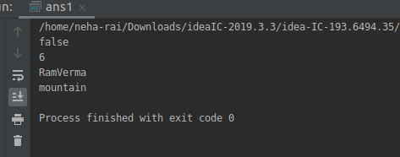

Q.2) Create a functional interface whose method takes 2 integers and return one integer.
Ans-
interface myMethod{
int oneNo(int a, int b);
}
public class ans2 {
public static void main(String[] args) {
myMethod m = (a, b) -> {
return a;
};
System.out.println("\n Returning single value: " + m.oneNo(11, 45));
}
}
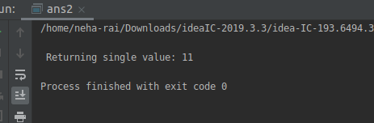
Q.3) Using (instance) Method reference create and apply add and subtract method and using (Static) Method reference create and apply multiplication method for the functional interface created.
Ans-
interface Addition{
int add (int a, int b);
}
interface Subtraction {
int sub(int a, int b);
}
interface Multiplication{
int mul (int a, int b);
}
public class ans3 {
public int add1 (int a, int b){
return a+b;
}
public int sub1 (int a, int b){
return a - b;
}
public static int multiplication (int a, int b){
return a * b;
}
public static void main(String[] args) {
Addition add = new ans3()::add1;
Subtraction sub= new ans3()::sub1;

Multiplication multiplication = ans3::multiplication;

System.out.println("Addition of Two Numbers is: "+add.add(6,94));
System.out.println("Subtraction Of Two Numbers is: "+sub.sub(100,6));
System.out.println("Multiplication Of Two Numbers is: "+multiplication.mul(5,20));
} }
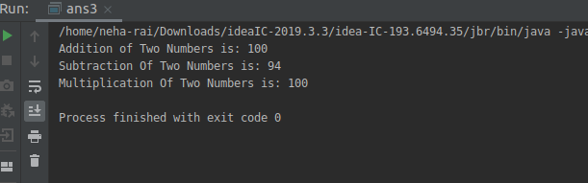

Q.4) Create an Employee Class with instance variables (String) name, (Integer)age, (String)city and get the instance of the Class using constructor reference
Ans:
interface Employee1{
Employee getInfo(String name, int age, String city);
}
class Employee{
String name;
int age;
String city;
Employee(String name1, int age1, String city1){
this.name = name1;
this.age = age1;
this.city = city1;
System.out.println("Name of Employee: "+name);
System.out.println("Age of Employee: "+age);
System.out.println("City of Employee: "+city);
}
}
public class ans4 {
public static void main(String[] args) {
Employee1 e = Employee::new;
e.getInfo("Neha",22,"Greater Noida");
e.getInfo("Pragati",21,"Noida");
}
}
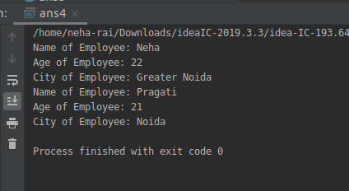

Q.5) Implement following functional interfaces from java.util.function using lambdas:
(1) Consumer
(2) Supplier
(3) Predicate
(4) Function
Ans:
1) import java.util.Arrays;
import java.util.List;
import java.util.function.Consumer;
import java.util.function.Supplier;
public class ans5 {
public static void main(String[] args) {
List<String> list = Arrays.asList("blue","red","yellow","brown","black");
Consumer<String> t = s -> System.out.println(s);
list.forEach(t); }
}
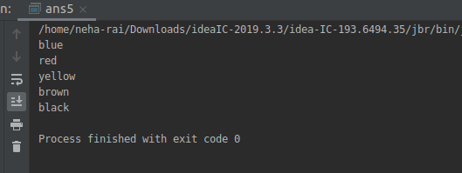
2) import java.util.Arrays;
import java.util.List;
import java.util.function.Supplier;
public class ans5{
public static void main(String[] args) {
List<String> list = Arrays.asList("table", "chair", "bed", "T.V","Fan");
list.forEach((item)->{printnames(()->item);});
}
public static void printnames(Supplier<String> supplier){
System.out.println(supplier.get());
}
}
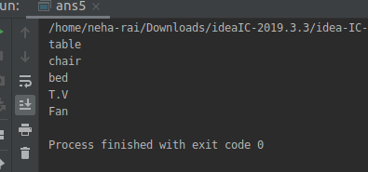
3)
import java.util.function.Predicate;
public class ans5{
public static void main(String[] args) {
Predicate<Integer> predicate = ans5::isEven;
System.out.println("\n"+predicate.test(2));
System.out.println("\n"+predicate.test(23));
}
static boolean isEven(int n){
if (n% 2 == 0){
return true;
}
else{
return false;
}
}
}
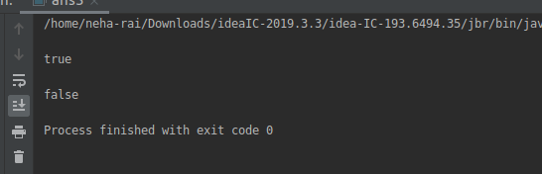
4)
import java.util.function.Function;

public class ans5{
public static void main(String[] args) {
Function<Integer,Integer> function = a -> a/2;
function = function.andThen(a -> a*6);
System.out.println("\n Result of AndThen Function: "+function.apply(25));
}
}
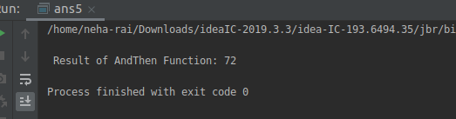
Q-6) Create and access default and static method of an interface.
Ans:
interface DefaultAndStaticDemo{
static boolean isEven(int a){
if (a%2 ==0){
return true;
}
else{
return false;
}
}
default boolean isOdd(int a){
if(a%2 != 0){
return true;
}
else {
return false;
}
}
}
public class DefaultAndStaticMethodsOfInterface implements DefaultAndStaticDemo {
public static void main(String[] args) {
DefaultAndStaticMethodsOfInterface obj = new DefaultAndStaticMethodsOfInterface(); System.out.println(DefaultAndStaticDemo.isEven(24));
System.out.println(DefaultAndStaticDemo.isEven(23));
System.out.println(obj.isOdd(23));
System.out.println(obj.isOdd(24));
}
}
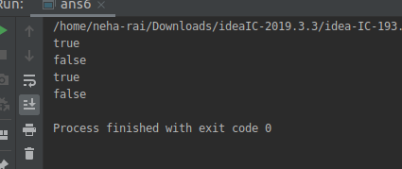
Q.7) Override the default method of the interface.
Ans-
interface Demo{
default void Details(){
System.out.println("This is interface method");
}
}
public class ans7 implements Demo{
@Override
public void Details(){
System.out.println("This is class Method:");
}
public static void main(String[] args) {
ans7 obj = new ans7();
obj.Details();
}
}
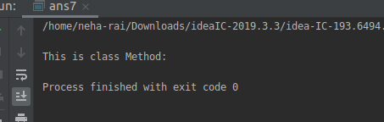
Q.8) Implement multiple inheritance with default method inside interface.
Ans:
interface even{
default boolean isEven(int a){
if (a%2 == 0){
return true;
}
else{
return false;
}
}
}
interface odd{
default boolean isOdd(int a){
if (a%2 != 0){
return true;
}
else{
return false;
}
}
}
public class ans8 implements even,odd{
public static void main(String[] args) {
ans8 obj = new ans8();
System.out.println("Method of even interface: "+obj.isEven(38));
System.out.println("Method of odd interface: "+obj.isOdd(93));
}
}
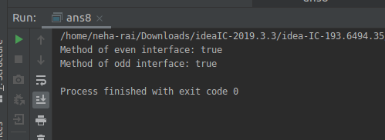

Q.9) Collect all the even numbers from an integer list.
Ans-
import java.util.Arrays;
import java.util.List;
import java.util.stream.Collector;
import java.util.stream.Collectors;
public class ans9 {
public static void main(String[] args) {
List<Integer> list = Arrays.asList(1,2,3,4,5,6,7,8,9,10);
System.out.println(
list
.stream()
.filter(e->(e%2==0))
.collect(Collectors.toList()) );
}
}
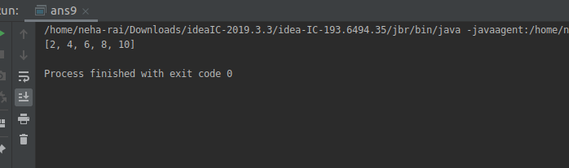
Q.10) Sum all the numbers greater than 5 in the integer list.
Ans-
import java.util.Arrays;
import java.util.List;
import java.util.stream.Collectors;
public class ans10 {
public static void main(String[] args) {
List<Integer> list = Arrays.asList(1,2,3,4,5,6,7,8,9,10);
System.out.println(
list
.stream()
.filter(e->e>5)
//.collect(Collectors.toList())
.collect(Collectors.summingInt(e->e)) );
}
}
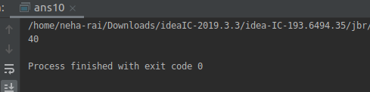

Q.11) Find average of the number inside integer list after doubling it.
Ans-
import java.util.Arrays;
import java.util.List;
import java.util.stream.Collectors;
public class ans11 {
public static void main(String[] args) {
List<Integer> list = Arrays.asList(1,2,3,4,5,6,7,8,9,10);
System.out.println(
list
.stream()
.map(e->e*2)
.collect(Collectors.averagingInt(e->e)) );
} }
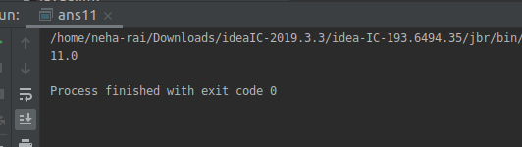

Q.12) Find the first even number in the integer list which is greater than 3.
Ans-
import java.util.Arrays;
import java.util.List;
import java.util.stream.Collectors;
public class ans12 {
public static void main(String[] args) {
List<Integer> list = Arrays.asList(1,2,3,4,5,6,7,8,9,10);
System.out.println(
list
.stream()
.filter(e->e>3)
.filter(e->e%2==0)
.findFirst() );
}
}
