MULTITHREADING PROGRAM

Q.1) Write a program do to demonstrate the use of volatile keyword.
Ans.1:
public class ans1 {
private volatile int count=0;
public static void main(String[] args) {
ans1 work = new ans1();
work.threadworking();

}
public void threadworking()

{
Thread t1 = new Thread(new Runnable() {
@Override
public void run() {
for (int i = 0; i < 10000; i++) {
count++;
}
}
});
Thread t2 = new Thread(new Runnable() {
@Override
public void run() {
for (int i = 0; i < 10000; i++) {
count++;
}
}
});
t1.start();
t2.start();
try {
t1.join();
t2.join();
} catch (InterruptedException e) {
e.printStackTrace();
}
System.out.println(count);
}
}
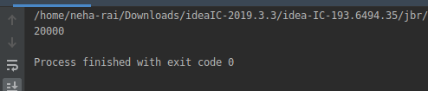

Q.2)Write a program to create a thread using Thread class and Runnable interface each.
Ans-2:
Thread class:
public class ans2 {

public static void main(String[] args) {
Runner runner1 = new Runner();
runner1.start();
Runner runner2 = new Runner();
runner2.start(); }
}
class Runner extends Thread {

@Override
public void run() {
for(int i=0; i<10; i++) {
System.out.println("Hello TTN: " + i);

try {
Thread.sleep(800);
} catch (InterruptedException e) {

e.printStackTrace(); }
}
}
}

Output-
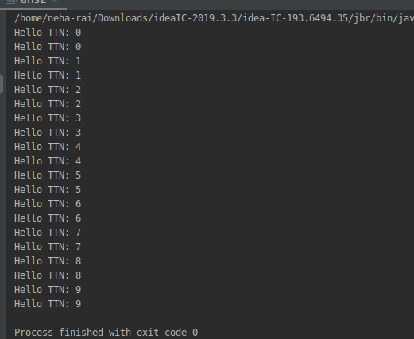

Using Runnable Interface:
class ans02 {
public static void main(String[] args) {
Thread thread1 = new Thread(new ghs());
thread1.start(); }
}
class abc implements Runnable {

@Override
public void run() {
for(int i=0; i<5; i++) {
System.out.println("Hello: " + i);

try {
Thread.sleep(100);
} catch (InterruptedException e) {

e.printStackTrace() } } } }
Output-
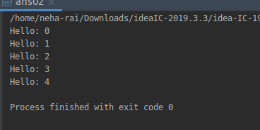

Q.3) Write a program using synchronization block and synchronization method
Ans-3:
Synchronized method
import java.util.Scanner;
class sync{
//Synchronized Method
synchronized public void getLine()
{ for (int i = 0; i < 3; i++) {
System.out.println(i);
try {
Thread.sleep(400);
} catch (Exception e) {
System.out.println(e);
}
}
System.out.println("End of Synchronized Method");
}
class myClass extends Thread
{
sync l;

myClass(sync t)
{
this.l = t;
}

@Override
public void run()
{
l.getLine();
}
}
public class ans3
{
public static void main(String[] args) {
sync obj = new sync();
myClass th1=new myClass(obj);
myClass th2=new myClass(obj);
th1.start();
th2.start();
}
}
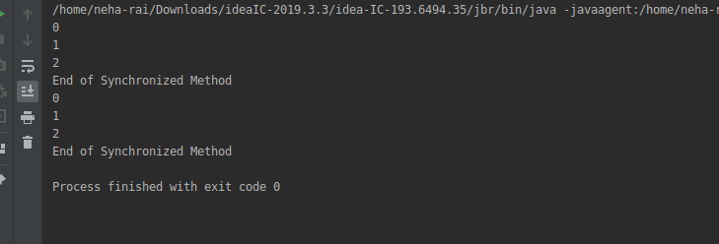

Synchronized block

import java.util.Scanner;
class Line {

//Synchronized Block
public void getLine() {
synchronized (this) {
for (int i = 0; i < 4; i++) {
System.out.println(i);
try {
Thread.sleep(400);
} catch (Exception e) {
System.out.println(e);
}
}
System.out.println("End of Synchronized BLock");
}
}
}
class myClass extends Thread
{
sync l;
myClass(sync t)
{
this.l = t;
}
@Override
public void run()
{
l.getLine();
}
}
public class ans3
{
public static void main(String[] args) {
sync obj = new sync();
myClass th1=new myClass(obj);
myClass th2=new myClass(obj);
th1.start();
th2.start();
}
}
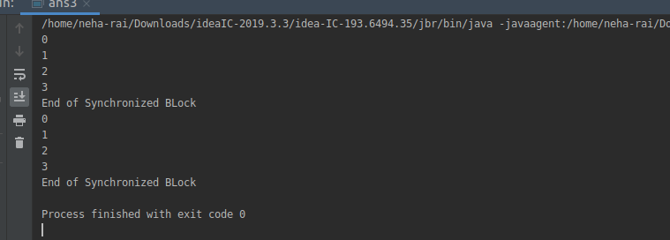

Q.4)Write a program to create a Thread pool of 2 threads where one Thread will print even numbers and other will print odd numbers.
Ans-
import java.util.concurrent.Executor;
import java.util.concurrent.Executors;
public class ans4 {public static int number;
public static void main(String[] args){
final int max = 10;
Executor executor = Executors.newFixedThreadPool(2);
final Object lock = new Object();
executor.execute(new Runnable() {
@Override
public synchronized void run() {
while (number < max) {
if (number % 2 == 0)
number = number+1;
System.out.println(Thread.currentThread().getName()+" "+number+" ");
synchronized(lock){
lock.notify(); }
}else{ synchronized(lock){
try {
lock.wait();
} catch (InterruptedException e) {
e.printStackTrace();
} } } } }
});
executor.execute(new Runnable() {
@Override
public synchronized void run() {
try {
Thread.sleep(500);
}catch (Exception e)
{ e.printStackTrace(); }
while (number < max) {
if (number% 2 != 0) {
number++;
System.out.println(Thread.currentThread().getName()+" "+number+" ");

synchronized(lock){
lock.notify();}
}else{ synchronized(lock){
try {
lock.wait();
} catch (InterruptedException e)
e.printStackTrace();
} } } } }
});
do { try {
Thread.currentThread().sleep(2000);
} catch (InterruptedException e) {
e.printStackTrace();}
} while (number!= max);
System.out.println("THE END");
} }
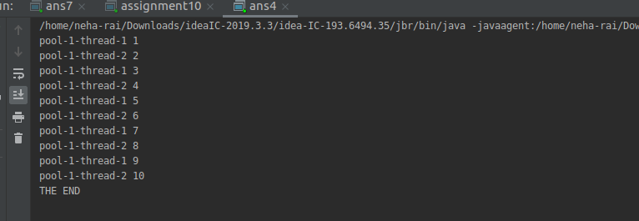

Q.5)Write a program to demonstrate wait and notify methods.
Ans-5:
public class ans5 {
public static void main(String[] args) throws InterruptedException {
wn s=new wn();
Thread t=new Thread(s);
t.start();
synchronized (t){
try{
System.out.println("wait till Sum class finishes");
t.wait();
Thread.sleep(200);
}
catch (InterruptedException e){
e.printStackTrace();
}
}
System.out.println("total is: "+s.sum);
} }
class wn implements Runnable{
int sum=0;
@Override
public void run() {
synchronized (this){
for(int i=0;i<100;i++)
sum+=i;
notify(); } } }
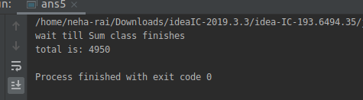
Q.6) Write a program to demonstrate sleep and join methods.
Ans-6:
public class ans6{
public static void main(String[] args) {
sj s1=new sj();
sj s2=new sj();
s1.start();;
s2.start();
} }
class sj extends Thread {
@Override
public void run() {
sj sp= new sj();
try {
for (int i = 0; i < 10; i++) {
System.out.println("Thread name: " + sp.getName() + " " + i);
sp.sleep(500);
}
} catch (InterruptedException e) {
e.printStackTrace();
} } }

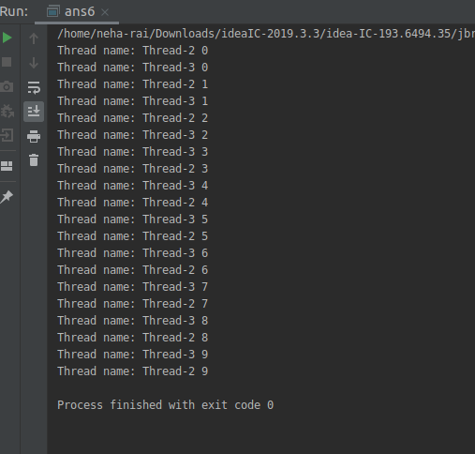

Q.7)Run a task with the help of callable and store it's result in the Future.
Ans:

import java.util.concurrent.*;

public class ans7 {

public static void main(String... args) throws ExecutionException, InterruptedException {
ExecutorService es = Executors.newSingleThreadExecutor();
System.out.println("submitted callable task to calculate factorial of 10");
Future result10 = es.submit(new FactorialCalculator(10));
System.out.println("submitted callable task to calculate factorial of 15");
Future result15 = es.submit(new FactorialCalculator(15));
System.out.println("Calling get method of Future to fetch result of factorial 10");
long factorialof10 = (long) result10.get();
System.out.println("factorial of 10 is : " + factorialof10);
System.out.println("Calling get method of Future to get result of factorial 15");
long factorialof15 = (long)result15.get();
System.out.println("factorial of 15 is : " + factorialof15); }

}
class FactorialCalculator implements Callable<Long> {
private int number;
public FactorialCalculator(int number){
this.number = number; }
@Override
public Long call() throws InterruptedException {
return factorial(number);
}
private long factorial(int n) throws InterruptedException {
long result = 1;
while (n != 0) {
result = n * result;
n = n - 1;
Thread.sleep(100);
}
return result;
} }

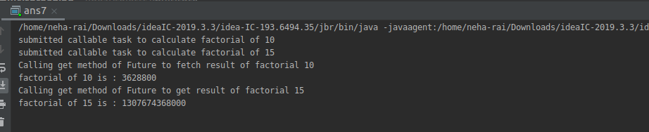

Q.8) Write a program to demonstrate the use of semaphore
Ans 8:
import java.util.concurrent.Semaphore;
public class ans8 {
static Semaphore semaphore = new Semaphore(4);
static class MyATMThread extends Thread {
String name = "";
MyATMThread(String name) {
this.name = name;
}
public void run() {
try {
System.out.println(name + " : acquiring lock...");
System.out.println(name + " : available Semaphore permits now: "
+ semaphore.availablePermits());
semaphore.acquire();
System.out.println(name + " : got the permit!");

try { for (int i = 1; i <= 5; i++) {
System.out.println(name + " : is performing operation " + i
+ ", available Semaphore permits : "
+ semaphore.availablePermits());
Thread.sleep(1000 );} finally {
System.out.println(name + " : releasing lock...");
semaphore.release();
System.out.println(name + " : available Semaphore permits now: "
+ semaphore.availablePermits());}

} catch (InterruptedException e) {
e.printStackTrace(); } } }
public static void main(String[] args) {
System.out.println("Total available Semaphore permits : "
+ semaphore.availablePermits());
MyATMThread t1 = new MyATMThread("A");
t1.start();
MyATMThread t2 = new MyATMThread("B");
t2.start();
MyATMThread t3 = new MyATMThread("C");
t3.start(); } }
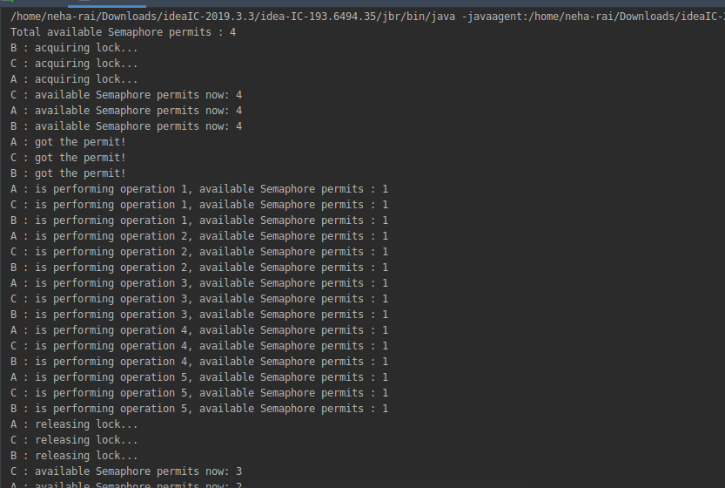

Q.9) Write a program to demonstrate the use of CountDownLatch.
Ans:
import java.util.concurrent.CountDownLatch;
public class ans9
{ public static void main(String args[])
throws InterruptedException
{ CountDownLatch latch = new CountDownLatch(4);
Worker first = new Worker(1000, latch,
"WORKER-1");
Worker second = new Worker(2000, latch,
"WORKER-2");
Worker third = new Worker(3000, latch,
"WORKER-3");
Worker fourth = new Worker(4000, latch,
"WORKER-4");
first.start();
second.start();
third.start();
fourth.start();
latch.await();
System.out.println(Thread.currentThread().getName() +
" has finished");
} }
class Worker extends Thread
{ private int delay;
private CountDownLatch latch;
public Worker(int delay, CountDownLatch latch,
String name)
{ super(name);
this.delay = delay;
this.latch = latch;}
@Override
public void run()
{ try
{ Thread.sleep(delay);
latch.countDown();
System.out.println(Thread.currentThread().getName()
+ " finished"); }
catch (InterruptedException e)
{ e.printStackTrace();
} } }
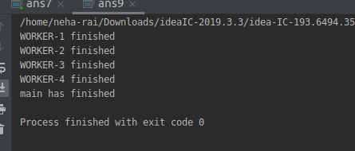
Q.10) Write a program which creates deadlock between 2 threads
Ans-10
import java.util.*;
import java.lang.*;
import java.io.*;

class assignment10 {
String str1 = "ToThe";
String str2 = "New";
Thread thd1 = new Thread("My Thread 1"){
public void run(){
while(true){
synchronized(str1){
synchronized(str2){
System.out.println(str1 + str2);
} } } } };
Thread thd2 = new Thread("My Thread 2"){
public void run(){
while(true){
synchronized(str2){
synchronized(str1){
System.out.println(str2 + str1);
} } } } };
public static void main(String a[]){
assignment10 sol = new assignment10();
sol.thd1.start();
sol.thd2.start();
} }
