2017

Neha Arora - 101043939

Assignment1 – Trick Or Treat Game

10/18/2017

Comp3064 – Assignment1

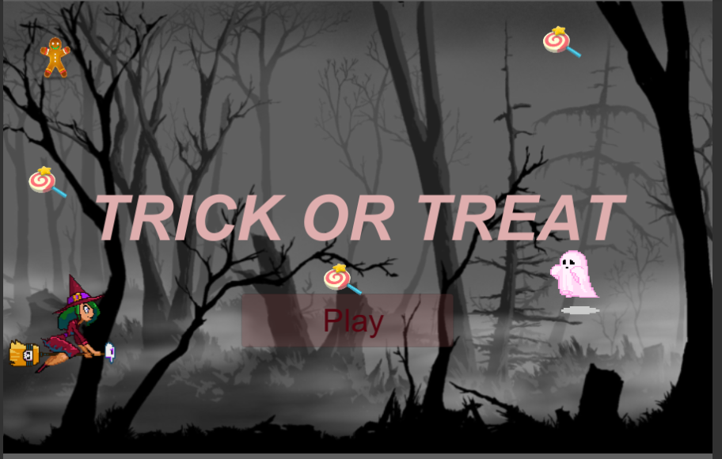

Table of Content

* 1. **Detailed Game Description** – describing how your game works
  2. **Controls description**
  3. **Interface Sketch** – this section should include wireframes of each of your game screens with appropriate labels
  4. **Screen Descriptions** – Include at least 3 screen shots for your game: 1 for your Start State, 1 for your Gameplay State and 1 for your Game-End State
  5. **Enemies** – Describe the computer controlled enemies and how they function
  6. **Scoring** – Describe how the player can score and how the score is calculated
  7. **Sound Index** – Include an index of all your sound clips
  8. **Art / Multimedia Index** – Include examples of your image assets. Each image should be displayed as a thumbnail

Game Description

* Game Name – Trick or Treat Game
* Game Theme – Halloween
* This game has a main character called “Halloween Girl” who is travelling to collect candies and tries to avoid ghost on her way. She flies like a witch on her magic broomstick throughout the game.
* Game begins with 0 score of candies and 3 lives for the main character.
* This game lets our main character to score points by collecting candies. She earns 10 points for each candy and 20 points for each ginger man.
* If she gets collides with the enemy (i.e., the ghost), she loses one life. If lives are 0 then game overs and user can play it over again.

Control Description

* User can use (W, S, A, D) keys to move the character up, down, left and right respectively.
* User can also use arrows from the keyboard. (left/right arrow, up/down arrow).

Interface sketch

TRICK OR TREAT

Play

Screen Description

* Screen 1 – Start game
* Screen 2 – Game state while playing

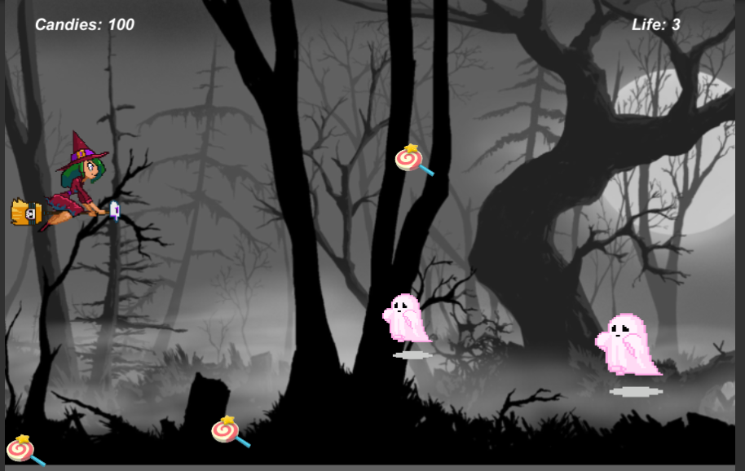

* Screen – Game over

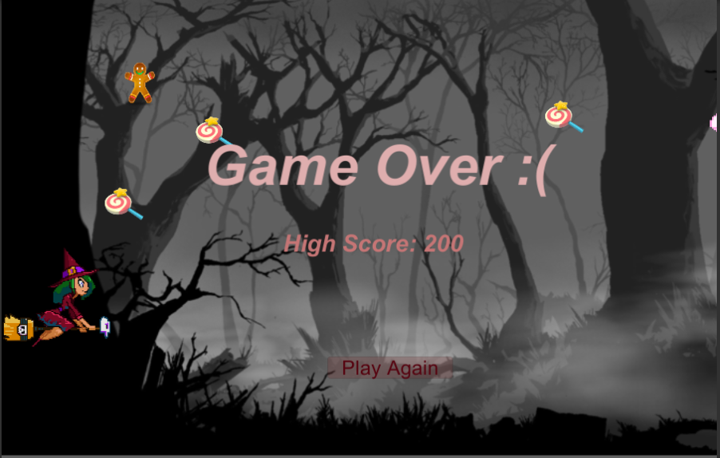

Enemies

* In this game, enemy of the Halloween girl is the ghost who takes her 1 life every time he collides with her. There is no any functionality to kill or destroy him rather to avoid him and not to collide with him.
* In a single screen at a time, a user can see two ghosts coming towards the character from any random position and the main character must avoid him.
* When the girl collides with ghost, she blinks which refers to lost of her one life.

Scoring

* Score in this game are referred as candy score. Number of candies denotes the score of the character.
* If a user manages to collect a candy, 10 points are added to the candy score and if a user collects a ginger man candy then 20 points are added to the score board.
* Colliding with the enemy each time effects life of the character but not the score and if life is equal to 0 then the game overs.

Sound index

* Sound when a candy/ginger man is collected:



* Sound when collides with the ghost:



* Music when the game is loaded:



Art/multimedia index

* Halloween Girl:



* Ghost:



* Candy:



* Ginger Man:



* Background:

