Smart Asset Management System
Project Objective
The Smart Asset Management System is a web-based application developed to efficiently manage IT assets within an organization. The system will help administrators register, assign, maintain, and monitor assets while tracking warranties, software licenses, maintenance schedules, and asset history.
Functional Features
- User Login
- Dashboard
- Asset Registration
- Asset Categories
- Employee Management
- Asset Assignment
- Asset Return
- Maintenance Scheduling
- Warranty Tracking
- Software License Tracking
- QR Code Generation
- Inventory Dashboard
- Asset Depreciation Report
- Audit Logs

Project Modules
Authentication
• Login
• Logout
Asset Management
• Add Asset
• Update Asset
• Delete Asset
• View Assets
Employee Management
• Add Employee
• Edit Employee
• Delete Employee
Assignment
• Assign Asset
• Return Asset
Maintenance
• Schedule Maintenance
• Update Status
Warranty
• Warranty Details
• Expiry Alerts
Software License
• Add License
• Update License
• Track Expiry
QR/Barcode
• Generate QR Code
• Scan Asset QR Code
Reports
• Dashboard
• Inventory Report
• Depreciation Report
Audit
• History Logs
Database Tables
Assets
Employees
Assignments
Maintenance
Users
SoftwareLicenses
AuditLogs
Categories
Vendors
Technology Stack
Frontend
- HTML5
- CSS3
- Bootstrap 5
- JavaScript
Backend
- Node.js
- Express.js
Database
- MySQL
API
- RESTful APIs
Version Control
- Git
- GitHub
Code Editor
- Visual Studio Code

1. Project Scope
The Smart Asset Management System is designed to help organizations efficiently manage their IT assets. The system allows administrators to register assets, assign them to employees, track maintenance schedules, monitor warranty and software licenses, generate reports, and maintain audit logs. The system aims to improve asset tracking, reduce manual work, and ensure accurate inventory management.
2. User Roles
Admin
- Login to the system
- Manage assets
- Manage employees
- Assign assets
- Schedule maintenance
- Track warranty
- Generate reports
- View audit logs

Employee
- View assigned assets
- Request maintenance
- Return assigned assets
3. Functional Requirements
- User Authentication
- Asset Registration
- Asset Management
- Employee Management
- Asset Assignment
- Asset Return
- Maintenance Scheduling
- Warranty Tracking
- Software License Tracking
- QR Code Generation
- Inventory Dashboard
- Audit Logs
- Reports

4. Non-Functional Requirements
- User-friendly interface
- Secure login system
- Fast response time
- Responsive design
- Data accuracy
- Database backup support

5. Software Requirements
- Visual Studio Code
- Node.js
- Express.js
- MySQL
- XAMPP
- Git
- GitHub
- Postman
- Google Chrome

6. Hardware Requirements
- Windows 10/11
- Minimum 8 GB RAM
- Intel Core i3 or above
- Internet Connection

7. Database Design
Users Table
Column | Data Type
user_id | INT (Primary Key)
name | VARCHAR(100)
email | VARCHAR(100)
password | VARCHAR(255)
role | ENUM(Admin,  Employee)

Assets Table
Column | Data Type
asset_id | INT (Primary Key)
asset_name | VARCHAR(100)
category_id | INT
brand | VARCHAR(100)
model | VARCHAR(100)
serial_number | VARCHAR(100)
purchase_date | DATE
purchase_cost | DECIMAL(10,2)
warranty_expiry | DATE
status | ENUM(Available, Assigned, Maintenance)

Categories Table
Column | Data Type
category_id | INT (Primary Key)
category_name | VARCHAR(100)

Employees Table
Column | Data Type
employee_id | INT (Primary Key)
employee_name | VARCHAR(100)
department | VARCHAR(100)
designation | VARCHAR(100)
email | VARCHAR(100)

Asset Assignments Table
Column | Data Type
assignment_id | INT (Primary Key)
asset_id | INT
employee_id | INT
assigned_date | DATE
return_date | DATE
status | VARCHAR(50)

Maintenance Table
Column | Data Type
maintenance_id | INT (Primary Key)
asset_id | INT
maintenance_date | DATE
description | TEXT
status | VARCHAR(50)

Software Licenses Table
Column | Data Type
license_id | INT (Primary Key)
software_name | VARCHAR(100)
license_key | VARCHAR(255)
expiry_date | DATE

Audit Logs Table
Column | Data Type
log_id | INT (Primary Key)
user_id | INT
action | VARCHAR(255)
log_date | DATETIME

8. Database Relationships
- Categories → Assets (One-to-Many)
- Vendors → Assets (One-to-Many)
- Employees → Assignments (One-to-Many)
- Assets → Assignments (One-to-Many)
- Assets → Maintenance (One-to-Many)
- Assets → Software Licenses (One-to-Many)
- Users → Audit Logs (One-to-Many)

Database Name: smart_asset_db
9. Entity Relationship Diagram (ERD)
The following ER Diagram represents the database structure and relationships used in the Smart Asset Management System.
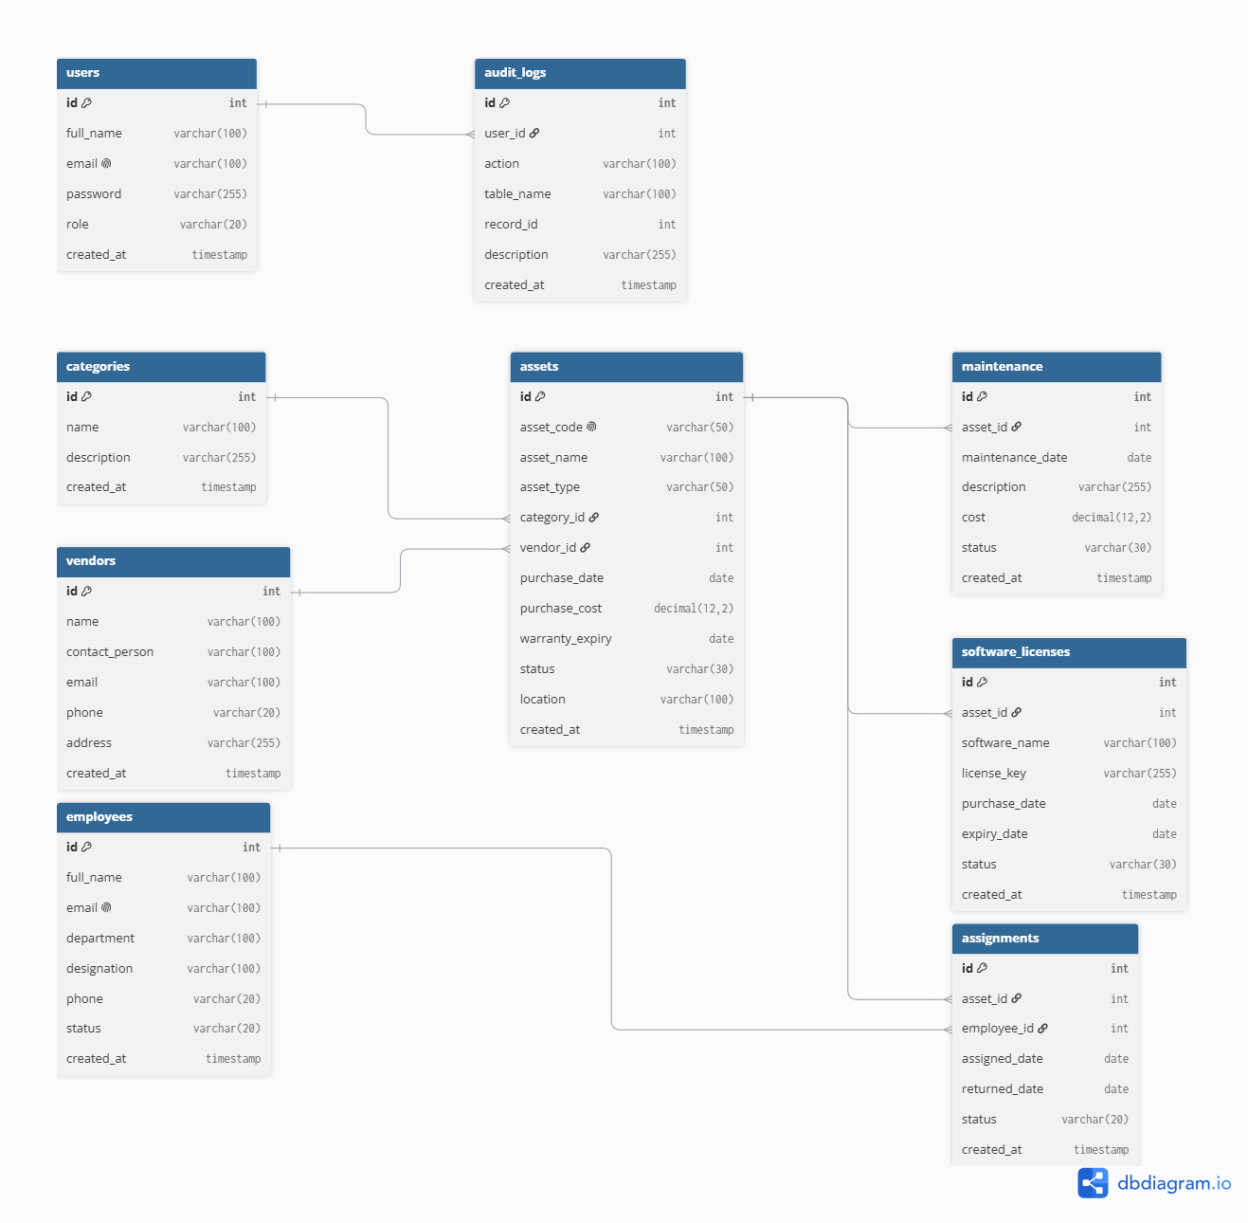
10. Database Normalization
1NF (First Normal Form): All database tables contain atomic values, and repeating groups or multi-valued attributes are avoided.
2NF (Second Normal Form): Non-key attributes are fully dependent on their respective primary keys, eliminating partial dependencies.
3NF (Third Normal Form): Transitive dependencies are minimized by separating independent entities such as Employees, Categories, Vendors, Users, and Assets into dedicated tables.
4NF (Fourth Normal Form): Independent multi-valued relationships are separated into dedicated tables such as Assignments, Maintenance, and Software Licenses to reduce redundancy and maintain data integrity.
Primary Key–Foreign Key Joins: The database uses PK–FK relationships to connect related entities. Assets are linked with Categories and Vendors, Assignments connects Employees with Assets, Maintenance and Software Licenses are linked with Assets, and Audit Logs are linked with Users.
Relationships and Joins:
Categories → Assets → Assignments ← Employees
Vendors → Assets
Assets → Maintenance
Assets → Software Licenses
Users → Audit Logs
11. User Interface (UI) Screens

• Login Page
• Dashboard
• Asset Management
• Employee Management
• Asset Assignment
• Maintenance Management
• Warranty Tracking
• Software License Tracking
• QR Code Management
• Inventory Dashboard
• Reports
• Audit Logs

12. Future Enhancements

Future Enhancements
• Email notifications for warranty and license expiry.
• QR/Barcode Scanner Integration (using mobile camera or handheld scanner) .
• Mobile responsive interface.
• Export reports in PDF and Excel formats.
• Advanced asset search and filtering.

