1. What is stationarity in TSM?
A time series is called stationary if its statistical properties like mean, variance, and autocorrelation do not change over time. Stationarity is very important in forecasting because most models (like ARIMA) work only on stationary data. If a series is not stationary, we usually make it stationary using differencing, detrending, or removing seasonality.
Points:
- Mean and variance constant over time
- No trend or seasonality
- Easier to model and predict
Diagram to draw: Compare one non-stationary series (with upward trend) and one stationary series (random fluctuations around mean 0).
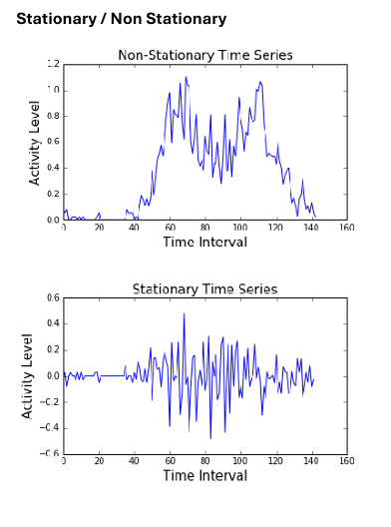

2. Explain ARIMA in detail with diagram and explanation.
ARIMA stands for Auto-Regressive Integrated Moving Average.
- AR (Auto-Regressive): The current value depends on past values.
- I (Integrated): Differencing of raw observations to make the series stationary.
- MA (Moving Average): The current value depends on past error terms.
It is written as ARIMA(p, d, q), where:
- p = order of AR part
- d = order of differencing
- q = order of MA part
Example: ARIMA(1,1,1) means 1 autoregressive term, differencing once, and 1 moving average term.
Diagram to draw: A block diagram showi ng AR → Differencing → MA steps.
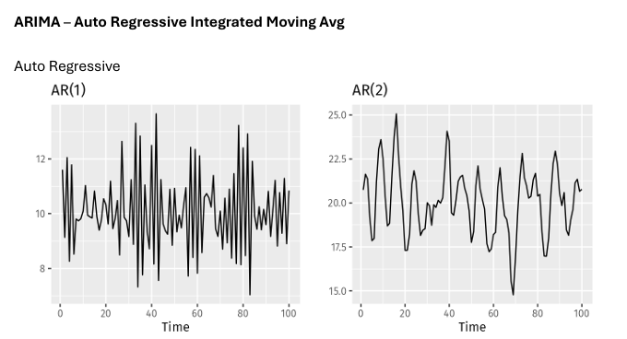

3. What is ACF? Explain in detail with diagram and example.
ACF (Autocorrelation Function) measures the correlation of a time series with its own past values (lags). It helps to identify seasonality and the order of MA models.
Points:
- Shows how current values are related to previous values.
- Useful in identifying patterns in the data.
- ACF gradually decreases for AR models, but cuts off sharply after q lags for MA models.
Diagram to draw: ACF bar chart (correlogram) showing spikes at lags.
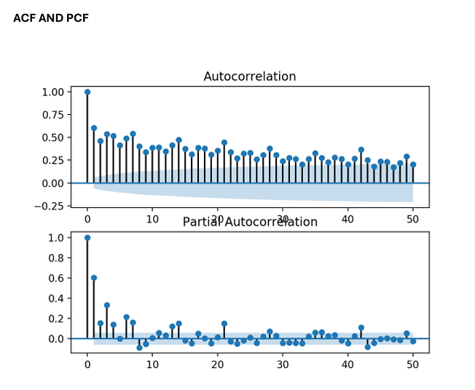

4. What is PACF? Explain with example and diagram.
PACF (Partial Autocorrelation Function) measures the correlation between a series and its lag, after removing the effects of intermediate lags.
Points:
- Helps identify the order of AR models.
- PACF cuts off after p lags in AR models.
- In MA models, PACF tails off gradually.
Diagram to draw: PACF plot showing cutoff after certain lags.
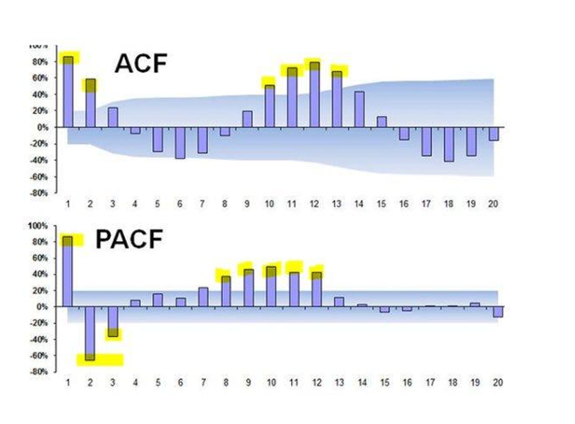

5. Explain what is Moving Average with graph.
A Moving Average (MA) is a statistical method used in time series analysis to smooth out short-term fluctuations and highlight long-term trends or patterns.
It works by taking the average of data points over a fixed number of periods (like days, weeks, or months) and then updating this average as new data comes in.
Points:
- Simple method to smooth time series data.
- Can be Simple Moving Average (SMA) or Weighted Moving Average (WMA).
- Used for short-term forecasting.
In the graph:
- The small red and green lines represent the daily stock prices (they go up and down sharply).
- The blue line is the 50-day Simple Moving Average (SMA).
  - This line is smoother because it averages the last 50 days of stock prices.
  - It reduces noise from daily ups and downs and shows the overall trend (whether the stock is generally rising or falling).
For example:
- Around May–July, the stock fell sharply, and the moving average also went down.
- From Oct–Dec, the stock rose again, and the moving average moved upward too.
Diagram to draw: Original noisy series with a smooth moving average line.
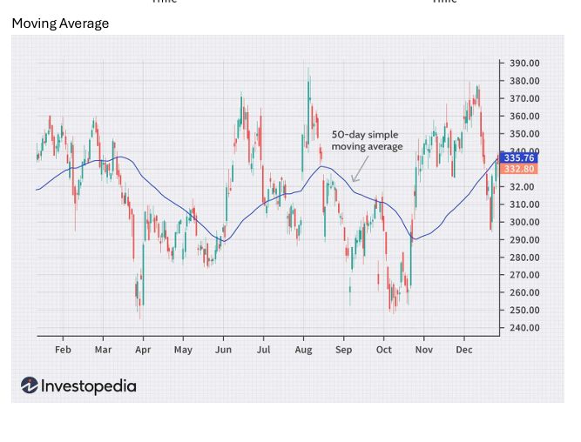

6. Explain the graph of decomposition.
Time series can be decomposed into:
- Trend (T) – long-term increase or decrease
- Seasonality (S) – repeating short-term cycle
- Residual (R) – random noise
So, Time Series = Trend + Seasonality + Residual.
Explanation of the Graph
The graph is divided into four panels:
- Observed (Top graph):
  - This is the original time series (1949–1960).
  - We see both a rising trend and repeating seasonal fluctuations.
- Trend (Second graph):
  - Shows the long-term upward movement.
  - The series is steadily increasing over time, meaning the values are growing overall.
- Seasonal (Third graph):
  - Captures repeating patterns within each year.
  - Notice the same up-and-down cycle repeats every 12 months → this shows yearly seasonality.
- Residual (Bottom graph):
  - Represents the irregular part of the data after removing trend and seasonality.
  - These are random variations, which don’t follow a fixed pattern.
Diagram to draw: Show decomposition plot (original series → trend → seasonality → residual).
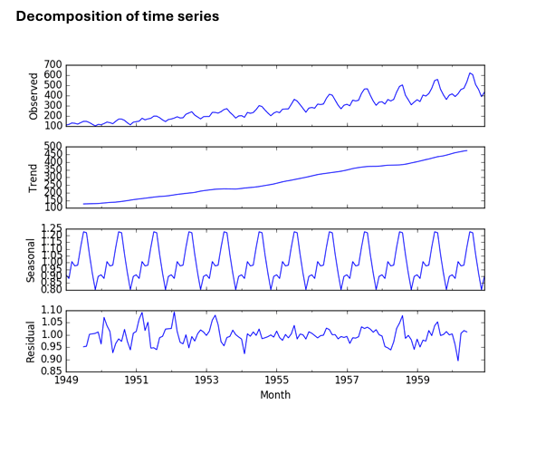

7. What is SARIMA? Explain in detail.
SARIMA (Seasonal Autoregressive Integrated Moving Average) is a time series forecasting model that is used when the data shows both trend and seasonality. It is an extension of the ARIMA model that adds seasonal components.
SARIMA(p, d, q)(P, D, Q)m
- (p, d, q) → ARIMA terms
- (P, D, Q) → seasonal terms
- m → length of seasonality
Here, p is the order of autoregression, d is the order of differencing to remove trend, and q is the order of moving average.
In simple terms, SARIMA first removes trends and seasonal patterns using differencing, then models short-term dependencies using AR and MA terms, and finally captures repeating seasonal effects using seasonal AR and MA terms. The steps to use SARIMA are: analyze the data, apply necessary differencing, choose suitable parameters, fit the model, check the residuals (errors), and then forecast future values.
Example: For monthly sales with yearly pattern, SARIMA is useful.
Diagram to draw: Show yearly repeating cycles with SARIMA model structure.
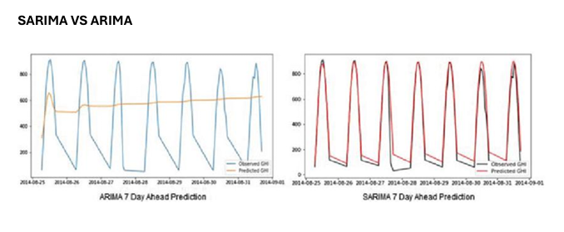
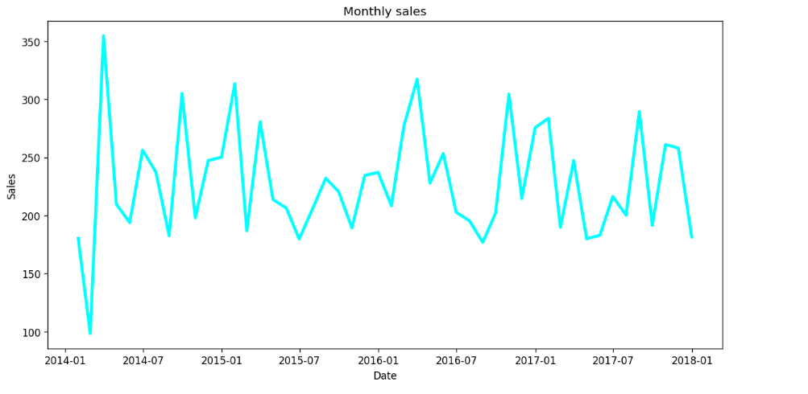

8. What is Exponential Smoothing?
Exponential smoothing forecasts future values by giving more weight to recent observations while still considering older ones.
Points:
- Uses smoothing factor α (0–1).
- High α → more weight to recent values.
- Types: Simple, Double (Holt’s), and Triple (Holt-Winters).
Diagram to draw: Compare forecasts with high α vs low α.
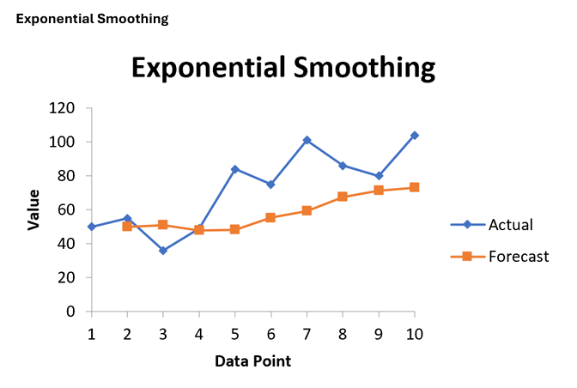

9. What is White Noise?
White Noise is a random time series where values are completely uncorrelated, with constant mean and variance.
Points:
- No trend or seasonality
- Mean = 0, constant variance
- ACF shows no significant correlation
Diagram to draw: Random scatter plot with no visible pattern.
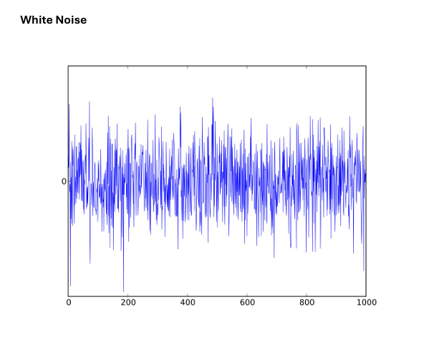

10. Differencing concept explain in detail.
Differencing is a way to turn a non-stationary time series (one with a trend or changing mean) into a stationary one by subtracting past values. A stationary series has a constant mean and variance over time, which many forecasting methods (like ARIMA) require.
Types:
- First-order differencing: Yt – Yt-1
- Second-order differencing: difference applied twice
Points:
- Removes trend and seasonality
- Helps in ARIMA modeling
Diagram to draw: Show non-stationary series and its differenced stationary version.
