<https://leetcode.com/problems/maximum-subarray/>

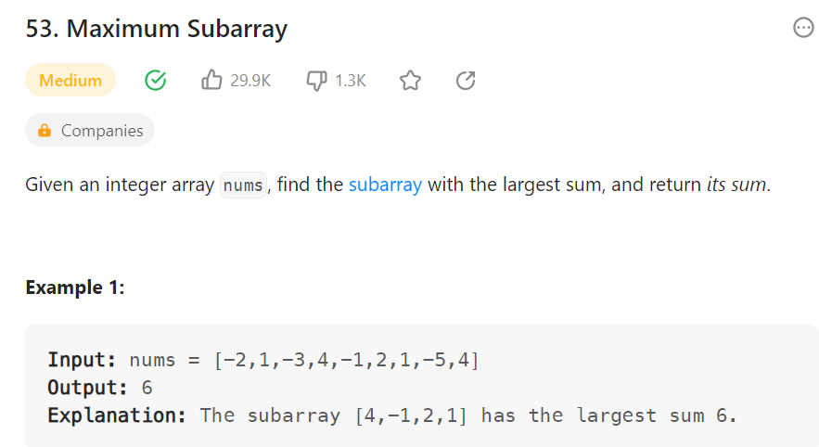

Method1:

Method2:

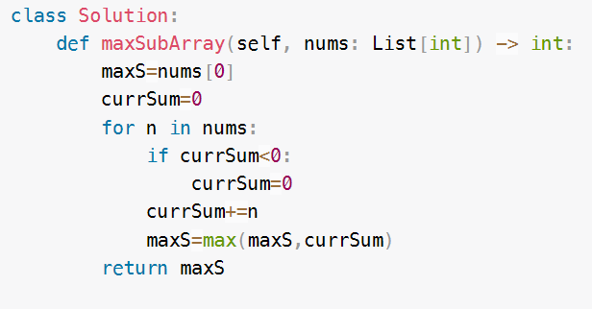

Method3: time-O(n),space-O(1)

Method4: DP

time-O(n),space-O(n)

Method : Kadane algorithm

<https://leetcode.com/problems/maximum-subarray/solutions/3227063/kadane-s-algo-o-n-time-and-o-1-space-easiest-beginner-friendly-sol/>

