<https://www.geeksforgeeks.org/chocolate-distribution-problem/>

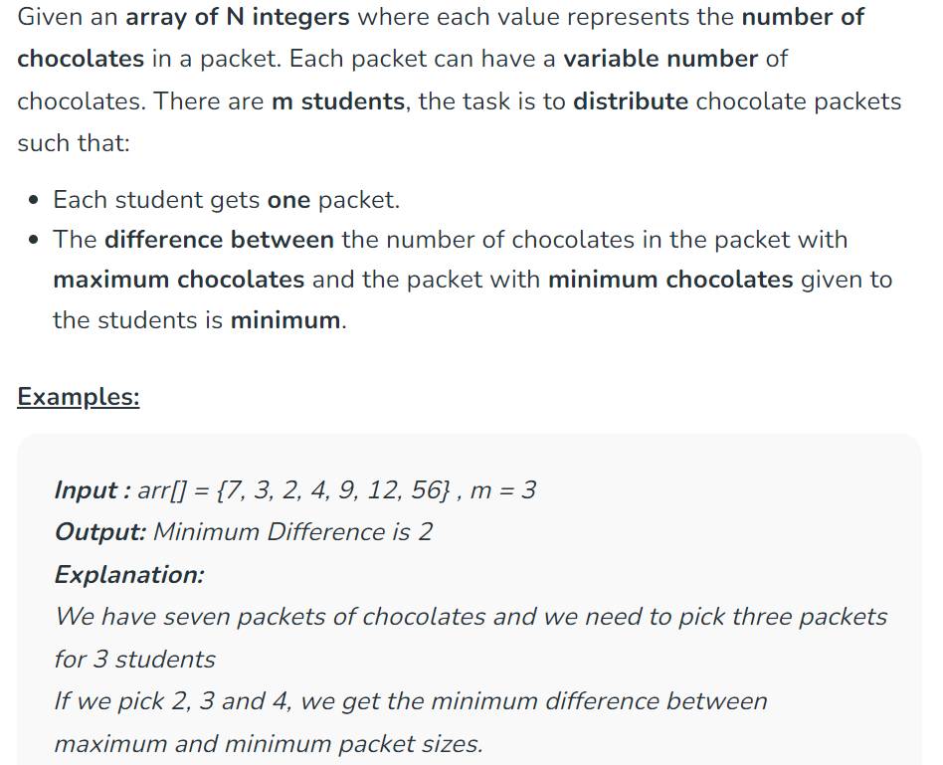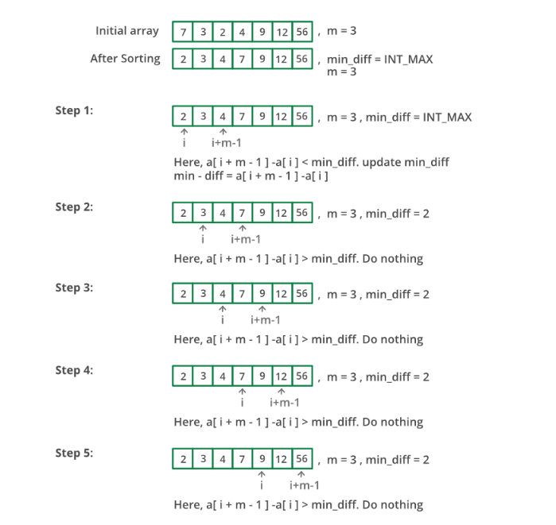

**Time Complexity:** O(N*log(N))  
**Auxiliary Space**: O(1)