<https://leetcode.com/problems/search-in-rotated-sorted-array/>

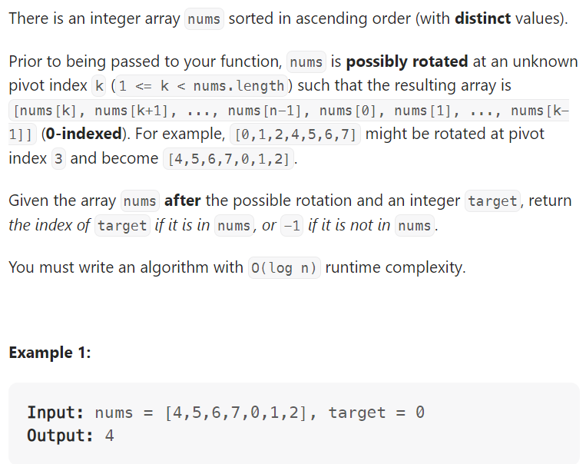

Method1: O(n)

Method2: Binary search O(logn)

