[Activity Selection Problem | Greedy Algo-1 - GeeksforGeeks](https://www.geeksforgeeks.org/activity-selection-problem-greedy-algo-1/)

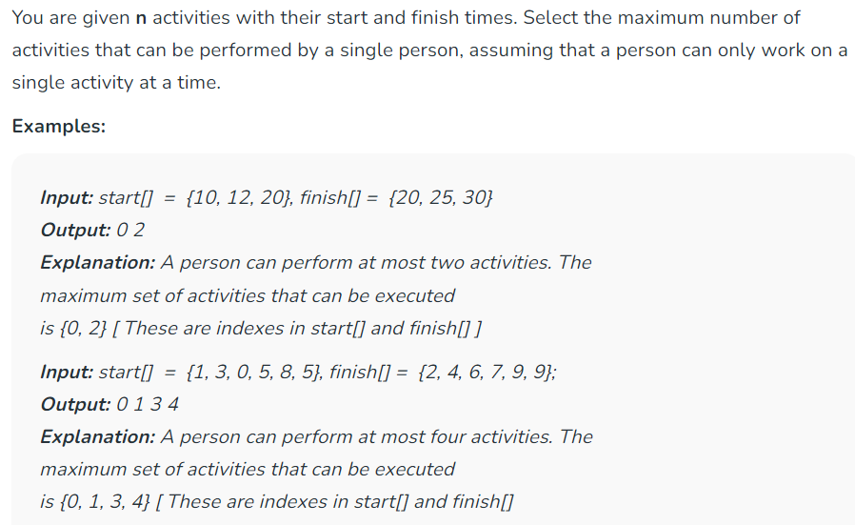

**Time Complexity:** O(N log N), If input activities may not be sorted. It takes O(n) time when it is given that input activities are always sorted.  
**Auxiliary Space:** O(1)

Method3:

