<https://leetcode.com/problems/subtree-of-another-tree/description>

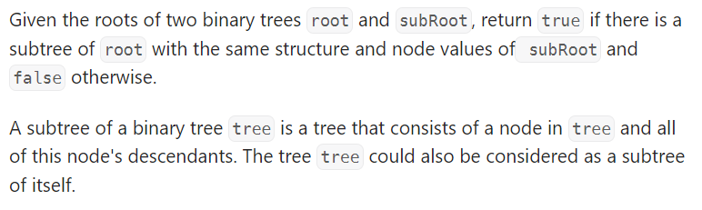

Do KMP sol also