<https://www.geeksforgeeks.org/job-sequencing-problem>

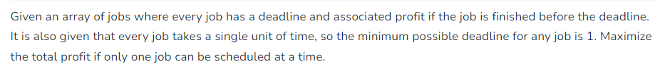

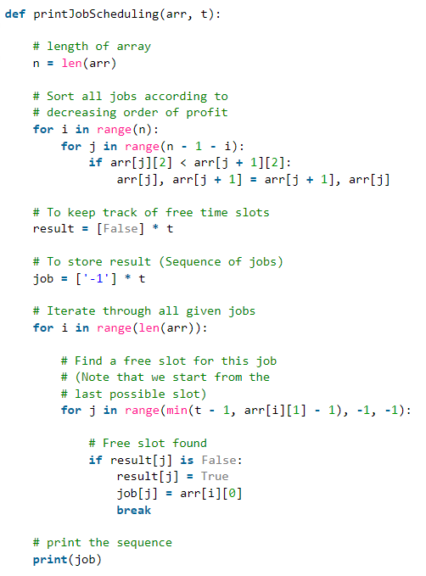

[Job Sequencing Problem using Disjoint Set - GeeksforGeeks](https://www.geeksforgeeks.org/job-sequencing-problem-using-disjoint-set/)