[Print all the duplicates in the input string - GeeksforGeeks](https://www.geeksforgeeks.org/print-all-the-duplicates-in-the-input-string/)

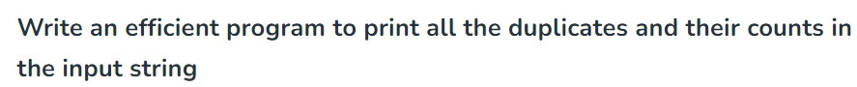

Method2:

**Time Complexity**: O(N*log(N)), where N = length of the string passed and it generally takes O(log(N)) time for an element insertion in a map.   
**Space Complexity**: O(K), where K = size of the map (**0<=K<=input_string_length**).

Method3:

**Time Complexity: O(N)**, where N = length of the string passed and it takes O(1) time to insert and access any element in an unordered map  
**Auxiliary Space:** **O(K)**, where K = size of the map (0<=K<=input_string_length).

Method4:

**Time Complexity:**O(nlogn), where n is the length of the string

**Space Complexity:**O(1), if you observe we did not use any extra space .