[Height of Binary Tree | Practice | GeeksforGeeks](https://practice.geeksforgeeks.org/problems/height-of-binary-tree/1)

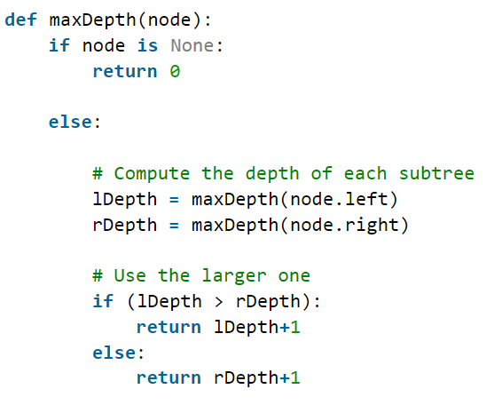

**Time Complexity:**O(N)   
**Auxiliary Space:** O(N) due to recursive stack.

Method2: Level Order traversal

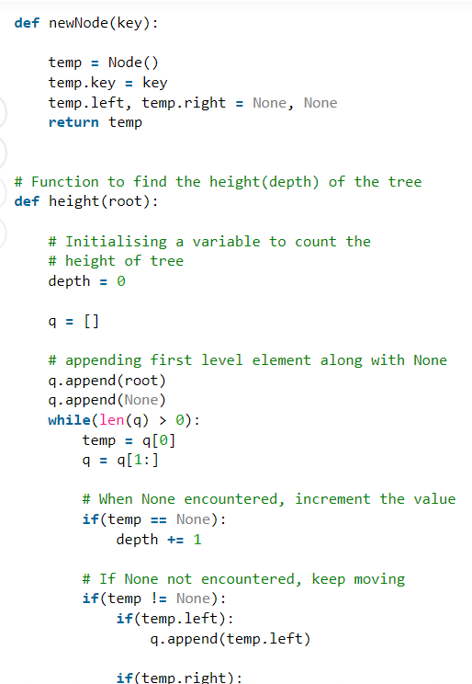

Height(Depth) of tree is: 3

**Time Complexity:**O(N)  
**Auxiliary Space:**O(N)

Method3:

**Time Complexity:**O(N)  
**Auxiliary Space:**O(N)