<https://leetcode.com/problems/subtree-of-another-tree/>

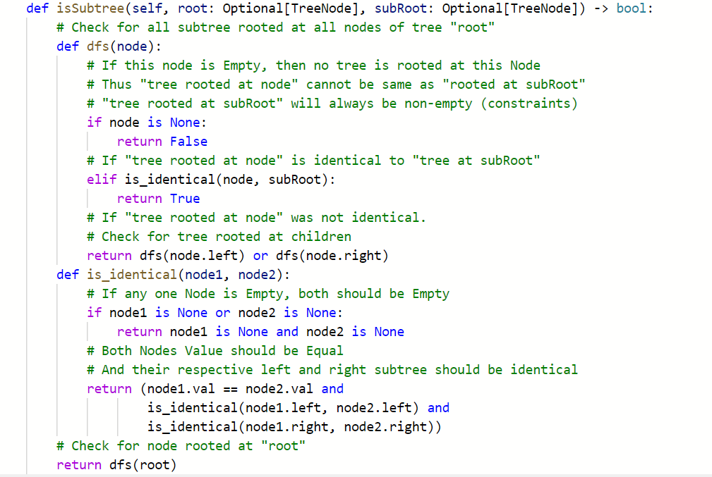

OR

