PROJECT NAME: Foodigo

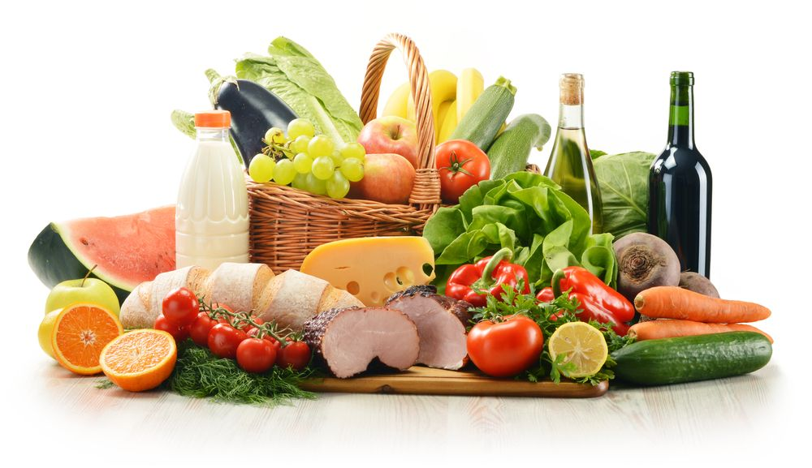

OVERVIEW

Foodigo, is an Indian online grocery delivery service. It delivers the grocery goods found in convenience stores, home essentials and food supplies to its customers.

**HOME PAGE:**

HEADER:

* LOGO
* SHOP BY CATEGORY
* SEARCH BAR
* ADD TO CART
* LOGIN/SIGN UP

CONTAINER

* SLIDESHOW(IMAGES)
* OFFER (IMAGES) WITH SLIDESHOW
* VIEW ALL (SIDE BUTTON)
* SLIDERS WITH ARROWS (IMAGES)
* MOST POPULAR (IMAGES)
* CATEGORIES OF PRODUCTS (IMAGES)

FOOTER

* CONTACT US
* ABOUT US
* SOCIAL MEDIA LINKS

**PRODUCT PAGE**

Provides description of the products in the selected category.

It includes:

FILTERS

CATEGORY, BRAND, FLAVOURS, PRICE, DISCOUNT

SLIDESHOW

Showing the images of the products of the selected category.

IMAGES OF THE PRODUCTS WITH THE FOLLOWING DETAILS

BRAND, PRODUCT NAME, PRICE, DELIVERY TIMING

PAYMENT PAGE

PAYMENT OPTIONS

GOOGLE PAY, UPI, COD, CREDIT/DEBIT CARD, NETbanking, Cash/Card on Delivery.

By NEHA ABHIRUP

BATCH-36