**CSE 3112 -Digital Assignment 2**

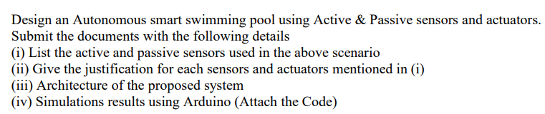

1. List the active and passive sensors used in the above scenario

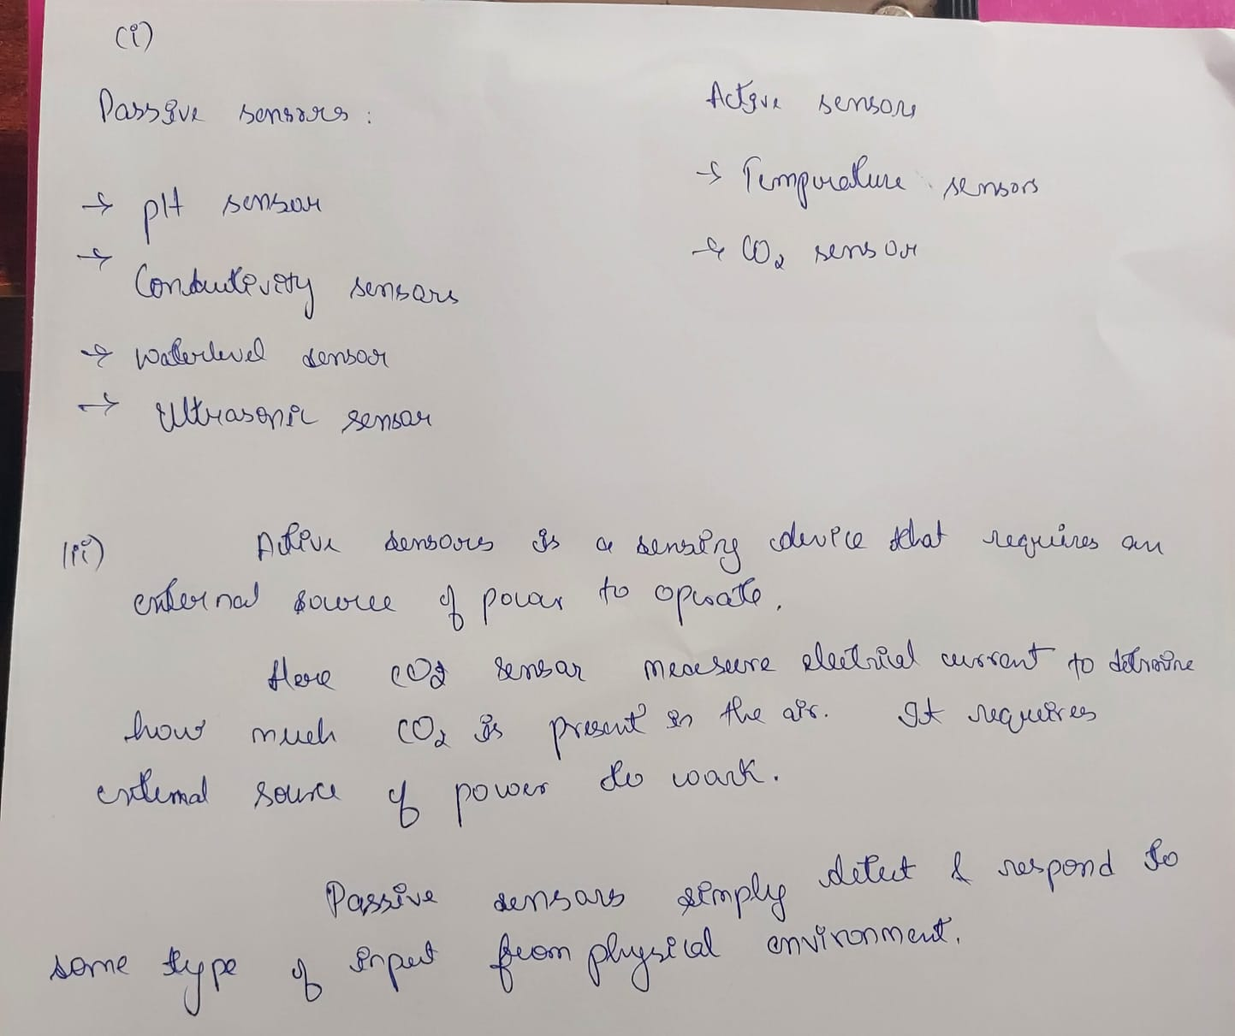

1. Give the justification for each sensor and actuators in (i)



1. Architecture of the proposed system

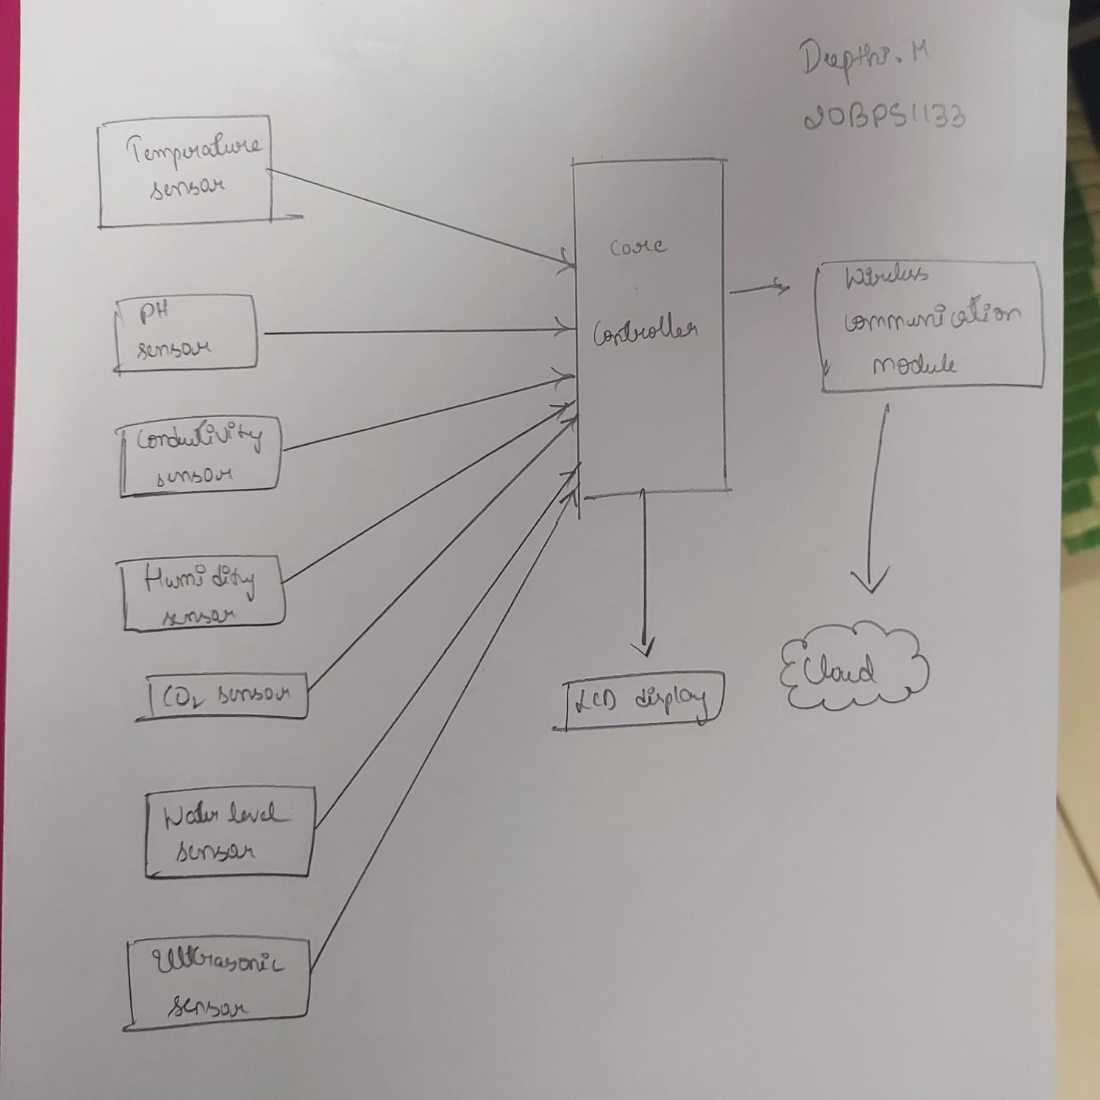

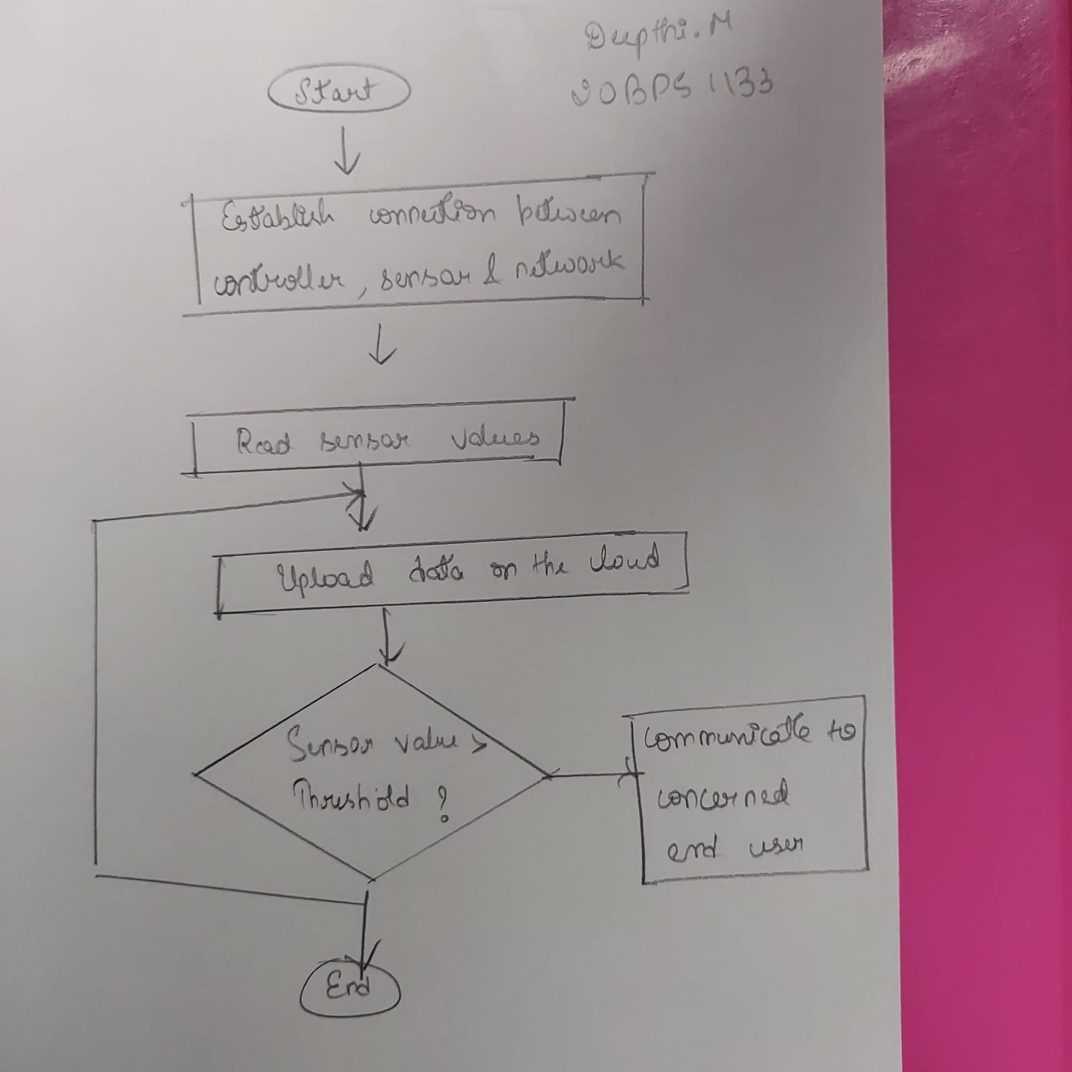

1. Simulations results using Arduino (Attach the Code)

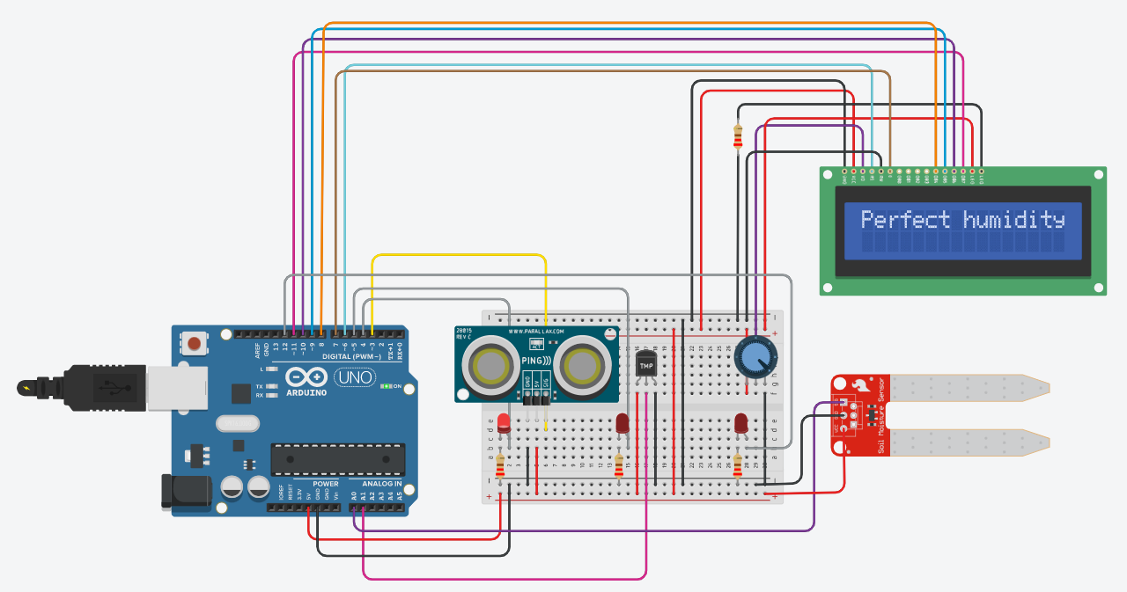

Code:

#include <LiquidCrystal.h>

int Humidity = A0;

int Temperatura = A1;

int US = 3;

int LedUS = 4;

int LedTemp = 5;

int LedHum = 12;

float time = 0, distance = 0, humidity = 0;

LiquidCrystal lcd(6, 7, 8, 9, 10, 11);

void setup () {

//lcd setup

Serial.begin(9600);

lcd.print("Starting");

delay(1000);

lcd.clear();

pinMode(US, OUTPUT);

pinMode(LedUS, OUTPUT);

pinMode(LedTemp, OUTPUT);

pinMode(LedHum, OUTPUT);

pinMode(Humidity, INPUT);

}

void loop() {

int ts = analogRead(Temperatura);

float Temp = (ts * 500.0 / 1023.0)-50.0;

lcd.print("Temp = ");

lcd.print(Temp);

if (Temp > 28){

digitalWrite(LedTemp, HIGH);

lcd.setCursor(0, 1);

lcd.print("HOT");

delay(2000);

lcd.clear();

}

else {

digitalWrite(LedTemp, LOW);

lcd.setCursor(0, 1);

lcd.print("Stable temp");

delay(2000);

lcd.clear();

}

pinMode(US, OUTPUT);

digitalWrite(US, LOW);

delay(0.1);

digitalWrite(US, HIGH);

delay(0.1);

digitalWrite(US, LOW);

delay(0.1);

pinMode(US, INPUT);

time = pulseIn(US, HIGH);

distance = (time)/29 /2;

lcd.print("Distance = ");

lcd.print(distance);

lcd.print("cm");

if (distance <= 150){

digitalWrite(LedUS, HIGH);

lcd.setCursor(0, 1);

lcd.print("Object nearby");

delay(2000);

lcd.clear();

}

else {

digitalWrite(LedUS, LOW);

lcd.setCursor(0, 1);

lcd.print("No one near");

delay(2000);

lcd.clear();

}

humidity = analogRead(Humidity);

lcd.print("Humidity = ");

lcd.print(humidity);

if (humidity >= 150){

digitalWrite(LedHum, HIGH);

lcd.setCursor(0, 1);

lcd.print("Excessive humidity");

delay(2000);

lcd.clear();

}

else {

digitalWrite(LedHum, LOW);

lcd.setCursor(0, 1);

lcd.print("Perfect humidity");

delay(2000);

lcd.clear();

}

}

To check water level:

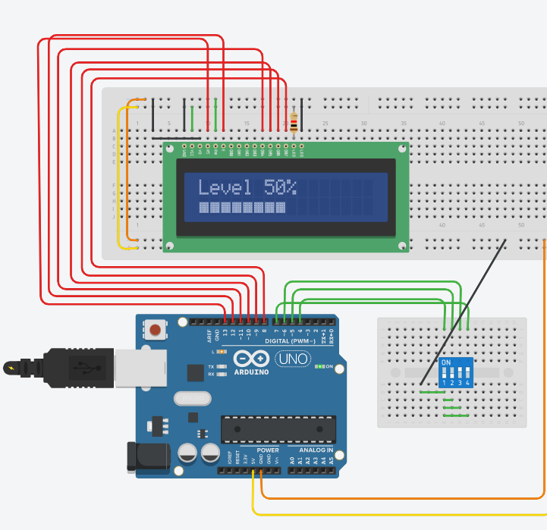

Code:

#include <LiquidCrystal.h>

int pin1 = 4;

int pin2 = 5;

int pin3 = 6;

int pin4 = 7;

int num = 0;

int counter = 0;

bool blink = true;

bool done = false;

LiquidCrystal lcd(13, 12, 11, 10, 9, 8);

void setup()

{

lcd.begin(16, 2);

pinMode(pin1, INPUT_PULLUP);

pinMode(pin2, INPUT_PULLUP);

pinMode(pin3, INPUT_PULLUP);

pinMode(pin4, INPUT_PULLUP);

}

void loop()

{

int max = 0;

int level25 = digitalRead(pin1);

int level50 = digitalRead(pin2);

int level75 = digitalRead(pin3);

int level100 = digitalRead(pin4);

if (level25 == HIGH) {

max = 25;

if (level50 == HIGH) {

max = 50;

if (level75 == HIGH) {

max = 75;

if (level100 == HIGH) {

max = 100;

}

}

}

}

int incDec = min(10, abs(num - max));

if (num < max) num += incDec;

if (num > max) num -= incDec;

if (!done) {

//

lcd.clear();

lcd.setCursor(0, 0);

lcd.print("Level " + String(num) + "%");

delay(500);

}}