**CSE 3505-FDA DA2**

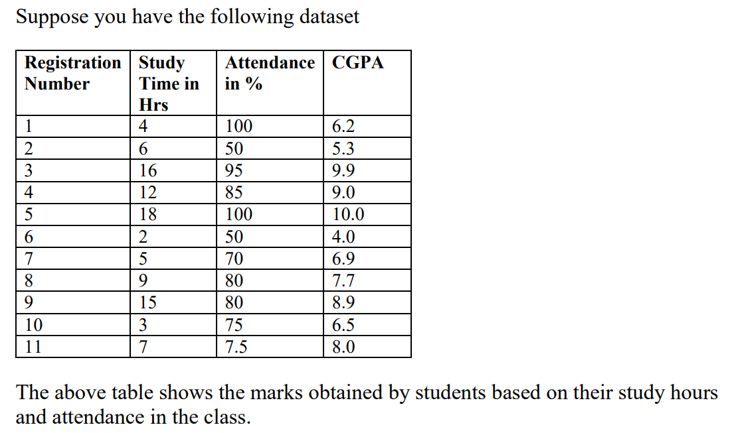



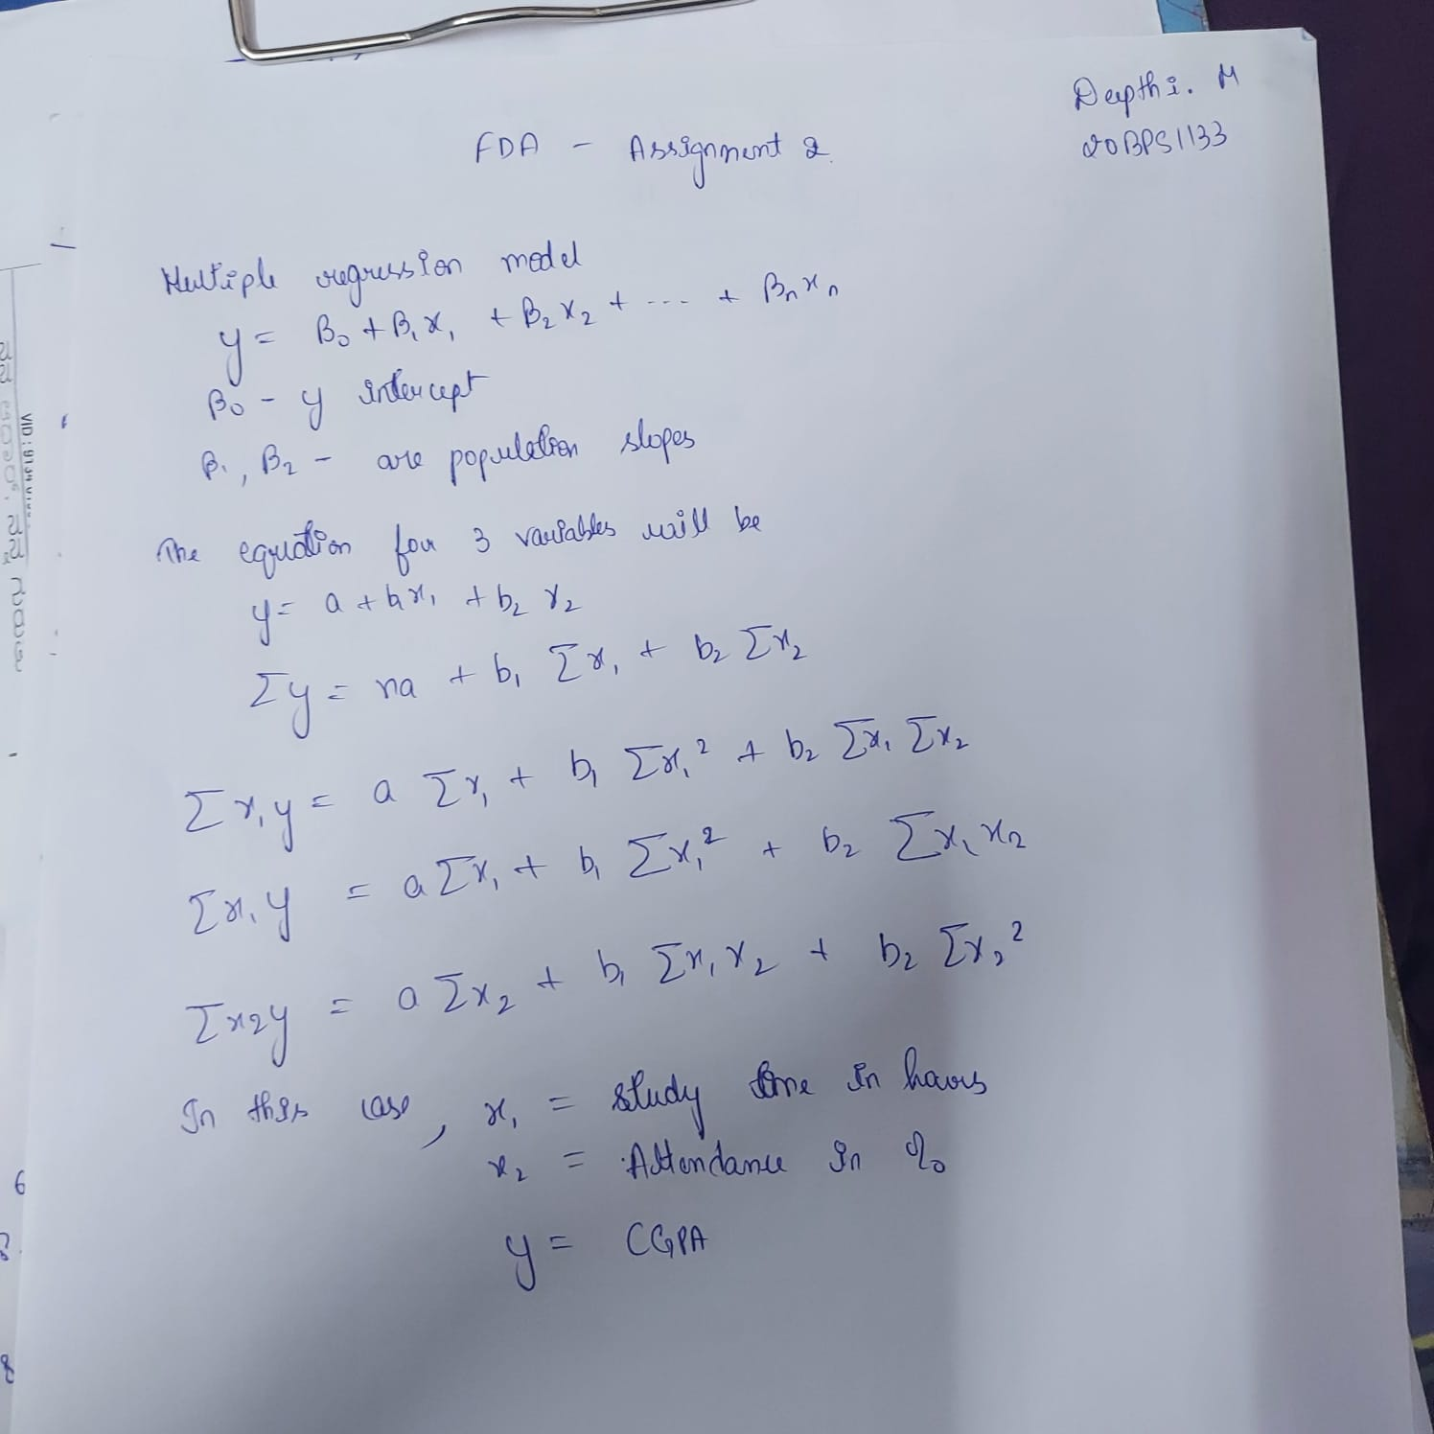

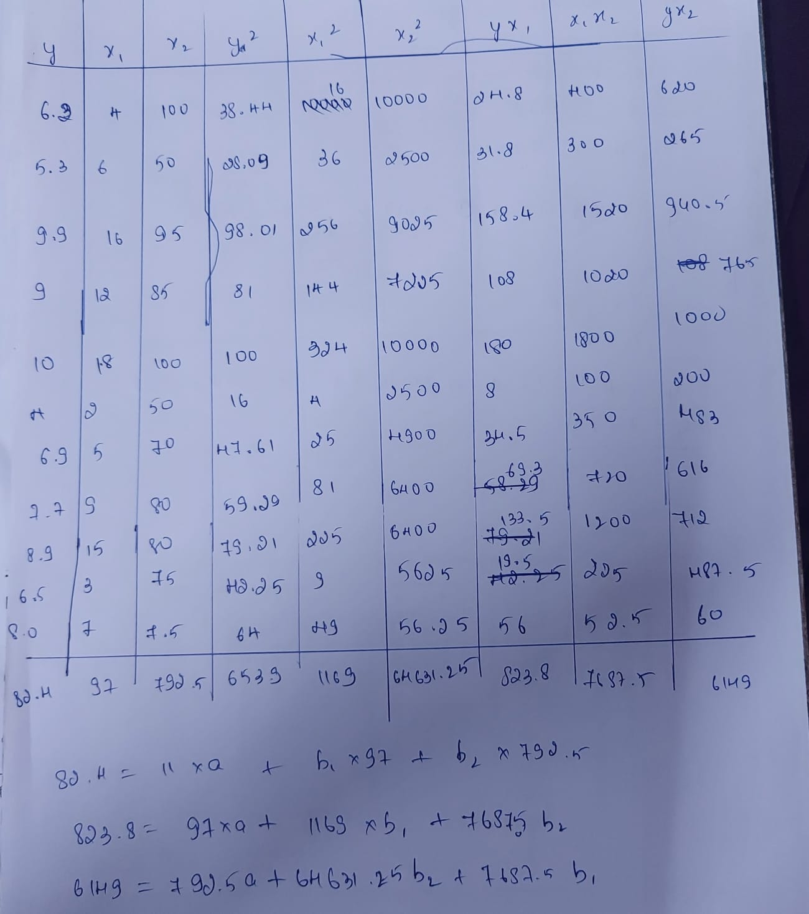

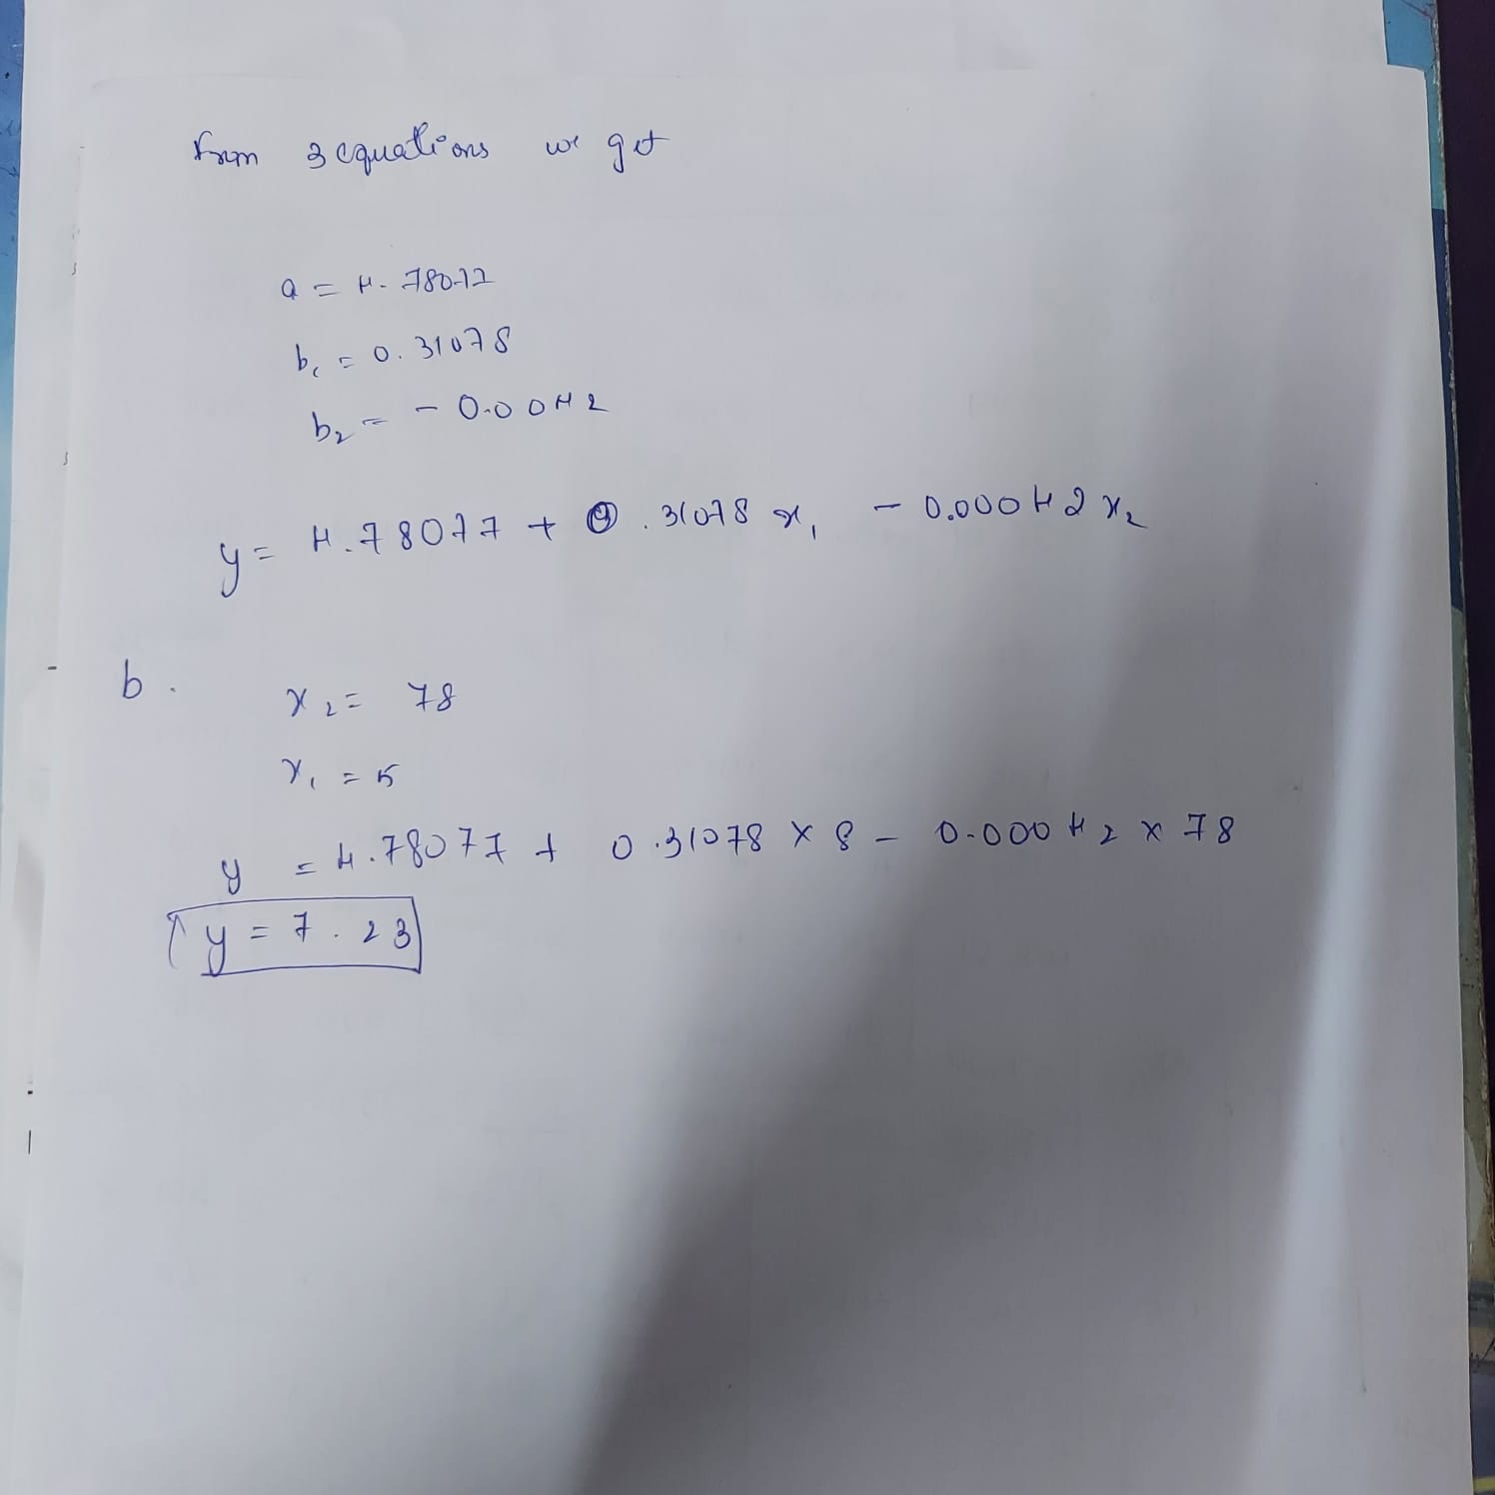







Code:

x1<-c(4,6,16,12,18,2,5,9,15,3,7)

x2<-c(100,50,95,85,100,50,70,80,80,75,7.5)

y<-c(6.2,5.3,9.9,9,10,4,6.9,7.7,8.9,6.5,8)

input<-data.frame(y,x1,x2)

input

regM<-lm(y~x1+x2,data=input)

regM

summary(regM)

