**CSE 1003 - Assignment – 2**

**Date of Submission: June 12, 2021**

1. Implement the Boolean function using 4 X 1 MUX and 2 X 1 MUX.
$$F=\sum{m\left(0,2,4,8,9,10,11,12,14\right)}$$

2. A cafeteria orders a machine to dispense coffee, tea, and milk. Design the machine so that it has a button (input line) for each choice and so that a customer can have *at most one* of the three choices. Simplify the expression using K Map and draw the logic circuit to ensure that the “at most one” condition is met.

Implement the expression using Multiplexer and decoder.

1. The logic circuit shown in the fig.1 is fed with the waveform *X* also shown in fig.1. All gates have equal propagation delay of 10 ns. The output *Y* of the circuit and draw its waveform.

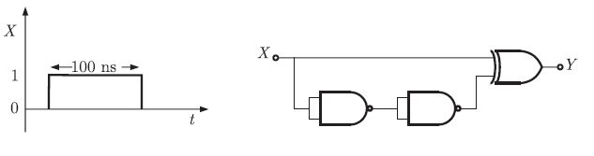

Fig.1

1. Convert D Flip Flop into T Flip Flop.
2. Realize the function F with 2*1 MUX; F(X,Y,Z)= ∑m(2,3,4,5,7)
3. Design a 4 bit binary parallel adder/subtractor circuit in the simplest form using Full adder with neat diagram.
4. Design a 4-to-16 decoder using 2-to-4 decoders only.
5. Implement the full subtractor with 2 x 4 decoder.
6. Convert SR Flip Flop into T Flip Flop.
7. Design a 8 bit binary adder circuit with full adder IC.
8. Obtain a truth table for comparing two numbers A and B, where A and B are two bit numbers.
   1. How many inputs and outputs can be obtained in the above definition?
   2. Draw the logic circuit only these two numbers are equal.
9. Design a 3 bit even parity generator circuit.
10. The active-low enabled 2 X 4 decoder circuit has  active low output. Let us assume that A0 and A1 are the inputs and D0 to D3 are the outputs. Write the expression of the output of D3 when A0=A1=1.
11. Construct a 16 X 1 multiplexer with 8 x 1 and 2 x 1 multiplexers. Use block diagram representation.
12. Draw the logic diagram of 2 * 4 line decoder using
13. NOR Gate only
14. NAND Gate only

Indicate enable input.

1. If the clock frequency driving this flip-flop is 240 Hz, what is the frequency of the flip-flop’s output signals of the given circuit.

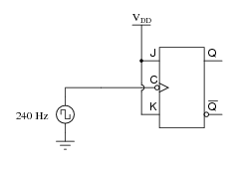

1. Explain the priority encoder of 4 x 2.