## **Event Management System**

**## Explanation**

**## User Authentication :**

1.New Users can register themselves.

2.Each user has to login in order to add or manage the events.

3.User who is not logged in, will not be able to perform event operations

**## Project flow**

**1. After Login User will be redirected to the Home page which will show events list**

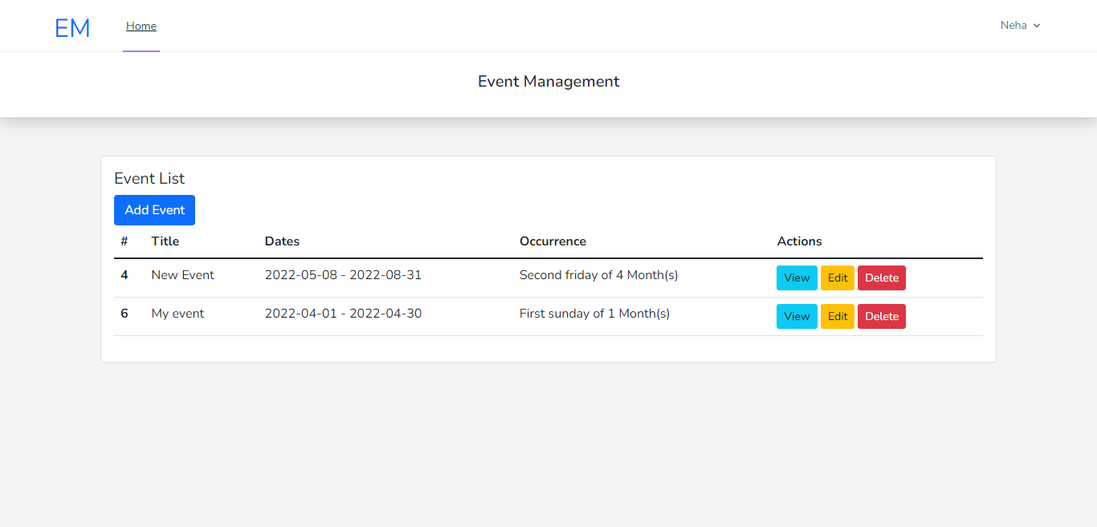

**2. On clicking Add Event button, add event page will open and from there user can add events**

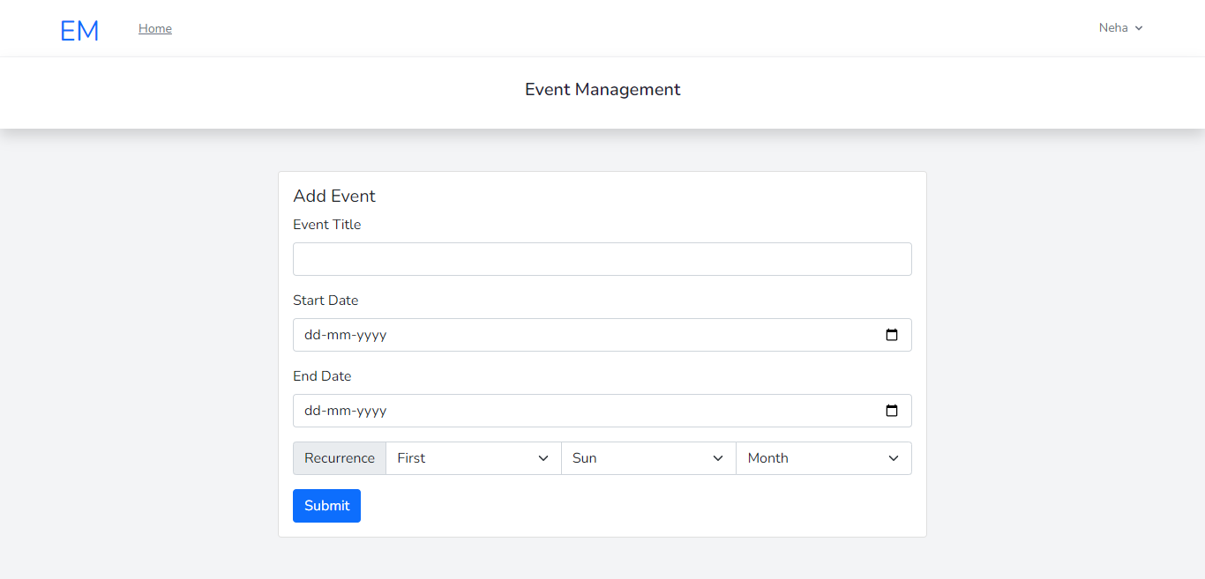

**3. On clicking the Delete button, User can delete the event.**

**4. On clicking the Edit button, a new page will open with edit form where we can edit event details.**

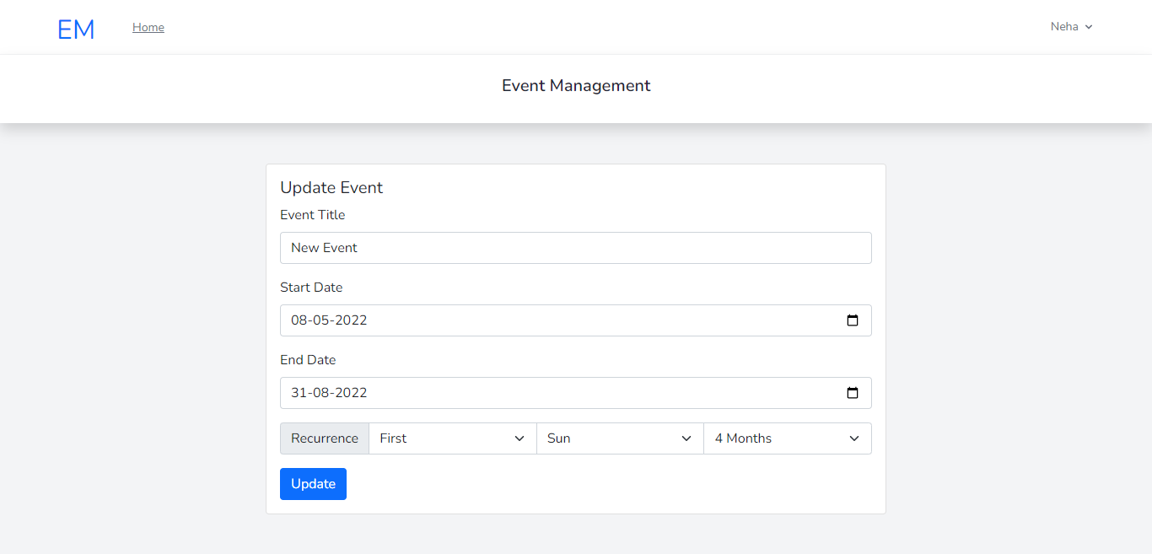

**5. On clicking the View button, User can view all recurrence event list**

