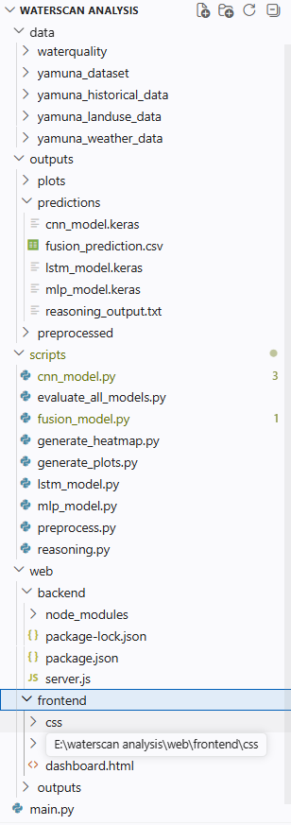
scripts/cnn_model.py:
import numpy as np
import pandas as pd
from tensorflow.keras.models import Sequential
from tensorflow.keras.layers import Conv2D, MaxPooling2D, Flatten, Dense, Dropout, Input
from tensorflow.keras.optimizers import Adam
from sklearn.utils.class_weight import compute_class_weight

DATA_PATH = "outputs/preprocessed/satellite_images.npy"
HIST_PATH = "outputs/preprocessed/historical_clean.csv"

# ---------- LOAD DATA ----------
def load_data():
X = np.load(DATA_PATH)
print("Images loaded:", X.shape)

# Normalize images
X = X / 255.0

# Load labels from historical data
df = pd.read_csv(HIST_PATH)

y = df.select_dtypes(include=[np.number]).iloc[:, 0].values

# Align sizes
min_len = min(len(X), len(y))
X = X[:min_len]
y = y[:min_len]

# Balance labels using median
threshold = np.median(y)
y = (y > threshold).astype(int)

print("Label distribution:", np.bincount(y))

return X, y

# ---------- BUILD MODEL ----------
def build_model(input_shape):
model = Sequential([
Input(shape=input_shape),

Conv2D(32, (3,3), activation="relu"),
MaxPooling2D((2,2)),

Conv2D(64, (3,3), activation="relu"),
MaxPooling2D((2,2)),

Conv2D(128, (3,3), activation="relu"),
MaxPooling2D((2,2)),

Flatten(),

Dense(128, activation="relu"),
Dropout(0.5), # prevents overfitting

Dense(1, activation="sigmoid")
])

model.compile(
optimizer=Adam(learning_rate=0.001),
loss="binary_crossentropy",
metrics=["accuracy"]
)

return model

# ---------- MAIN ----------
def main():
X, y = load_data()

model = build_model(X.shape[1:])

# Compute class weights
classes = np.unique(y)
weights = compute_class_weight("balanced", classes=classes, y=y)
class_weights = dict(zip(classes, weights))

print("Class weights:", class_weights)

model.fit(
X, y,
epochs=20,
batch_size=16,
validation_split=0.2,
shuffle=True,
class_weight=class_weights
)

model.save("outputs/predictions/cnn_model.keras")

print("✅ Improved CNN model trained and saved.")

if __name__ == "__main__":
main()

scripts/fusion_model.py:
import os
import numpy as np
import pandas as pd
from tensorflow.keras.models import load_model

# model paths
CNN_MODEL = "outputs/predictions/cnn_model.keras"
LSTM_MODEL = "outputs/predictions/lstm_model.keras"
MLP_MODEL = "outputs/predictions/mlp_model.keras"

# preprocessed data
IMG_PATH = "outputs/preprocessed/satellite_images.npy"
HIST_PATH = "outputs/preprocessed/historical_clean.csv"
WEATHER_PATH = "outputs/preprocessed/weather_clean.csv"
LANDUSE_PATH = "outputs/preprocessed/landuse_clean.csv"

def load_data():

images = np.load(IMG_PATH)

hist_df = pd.read_csv(HIST_PATH)
hist_df = hist_df.select_dtypes(include=[np.number])
hist = hist_df.values

weather_df = pd.read_csv(WEATHER_PATH)
weather_df = weather_df.select_dtypes(include=[np.number])

landuse_df = pd.read_csv(LANDUSE_PATH)
landuse_df = landuse_df.select_dtypes(include=[np.number])

weather_data = weather_df.values
landuse_data = landuse_df.values

if landuse_data.shape[0] < weather_data.shape[0]:
repeat_factor = int(np.ceil(weather_data.shape[0] / landuse_data.shape[0]))
landuse_data = np.tile(landuse_data, (repeat_factor, 1))
landuse_data = landuse_data[:weather_data.shape[0], :]

context = np.concatenate([weather_data, landuse_data], axis=1)

return images, hist, context

def main():

print("Loading trained models...")

cnn = load_model(CNN_MODEL)
lstm = load_model(LSTM_MODEL)
mlp = load_model(MLP_MODEL)

print("Loading data...")

images, hist, context = load_data()

print("Generating predictions...")

cnn_pred = cnn.predict(images)

# reshape for LSTM
hist = hist[:, 0]
hist = hist.reshape((1, len(hist), 1))
lstm_pred = lstm.predict(hist)

mlp_pred = mlp.predict(context)

# fusion using weighted average
cnn_score = np.mean(cnn_pred)
lstm_score = np.mean(lstm_pred)
mlp_score = np.mean(mlp_pred)

final_score = (0.4 * cnn_score) + (0.3 * lstm_score) + (0.3 * mlp_score)

print("\nCNN contribution:", cnn_score)
print("LSTM contribution:", lstm_score)
print("MLP contribution:", mlp_score)

print("\nFinal Pollution Risk Score:", final_score)

# save result
os.makedirs("outputs/predictions", exist_ok=True)

result = pd.DataFrame({
"cnn_score": [cnn_score],
"lstm_score": [lstm_score],
"mlp_score": [mlp_score],
"final_pollution_score": [final_score]
})

result.to_csv("outputs/predictions/fusion_prediction.csv", index=False)

print("Fusion result saved to outputs/predictions/fusion_prediction.csv")

if __name__ == "__main__":
main()

scripts/generate_heatmap.py:
import folium
from folium.plugins import HeatMap
import os

OUTPUT = "web/outputs/pollution_map.html"

os.makedirs("web/outputs", exist_ok=True)

# Center of Yamuna region
m = folium.Map(location=[28.61, 77.23], zoom_start=9)

# Pollution data: lat, lon, intensity (0–1)
pollution_data = [
[28.65, 77.22, 0.9], # high
[28.63, 77.25, 0.8],
[28.60, 77.27, 0.7],
[28.57, 77.30, 0.6], # moderate
[28.54, 77.32, 0.5],
[28.50, 77.35, 0.4],
[28.48, 77.37, 0.3], # low
]

# Custom gradient for clear colors
gradient = {
0.2: "green",
0.4: "lime",
0.6: "orange",
0.8: "red"
}

HeatMap(
pollution_data,
radius=50,
blur=20,
max_zoom=10,
gradient=gradient
).add_to(m)

# Legend
legend_html = """
<div style="
position: fixed;
bottom: 40px; left: 40px; width: 220px;
background-color: white;
border:2px solid grey;
z-index:9999;
font-size:14px;
padding:10px;">
<b>Pollution Intensity</b><br>
<span style="color:green;">■</span> Low Pollution<br>
<span style="color:orange;">■</span> Moderate Pollution<br>
<span style="color:red;">■</span> High Pollution
</div>
"""

m.get_root().html.add_child(folium.Element(legend_html))

m.save(OUTPUT)

print("Clear pollution heatmap generated")

scripts/generate_plots.py:
import pandas as pd
import matplotlib.pyplot as plt
import os

HIST_PATH = "outputs/preprocessed/historical_clean.csv"
WEATHER_PATH = "outputs/preprocessed/weather_clean.csv"

PLOT_DIR = "outputs/plots"

os.makedirs(PLOT_DIR, exist_ok=True)

def pollution_trend():

df = pd.read_csv(HIST_PATH)

numeric = df.select_dtypes(include=["number"])

col = numeric.columns[0]

plt.figure()

plt.plot(numeric[col])

plt.title("Historical Pollution Trend")
plt.xlabel("Time")
plt.ylabel(col)

plt.savefig(f"{PLOT_DIR}/pollution_trend.png")

plt.close()

def weather_trend():

df = pd.read_csv(WEATHER_PATH)

numeric = df.select_dtypes(include=["number"])

col = numeric.columns[0]

plt.figure()

plt.plot(numeric[col])

plt.title("Weather Trend")
plt.xlabel("Time")
plt.ylabel(col)

plt.savefig(f"{PLOT_DIR}/weather_trend.png")

plt.close()

if __name__ == "__main__":

pollution_trend()

weather_trend()

print("Plots generated.")

scripts/lstm_model.py:
import pandas as pd
import numpy as np
from sklearn.preprocessing import MinMaxScaler
from tensorflow.keras.models import Sequential
from tensorflow.keras.layers import LSTM, Dense

DATA_PATH = "outputs/preprocessed/historical_clean.csv"

def load_data():

df = pd.read_csv(DATA_PATH)

values = df["value"].values.reshape(-1,1)

scaler = MinMaxScaler()
scaled = scaler.fit_transform(values)

return scaled, scaler

def create_sequences(data, seq_length=5):

X = []
y = []

for i in range(len(data) - seq_length):

X.append(data[i:i+seq_length])
y.append(data[i+seq_length])

return np.array(X), np.array(y)

def build_model():

model = Sequential()

model.add(LSTM(64, input_shape=(5,1)))
model.add(Dense(32, activation="relu"))
model.add(Dense(1))

model.compile(optimizer="adam", loss="mse")

return model

def main():

data, scaler = load_data()

X, y = create_sequences(data)

model = build_model()

model.fit(X, y, epochs=30, batch_size=8)

model.save("outputs/predictions/lstm_model.keras")

print("LSTM model trained and saved.")

if __name__ == "__main__":
main()

scripts/mlp_model.py:
import pandas as pd
import numpy as np
from tensorflow.keras.models import Sequential
from tensorflow.keras.layers import Dense

WEATHER_PATH = "outputs/preprocessed/weather_clean.csv"
LANDUSE_PATH = "outputs/preprocessed/landuse_clean.csv"

def load_data():

weather = pd.read_csv(WEATHER_PATH)
landuse = pd.read_csv(LANDUSE_PATH)

# merge datasets
data = pd.concat([weather, landuse], axis=1)

# keep only numeric columns
data = data.select_dtypes(include=[np.number])

X = data.values

print("Weather + Landuse data loaded:", X.shape)

return X

def build_model(input_dim):

model = Sequential()

model.add(Dense(64, activation="relu", input_dim=input_dim))
model.add(Dense(32, activation="relu"))
model.add(Dense(1))

model.compile(
optimizer="adam",
loss="mse"
)

return model

def main():

X = load_data()

# temporary labels
y = np.random.rand(len(X))

model = build_model(X.shape[1])

model.fit(X, y, epochs=20, batch_size=4)

model.save("outputs/predictions/mlp_model.keras")

print("MLP model trained and saved.")

if __name__ == "__main__":
main()

scripts/preprocess.py:
import os
import pandas as pd
import numpy as np
from PIL import Image

BASE_PATH = "data"

# folders
WQ_FOLDER = os.path.join(BASE_PATH, "waterquality")
IMG_FOLDER = os.path.join(BASE_PATH, "yamuna_dataset")
HIST_PATH = os.path.join(BASE_PATH, "yamuna_historical_data", "gyanganga_yamuna_cleaned.csv")
WEATHER_PATH = os.path.join(BASE_PATH, "yamuna_weather_data", "weather_data.csv")
LANDUSE_PATH = os.path.join(BASE_PATH, "yamuna_landuse_data", "landuse.csv")

OUTPUT_FOLDER = "outputs/preprocessed"

# -----------------------------
# 1️⃣ Merge Water Quality CSVs
# -----------------------------
def preprocess_waterquality():

print("Processing water quality files...")

dfs = []

for file in os.listdir(WQ_FOLDER):
if file.endswith(".csv"):
path = os.path.join(WQ_FOLDER, file)

df = pd.read_csv(path)
df.columns = df.columns.str.lower()

dfs.append(df)

merged = pd.concat(dfs, ignore_index=True)

merged = merged.dropna()

return merged

# -----------------------------
# 2️⃣ Process Satellite Images
# -----------------------------
import rasterio
import numpy as np
import os

def preprocess_images():

print("Processing satellite images...")

image_arrays = []
image_names = []

for file in os.listdir(IMG_FOLDER):

if file.endswith(".tif"):

path = os.path.join(IMG_FOLDER, file)

try:
with rasterio.open(path) as src:

img = src.read()

# Convert from (bands, height, width) → (height, width, bands)
img = np.transpose(img, (1, 2, 0))

# Normalize
img = img / img.max()

# Resize to 128x128
from skimage.transform import resize
img = resize(img, (128,128,img.shape[2]))

image_arrays.append(img)
image_names.append(file)

except Exception as e:

print("Skipping corrupted file:", file)
print(e)

X_images = np.array(image_arrays)

print("Total images processed:", len(X_images))

return X_images, image_names

# -----------------------------
# 3️⃣ Load Historical Data
# -----------------------------
def preprocess_historical():

print("Processing historical pollution data...")

df = pd.read_csv(HIST_PATH)

df["value"] = pd.to_numeric(df["value"], errors="coerce")

df = df.dropna(subset=["value"])

return df

# -----------------------------
# 4️⃣ Weather + Landuse
# -----------------------------
def load_context_data():

print("Loading weather and landuse...")

weather = pd.read_csv(WEATHER_PATH)
landuse = pd.read_csv(LANDUSE_PATH)

return weather, landuse

# -----------------------------
# Save outputs
# -----------------------------
def save_outputs(wq, hist, images, weather, landuse):

os.makedirs(OUTPUT_FOLDER, exist_ok=True)

wq.to_csv(os.path.join(OUTPUT_FOLDER, "waterquality_clean.csv"), index=False)

hist.to_csv(os.path.join(OUTPUT_FOLDER, "historical_clean.csv"), index=False)

weather.to_csv(os.path.join(OUTPUT_FOLDER, "weather_clean.csv"), index=False)

landuse.to_csv(os.path.join(OUTPUT_FOLDER, "landuse_clean.csv"), index=False)

np.save(os.path.join(OUTPUT_FOLDER, "satellite_images.npy"), images)

print("Preprocessed data saved.")

# -----------------------------
# Main
# -----------------------------
def main():

waterquality = preprocess_waterquality()

images, names = preprocess_images()

historical = preprocess_historical()

weather, landuse = load_context_data()

save_outputs(waterquality, historical, images, weather, landuse)

if __name__ == "__main__":
main()
scripts/reasoning.py:
import pandas as pd
import os

FUSION_FILE = "outputs/predictions/fusion_prediction.csv"
HIST_FILE = "outputs/preprocessed/historical_clean.csv"
WEATHER_FILE = "outputs/preprocessed/weather_clean.csv"
LANDUSE_FILE = "outputs/preprocessed/landuse_clean.csv"

OUTPUT_FILE = "outputs/predictions/reasoning_output.txt"

def analyze_pollution():

fusion = pd.read_csv(FUSION_FILE)
hist = pd.read_csv(HIST_FILE)
weather = pd.read_csv(WEATHER_FILE)
landuse = pd.read_csv(LANDUSE_FILE)

score = fusion["final_pollution_score"].iloc[0]

reasons = []

# historical pollution indicators
hist_numeric = hist.select_dtypes(include=["number"])

if "bod" in hist_numeric.columns:
if hist_numeric["bod"].mean() > 6:
reasons.append("High BOD levels indicate organic pollution")

if "do" in hist_numeric.columns:
if hist_numeric["do"].mean() < 5:
reasons.append("Low dissolved oxygen affecting aquatic health")

# rainfall influence
weather_numeric = weather.select_dtypes(include=["number"])

if "rainfall" in weather_numeric.columns:
if weather_numeric["rainfall"].mean() > 50:
reasons.append("Heavy rainfall may cause runoff pollution")

# land use influence
landuse_numeric = landuse.select_dtypes(include=["number"])

if len(landuse_numeric.columns) > 0:
reasons.append("Urban / industrial land use may contribute pollutants")

# pollution level
if score < 0.3:
level = "Low Pollution Risk"

elif score < 0.6:
level = "Moderate Pollution Risk"

else:
level = "High Pollution Risk"

print("\nPollution Assessment:", level)
print("Risk Score:", score)

print("\nPossible Causes:")

for r in reasons:
print("-", r)

# save reasoning
os.makedirs("outputs/predictions", exist_ok=True)

with open(OUTPUT_FILE, "w") as f:

f.write("Pollution Level: " + level + "\n")
f.write("Risk Score: " + str(score) + "\n\n")

f.write("Possible Causes:\n")

for r in reasons:
f.write("- " + r + "\n")

print("\nReasoning saved to:", OUTPUT_FILE)

if __name__ == "__main__":
analyze_pollution()

main.py:
import subprocess
import sys

def run_script(script):
print(f"\nRunning {script}...\n")

result = subprocess.run(
[sys.executable, script],
capture_output=True,
text=True
)

print(result.stdout)

if result.stderr:
print("Error:", result.stderr)

def main():

print("Starting Water Pollution AI Pipeline")

# Step 1
run_script("scripts/preprocess.py")

# Step 2
run_script("scripts/cnn_model.py")

# Step 3
run_script("scripts/lstm_model.py")

# Step 4
run_script("scripts/mlp_model.py")

# Step 5
run_script("scripts/fusion_model.py")

# Step 6
run_script("scripts/reasoning.py")

print("\nPipeline Completed")

if __name__ == "__main__":
main()

web/backend/server.js:
const express = require("express");
const path = require("path");
const fs = require("fs");

const app = express();
const PORT = 3000;

/* frontend folder */
app.use(express.static(path.join(__dirname, "../frontend")));

/* outputs folder (plots + maps) */
app.use("/outputs", express.static(path.join(__dirname, "../outputs")));

/* API to read prediction */
app.get("/prediction", (req, res) => {
const filePath = path.join(
__dirname,
"../../outputs/predictions/fusion_prediction.csv",
);

if (!fs.existsSync(filePath)) {
return res.send("Prediction file not found");
}

const data = fs.readFileSync(filePath, "utf8");

res.send(data);
});
app.get("/reasoning", (req, res) => {
const path = require("path");
const fs = require("fs");

const file = path.join(
__dirname,
"../../outputs/predictions/reasoning_output.txt",
);

if (!fs.existsSync(file)) {
return res.send("Reasoning not available");
}

const data = fs.readFileSync(file, "utf8");

res.send(data);
});

app.listen(PORT, () => {
console.log("Server running on port", PORT);
});

web/frontend/dashboard.html:
<!doctype html>
<html>
<head>
<title>Water Pollution Monitoring Dashboard</title>

<script src="https://cdn.jsdelivr.net/npm/chart.js"></script>

<link rel="stylesheet" href="css/style.css" />
</head>

<body>
<div class="header">
<h1>Water Pollution Monitoring Dashboard</h1>
</div>

<div class="dashboard">
<div class="card kpi">
<h3>Pollution Risk Score</h3>
<h1 id="score">Loading...</h1>
<p id="status"></p>
</div>

<div class="card">
<h3>Pollution Trend</h3>
<div class="chart-container">
<canvas id="pollutionChart"></canvas>
</div>
</div>

<div class="card">
<h3>Weather Trend</h3>
<div class="chart-container">
<canvas id="weatherChart"></canvas>
</div>
</div>

<div class="card">
<h3>Model Contribution</h3>
<div class="chart-container">
<canvas id="modelChart"></canvas>
</div>
</div>

<div class="card map">
<h3>Pollution Map</h3>
<iframe src="/outputs/pollution_map.html"></iframe>
</div>

<div class="card table">
<h3>Monitoring Stations</h3>
<table id="stationTable">
<tr>
<th>Station</th>
<th>Score</th>
<th>Status</th>
</tr>
</table>
</div>

<div class="card reasoning">
<h3>AI Pollution Analysis</h3>
<div id="reasoningBox">Loading reasoning...</div>
</div>
</div>

<script src="js/main.js"></script>
</body>
</html>

web/frontend/css/style.css:
body {
font-family: Arial, sans-serif;
margin: 0;
background: #f4f6f9;
}

.header {
background: #1f2d3d;
color: white;
padding: 12px;
text-align: center;
font-size: 20px;
}

.dashboard {
display: grid;
grid-template-columns: repeat(2, 1fr);
gap: 15px;
padding: 15px;
}

.card {
background: white;
padding: 15px;
border-radius: 8px;
box-shadow: 0 2px 6px rgba(0, 0, 0, 0.1);
}

.kpi {
text-align: center;
background: #2c7be5;
color: white;
height: 90px;
display: flex;
flex-direction: column;
justify-content: center;
}

.kpi h1 {
font-size: 28px;
margin: 0;
}

.chart-container {
position: relative;
height: 260px;
width: 100%;
}

.map iframe {
width: 100%;
height: 280px;
border: none;
}

.reasoning {
grid-column: span 2;
}

#reasoningBox {
background: #f8f9fa;
padding: 15px;
border-radius: 8px;
line-height: 1.7;
font-size: 16px; /* increased text size */
max-height: 180px;
overflow-y: auto;
color: #333;
}

web/frontend/js/main.js:
async function loadPollutionTrend() {
const data = [2, 4, 5, 3, 6, 7, 8];

const ctx = document.getElementById("pollutionChart");

new Chart(ctx, {
type: "line",
data: {
labels: ["Day1", "Day2", "Day3", "Day4", "Day5", "Day6", "Day7"],
datasets: [
{
label: "Pollution Level",
data: data,
borderColor: "#e74c3c",
backgroundColor: "rgba(231,76,60,0.2)",
borderWidth: 2,
tension: 0.4,
fill: true,
pointRadius: 3,
},
],
},
options: {
responsive: true,
maintainAspectRatio: false,
},
});
}

async function loadWeatherTrend() {
const data = [30, 32, 33, 31, 35, 34, 36];

const ctx = document.getElementById("weatherChart");

new Chart(ctx, {
type: "line",
data: {
labels: ["Day1", "Day2", "Day3", "Day4", "Day5", "Day6", "Day7"],
datasets: [
{
label: "Temperature",
data: data,
borderColor: "#3498db",
backgroundColor: "rgba(52,152,219,0.2)",
borderWidth: 2,
tension: 0.4,
fill: true,
pointRadius: 3,
},
],
},
options: {
responsive: true,
maintainAspectRatio: false,
},
});
}

async function loadReasoning() {
const response = await fetch("/reasoning");

const text = await response.text();

document.getElementById("reasoningBox").innerText = text;
}

async function loadScore() {
const response = await fetch("/prediction");

const text = await response.text();

const lines = text.split("\n");

const value = parseFloat(lines[1].split(",")[0]);

document.getElementById("score").innerText = value.toFixed(2);

let status = "Safe";
let color = "green";

if (value > 0.7) {
status = "High Pollution";
color = "red";
} else if (value > 0.4) {
status = "Moderate Pollution";
color = "orange";
}

const statusElement = document.getElementById("status");

statusElement.innerText = status;
statusElement.style.color = color;
}

function loadModelContribution() {
const ctx = document.getElementById("modelChart");

new Chart(ctx, {
type: "pie",
data: {
labels: ["CNN", "LSTM", "MLP"],
datasets: [
{
data: [40, 30, 30],
backgroundColor: ["#e74c3c", "#3498db", "#2ecc71"],
},
],
},
options: {
maintainAspectRatio: false,
},
});
}

function loadStations() {
const stations = [
{ name: "Delhi", score: 0.82 },
{ name: "Noida", score: 0.61 },
{ name: "Faridabad", score: 0.43 },
];

const table = document.getElementById("stationTable");

table.innerHTML = `
<tr>
<th>Station</th>
<th>Score</th>
<th>Status</th>
</tr>
`;

stations.forEach((s) => {
let status = "Low";

if (s.score > 0.7) status = "High";
else if (s.score > 0.4) status = "Moderate";

const row = `
<tr>
<td>${s.name}</td>
<td>${s.score}</td>
<td>${status}</td>
</tr>
`;

table.innerHTML += row;
});
}

loadStations();
loadModelContribution();
loadScore();
loadReasoning();
loadPollutionTrend();
loadWeatherTrend();

setInterval(() => {
location.reload();
}, 60000);

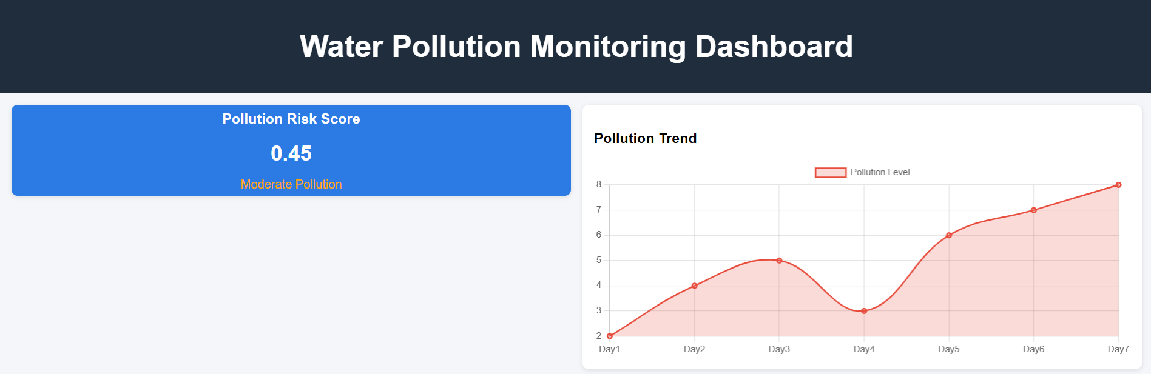

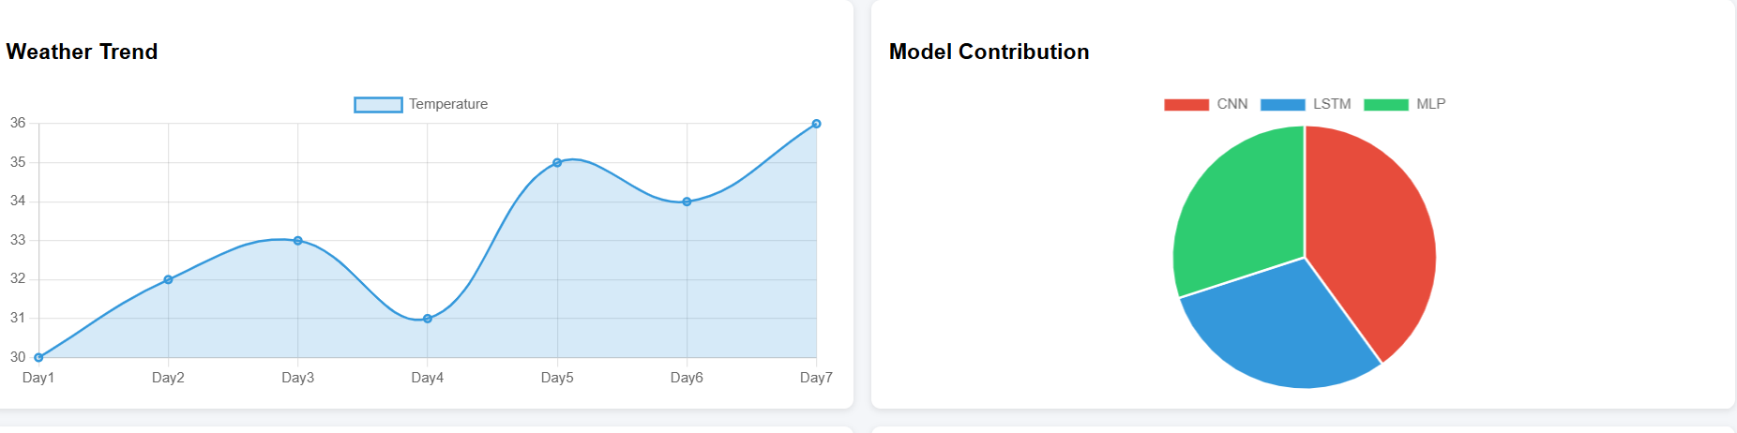
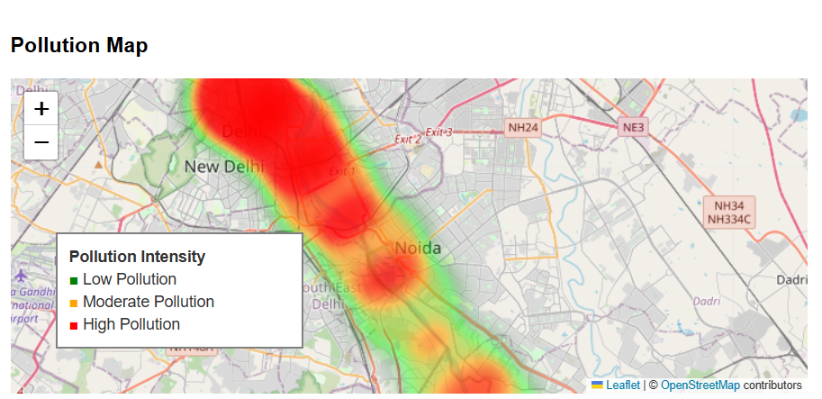
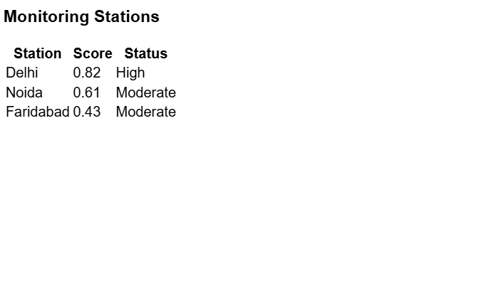
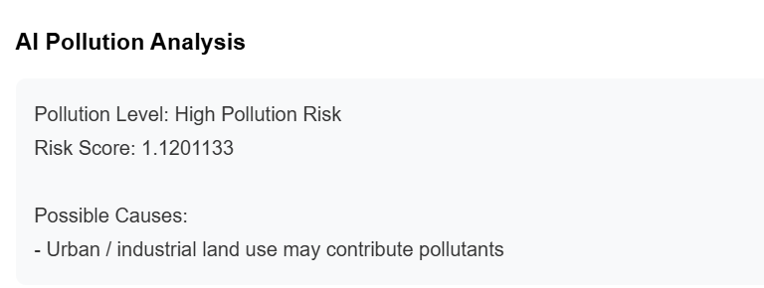
📊 Dataset Description (For Report)
1. Overview
The dataset used in this project is a multimodal environmental dataset designed for water pollution analysis. It combines information from multiple sources such as satellite imagery, historical records, weather conditions, and land use patterns to provide a comprehensive understanding of pollution levels.
The integration of different data types improves the model’s ability to capture complex environmental relationships and enhances prediction accuracy.

2. Dataset Components
2.1 Satellite Image Data
- File: satellite_images.npy
- Type: NumPy array (image data)
- Shape: (N, 128, 128, 6)
- Description:
  - Contains satellite images of water bodies and surrounding regions
  - Each image has 6 channels, representing multispectral bands
  - Used as input for the CNN model
- Purpose:
  - Detect visual pollution patterns such as discoloration, algae blooms, and industrial discharge

2.2 Historical Data
- File: historical_clean.csv
- Type: Tabular data (CSV)
- Features:
  - Water quality indicators (e.g., pH, turbidity, dissolved oxygen)
  - Pollution measurement values over time
- Description:
  - Time-series data used for trend analysis
  - Input for the LSTM model
- Purpose:
  - Capture temporal variations and predict future pollution levels

2.3 Weather Data
- File: weather_clean.csv
- Type: Tabular data (CSV)
- Features:
  - Temperature
  - Rainfall
  - Humidity
  - Wind speed
- Purpose:
  - Environmental conditions that influence pollution dispersion and accumulation

2.4 Land Use Data
- File: landuse_clean.csv
- Type: Tabular data (CSV)
- Features:
  - Urban areas
  - Agricultural land
  - Industrial zones
  - Vegetation cover
- Purpose:
  - Identify human activities contributing to pollution

3. Data Preprocessing
The dataset undergoes several preprocessing steps:
- Normalization:
  - Image pixel values scaled between 0 and 1
- Missing Value Handling:
  - Removed or filled using statistical methods
- Feature Selection:
  - Only numerical columns retained for modeling
- Reshaping:
  - Time-series data reshaped for LSTM input
- Alignment:
  - Different datasets aligned in size for fusion

4. Dataset Size
- Total samples: ~200 (approximate)
- Image resolution: 128 × 128
- Channels: 6 (multispectral)
- Tabular features: Multiple numerical attributes from different sources

5. Data Fusion Strategy
The project uses a multimodal fusion approach:
- CNN processes satellite images
- LSTM processes historical time-series data
- MLP processes contextual data (weather + land use)
The outputs from all models are combined using a weighted average fusion technique to generate the final pollution risk score.
7. Summary
This dataset provides a comprehensive representation of environmental conditions by integrating spatial, temporal, and contextual data. Such a multimodal dataset enables the development of robust AI models for water pollution monitoring and prediction.

