1. **Create History table:**

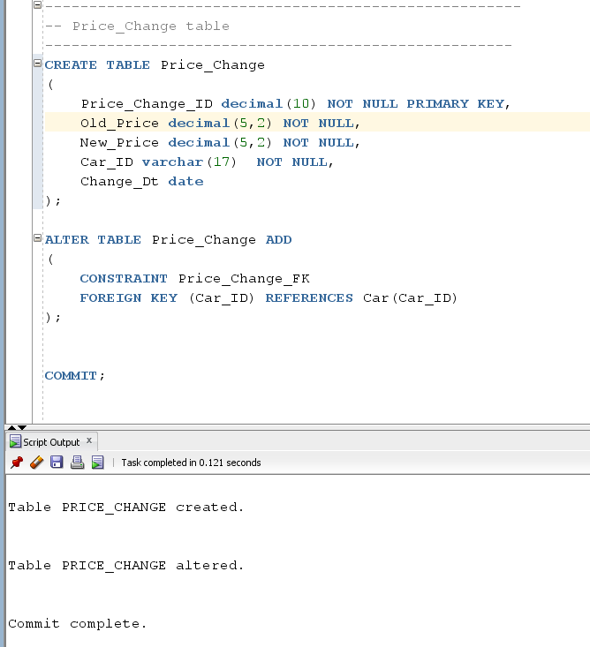

1. **Trigger for Updating history table for change of Price of a Car:**

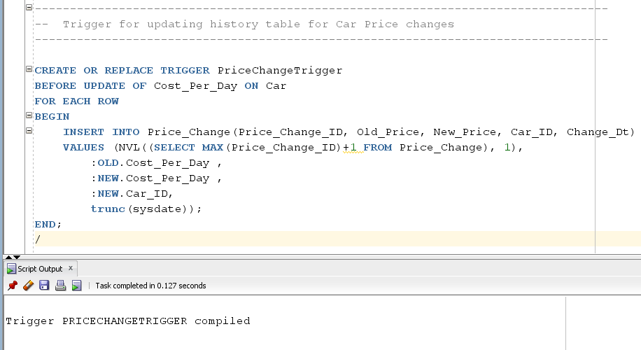

1. **Old Price for below car:**

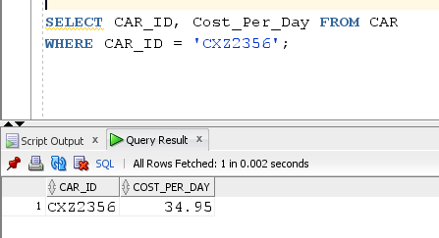

1. **Updating the car Prices:**

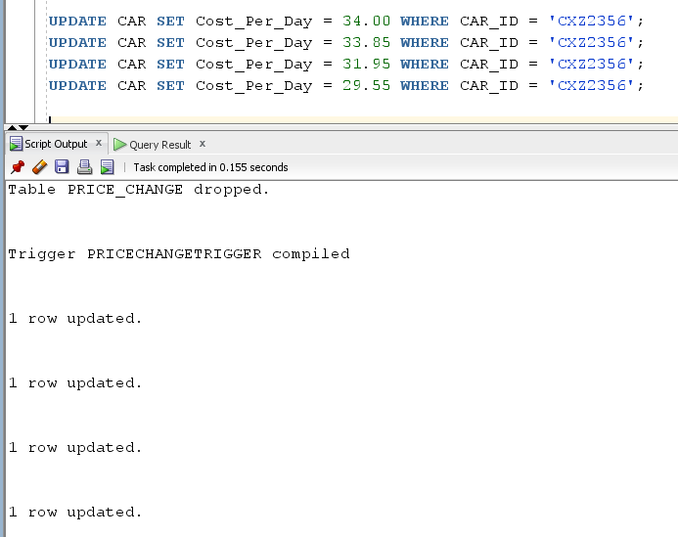

1. **Check for entries in History table (Price_Change):**

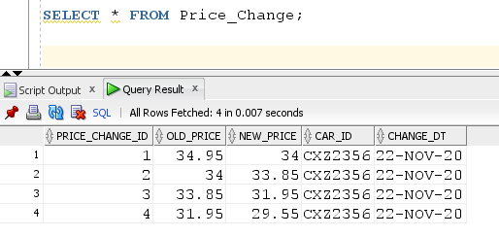

The results show that the price went from $34.95 to $34.00 to $33.85 to $31.95 all for Car_ID = ‘CXZ2356’.