**Try exception block:**

**1. *When user enters value other than p or q***

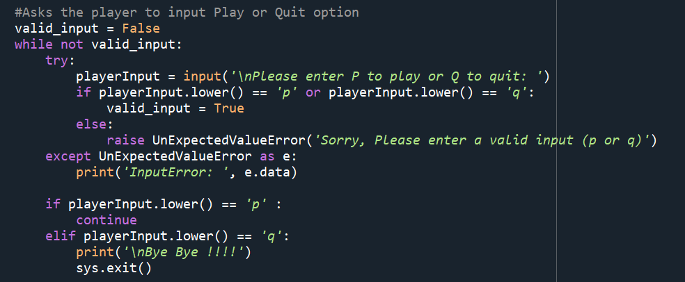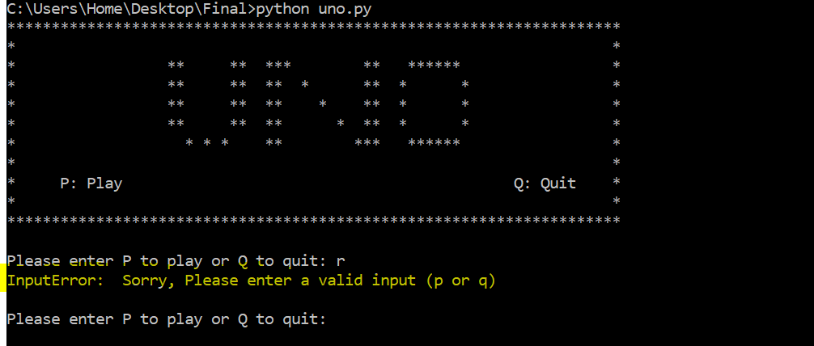

***2. When user enters q: Quit the game***

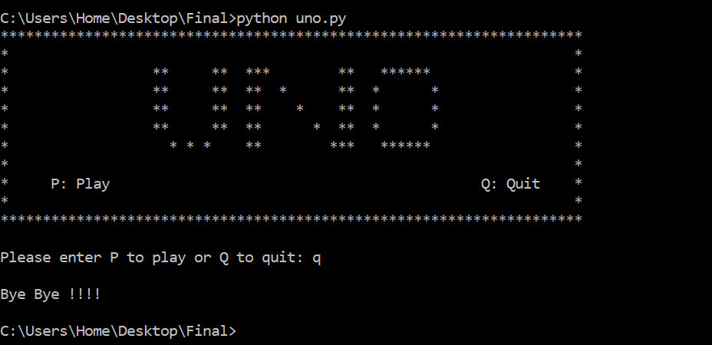

***3. When user enters p and then enters invaid number of players***

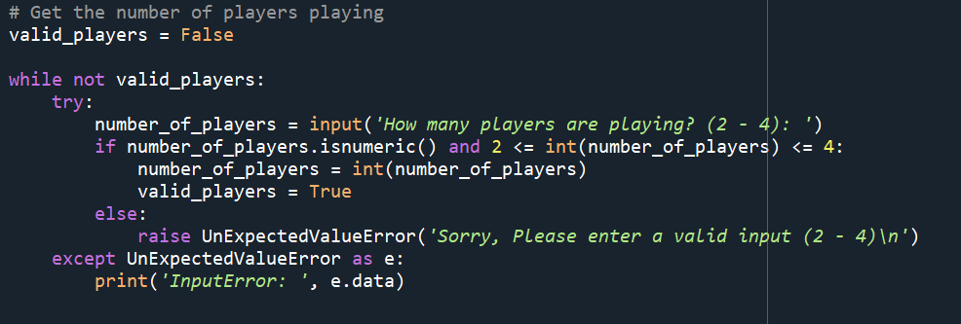

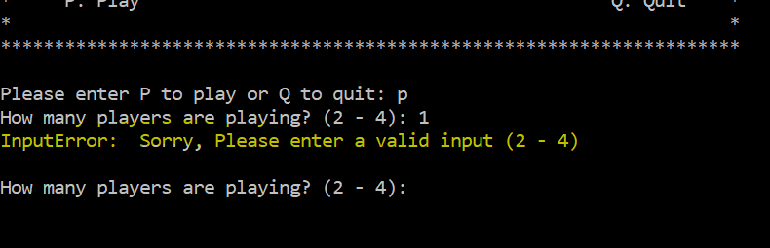

***4. Exception handling for name entered as blank***

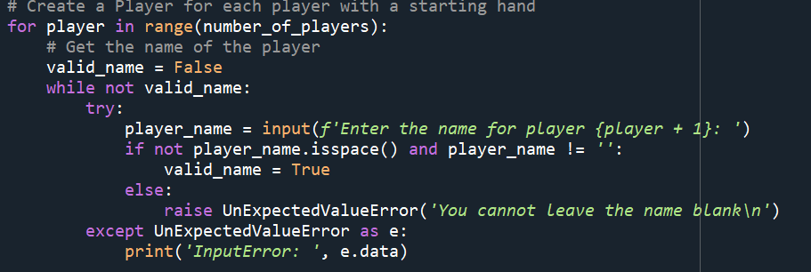

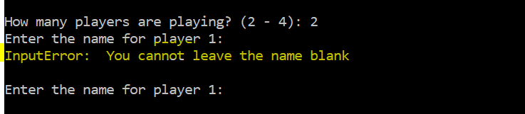

***5. When Player 1 plays Wild Draw 4 card, next player’s turn is skipped and 4 additional cards are appended to his hand of cards.***

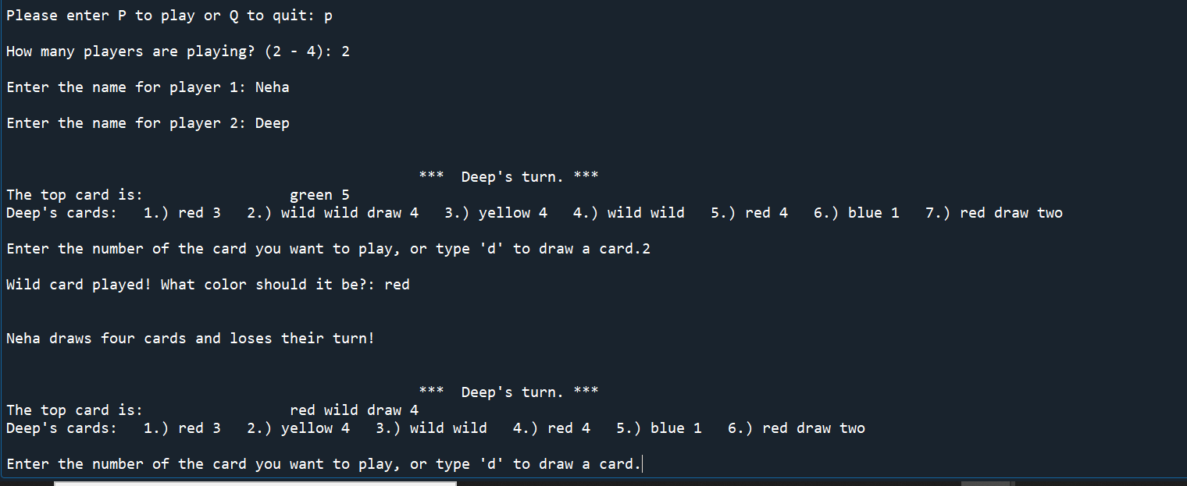

***6. When Player plays an invalid card(index or colour not matching): Prompted a message and asked to play again***

