PROJECT REPORT
SHOWTIME SHOWDOWN
An Interactive Entertainment Quiz — Movies • Sports • Music • TV & Cartoons • Fun Facts
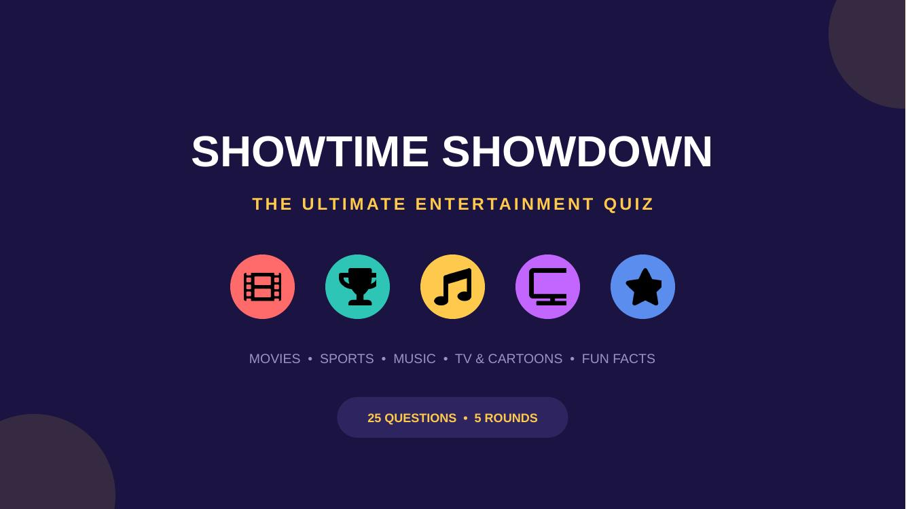

Project Title | Showtime Showdown — An Interactive Entertainment Quiz
Student Name | [Your Name]
Class / Grade | [Your Class]
Roll Number | [Roll No.]
Subject | [Subject Name]
School / Institution | [School Name]
Date of Submission | [Date]
Guided By | [Teacher's Name]

Table of Contents
1. Introduction 3
2. Objective 3
3. Methodology 3
4. Tools & Technologies Used 4
5. Project Description 4
6. Screenshots 6
7. Conclusion 8
8. Future Scope 8
9. References 8

1. Introduction
Quizzes are one of the most effective and enjoyable ways to test knowledge, encourage friendly competition, and bring a group of people together around a shared activity. This project, titled “Showtime Showdown,” is an interactive entertainment quiz designed to be played in a classroom or group setting using a slide presentation.
The quiz covers five popular entertainment categories — Movies, Sports, Music, TV & Cartoons, and Mixed Fun Facts — with a total of 25 multiple-choice questions. Each question is followed by an answer-reveal slide, allowing the quiz to be run smoothly in front of an audience while keeping the game engaging and fair for all participants.
This report documents the objective, planning, tools, and process behind building the quiz, along with the structure of the final presentation and the outcomes of the project.

2. Objective
The main objectives of this project are:
- To design an engaging, classroom-friendly quiz game centered on entertainment topics.
- To test general awareness of participants across movies, sports, music, and television.
- To practice structuring information clearly using a visual, slide-based format.
- To apply presentation design principles — layout, color, and typography — to make learning content visually appealing.
- To create a reusable activity that can be played repeatedly with different groups or teams.

3. Methodology
The project was carried out in a series of structured steps, from planning the content to designing and finalizing the presentation:
Step 1: Topic Selection
Five broad entertainment categories were chosen to keep the quiz varied and appealing to a wide audience: Movies, Sports, Music, TV & Cartoons, and Mixed Fun Facts.
Step 2: Question Research and Drafting
Five questions were written for each category (25 in total), each with four multiple-choice options and one correct answer. Questions were kept at a moderate difficulty level suitable for a general classroom audience.
Step 3: Structuring the Quiz Flow
The quiz was organized into a clear flow: a title slide, an instructions (“How to Play”) slide, five rounds each starting with a category introduction slide, followed by a question slide and its corresponding answer-reveal slide, and finally a closing “thank you” slide.
Step 4: Visual Design
A bold, game-show-inspired color palette (deep indigo background with coral, teal, gold, purple, and blue accents) was used, with each round assigned its own accent color for easy visual identification. Icons representing each category (a film reel, a trophy, a musical note, a television, and a star) were used throughout the deck.
Step 5: Review and Quality Check
Every slide was reviewed for spelling accuracy, correct answer alignment, and visual consistency (spacing, alignment, and contrast) before finalizing the presentation.

4. Tools & Technologies Used
- Presentation Software: Microsoft PowerPoint (.pptx format) for the final interactive quiz deck.
- Design Elements: Custom color palette, icon graphics, and card-based layouts for questions and answers.
- Content Planning: Manual research and drafting of quiz questions and answer options.
- Word Processing: Microsoft Word for preparing this project report.

5. Project Description
The final quiz presentation consists of 58 slides in total, structured as follows:
- 1 Title slide introducing the quiz name and categories.
- 1 “How to Play” instructions slide explaining the rules and scoring.
- 5 Round introduction slides, one per category.
- 25 Question slides, each presenting one question with four answer options (A–D).
- 25 Answer-reveal slides, each highlighting the correct option in green with a checkmark.
- 1 Closing “Thanks for Playing” slide.
Round-wise Breakdown
Round | Category | Focus Area
1 | Movies | Popular films, directors, and iconic movie moments
2 | Sports | General rules, records, and major sporting events
3 | Music | Artists, albums, instruments, and streaming platforms
4 | TV & Cartoons | Classic and popular television shows and characters
5 | Mixed Fun Facts | General knowledge and interesting trivia

6. Screenshots
A few representative slides from the final quiz presentation are shown below.

Fig 1: Title slide of the quiz presentation

Fig 2: Round introduction slide for the Movies category
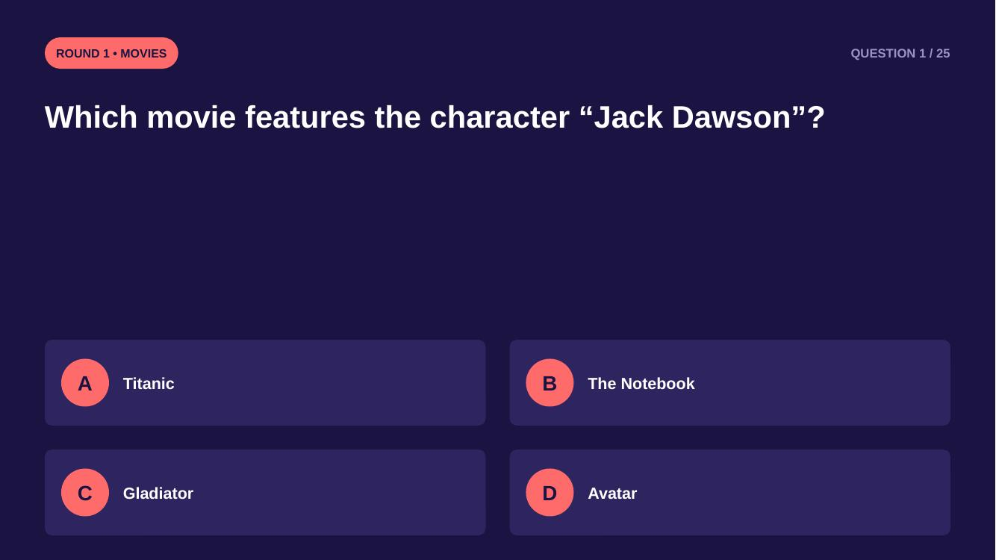
Fig 3: A sample question slide with four options
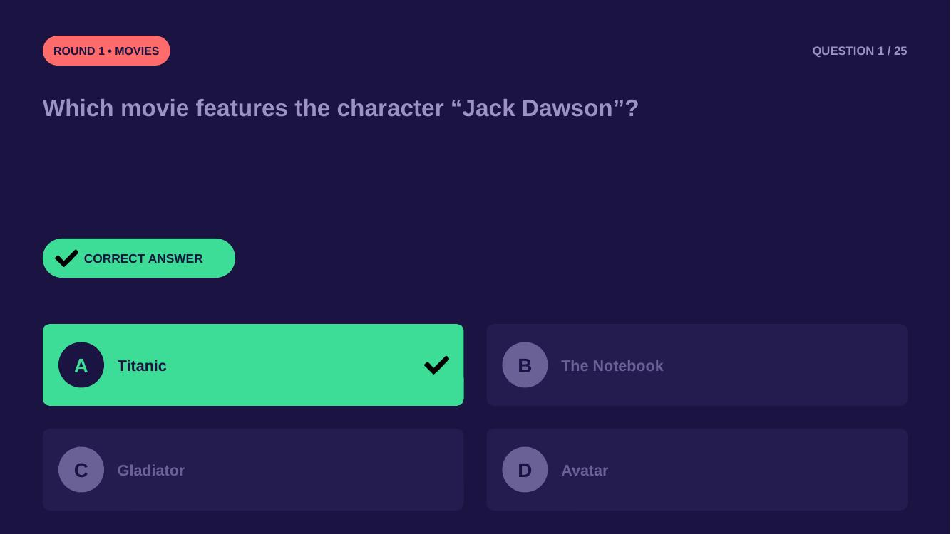
Fig 4: The corresponding answer-reveal slide

7. Conclusion
The “Showtime Showdown” quiz project successfully brings together entertainment trivia and visual presentation design into a single, ready-to-play activity. By organizing questions into clear categories and pairing each with a well-designed answer-reveal slide, the quiz is both easy to run and enjoyable to play.
Through this project, key skills were practiced, including research and content organization, visual design principles, and structuring information for an audience. The final presentation can be used repeatedly for classroom activities, group games, or informal get-togethers, and can easily be expanded with additional rounds or categories in the future.

8. Future Scope
- Adding a timer to each question slide to increase competitiveness.
- Introducing a digital scoreboard slide to track team scores automatically.
- Expanding the quiz with additional rounds, such as History, Geography, or Science.
- Converting the presentation into an interactive web-based quiz application.

9. References
- General knowledge and trivia facts compiled from common public knowledge.
- Presentation design principles based on standard slide-design best practices.

