# TOPIC CHOSEN - MURDER PROBLEM STATEMENT

“Last year, an alarming increase in homicides left communities reeling as officials searched for answers. Over the past few decades, the rate at which this horrendous crime is increasing is alarming, and Governments and Police all over have been looking for insights and solutions to help them understand the situation more.” Can you provide a detailed analysis of various attributes leading to this atrocious crime globally, as well as data-backed solutions to curb the same? Feel free to approach the problem as a Global and general issue, or delve into specifics about the crime of murder (and instead approach it with respect to a single Geographic region or one particular cause).

# THE LINKS FOR THE DATASETS

1. [https://www.kaggle.com/mathurinache/list-of-countries-byintentional-homicide-rate](https://www.kaggle.com/mathurinache/list-of-countries-by-intentional-homicide-rate)

We will be starting off with this data set and branch into the US stats. From here on we will be using 2 data sets to represent the US crime stats.

1. <https://www.kaggle.com/murderaccountability/homicide-reports>
2. <https://data.world/publicsafety/chicago-crime>

These 2 mentioned above ^ These 3 data sets are for the first part of our problem statement.

1. <https://www.kaggle.com/zusmani/us-mass-shootings-last-50-years> This data set is for the last part of our problem statement, the cause of crimes and such.

## OBSERVATIONS

We decided to take a closer look at the homicide rates in the US over the past few decades. The following are the trends we observed.

1. OBSERVATION 1

This was an interesting observation.Contrary to the problem statement, based on our dataset, we observed that the average number of homicides per year ACTUALLY decreased over the past 2-3 decades.

This can be observed through the line graph that we plotted

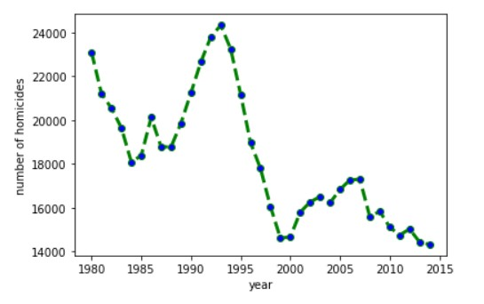

As we observe here, the cases in US have fairly decreased now as compared to the 1980’s and 1990’s.

1. OBSERVATION 2

Here, we plotted a pie chart to observe the proportions of victims and perpetrators race-wise, as per our dataset we see that major portions of victims and perpetrators fall under the “Black” or “White” race. This could be a direct result of ever-prevalent racism issues in the US.

Graph 1: Victims of homicide over the years

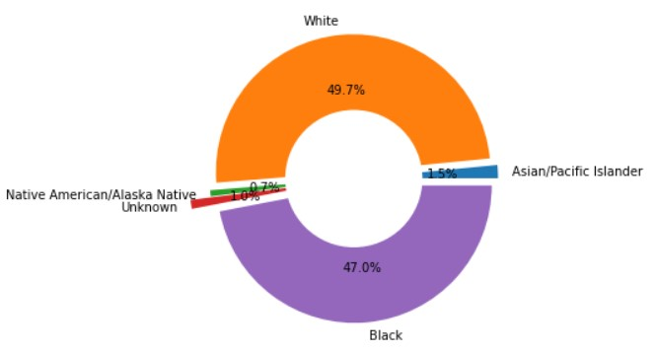

Graph 2: perpetrators of homicide over the years

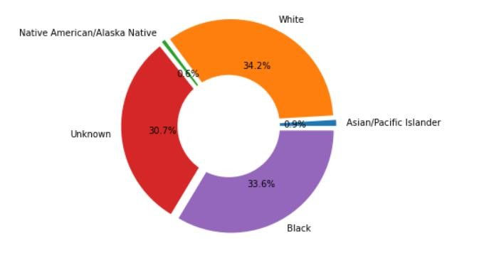

1. OBSERVATION 3

From the Chicago crimes 2014 dataset we have concluded that the most crimes took place in the month of JULY.

The graph is between the months and the number of homicides.

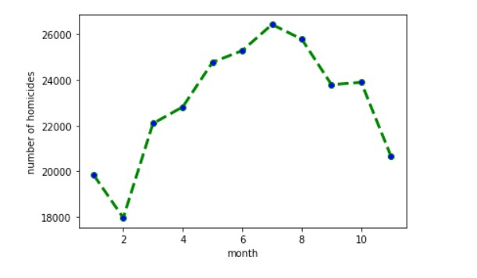

1. Open/Closed areas:

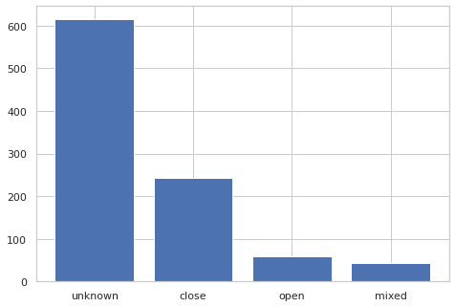

1. Did the shooters suffer from mental health issues? 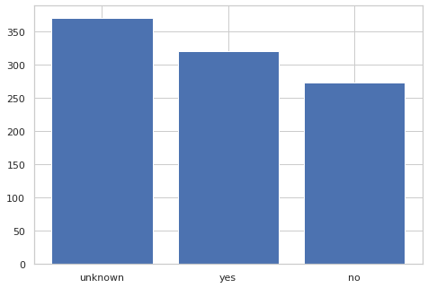
2. Major victims of the shootings: 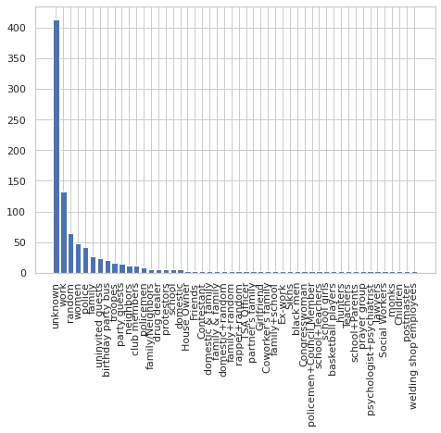
3. Gender stats of the shooters: 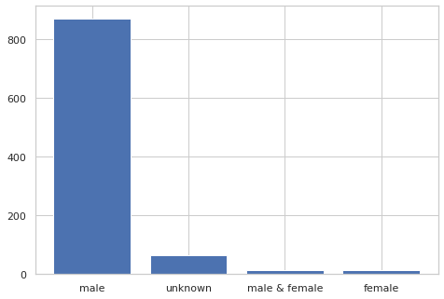
4. Reasons for shooting:

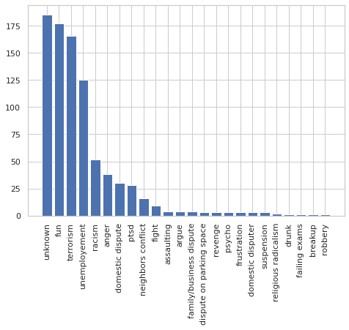

1. Race of the shooters:

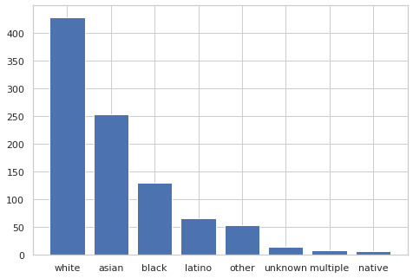

This is the link to our google colab:

<https://colab.research.google.com/drive/1SGw3sUis8tfAv0hYsNEv3zxbuAUSBV_H?usp=sharing>