INDIA SALES PERFORMANCE
Analysis & Dashboard Report
Prepared by: Neha Bhatt
Business Analyst | Data Analytics Portfolio
Nadiad, Gujarat, India
Dataset: India Sales Dataset (10,000 records)
Dashboard Tool: Tableau | Period: January 2023 – January 2024

1. Executive Summary
This report presents an analysis of India's sales performance for FY2023, based on a transactional dataset of 10,000 orders spanning four regions, eight states, and three product categories. The accompanying Tableau dashboard (Sales Performance Dashboard-India) visualizes sales, profit, quantity, and regional/product trends to support data-driven business decisions.
Key headline figures for the period:
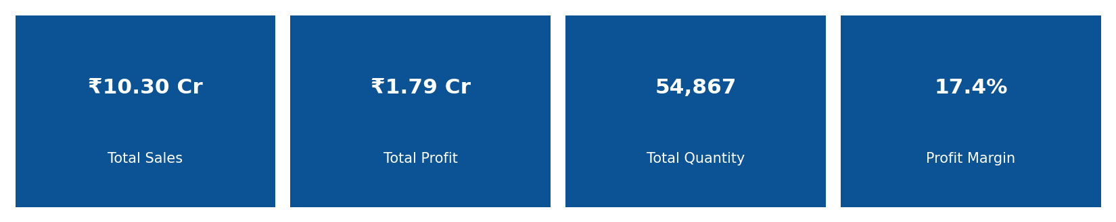
- Total Sales: ₹10.30 Crore (₹102,969,416.73) across 10,000 orders
- Total Profit: ₹1.79 Crore (₹17,894,155.21)
- Total Quantity Sold: 54,867 units
- Overall Profit Margin: 17.38%
- Average Order Value: ₹10,296.94

2. About the Dataset
The source dataset, India_Sales_Dataset_10000_Rows.xlsx, contains 10,000 order-level records with the following fields:
Field | Description
Order ID | Unique identifier for each transaction
Order Date | Date of sale (Jan 2023 – Jan 2024)
State / Region | Location of sale (8 states across 4 regions: North, South, East, West)
Category / Sub-Category | Product classification (3 categories, 9 sub-categories)
Sales | Revenue generated per order (₹)
Quantity | Units sold per order
Profit | Profit earned per order (₹)
No missing values were found in any column; the dataset was clean and required no imputation before analysis.

3. Dashboard Overview
The Tableau dashboard "Sales Performance Dashboard-India" (Sales_performance_Dashboard-India.twbx) brings together four KPI cards, three comparative charts, a geographic map, and an interactive filter panel:
- KPI Cards: Total Sales, Total Profit, Total Quantity, Profit Margin
- Region Performance: horizontal bar chart of Sales by Region
- Product Analysis: horizontal bar chart of Sales by Sub-Category
- Sales Trend Over Time: line chart of monthly Sales
- Map View: geographic distribution of Sales by State
- Filters: interactive controls for Region, Category and Order Date
The charts below are rebuilt directly from the underlying dataset to mirror each dashboard panel and support this written analysis.

4. Regional Performance
North is the clear leader, generating ₹3.79 Cr in sales — roughly 37% of total revenue and nearly 1.5x the next-highest region. West and South are closely matched at ₹2.59 Cr and ₹2.56 Cr respectively, while East trails at ₹1.35 Cr, about a third of North's total.
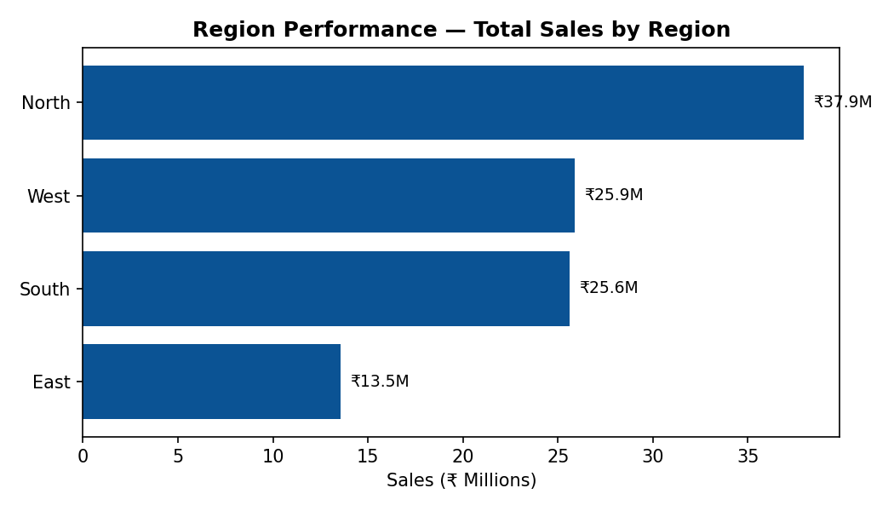
Figure 1 — Total Sales by Region
Region | Sales (₹) | Profit (₹) | Margin %
North | 3,79,37,575.78 | 66,39,968.95 | 17.50%
West | 2,58,85,854.85 | 44,69,389.99 | 17.27%
South | 2,56,05,050.69 | 43,94,158.77 | 17.16%
East | 1,35,40,935.41 | 23,90,637.50 | 17.65%
Margins are consistent across regions (17.2%–17.7%), so North's advantage comes from order volume rather than pricing or discounting differences — East, despite the lowest sales, actually posts the highest margin.

5. Product Analysis
Sales are evenly spread across the three top-level categories — Technology (₹3.45 Cr), Furniture (₹3.43 Cr) and Office Supplies (₹3.42 Cr) each contribute close to a third of revenue. At the sub-category level, Binders (₹1.20 Cr) and Chairs (₹1.17 Cr) lead, while Paper (₹1.09 Cr) is the smallest contributor — but the spread across all nine sub-categories is narrow (within ~10%).
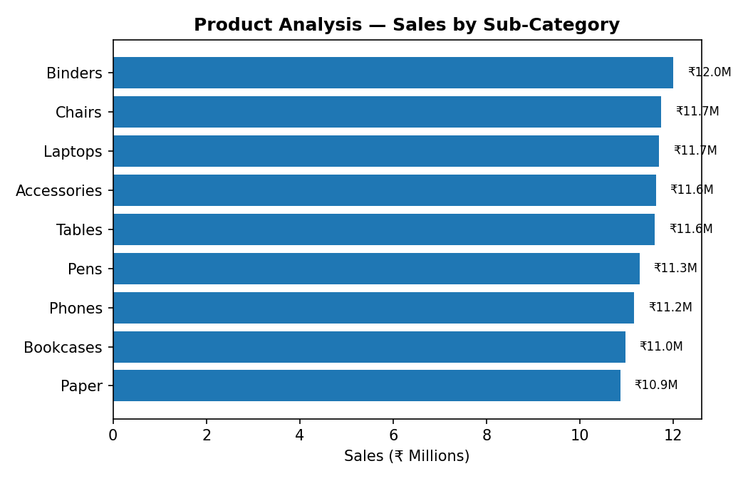
Figure 2 — Total Sales by Sub-Category
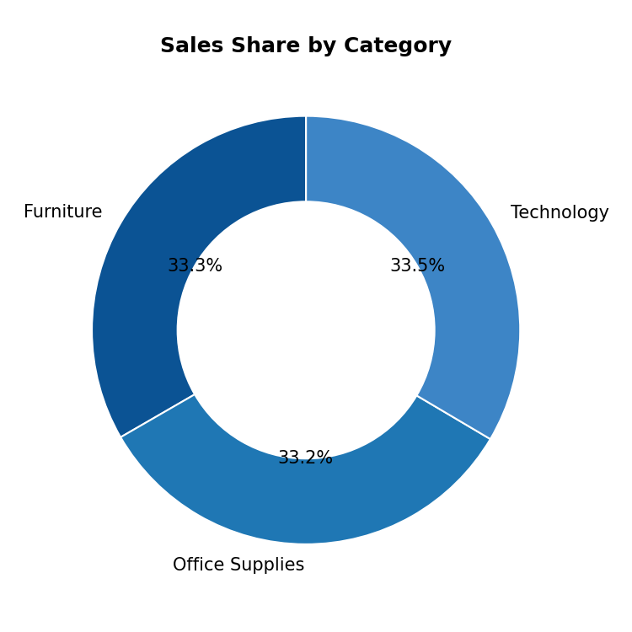
Figure 3 — Sales Share by Category

6. Sales Trend Over Time
Monthly sales were stable through 2023, ranging between ₹7.8 Cr and ₹9.4 Cr with no strong seasonal dips. July and December 2023 were the strongest months, with December peaking at ₹93.68 Lakh. The sharp drop shown for January 2024 reflects only a single day of data (2024-01-01) in the dataset, not an actual decline, since the dataset otherwise ends at 2023-12-31.
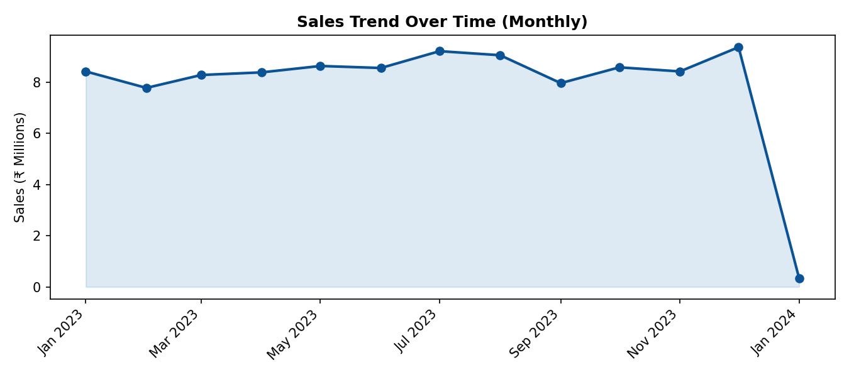
Figure 4 — Monthly Sales Trend (Jan 2023 – Jan 2024)

7. Geographic Performance (Map View)
Sales are distributed across eight states with West Bengal (₹1.35 Cr), Maharashtra (₹1.35 Cr) and Delhi (₹1.29 Cr) at the top, and Gujarat (₹1.24 Cr) at the lower end. Overall state-level spread is tight — the top and bottom states differ by only about 9% — indicating a fairly balanced footprint rather than dependence on one hub state.
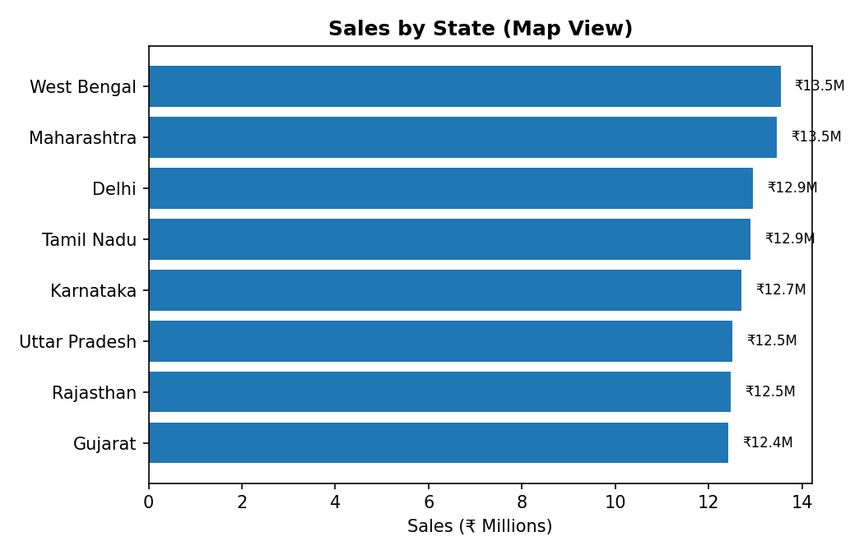
Figure 5 — Total Sales by State (proxy for the dashboard's Map View)

8. Key Insights
- North region drives the largest share of revenue (37%) despite having margins similar to other regions — its scale comes from higher order volume.
- Profit margin is remarkably consistent across regions (17.2%–17.7%) and categories (17.2%–17.5%), suggesting a uniform pricing/discount policy nationally.
- No single product category dominates — Technology, Furniture and Office Supplies each contribute roughly a third of sales, pointing to a well-diversified product mix.
- Monthly sales are stable with a mild upward pull toward year-end (Dec 2023 was the peak month), useful for staffing and inventory planning.
- State-level sales are evenly spread (Gujarat to West Bengal within ~9%), showing the business is not overly reliant on any one state.

9. Recommendations
- Investigate what is driving North's higher order volume (marketing spend, dealer network, demand) and evaluate replicating those drivers in East, the lowest-performing region.
- Since East has the smallest sales but the highest margin, consider a targeted growth push there rather than margin-focused actions — volume, not pricing, is the opportunity.
- Use the Dec/Jul peak pattern to plan inventory and promotional campaigns ahead of these months.
- Because sub-category performance is narrow, consider bundling lower-performing items like Paper with higher-performing ones like Binders to lift average order value.

10. Conclusion
The FY2023 India sales data shows a healthy, well-diversified business generating ₹10.30 Crore in revenue at a stable ~17.4% margin, led by the North region and an even product mix. The Tableau dashboard makes these regional, product and time-based patterns immediately visible for ongoing monitoring, and the recommendations above translate the analysis into concrete next steps for regional and product strategy.

